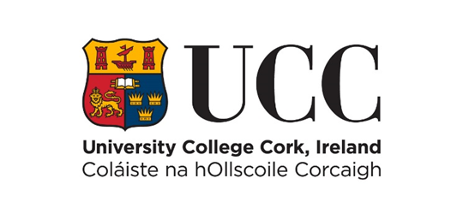

**Internal Progression Process Scheme**

**Stage 2 - Invited Full Application for Promotion to Professor (Scale 2) 2024/25**

**COVER PAGE – PLEASE READ CAREFULLY**

Name: Year of appointment to current post:

School: Discipline:

Please indicate whether part-time or full-time:

Link to IRIS profile (or equivalent):

**Typed forms must be submitted online using this template only via e-recruitment using Employee Self Service (ESS) – handwritten forms will not be considered.** Please use font type **Calibri, Size 11, single spaced, portrait orientation only, on this form.**

**The closing date for receipt of applications is strictly 12 noon (Irish Local Time) on Monday, 24th February 2025. No applications will be accepted for consideration after this time. Before proceeding, please ensure that you have carefully read the Regulations on Academic Promotions to Professor (Scale 2).**

Please ensure that the information and summary of achievements listed in each section of this form can be supported by indicative evidence. **You must indicate here how you have satisfied the relevant essential criteria requirements as found in Appendix C of the Regulations to establish a case for Promotion.** Please consider structuring your portfolio sections in line with the criteria structure as set out on page 11 of the Regulation'.

The Board reserves the right to verify the information supplied by applicants. Candidates should note that **any inaccurate or surplus information will render the application null and void.**

**Details submitted as part of this promotion process (including for example, any details submitted as part of this Stage 2 application) will be shared with the candidate’s Head of College, candidate’s Head of School, Promotion to Professor (Scale 2) Board members, the People & Culture Department, External Reviewers and where applicable, members of the Appeals Board. Full details of how your personal data is processed by the University are available at** [**https://www.ucc.ie/en/ocla/comp/data/**](https://www.ucc.ie/en/ocla/comp/data/)

Please note that it is optional to use a Teaching Profile Summary Template available at:

[**https://www.ucc.ie/en/hr/promotions/academic/ps2/**](https://www.ucc.ie/en/hr/promotions/academic/ps2/) **If using this Template in your application, however, be reminded that you should embed it into your application form within its existing page limits.**

**NB: This template may not be altered. Applications exceeding the specified page limit will not be considered.**

1. **Leadership in Research and Innovation (Font Calibri, size 11, single spaced only)**

*This should reflect the research approach and profile of the candidate and be organised in sections corresponding to the Leadership in Research and Innovation criteria detailed in Appendix C.* Please link to your top 5 publications/outputs on page 11 of this form. **Answers must not exceed the five-page limit.**

1. **Leadership in Learning and Teaching (Font Calibri, size 11, single spaced only)**

*This should reflect teaching activity and be organised in sections corresponding to the Leadership in Learning and Teaching criteria detailed in Appendix C.* **Answers must not exceed the three-page limit.**

1. **Leadership in Contribution to Academic Citizenship and Engagement (Font Calibri, size 11, single spaced only)**

*This should be reflective of the level of contribution made by the candidate to academic citizenship and should be organised in sections corresponding to the Leadership in Contribution to Academic Citizenship and Engagement criteria detailed in Appendix C.* **Answers must not exceed the two-page limit.**

**Top Five Research Publications /Outputs**

Please provide **links** for your **top five** research publications or outputs below. In exceptional circumstances, where links cannot be made available, hardcopies may be considered. Please email [ps2queries@ucc.ie](mailto:ps2queries@ucc.ie) to arrange same.