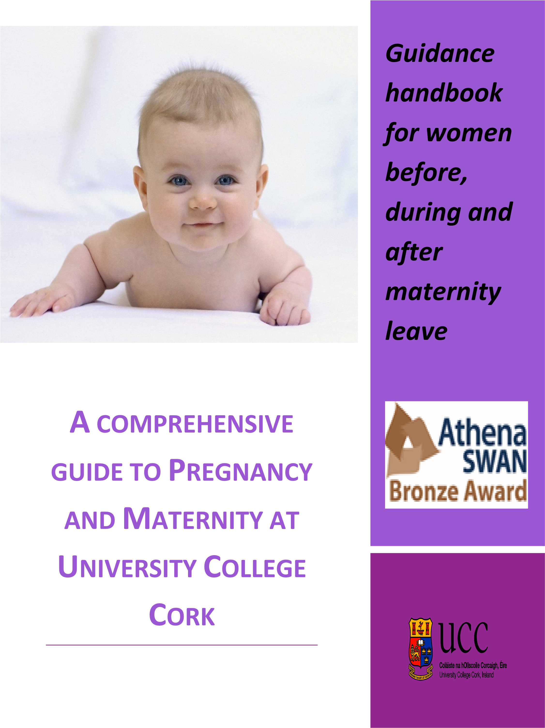
Table of Contents

- Pregnancy at Work
  - Looking after yourself
  - Informing your manager
  - Health and Safety
  - Antenatal Care
  - Staff on fixed term Contracts
  - Externally Funded Staff
  - Maternity Leave Cover

- Taking Maternity Leave
  - Maternity Leave at Work
  - Maternity Pay
  - Pension
  - Holiday Entitlement
  - Contact during maternity leave
  - Keeping in Touch days
  - Adoptive leave
  - Extension of Maternity Leave & Benefits in the Event of Premature Births

- Returning to Work
  - Return Date
  - Breastfeeding
  - Flexible Working
  - Parental Leave
  - Carers Leave
  - Parent’s Leave

- Supports Provided by the University
  - Maternity Connections
  - Coaching Service
  - Parking
  - Mentoring
  - University Crèche
  - Returners Scheme for Academic Staff
  - Work and family Initiatives
  - Check List

This handbook has been developed to provide a comprehensive source of information for women before, during and after maternity leave. The handbook is supported by a number of policies which are available on the HR website. http://www.ucc.ie/en/hr
Pregnancy and childbirth necessitate a break in employment for mothers and the way in which this interruption is managed has important implications for women and their families. As an employer the University recognises the importance of supporting and retaining female staff who take maternity leave, and also the impact that taking time out of the workplace to raise a family can have on the careers of some women. With this in mind, UCC has developed a range of policies and initiatives not only to support women while they are on maternity leave but also to support them upon returning to work and re-establishing their careers whilst simultaneously balancing home/work commitments.
The Coaching Panel provides additional supports to pregnant staff.
Details of the UCC Coaching panel are via the attached link below:- http://www.ucc.ie/en/hr/wellbeingdevelopment/coaching and can also be contacted via the email address coaching@ucc.ie

Pregnancy at Work

LOOKING AFTER YOURSELF
Continuing to work during your pregnancy is not easy and it is important that you look after yourself in the workplace during this time. In the event of you feeling that some pregnancy related symptoms are affecting your work you should inform your manager as soon as possible. Of course this may mean that you inform your line manager about your pregnancy earlier than you had anticipated, but your first priority is that you should remain healthy and safe while you are at work.

INFORMING YOUR MANAGER
You must inform your manager and Human Resources in writing of the date you intend to commence maternity leave. This notification must be submitted before the end of the 15th week prior to your baby’s due date. You apply to the Department of Human Resources for maternity leave using an Application for Maternity Leave Form ML1. A certificate from your doctor must be attached to the leave form. The certificate must confirm the pregnancy and specify the expected week of confinement.

HEALTH AND SAFETY

In the workplace there may be risks that may affect your health and safety and that of your unborn child. There are specific regulations that require the University as an employer to protect the health and safety of new and expectant mothers.

Under Safety, Health and Welfare at Work Act 2005 Pregnant Employees Regulations, a risk assessment/job assessment must be conducted at departmental level in relation to the impact of work on the person/unborn child and retained on Departmental Records.
Upon confirmation of pregnancy, HR will then issue you with a copy of UCC's Pregnancy Job Risk Assessment Form. You must complete this risk assessment in conjunction with your line manager and submit this to the Health and Safety Office.
The Health and Safety Office will submit the completed form to the University Occupational Health Physician who will advise if any modifications are required to your work activities during pregnancy or whilst nursing a new born child.

You may also be entitled to Health & Safety Leave if you are exposed to certain risks in the workplace during pregnancy or while breastfeeding. During this leave you may be entitled to Health & Safety Benefit which is a weekly payment for women who are granted Health & Safety Leave under the Maternity Protection Act, 1994. For more information please consult the Maternity Leave Policy.

YOUR RIGHTS AT WORK

Pregnancy is not an illness and you do not suddenly become less capable of doing your job. The two main acts that give you rights during pregnancy and maternity are the Maternity Protection Acts, 1994 and 2002 and the Employment Equality Acts 1998 and 2004. During Pregnancy you should receive:

- The same work duties and responsibilities, unless changes arise from unrelated restructuring of work activity or adjustments that are necessary for your health and safety
- Paid time off to attend antenatal appointments
- The same training and promotional opportunities as other staff
- The health and safety risk assessment
- Access to the usual contractual sick pay arrangements for any pregnancy related absence

ANTENATAL CARE

You have a statutory right to reasonable paid time off to attend appointments for ante-natal and post-natal care once accompanied by a certificate to confirm appointments. As far as is reasonably possible, these appointments should be made at times that cause least disruption to your work schedule.

Fathers are entitled to paid leave to attend two ante-natal classes, immediately prior to the birth. The same evidence of attendance will be required, as is currently required for mothers.

STAFF ON FIXED TERM CONTRACTS
If your contract of employment is due to expire during your maternity leave you should talk to your line manager and the HR Business Manager as soon as possible to review this contract. If a contract renewal is not possible than you may still be entitled to paid maternity leave and maternity benefit from the Department of Social Welfare up to the end date of your contract.

EXTERNALLY FUNDED STAFF

It is recommended that staff who are externally funded follow the process outlined:
- As soon as you are aware you are pregnant gather as much information as possible on your funding body’s policy on maternity leave and pay. Your PI should contact your funding body directly and ascertain their policy on maternity pay.
- A meeting between you and your PI should be arranged to discuss the options available to you.
- Once your maternity arrangements have been agreed, your PI should contact your funding body to agree the arrangements with them and ensure that the agreement is sent to you in writing.
- A copy of this letter should be sent to your Head of School and the HR Administrator responsible to processing maternity leave.

MATERNITY COVER
At the earliest convenience, you are advised to discuss any maternity cover that may be necessary during your absence with your line manager in the first instance and your line manager can then discuss this with the HR Business Manager. An outline of the cover agreed and the additional costs involved must be drawn up by the Head of School or Head of Central Unit. The line manager will assess the requirements of the department over the period of leave and may avail of a number of options including:-

- Re-evaluation of the work load and the timing of delivery
- Part-time Hourly Occasional teaching support for academic staff
- Reassignment or reallocation of key duties
- Part or fulltime replacement at a different grade
- Internal opportunity for skills development for staff

Taking Maternity Leave

MATERNITY LEAVE ENTITLEMENT

Under the maternity legislation all women are entitled to 42 weeks maternity leave. Payment of maternity leave may be sourced both from the Department of Social Welfare and/or the University. The 42 week entitlement is divided into 26 weeks paid and an additional 16 weeks unpaid. Entitlements to paid leave and unpaid leave are outlined in the Universities maternity leave policy. You are strongly encouraged to read the maternity policy which sets out in detail all the provisions to which you are entitled to.

MATERNITY PAY
If you pay Class D PRSI you may be granted full pay from the University whilst on maternity leave. If you pay Class A1 PRS you must fill in the MB1 form and the Dept of Human Resources must fill in the MB2 form. Both forms need to be returned directly to:-
Maternity Benefit Section,
Social Welfare Services,
McCarter’s Road,
Buncrana, Co. Donegal.
The standard amount of Є262.00 will be deducted from salary for 26 weeks. The maternity benefit payment will be sent directly to the staff member’s bank account. For further information please consult the Maternity Leave Policy.

PENSION

While on maternity leave you will continue to be a member of the relevant pension scheme. During the paid maternity leave your service continues to be reckonable. If you avail of the additional unpaid maternity leave this will not be reckonable for superannuation. Therefore this absence will not count as service.

HOLIDAY ENTITLEMENT

You will accrue annual leave during paid and unpaid maternity leave. You will also be entitled to public holidays that fall during the 26 week period of paid maternity leave and these will be added to the end of the period of maternity leave. If you are availing of additional unpaid maternity leave you will be entitled to annual leave and payment of public holidays which fall within the period of unpaid maternity leave. You should refer to the Maternity Leave policy for further details on how your leave can be taken.

CONTACT DURING MATERNITY LEAVE

It is advisable that you maintain reasonable contact with your line manager while you are on maternity leave so that you can be kept informed of any changes and developments at work and to facilitate any discussions around your plans for returning. Before you go on maternity leave you should talk to your manager about what contact might be appropriate and how you would prefer to be contacted.

KEEPING IN TOUCH DAYS

While on Maternity Leave you are entitled by agreement with your Head of School/Department/Unit to work for a maximum 3 Keep in Touch Days (KIT) for which you would be paid. The type of work undertaken is a matter for agreement between both parties – the days may be used for any activity which would ordinarily be classed as work under your contract of employment.

ADOPTION LEAVE

If you are adopting a child and have been identified as the primary carer you may be entitled to take up to 40 weeks adoption leave. You must inform your Line Manager in writing of the pending adoptive leave as soon as is practicable, but no later than fifteen weeks before the commencement of adoptive leave. For practical reasons, it is desirable that employees provide as much notice as possible so that appropriate arrangements can be made regarding workload distribution or replacement. You must apply to the Department of Human Resources for adoptive leave using an Application for Adoption Leave Form AL1. A certificate of placement must be submitted to the Department of Human Resources as soon as is reasonably practicable, but no later than four weeks after the placement. For further information please consult the university’s Adoptive Leave Policy.

EXTENSION OF MATERNITY LEAVE & BENEFITS IN THE EVENT OF PREMATURE BIRTHS

From 1st October 2017, the period for which maternity benefit is paid is being extended in cases where a baby is born prematurely. The extended period of benefit will be equivalent to the duration between the actual date of birth of the premature baby and the date when the maternity leave was expected to commence (i.e. ordinarily two weeks before the expected date of birth). This new measure, which takes effect for premature babies born on or after Sunday, 1st October 2017, will increase the duration of maternity leave and the associated maternity benefit to be paid in cases where a baby is born prematurely.

Returning to Work

RETURN DATE

The University will assume that you are going to return to work on the anticipated return date that you provide prior to the commencement of your maternity leave. If you wish to amend this date or return prior to the end of your maternity period you must give at least four weeks’ notice before the expected return to work date.

BREASTFEEDING
The provision for women to breastfeed at work was brought into effect on the 18th October, 2004 through SI 654 of 2004 Maternity Protection (Protection of Mothers who are Breastfeeding) Regulations 2004. If you are breastfeeding your child you are entitled, without loss of pay, to a reduction in working hours of one hour each day, until your child is 6 months old (26 weeks). The break, or reduction in hours, may be taken as one break of 60 minutes, two breaks of 30 minutes each, or three breaks of 20 minutes each, or in such a manner agreed between you and the line manager. The University has made available facilities on campus for breastfeeding. Please contact the Welfare Officer for further details.

FLEXIBLE WORKING

Flexible working and flexi-time are terms used to describe a wide range of working styles that differ from the traditional nine-to-five full-time job. UCC accommodates a range of such schemes including, but not limited to EA/SEA Flexible working scheme, Job Sharing, changing your working hours, part-time working or working term time only.

Flexible working is not an automatic right and requests can be refused if there is a clear business reason for doing so. You need to have a discussion with your line manager to explore all possible options that may be available.

PARENTAL LEAVE
Parental Leave is a statutory right designed to enable staff that have at least one year’s continuous service to spend more time with their children while keeping their employment open.

Under the Parental Leave Policy you can apply for unpaid leave up to 22 weeks per qualifying child (since 1st September 2019) which can be taken in one continuous period or in 2 separate blocks of a minimum of six weeks. Leave can be taken in respect of a child up to 13 years of age (from 1st January 2015). Parental Leave will not be regarded as a break in service as you will still remain employed during this time. For more information see the Parental Leave Policy.

CARERS LEAVE
Carer's Leave is unpaid leave from work to allow you to provide full-time care and attention to a care recipient who needs continual supervision and frequent assistance throughout the day in connection with normal bodily functions or, need continual supervision in order to avoid danger to themselves. Carer's Leave is unpaid leave up to a maximum of 104 weeks per qualifying relevant person. The minimum statutory entitlement that may be taken in one period is 13 weeks. For more information see the Carers Leave Policy.

Parent’s Leave

Parent’s Leave & Benefit Act 2019 came into operation from 1st November 2019. This Act provides employees who are relevant parents are entitled to leave to assist in the provision of care to the child within 12 months of the birth or adoption placement date of the child. This leave is referred to as “Parent’s Leave” and applies to births or adoptions which occur on or after 1st November 2019. From July 2022, the entitlement increased to 7 weeks which can be taken consecutively or in separate blocks up to the maximum of 7 weeks. This leave can be availed of up to the child’s 2nd birthday. The Act provides for the payment of parent’s benefit from Dept of Employment Affairs and Social Protection to eligible employees who satisfy the PRSI contribution conditions. For further details, please refer to www.welfare.ie/en/pages/parents-benefit.aspx

Supports Provided by the University

MATERNITY CONNECTIONS

Maternity connections is an informal initiative set up by the Welfare and Equality teams in HR that enables members of staff to directly contact volunteer members of staff with experience of pregnancy at work, maternity leave and life as a working parent for support and advise. The scheme is open to all members of staff. For more information on this scheme please see the HR Website. https://www.ucc.ie/en/hr/

COACHING SERVICE

Details of the UCC Coaching Panel are available via the attached link
https://www.ucc.ie/en/hr/wellbeingdevelopment/coaching/ and can
be contacted also via the email address coaching@ucc.ie.
Parental transition – planning and preparation (before); returning with
confidence (during); and working parents (within 6 months of returning)
or following “the empty nest”.

PARKING

Pregnant women in the 28th week of pregnancy can apply for a parking permit to avail of car-pooling reserved spaces. To request a permit, please contact the Capital Projects Office, Buildings & Estates, at i.sheehan@ucc.ie. You will need to provide a copy of a doctor’s medical certificate confirming the week of pregnancy. Any other accommodation for pregnant staff in relation to parking will be addressed and you can contact Buildings & Estates directly to discuss this further.

MENTORING
Mentoring is a powerful personal development and empowerment tool. It is a partnership between two people normally working in a similar field but not within the same Unit. It is a mutually beneficial learning exchange of perspectives and informal knowledge. Mentoring relationships are goal-oriented and based upon mutual trust and respect.
Mentoring is an effective way of helping people to:
- reflect on their current roles and identify areas for personal and professional development, to enable them deliver to their potential in their role,
- progress in their careers,
- assimilate into their surroundings and new position (for new staff) or new role (for existing staff)
- achieve a greater work life balance.

UNIVERSITY CRÈCHE

Crèche Cois Laoi provides the highest quality childcare for the children of staff and students of UCC. It is a safe, loving and accepting environment, within which, each child is supported in developing their full potential at their own pace, and where self-respect and respect for others is consistently promoted. Crèche Cois Laoi is a center of excellence providing focused, integrated services. The caring staff encourage children to express themselves freely and spontaneously, and promote enthusiasm for learning. Children, parents and staff regard the facility as an extension of the home. The service is equal for all and positive interactions are encouraged between all parties.

RETURNERS SCHEME FOR ACADEMIC STAFF

The University has introduced a returners scheme to support academic staff across all colleges in re-establishing their academic and independent research careers on return from maternity or adoptive leave.

Commencing in September 2017, the Scheme is available to facilitate academic staff returning from maternity/adoptive leave. The University covers the cost of a grant of up to €5,000 to enable staff to get their academic and research career back on track. For Returners Grant, please see the following link
https://www.ucc.ie/en/hr/policies/family/returners/
Independent of this scheme Heads of Schools/Units should engage with returning staff members to discuss how best they can be supported during the initial return to work period. It is within the remit of each school to agree local level arrangements.

WORK AND FAMILY INITIATIVES

There are multiple support services available on campus to assist with positive wellbeing. They are offered to staff to help meet their personal and professional goals and for additional assistance during life's planned and unplanned challenges.
UCC is committed to enhancing staff welfare and positive wellbeing in the University and a wellbeing plan has been prepared to underline that commitment. The activities identified will benefit staff by improving the quality of the workplace experience. The plan will also help to improve staff engagement thus enabling schools and departments to flourish and achieve their full potential. For further information please visit the HR website. https://www.ucc.ie/en/hr/.

Maternity Checklist and Guidance – Employees

Employee Name: ____________________________________________________

School/Unit: _____________________________________________________

Expected week of childbirth (EWC): _____________________________________________________

Maternity leave start date: ______________________________________________________
Ensuring your maternity leave is effectively planned and supported requires a number of activities to be undertaken. This checklist aims to support you in planning for your maternity leave. Many of these activities will require close liaison with your manager. It is recommended that you arrange a meeting with your manager as soon as possible to run through each step and to plan accordingly.
Before Maternity Leave
Read the University’s Comprehensive Guide to Pregnancy and Maternity. This provides an overview of the process, the provisions you may be entitled to and what will be required from both you and your manager at different stages of the process.
Notify your line manager of your pregnancy as soon as is reasonably practicable. This will provide more time to consider how to plan for the absence and any ongoing commitments.
Arrange/participate in regular risk assessments (as required) providing any additional information you may have gained from your health visitor/GP.
With your manager, discuss and agree the appropriate communication of your pregnancy with colleagues and key stakeholders.
With your manager, discuss and agree any additional arrangements for during your pregnancy, i.e. antenatal appointments, workload allocation, rest breaks etc.
Ensure you have received completed the relevant forms as advised in the Maternity Leave Policy
Consider maternity leave funding/research council funding extensions, if appropriate.
Consider your maternity leave entitlement and the options for maternity pay and leave.
With your manager, discuss and agree plans for maternity arrangements i.e. cover for you/your workload during your period of leave; and any handover arrangements.
Complete your Maternity Leave 1 Form, and obtain your manager’s signature. Submit this with your ML1 to the Maternity Leave Administrator in HR
With your manager, discuss and agree contact during the leave period.
With your manager, discuss and agree the use of KIT days (Optional).
Discuss with your manager how you may wish to use your annual leave leading up to and/or following your leave period. The expectation is that most annual leave will be taken during the leave year it is accrued, however, some carryover could be agreed by your manager. All requests for annual leave remain subject to the managers approval
Consider availing of Maternity Transition Coaching
For academic staff: https://www.ucc.ie/en/hr/policies/family/returners/
During maternity leave
Maintain the agreed contact with your manager.
If utilised, ensure that KIT days (3 maximum) are used as agreed.
If you wish to alter your return date, ensure you have provided the appropriate notice.
With your manager, discuss and agree the plans for your return to work, e.g. breastfeeding arrangements and risk assessments (if applicable), re-induction, office arrangements, breastfeeding arrangements and workload.
If considering flexible working arrangements following your return to work, allow adequate time to discuss this with your manager and submit the formal application prior to your return.
Consider any additional support you may need upon your return and discuss this with your manager, e.g. the arrangements for your re-induction.
With your manager, consider and identify any potential training requirements for your return.
Consider availing of Maternity Transition Coaching
Confirm your actual return date with your manager, including any annual leave which has been agreed.
Returning to work
Ensure breastfeeding arrangements and risk assessments are in place (if applicable).
Complete appropriate re-induction programme as agreed with your Line Manager
Ensure you receive appropriate updates on new or amended systems of work, and any new members of staff or staff departures.
Arrange regular meetings with your manager to discuss how your return is going.
Review flexible working arrangements, if appropriate.
Consider the wide variety of free Health and Wellbeing services available to staff;
Consider availing of Maternity Transition Coaching

