Appendix a

Case studies

The following 12 case-studies are a selection of health promoting projects, events and services which members of University College Cork and locals provide to staff and students. These case studies tie into the eight action areas of UCC Health Matters, and though some are directly related to the initiative, some have been in existence for many years, and this reinforces the intention of the initiative i.e. to act as an umbrella brand and facilitator for all health promoting activity on campus. UCC Health Matters does not aim to take ownership of the activities on campus. It is an ‘of the people, by the people, for the people’ initiative.
The case study headings and relative action area are listed below.

Number Name Action Area
Case study 1 Stress Management workshop Mental Health
Case study 2 Operation Transformation Physical Activity & Active Transport
& Food & Nutrition
Case study 3 Budgeting service Mental Health
Case study 4 Niteline Mental Health
Case study 5 Campus Bikes Physical Activity & Active Transport
Case study 6 Mental health & wellbeing week Mental Health
Case study 7 Sexual health clinic Sexual Health
Case study 8: uLink peer support Mental Health
Case study 9: UPLIFT Mental Health
Case study 10: College Road Dinners Food & Nutrition
Case study 11: Kylemore Services Group Nutrition
Case study 12 Alcohol free accommodation Alcohol & Substance Misuse

CASE STUDY 1
What: Stress Management Workshop
Who: DSS Occupational Therapy Service
When: February 2014

Aims
The aims of this workshop were to: promote health and wellness across UCC’s student population, to promote awareness around stress in the lives of college students and stress management skills, to provide students with coping skills and strategies that will help them better manage everyday stressors and anxieties; provide a preventative approach by creating an awareness among students around their mental health and how to manage stress before they reach crises point. This proactive approach aims to address the significant increase of students registering with mental health difficulties in UCC. This will then reduce the burden of these numbers on Counselling Services and the Disability Support Service (DSS).
Reading can be a great way of relieving stress

Overview
Background: The DSS reported a significant increase in the number of students registering with mental health difficulties (registered students increased from 98 to 195 over 5 years: 2008-2013). Following a needs assessment it appeared that it is only when a student reaches breaking point do they seek any support or services. By this time it will be far more challenging and complicated to rectify the students’ difficulties, potentially resulting in a high drop-out rate among these students. Currently students are going into the service at a time of crisis with the disability rather than facing potential risk of disability. Only when the problem is visible are services able to step in therefore, it represents a reactive model.
The DSS Occupational Therapy service wanted to shift from this reactive model to a proactive model. This proactive model supports their vision of prevention rather than cure and views the student’s college life as a journey, providing support for students throughout, not just at crisis point.

Levers and drivers for change:
These can be as follows: the pathway to college, transition from school to college, the pathway through college, managing and maintaining coursework and student life, the pathway to employment and transition to further study or employment.
The aim for this new model of service delivery is to support the acquisition of transferable skills that can be developed across three stages. It aims to encourage the student to work independently from the beginning of their university career
Facilitation: Sandra O’ Sullivan (Occupational Therapist); Liath Sheehan (Final Year Occupational Therapy student) held Group sessions in the Occupational Therapy Department Room (G.26), using OT college resources. Methods of communication included hand-outs, flip-chart and group discussions. The workshop addressed stress management which students are struggling with on a day to day basis, evident in the rise of students registering with mental health difficulties in the DSS.
Workshop Layout:

Introduction of workshop members and facilitators, Ice-Breaker, Stress Rating Scale, What is stress, Living a stress free lifestyle- Diet, Exercise, Sleep, Relaxation Techniques (mindfulness/ Deep Breathing/ Progressive Muscle Relaxation), Leisure Activities, Stressful situations, Altering, Avoiding & Accepting, Stress Reducing Brainstorming Scenarios, Laughter Yoga.

Monitoring & Evaluation:
Critical Success Factors
Success factors identified by the trainers were: Variety; group discussions; practicing relaxation strategies; laughter yoga. An evaluation form was handed out at the end of the session to measure impact.
Results
The workshop received very positive feedback from workshop members. Every respondent would recommend the workshop to a friend, and there was a waiting list of thirty five people waiting to take part in one at that time. (March 2014)

Key Learning Points
The challenges/barriers found by facilitators related to group size and personality differences- a large group of 14 resulted in some group members not contributing at all while others contributed a lot.
Preparation: This helped to achieve success. A useful take home resource pack was provided to all those who participated.

Contributions of work to 3 key areas of healthy universities?

1. Create healthy and sustainable learning, working and living environments
The workshop addresses lifestyle balance throughout the workshop. By learning the importance of leading a healthy and balanced lifestyle and learning to develop coping strategies to manage stress effectively, students can carry and apply these transferable skills throughout their time in college, and again in their transition from college to employment.
2. Integrate health and sustainability into core business
By being better able to manage stress, students are happier, become more productive in their studies which in turn facilitate both student and future career success. This also decreases the burden on college mental health services.
3. Contribute to the health and wellbeing and sustainability of local, regional, national and global communities
The workshops provide students with transferable life skills that they can apply throughout their college journey and transition to employment. Its proactive approach addresses the rise in students registering with mental health difficulties, potentially reducing these increasing numbers.

CASE STUDY 2
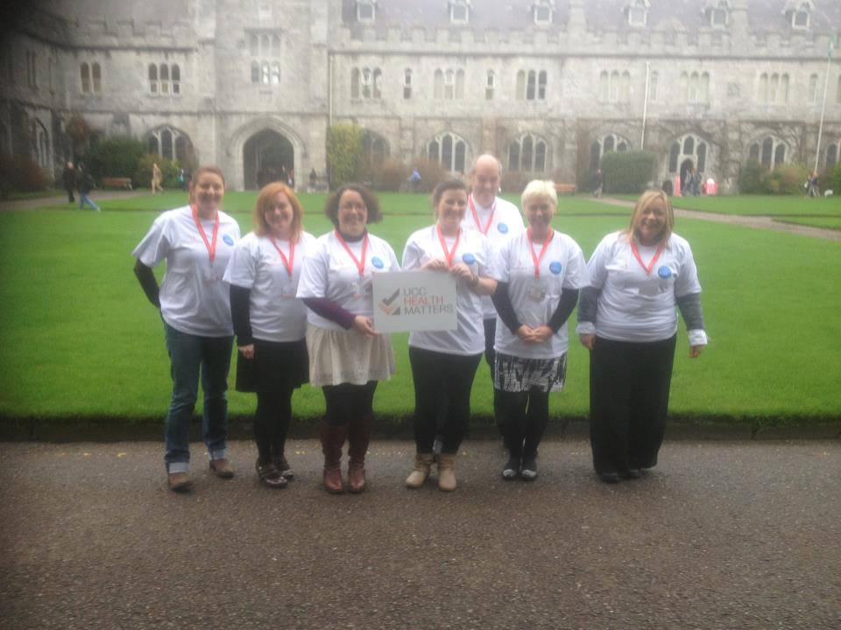

What: Operation Transformation 2014
Who: Student Health, Kylemore, Mardyke
& UCC Societies
When: Every January

Summary
Following on from the success of the 2013 programme, UCC Operation Transformation 2014 expanded to include 9 leaders and incorporated a ‘Groups’ model. This allowed the inclusion of groups of individuals to participate in teams. Similar to the previous year the leaders consisted of 4 members of staff and 5 students. The leaders partook in individually tailored nutrition and exercise plans with an emphasis on mindfulness, wellbeing and peer support. As part of the UCC Health Matters initiative, the programme was delivered through partnerships such as the UCC Student Health Department, the Mardyke Arena, Kylemore Services Group (KSG), UCC Societies, and a range of groups and individuals throughout the university and further afield.
Participants from Operation Transformation exercising in the Mardyke Arena.
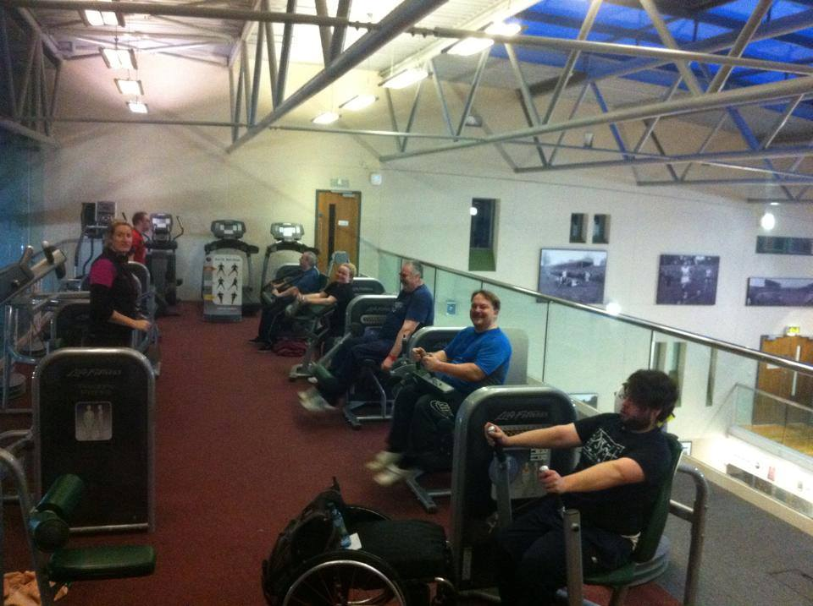
Aims
- Provide opportunities for individual leaders and groups within the programme to make lifestyle changes.
- Demonstrate to staff and students of UCC that eating healthily, being active, and keeping a positive mind-set can improve and maintain health.
- Provide opportunities for the population of UCC to make healthy choices, through education and the provision of the required support and resources.
Objectives
- Build on/maintain partnerships between departments, organisations, groups and individuals within UCC and the wider community.
- Use these partnerships to make healthy choices easier for the students and staff of UCC.
- Develop tailored diet and exercise plans for the leaders in the programme.
- Organise events for the wider university population to participate in and promote awareness of healthy eating and exercise habits.
- Measure the progress for each participant; weight loss, BMI, blood pressure, exercise levels and level of wellbeing.
- Use trackers to monitor changes for the duration of the programme.
- Provide encouragement and support for the leaders and groups participating in the programme.
- Use social media as a means of communication and promotion with the participants and the wider UCC population.

Overview

What was the context/background?
Modelled on the successful Irish TV show which airs every January, UCC Health Matters decided to stage its own Operation Transformation by stimulating a structured and motivational environment for students and staff who wanted to lose some weight and improve health. A multi-dimensional diet and exercise plan was developed for each individual leader. Both individual leaders and group participants had weekly weigh-ins to monitor progress, and blood pressure measurements were taken at regular points throughout for leaders, and at week 4 of 8 for groups.

What were the drivers and levers for change?
Awareness of the increasing number of people who needed help in starting their journey to improved health was a driver for change. The demand and success of the UCC Operation Transformation 2013 programme, coupled with the popularity of the national television show, acted as a major driver of the programme. The levers for making this programme a reality came through the partnerships with Kylemore who provided healthy meals for participants throughout the 8 week period, the Mardyke Arena who provided classes for the leaders, the staff of Student Health who monitored leaders metabolic progress, and Aras na MacLeinn for hosting group weigh-ins among more. Without these collaborations, UCC Operation Transformation would not have happened.

Who led the work internally and externally?
As with the previous year, the work on Operation Transformation 2014 was led by the steering and working groups of UCC Health Matters. The UCC Health Matters Steering Committee was responsible for the strategic lead in the programme. Members of the Health Matters working groups were as follows: representatives from KSG, the Student Health Centre, the Mardyke Arena, UCC Students Union and the student centre took responsibility for operational matters.

What resources were needed (financial and human)?
Resources included; the use of the Mardyke Arena’s sports facilities and two of its personal trainers; free healthy meals for the programme leaders, a nutritionist (provided by the campus catering company KSG); access to student counselling and health services; numerous volunteers to help with operational aspects of the programme; weighing scales, pedometers, blood pressure measuring devices; and sponsorship for prizes for the programme leaders and the best groups.

How did it run?
8 leaders, 4 staff and 4 students, were recruited via an application process. This was extended to 9 leaders due to demand and ultimately consisted of 4 staff and 5 students. Additionally, a total of 18 groups from various areas of the university were also recruited to help increase the programme’s impact.
Leader training sessions were provided by personal trainers from the Mardyke Arena. Sessions specific to each leader’s abilities and needs were also incorporated into the programme. Nutritionally tailored meals, for each of the leaders, were provided by KSG 3 times daily 5 days a week over the duration of the event.
Other events such as the “Relay for Life”, “Off the Booze and On the Ball”, and the “Desk to 5K Challenge” were used as subsidiary events for the Operation Transformation programme.

Operation Transformation taking to the streets of Cork
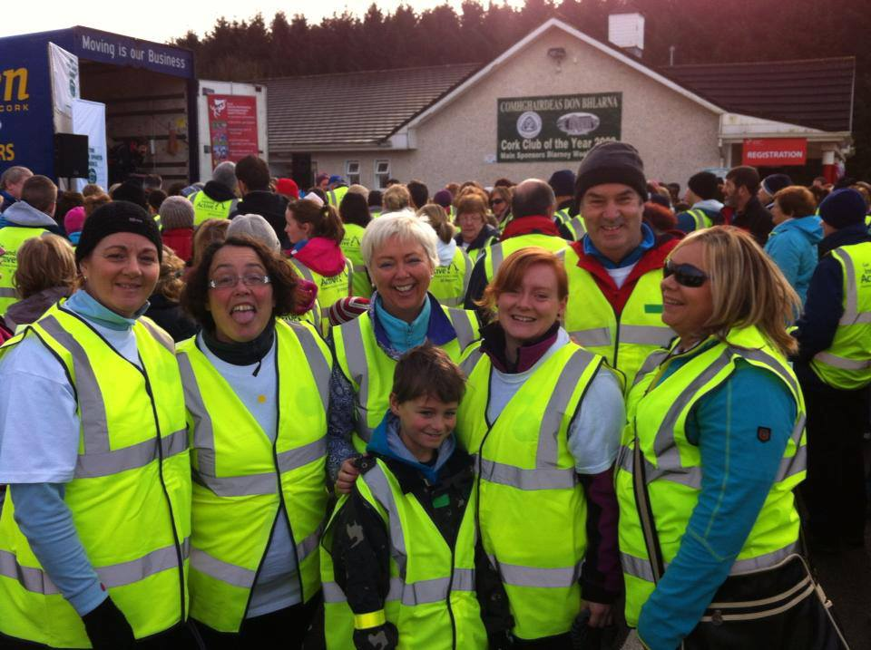

What methods of communication were used?
Progress was shared with the student and staff population on a regular basis. The main method of communication was via social media, in particular the UCC Health Matters Facebook page. Student and staff email, campus display screens, bulletin boards and the college newspaper were also used to promote the programme.

Monitoring and Evaluation

What were your critical success factors?
Promoting the uptake of healthier lifestyles across the university, changes to lifestyle habits in many instances can be simple and easy. Leader’s success stories shared at the end of the programme were the success factor needed to spur other people who hadn’t been involved to do the same.

How did you measure impact?
Individual impact of the programme on leaders were monitored on a weekly basis throughout the programme, where weight, BMI, waist circumference and exercise levels were recorded. Blood pressure measurements were taken by the doctors from the student health department for each participant at a half-way point. Exercise levels were recorded through the use of pedometers. The high level of social media interaction by members of staff and students acted as a marker as to the extent of the impact UCC Operation Transformation 2014 was having. This was evident on the Facebook page dedicated to the programme which was aided by an entertaining, yet inspiring, blog that was continually updated by one of the leaders detailing the process of personal change throughout. A post programme feedback survey was disseminated to all involved with 30 responses, all highly recommending the programme.

What were the outcomes/outputs?
- 8 of the programmes leaders were successful in losing weight, with 6 of them losing in excess of their targeted weight loss for the programme. The collective weight loss of the individual leaders amounted to 70kg.
- Of 129 participants who made up the groups, 95 had lost weight, collectively totalling just over 220kg in weight loss.
- Both individual leaders and groups together, the collective weight loss was an estimated 290kg. In other words this was 1/3 ton weight loss.
- Many positive changes were made in the lives of those who participated in the programme, particularly in the improvement of their exercise and eating habits.
- Improvements were made in many participants’ BMI, blood pressure level, cholesterol levels, fitness, and overall wellbeing.
- The partnerships that were founded when planning and running UCC Operation Transformation 2013 were built on and maintained in 2014.
- The benefits of improved diet and physical activity levels were promoted throughout the university and beyond.
- Awareness of the services and facilities that are at the disposal of staff and students to help make positive lifestyle changes was increased by the programme.
- The programme’s social media campaign helped increase the profile of UCC Operation Transformation 2014, and with it all the benefits of leading a more active lifestyle coupled with a healthy diet.
- The programme provided opportunities for work experience to an international student, who completed a pre-set number of required hours assisting in the operational aspects of the programme.

How did the work contribute to the three key focus areas of healthy universities?
- Create healthy and sustainable learning, working and living environments
Steps to making positive lifestyle changes, particularly in the area of physical activity and diet, are not as difficult as some may think. With the resources at the disposal of any member of the population of UCC, students and staff alike, the opportunities to make these changes are readily available.
- Integrate health and sustainability into core business
Health promotion has been increasingly instilled into the core business of UCC. The success of UCC Operation Transformation, along with the overall work of UCC Health Matters, illustrated the need for healthier options for diet and exercise to be made readily accessible.
- Contribute to the health and wellbeing and sustainability of local, regional, national and global communities
UCC Operation Transformation has had a positive effect on the individual leaders and groups that took part in the programme. Many of the participants have expressed interest in continuing in such a positive manner. Just as with the programme in the previous year, UCC Operation Transformation 2014 contributed to the national Operation Transformation programme which promotes healthy lifestyles on a national scale.

CASE STUDY 3
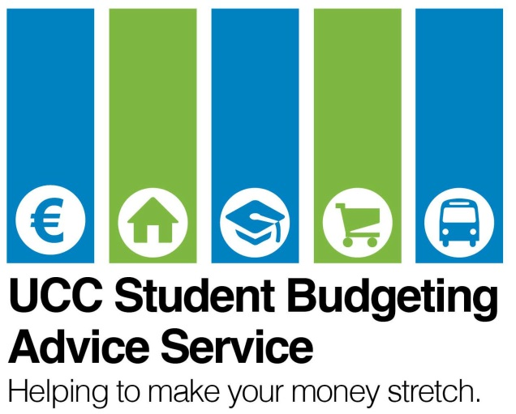

What: UCC Budgeting Service
Who: Evan Healy
When: Year-round

Summary
Many of the activities that take place in the University affect health and wellbeing indirectly. The Budgeting Advice service is one such example where students can access sound professional financial advice which can have a significant effect on the subsequent quality of life and wellbeing of the individual.
Aims
The Budgeting Advice Service aims to alleviate some of the financial difficulties that face UCC Students while also teaching students the importance of budgeting.
Overview
The Budgeting and Advice Service is a part-time service, completely free and available to all students of UCC. The service (located in Brighton Villas) began in February 2012 in advance of the academic year beginning in September 2012. The Budgeting Advisor provides workshops giving general or targeted budgeting and financial management information, including sessions on grants etc. The Advisor also provides one-to-one sessions for specific queries and concerns.
The service gives students the skills, resources, information and advice they need to help better manage their money and survive financially.
The project began several years ago at the behest of the then SU Welfare Officer, Padraig Rice, Paul Moriarty (Head of Student Counselling and Development), and the then Vice President of the Student Experience- Con O’ Brien. The financial difficulties students were suffering with were having apparent effects on academic performance, first year retention rates and mental health of students presenting at counselling.
Students presenting to the SU Welfare Officer are usually referred on to the appropriate service but none existed for a centralised financial advice. The Welfare Officer did not have the required time or expertise to provide appropriate advice on all aspects of grants, budgeting, fees etc. Students could not be referred to any appropriate service. In addition to this difficulty, first years often cited financial difficulties as one of the main reasons for dropping-out in exit interviews with First Year Experience Coordinator, Noirin Deady. Following the publication of a national undergraduate survey, which demonstrated amongst other things the extent of financial difficulties of undergraduate students, and the collection of the above signs, the university assigned funding for the Budgetary Advisor.

What resources were needed?
The resources involved in the service are effectively limited to the wages of the part-time Budgetary Advisor. No other resources are available to the position save in the case where the Students’ Union provides petty cash for business cards etc.
The initiative commenced in February 2012, and was communicated to all potential users in September 2012. The service is discussed at first year orientation speeches, included in first year information packs, advertised in the Students’ Union Fresher’s packs and diaries, is communicated by email to all students and staff, has a dedicated section on the UCC website, and is advertised on student hub collegeroad.ie.

Monitoring and Evaluation
Uptake of the service is high. All service users to date have been asked for feedback following an appointment. From September 2013, all service users have been requested to complete an anonymous survey following an appointment. These surveys will be analysed and used to implement changes and improve the service.
The outcomes thus far of the initiative have been limited, as the service has operated only on a one-to-one basis. Despite this fact, one of the immediate results has been reduced case-work levels for the SU Welfare Officer which has allowed him to refocus his time on other areas. A further outcome is that the University have recognised the financial hardship faced by students. By having this position there will be accurate, detailed information regarding specific cases cumulated and reported to the university which will further illustrate the issue.
The service is currently offering finance workshops to prospective mature students, this activity has meant that these students are more aware of the costs facing them and the supports available to them, ensuring that on entering college they are more prepared and can budget more efficiently.

Key Learning Points
One of the greatest difficulties in securing the budgetary advisor was the national embargo and headcount regulations. A specific headcount exists that is not allowed to be breached. Some of the factors that made the process easier were the fact that there was demonstrative evidence from multiple sources, internally and externally, stating the financial difficulties of students. The fact that the strategic plan was up for review, also aided in the development of this service as it was something that it could be included in to become concrete.
One of the key learning points related to this service is that of mental health and knock on effects. According to the welfare officer 2011/2012, Dave Carey, almost half of students presenting to him with financial issues suffered also from mental health issues.
The idea of a budgetary advisor being health related is not immediately obvious but when taken in the context of extreme financial difficulty in a university setting certain points become apparent. Prior to the advent of this service there was no appropriate referral system in place. If you had financial difficulties, grant questions or any other money related matters there was little in the way of services available. This financial pressure then developed into further concerns and issues putting pressure on other services e.g. uLink and Student Counselling.
Investing in the budgetary advisor takes a holistic view at health and health promotion. By promoting good financial management and budgeting skills, students are equipped with the necessary knowledge to manage their money and thus avoid some more serious difficulties.

One of the many events outlining budgetary issues
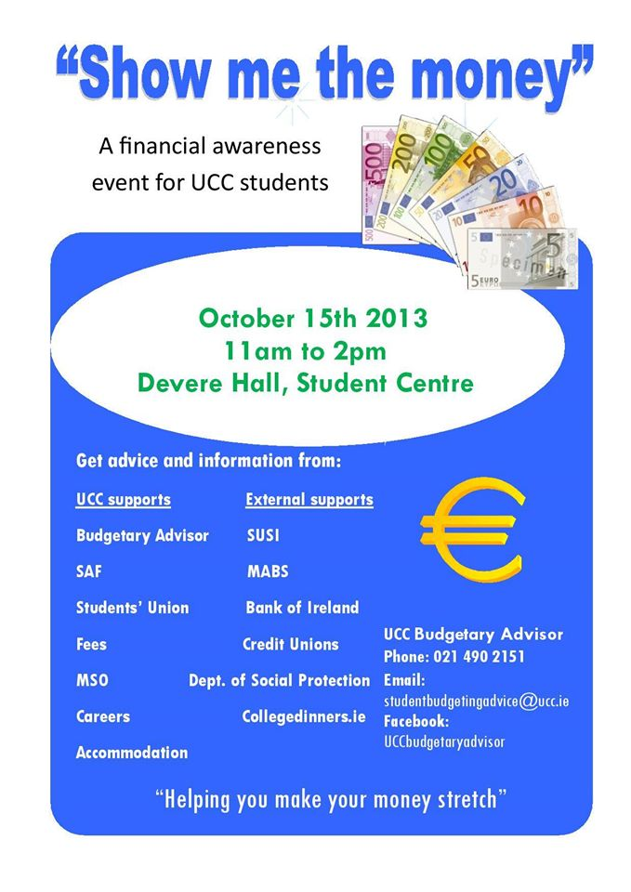

How did the initiative create healthy and sustainable learning, working and living environments?
By recognising the knock-on effects financial difficulties can have on mental health; this service attempts to prevent the development of mental health issues and promote healthier, more sustainable learning, working and living environments. In addition to this, certain links can be drawn between financial difficulties and physical health or nutrition. If a student is suffering from severe financial difficulties there is a strong likelihood that they will forgo on light and heat in their home, or adequately nutritious meals. By budgeting properly, and by availing of all supports available, these issues may be resolved or reduced.

How did the initiative integrate health and sustainability into core business?
The initiative is the result of the integration of health and sustainability into the core of the university. The recognition, on the part of the university, of the knock-on effects of financial difficulties on the student population was extremely significant. As a result of recognising the impact it had on health and the continued studies of students, the university included the budgetary advisor in the strategic plan for the university and also provided the funding for this position.

How did the initiative contribute to the health and wellbeing and sustainability of local, regional, national and global communities?
The initiative’s effects are limited to the confines of the UCC student and staff population. Students benefit directly from the service. Staff now has the opportunity to refer on students to a qualified service and as such remove the necessity for them to take on these issues. The only discernable effect on the external communities would be that students are more likely to stay in college, to finish their degrees.

CASE STUDY 4
What: Niteline
Who: Peer Support Volunteers
When: On-going, three times per week

Summary
Niteline is a free telephone listening service for students in UCC. Niteline is confidential, non-judgmental, non-directive and anonymous. The service operates each Tuesday, Wednesday and Thursday night from 9pm-1am during the college year. The remit was recently expanded in September 2014 with the launch of an online anonymous messaging service.

Aims
Niteline’s mission is to promote mental wellbeing amongst UCC students, to listen to any problems which UCC students may have related to course work, personal life or any other issues, and to provide an anonymous listening service that is non-advisory.

What were the drivers and levers for change?
Certain issues do not require an appointment for counselling, rather just a listening ear e.g. example minor stress over exams, quarrelling with friends, missing home. Niteline has been in operation at UCC for many years and continues to provide a beneficial service for students who wish to use it. Levers for change came from the support of the Student Health & Counselling Department, and boosted by the fact that it is volunteer led.

Who led the work internally and externally? Who was the strategic lead, who was the operational lead?
The service is run by the funded Peer Assisted Student Support (PASS) coordinator, currently Rebecca Murphy, who is the operational lead. She recruits and trains over 150 student peer support volunteers every summer for the new academic year, who help to run a number of services, including Niteline.

How are you set up (working/Steering Committees)?
There are no official working/Steering Committees for Niteline. However, the peer support volunteers can be considered as working groups who train and offer their services to run Niteline. The College Counselling Services hold responsibility for the overall operation of Niteline and the PASS coordinator holds the day-to-day management responsibility.

What resources were needed (financial and human)? What existing resources were used?
Originally a student was paid to run the program through the Student Union. It was subsequently taken over and managed by the funded PASS coordinator so that an official staff member was in charge and funds were conserved. Human resources required were willing, able and fully trained volunteers. On-going training and support for volunteers is also a resource which needs funding.

What was done?
Niteline was re organised in terms of its structure after the PASS coordinator took charge of responsibilities. A Free phone number was organised for people needing help. Set days and times were agreed and the service was advertised around college. Volunteers were trained to answer anonymous phone calls from UCC students. Training emphasised critical importance of confidentiality- that each call’s conversation remain strictly between the caller and the volunteer spoken to. Volunteers are also required to remain extremely discreet about their involvement in the service. Niteline has no political, religious, ethnic, cultural, political or moral bias. Volunteers are committed to providing an atmosphere that is free from moral judgments. The volunteers do not give advice to callers but can provide details of possible sources of professional advice to callers if desired. In September 2014, the online listening service was launched, as the uptake of the phone service was not hugely subscribed to. It reduces even more barriers as the conversation cannot be overheard, and can be discreet even when around other people for example housemates.

What methods of communication were used?
The service was and still is advertised around campus through posters on boards and stickers on most bathroom stall doors which informs students of the service and the free phone number (1 800 32 32 42). The UCC Niteline Facebook page is in operation also. Niteline promotion stands offer information at UCC events such as Health Matters Day.

Monitoring and Evaluating

How has this project been evaluated/measured impact?
There has been no thorough evaluation of Niteline to date, however feedback has been gathered from the volunteers in their meetings. The use of the line is quite low, with only about 25 calls per college year currently. Niteline has set up an online chat service to accompany phone calls. A possible reason students do not call is a fear of being recognized through calling. An online chat eliminates that aspect and it has been very successful for other universities in UK. During 2012 and 2013, time was spent exploring software programs and putting together policies for the online chat service.

Key Learning Points

What were challenges or barriers?
The service is only open 3 nights a week which makes it fairly inaccessible for people trying to call in. Ideally it would be a 24 hour service to make it easier to contact. Volunteer availability is a potential barrier to the service, i.e. if a volunteer calls in sick. Unpredictability of the level of calls can be a barrier for students, and a challenge for volunteers as one volunteer may not be able to manage the influx of calls on a certain night, but may have no calls another night.

How did the work contribute to the three key focus areas of healthy universities?
- Niteline is a health promoting service which allows people to seek a listening ear when stress and worry is becoming too much for them to deal with alone. It acts as an early stage mental health service for students who need a listening ear.
- As the service is volunteer led, it can be considered sustainable. As the function of the service is health promoting and promotes mental wellbeing and support, it can be considered healthy.
- As this is a UCC based service, the ability to contribute to the health and wellbeing of locals i.e. students is apparent. UCC took its idea from Universities in UK which proves there is an international reach.

CASE STUDY 5
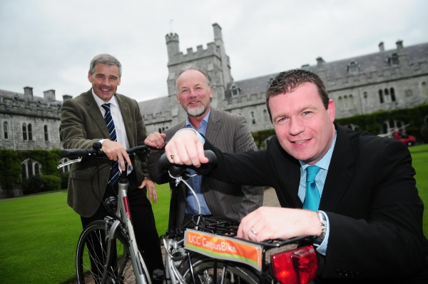

What: UCC Campus Bikes
When: 2011- present
Where: Campus wide

Summary
The UCC CampusBike initiative is part of the wider UCC Commuter Plan, which includes other elements such as a carpooling scheme, a strong Park and Ride system, and a heavily subscribed to Cycle to Work (bike purchase) Scheme. Campus bikes provide the option for UCC staff to cycle from one part of campus to another or into town instead of using a bus or car.

Aims
- To reduce the level of sedentary transport chosen by UCC staff and to increase the uptake of cycling to, from, and during work by providing easy access to a bike.

What was the context/background?
The programme started in 2009 among a small number of UCC staff (Buildings and Estates), whereby a communal foldable bicycle was used for getting around campus, and to meetings outside campus. The Smarter Travel Workplaces programme began in 2009 and encouraged the development of the UCC CampusBikes scheme.

What were the drivers and levers for change?
The drivers for change were down to becoming more active as a campus, and reducing dependency on methods of transport which are damaging to the environment. The lever for change came through the introduction of the Smarter Travel initiative (Department of Transport / National Transport Authority-NTA) which provided the financial support for the introduction of UCC CampusBikes as one of the programme’s demonstration projects.

Who led the work internally and externally?
UCC Buildings and Estates with its Commuter Plan Manager (Stephan Koch) was, and continues to be, the operational and strategic lead for this initiative. This initiative is managed by staff of Buildings and Estates, but overall promotion of cycling to and from campus is also part of the Sustainable Environment working group of the Health Promoting University Initiative.

What resources were needed?
The main issue was getting the financial resources to purchase the bikes. The Department of Transport (DoT) provided a €20,000 grant to assist the set-up of the scheme. A degree of commitment and buy-in from local staff was essential. Basic checks of the bikes are done by hourly paid students on a regular basis.

What was done?
The grant was used to purchase a first lot of 12 fully fitted unisex bikes including adjustable saddles, baskets, dynamo lights, locks and some helmets and extra pumps. In parallel, an additional injection of bike stands was installed around the University Campus, in popular meeting spots. Extensions are being made to bike stands in advance of the 2014/15 academic year. All staff emails and promotional days on campus were used to attract attention from staff.

How was the case for action made?
The case for action was to make a bike available as easily as possible to encourage a shift in mind set regarding travelling to, from, and during work.
Promoting the UCC Bikes scheme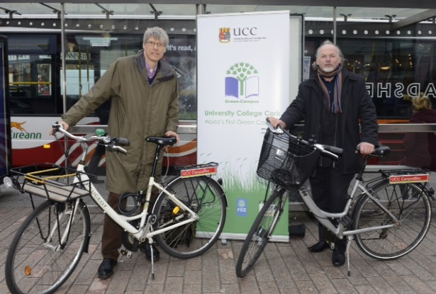

Monitoring & Evaluation

What were the critical success factors?
The critical success factors were uptake and usage of the scheme.

How did you measure impact?
Users of the scheme have to register first. A bank of 200 registered users has been built up over the past three years.

What were the outcomes/outputs?
There are approximately 80 regular users of the scheme. The scheme has contributed to the uptake of biking for many staff members. It has also been an important intermediary step for them (particularly for women) to regain confidence on the two wheels, and subsequently to go forward and purchase a bike through the Cycle-to-Work scheme.

Key Learning Points

What were the challenges or barriers
Challenges are with management of the bikes. They are not (yet) part of an automated system, so the control over their safe keeping is limited, and the scheme depends on trust in its responsible use. However they have been remarkably well kept since the start of the scheme in 2011. Another more pertinent barrier is the fact that the scheme is primarily designed for staff members, while students can avail of a similar service offered by the Student Centre. UCC CampusBikes started as a pilot scheme and are provided free of any charge, so limitation to the staff body ensured having a large enough, yet oversee-able target audience. Both aspects are issues that are being worked on, in the sense that with future (part) automation, both schemes might eventually be married.

What helped you achieve success?
Good financial backing, positive support from senior staff members in UCC, and a general shift towards greener thinking among staff and students in UCC.

How did the work contribute to the three key focus areas of the healthy Universities?
1. UCC Campus Bikes and Cycle-to-Work encourage exercise instead of sedentary travel options. This is a health promoting initiative which encourages active travel. It makes UCC a more vibrant working environment through the increased numbers of cyclists around campus. It makes the idea of cycling more attractive to people who wouldn’t normally consider cycling. It normalises getting on a bike for people who would usually be too shy or embarrassed to.
2. The Campus Bike scheme has been mirrored by both the Cork City Council and County Council, for their staff. There has been collaboration with the Transport & Mobility Department in the Local Council, and the large success of cycling in UCC has contributed to bicycle lanes being put in place between the city centre and University

CASE STUDY 6
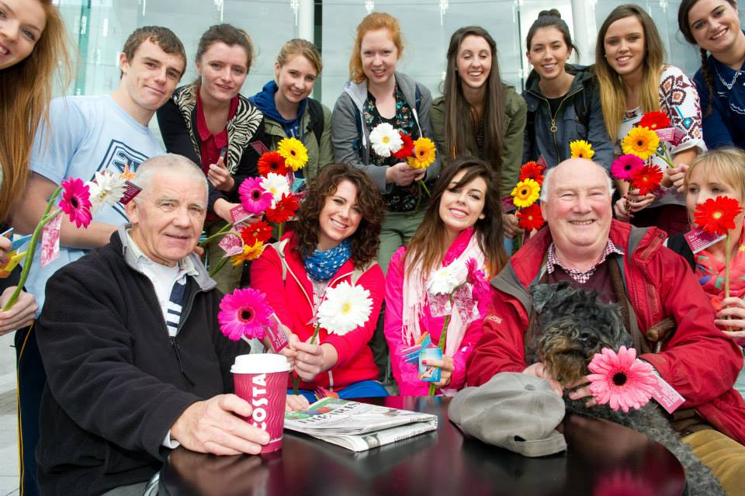
What: UCC Mental Health and Wellbeing Week
When: Every November
Where: Around UCC Campus

Summary
A weeklong program is run by the Student Union at University College Cork in which talks, workshops, videos, programs and seminars are held to discuss student health issues including suicide, alcohol, depression, stress, anxiety and substance abuse. Information stands are set up to advertise and promote the various health services offered around campus and externally, to encourage students and staff to seek help if they need it.

Aims
The event aimed to spread awareness of relevant health issues and provide information to students and staff about the various health services and resources available at UCC.

Overview

What was the context/Background?
This annual event is held each November to promote awareness of healthy living among students and staff. It offers the opportunity for students to effortlessly pick up information on a variety of health topics.

What were the main reasons that this program was set up?
The main drivers for this event were to spread awareness and provide information about mental health issues and services. It was especially important at the time as Ireland was suffering a deteriorating economy due to the banking crisis, which indirectly placed students and staff under a lot of stress

regarding job prospects and security. Therefore, mental health and wellbeing was and still is a very important issue. It’s essential for people to know that there are counselling services available to them.

What was responsible for driving this project?
This project is coordinated by the Students Union (SU) with the SU Welfare officer taking the lead. This event involved partnership working between numerous societies, the class representatives, student health services and personnel and external health services.
What resources were needed ?
This event is virtually free to run, as the information stands are provided by each service, and run by volunteers or staff members. Promotional materials are funded by the Students Union budget.

What was done?
Preparation for the program began in July with initial talks and planning. In September the societies and clubs were contacted and asked to participate, and then the final planning and crystallization of details was carried out in October so that the event was ready for November.

What methods of communication were used?
The event primarily utilizes Facebook & Twitter, campus presence, and staff/student emails to communicate information.

Monitoring and Evaluation

How did they measure impact?
It was very difficult to measure the impact of this program directly because the impacts vary greatly from student to student.

What were the outcomes?
Students and staff received valuable information about the various health services available to them. It also raised awareness of important health issues including drug abuse, alcoholism, suicide, and depression.
Pieta House-Darkness into Light run
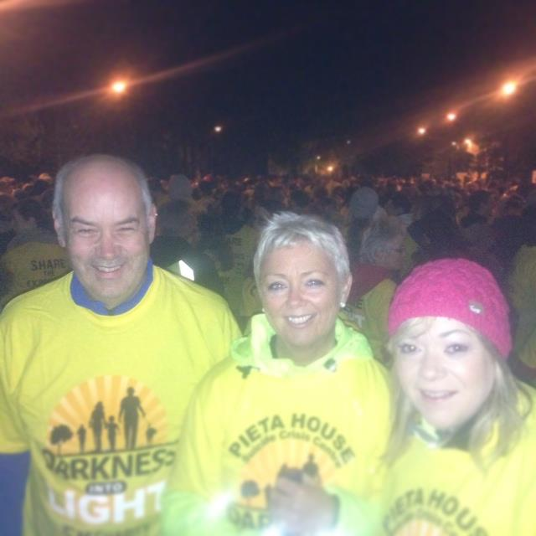

Key Learning Points

What were the main challenges or barriers? Overall there were very few barriers to overcome because this is an annual, well-established event and there is very wide support for health promoting programs.

How did the work contribute to the key focus areas of healthy universities?

Create healthy and sustainable learning, working and living environment?
This is difficult to gauge, but the head of counselling and students who participated in the programs all reported positive feedback.

Contribute to the health and wellbeing and sustainability of local, regional, and global communities?

Some national organizations were used including some speakers from the government. These organizations are used on other campuses around the country and so they spread information about the successful aspects of the programs to other schools around Ireland.

CASE STUDY 7
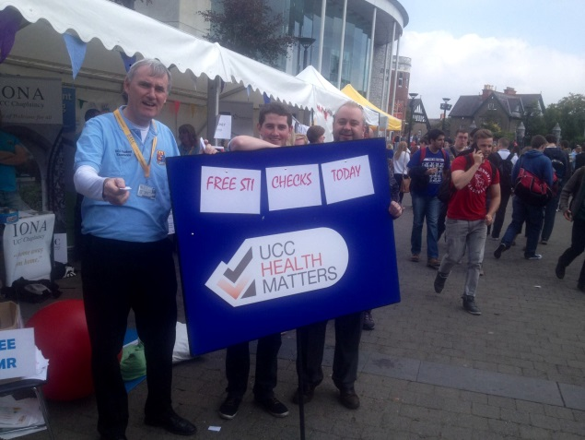
What: UCC Sexual Health Clinic
Where: Student Health Centre
When: Year round

Summary
UCC Sexual Health clinic aims to improve student access to sexual health information, screening and condom distribution. Available are student services such as the Students Union and societies such as LBGT that also aim to support students with their sexual health issues. A dedicated team of female doctors, a male doctor and a Sexual Health Advisor are available to provide sexual health services.

Aims
The aim of the clinic is to promote access to sexual health services, to deliver sexual health screening and treatment, and to provide an inclusive & confidential service.

What was the context /background?
The UCC Student Sexual Health Clinic was set up in 2010. Up to then there was no specific sexual health service. Mondays to Thursdays, students are seen by doctors for any health concerns they may have including counselling. On Fridays, one doctor attends to sexual health problems while two others attend to regular consultations.

What were the drivers and levers for change?
The medical staff of the student health department noticed an increase in students presenting with sexual health issues. Feedback from the Students Union reported that there was need for an STI clinic for students and the development of a service was highly supported by the Student Welfare Officer. There is only one Genitourinary Clinic (GUM) in Cork which is free, but has a long

waiting list of 6-8 weeks. There is a 20 euro charge for the clinic in the student health, but the waiting list is just 1-2 weeks for an appointment.

What was done?
In the initial development of the STI Clinic, the staff in the student health department attended sexually transmitted infection foundation course (STIF) in Dublin and also attended the GUM clinic in Cork for training. Input was also received from the sexual health centre Cork (an organisation that promotes and supports sexual health) and from the student counselling service.
Who led the work internally and externally?
UCC Student Health service doctors and nurses in the department recognised the need for a specific sexual health service. Additionally, the Students Union, especially the student welfare officer, and Dr Mary Horgan who is a consultant in infectious diseases in Cork University Hospital, also contributed to the work.

How is this initiative set up?
This service is currently run internally in and by the Student Health Department. Many students are referred from the Students Union Welfare Officer who has a lot of dealing with sexual health queries.

What resources were needed?
The service is funded by the Student Health Department which includes staff and medical equipment. Additional resources include health service waiting room, screen presentations on different sexual health issues and information leaflets in the waiting room. The Students Union provides free condoms for students.

Methods used for communication
The UCC Student Health Service and collegeroad.ie websites offer information to students about the service. The Student Health Service also has a regularly updated Facebook page and Twitter and a mobile app, as does the Students Union. Fresher’s week orientation talks are used as an opportunity to inform first year students about the services provided by the student health department including the STI clinic. The Student Welfare Officer also has a huge part to play in directing worried students to the sexual health clinic.
Poster advertising SHAG Week
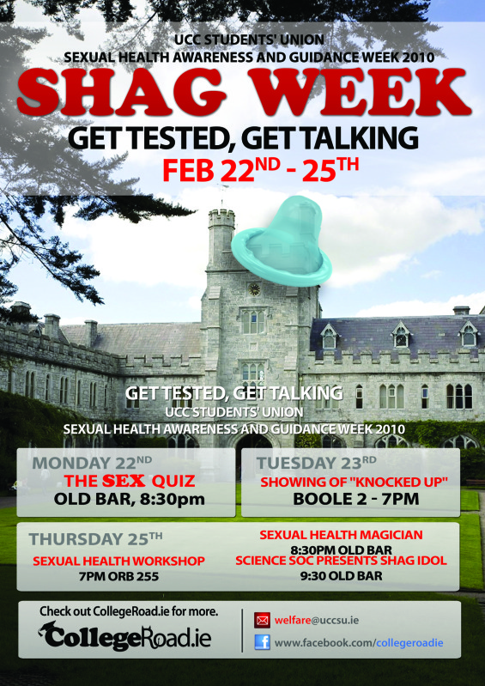

Monitoring and evaluation

How is impact measured?
The statistics are recorded on a confidential database and are collated each year to report on the levels of usage and impact of the service.

What are the outcomes /outputs? (For 2011)
- 895 students attended the sexual health clinic
- 589 diagnoses
- 428 screens came negative
- 76 had candida also known as thrush
- 40 % had illnesses
- 56% of students attended the sexual clinic for screens
- 39% attended because of symptoms presenting
- 5% attended because they were in contact with someone with STI

Key Learning Points

Challenges and barriers
One challenge was the initial time needed for commitment to the service and the cost for set up of the service. Time was taken from general consultations to dedicate to STI Clinic, and extended the list of general consultations. Certain groups have been identified that need targeting for example Men having sex with men (MSM), but they are difficult to engage. Lastly, the €20 charge for the use of the service meant that it could be a possible access barrier for some students.

How did the work contribute to the three key focus areas of the healthy Universities?
The UCC Sexual Health Service provides support and treatment for students who have sexual health problems, provides counselling for behaviour change, and provides screening for health promotion and early detection of sexual health problems. This has an impact on a large number of students every year, and reduces stress caused by previously long waiting times. The service relieves a certain level of strain from the external services in the area, or the areas where the students are from. The national contribution of the service is a reduced incidence of sexually transmitted infection through screening and health promotion. The adoption of a sexual health counsellor has been an original step taken by UCC.

CASE STUDY 8
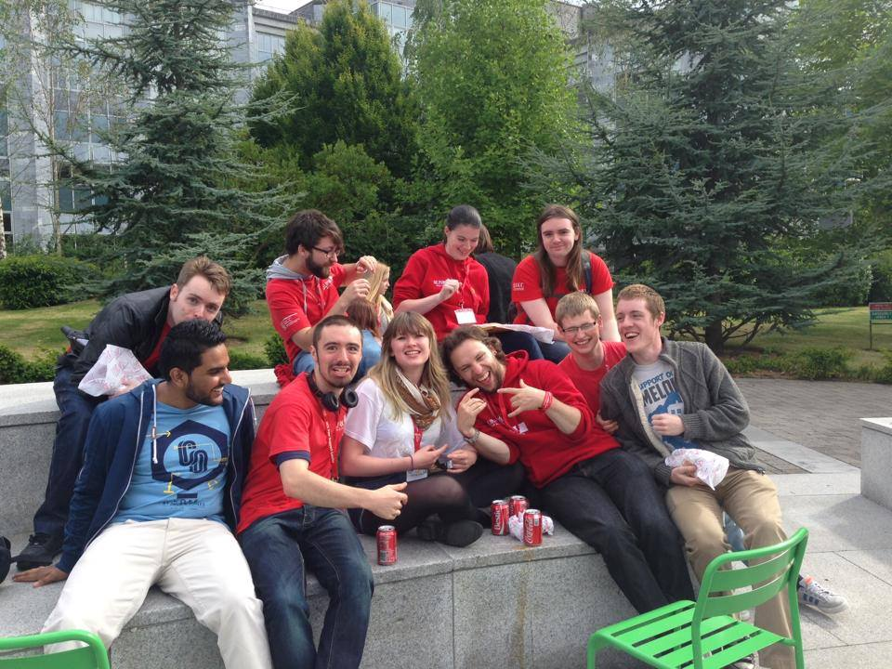
What: uLink Peer Support
Where: 3rd Floor, 1-2 Brighton Villas
When: During the academic year

Summary
uLink Peer Support is a service to support first year students in UCC. Peer support leaders meet with first year students and offer a friendly and confidential ear, they offer their take on life at UCC and they give practical help in dealing with issues that they themselves experienced in first year.

Aims
- To provide first year students at UCC with a person to discuss questions and concerns regarding life at UCC
- To foster a sense of community between different years
- To provide first years an outlet to relieve anxiety and stress that accompanies starting college
What was the context/background?

uLink was established in 2009. The Students Union, Students Counselling Services and Access wanted to start a program which provided peer supports for incoming first year students.

What were the drivers and levers for change?
The communal effort between the three bodies mentioned above was the driver for change, and the funding availability to hire a coordinator and provide a budget for activities was the lever for change.
How is the initiative set up?

The Students Union, Counselling Services and ASSIST guide the initiative. Volunteers who provide their time to work as peer supporters carry out the daily tasks involved.

What resources were needed?
Funding for the hire of a Peer Assisted Support Services (PASS) coordinator to run a two year pilot program was needed. After the two year pilot the program was continued due to continued funding. The programme is in its 6th year presently.

What was done?
The PASS Coordinator organizes the 150+ student volunteers who serve as peer supporters in uLink. Students can apply to become volunteers in January of their first year (or any year after that), and are then trained in small groups in the spring or summer to begin work at the start of the new academic year in September. During orientation, the incoming first years are split into groups based on their various academic programs. uLink supporters are assigned to these academic groups based on their course of study.

What methods of communication were used?
Throughout the school year the uLink peer supporters maintain contact with the first years by periodic emails; some mentors organize first year parties, others make sure they are available to meet with people during the same hours in the library each week, and others host coffee get-togethers periodically.

Monitoring and Evaluating

How has this project been evaluated?
First years are emailed at the end of each college year with a survey to gather feedback on how they felt the program went. The uLink peer supporters are surveyed and feedback is gathered from them about the training they received. The First Year Experience Coordinator gathers information from orientation.

What were the critical success factors?
The program has been incredibly successful, with first years feeling that their peer supporters provide useful help and guidance. After the initial two year pilot, the program has been renewed continuously to date.

A peer support leader conducting a college tour.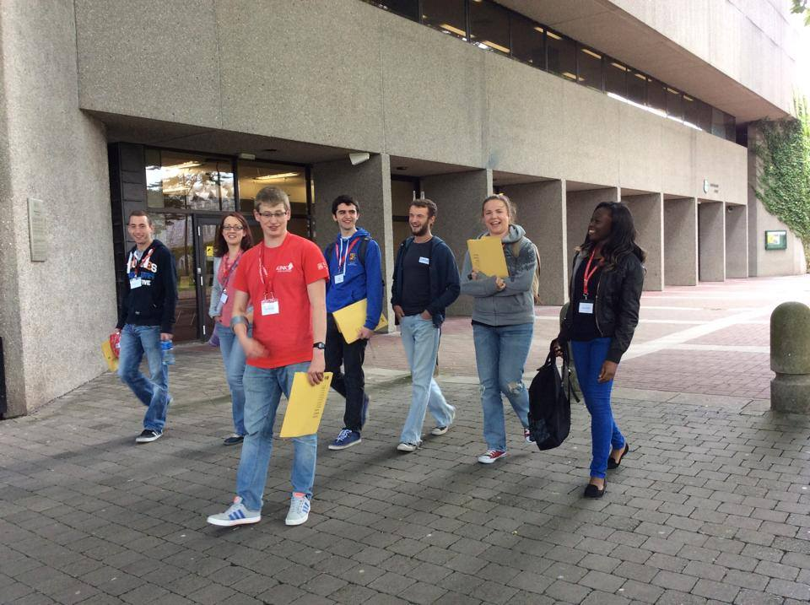

Key Learning Points
What were challenges or barriers?
The PASS Coordinator struggles with a lot of administrative challenges, as there are 150+ volunteers to organise. The coordinator also runs Niteline and the Uplift Program so time is stretched as there are plentiful meetings to coordinate, programs to plan, and other responsibilities.

What helped you achieve success?
A positive and hardworking team. The interest among students to become volunteers was critical to carrying out the work of the programme. The proactivity and confidence of the PASS coordinator helped the project through its initial pilot.

How did the work contribute to the three key focus areas of the healthy Universities?

Create healthy and sustainable learning, working and living environments?
The programme helps first year students to find their feet and to help with them should they have any health impacting concerns such as depression, and loneliness. The programme helps to give first year students a helping hand in becoming accustomed to living away from home and to adapt to university life. This is very important for many students who may without such help drop out.

Contribute to the health and wellbeing of local, regional, national, and global communities
The local impact is obvious through direct help of over 150 volunteers each year to help incoming first years. The contribution of this programme to health and wellbeing of regional and national and international communities is also touched upon through the fact that many first years are from other parts of the country.

Case Study 9
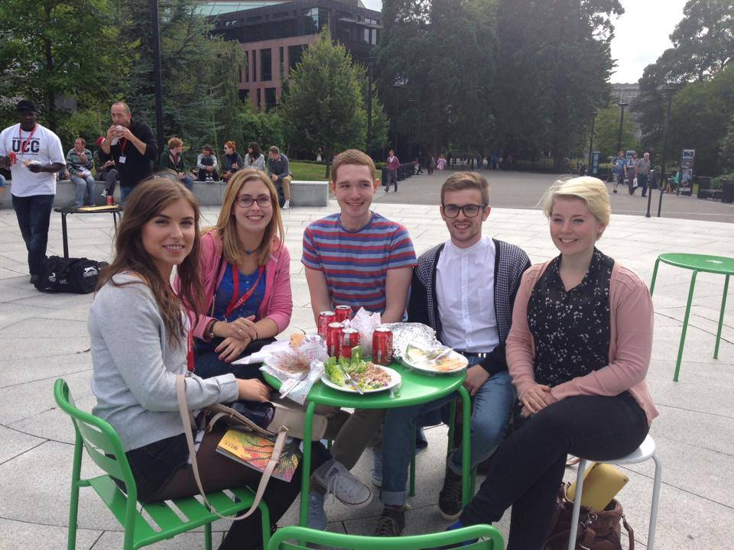
What: UPLIFT
Where: Across campus
When: Throughout the academic year

Summary
The UCC Peer Mentoring Programme (UPLIFT) recruits trains and matches student volunteers (mentors) to fellow students (mentees) who may be experiencing mental health challenges. A key component of the programme is that the mentors themselves have had mental health challenges in the past which they have overcome. Mentors provide support throughout the academic year to help enhance the academic, personal and social development of the mentee while they attend college.

Aims
The main objective of UPLIFT is help participating students (mentees) to become resilient, resourceful and self-determined learners by:
- Improving retention rate of students with mental health challenges in UCC
- Increasing the participants’ self-esteem, self-confidence and self-efficacy
- Increasing the participants’ engagement with college life
- Facilitating students’ engagement with community mental health services
- Training mentors to support students experiencing mental health challenges
- Providing support to mentors and mentees throughout the process
- Evaluating and document the outcomes and effectiveness of the project

Overview
In 2010 a publication entitled Students with Disabilities Tracking Report – 2005 Intake found that students with mental health difficulties had the lowest retention rate across all nine third level institutions participating in the study. The report recommended ‘the need to target students with Mental Health Difficulties, particularly in first year, when the highest withdrawals occur’ (2010: 39). This sparked a response from University College Cork and in particular the Disability Support Service who created the UCC UPLIFT Programme.
Such a programme needed funding and in 2010 the opportunity for funding was available from Genio Trust- a non-profit organisation with the firm belief that everyone should have the right to contribute and participate in society to their full potential. With this in mind an application was made by UCC to create a unique and innovative peer led programme.

What were the drivers and levers for change?
UCC and the Disability Support Service are committed to increasing access to higher education for people with disabilities. This coupled with the findings of the publication Students with Disabilities Tracking Report – 2005 Intake encouraged action to be taken.

Who led the work internally and externally?
Within UCC there are four lead members of the Genio team:
Mary O Grady, Disability Support Officer at UCC, Diarmuid Ring, Advocate & Peer Supporter of people with mental health difficulties, Claire Dunne (now Rebecca Murphy), coordinator of the UCC PASS Ulink scheme and Aimee Brennan of the School of Sociology and Philosophy. There is a monthly Steering Committee with inclusion of External experts.
Mentors of uLink Peer Support
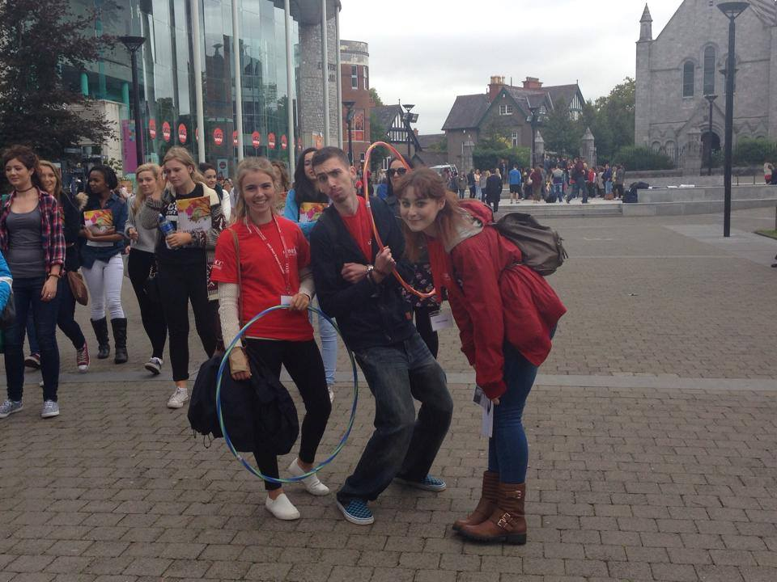

What resources were needed?
€80,000 was awarded by The Genio Trust with €20,000 matched by the UCC Disability Support Service.

What was done?
Mentors were recruited and trained over a three day period. Topics covered included:
- Knowledge of mental health perspectives
- Development of personal skills and competencies
- Understanding the University culture/context.

Mentors were then matched to mentees with whom they worked for the year. Throughout the process mentors attended reflective learning meetings.

Monitoring and Evaluation
What were your critical success factors?
The main factor of success was the retention of mentees within the University. In addition, enabling students to be able to cope and interact with university life was important.

How did you measure impact?
An independent evaluation of the pilot programme was carried out to monitor and assess the impact of the programme on the 27 participants who participated in the first year. The following results are based on feedback from a representative sample of 13 students, covering over 64 hours of mentoring. This represents a 48% response rate.

What were the outcomes /outputs?
Outcomes for Mentees:
- 100% retention of mentees within the University
- Performed successfully in their exams
- More than three quarters of mentees felt more academically capable by the end of the programme
- Experienced an increase in self-esteem
- Almost three quarters of mentees felt they expanded their social support network
- Almost three quarters of mentees experienced a decrease in their stress levels
- Half the mentees enhanced their engagement with campus life, participating in societies and developing new friendships

Outcomes for Mentors:
- Improvement in their communication and interpersonal skills
- Sense of accomplishment by being able to offer support and help to fellow students
- Greater awareness of their own learning strategies as a result of helping fellow students
- More knowledgeable about the extent and diversity of student support services
Many mentors learned that mentoring was a therapeutic experience for their own personal development and more than half of mentors continued their role into the second year of the programme.

How did the work contribute to the three key focus areas of healthy universities?

How did the initiative contribute to the health and wellbeing and sustainability of the local, regional, national and global communities?
As well as benefitting participants and their families, on a local and national level the programme made UCC a more supportive place for people with mental health difficulties thus making it more accessible to the national and global community. In turn the programme is ensuring that students who suffer from mental health difficulties have the skills to be able to cope with university life and so they will take these skills and their qualifications forward with them into their careers and into the world.

How did the initiative integrate health and sustainability into core business?
The initiative was conscious of the health and wellbeing of both the mentor and the mentee throughout the process and ensured that this integrated into core business. This was done through appropriate training of the mentor’s regular reflective learning meetings for the mentors.

How did the initiative create healthy and sustainable learning, working and living environments?
For the students who participated, the support programme made UCC a healthier and less stressful place from an academic, social and personal perspective. The programme helped to create a healthy and sustainable learning, working and living environment as it empowered the students themselves to be able to integrate and cope better with University life.

CASE STUDY 10
What: UCC College Dinners
Where: Drop-off points around UCC
When: Weekly

Summary
Food and nutrition is one of the seven key areas identified within our grouping of initiatives in relation to UCC as a Health Promoting University. As we are aware, the effects of the actions within the university do not stop at the gates, they permeate the surrounding community. In addition to this the surrounding community take action in relation to the university from time to time. College Dinners is one such example. This case study explains what College Dinners is, how it came about, what has been achieved and what remains to be completed.

Aims
College Dinners aim to provide the students of UCC, among others, with the ingredients and the information required to make four nutritious meals each week. The underlying intentions are to change the eating habits of students, to encourage healthier eating, to encourage students to cook and to benefit from the multiple positive aspects of cooking. These include, but are not limited to, being aware of the nutritional value of food and experiencing the positive social benefits of cooking together. It aims to educate people and empower them to learn to cook and to be able to cook for themselves.

What was the context/background?
Many students when living away from home do not consider the health impacts of eating processed and unbalanced meals, nor the cost which accompanies this type of diet. The initiative encourages students to eat healthier, to cook for themselves and to avoid convenience food. It also provides a very cheap yet healthy meal option for the week for €10.

What were the drivers and levers for change?
The business plan and interest of David O’Leary with his wife and father was the principle driver and lever for change. College Dinners began operating on September 24th 2011. The needed a van, a meat supplier and a vegetable supplier. As part of the service each week College Dinners also produce an online menu with the cooking instructions to make four meals for one person.
What was done?
Students register with the service and purchase a registration card. This card allows them to order their weekly dinners via text, email or Facebook by means of their registration number. Students order before Friday at 4pm and collect their fresh ingredients the following Monday from one of the designated drop-off points. The students, in return for €10, are provided with portions of meat, vegetables and potatoes necessary to make the four dinners for one, on the menu for that week.

What resources were needed?
The resources involved in this project come from private investment and have little involvement with the college. A portion of the profits are donated to the Students’ Union Student Hardship Fund in return for some promotion on the part of the Union.
The project began with market research by College Dinners; this was followed by striking the deal with the Students’ Union to promote. The next step was agreeing drop off locations with the student accommodation complexes giving access for delivery and the last phase involved development of the web site, Facebook page and launch.

What methods of communication were used?
The communication methods used by College Dinners were specific to the University. They began by creating a website and Facebook page. The most significant part, however, was having the support of the Students’ Union. This ensured that at each orientation speech the service was advertised. Prior to the orientations press releases were sent out around the time of the leaving cert results. This ensured coverage in the local and national papers where parents of future students were reading ‘guides to college’ etc.
Monitoring and Evaluation
What were the critical success factors?
The number of dinners sold, and also the returning customer base is a critical factor for success. College Dinners completed its first academic year in 2012 and sold in the region of 15,000 dinners. Of this number College Dinners estimate that 150 were weekly service users.
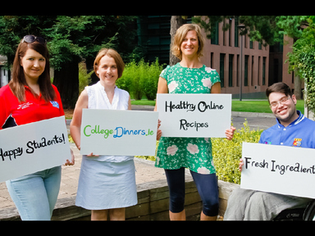

What were the challenges or barriers?
The most significant difficulties encountered by College Dinners in their first year primarily concerned access. The service delivers fresh food weekly to the students of CIT on campus which greatly increases uptake as it is more convenient for students. However, UCC does not allow College Dinners to distribute on campus. The university has a very large student population base with high concentration in a small area. This makes the student market one which is not particularly demanding with regard to logistics and supply.

How did the work contribute to the three key focus areas of the healthy Universities?
College Dinners contributes to the health of students in terms of nutrition but also empowers them to learn to cook for themselves. Students become more aware of nutrition and the value and benefits of eating well. The initiative has made healthy eating a reality and normality for its regular customers. It has highlighted the ease to which healthy eating can be achieved on a regular basis and has made it very accessible to students. As it does not operate through the university, to say that it has been integrated into core business would not be accurate. However, should distribution become possible on main campus it may make it a part of the core university life.
College Dinners contributes quite demonstratively so the health and wellbeing of the student population of UCC. It also however, contributes to the sustainability of local communities by using local suppliers for its meat and vegetables which provides employment in the local community. This highlights how the community surrounding the university can be beneficial to the university and vice versa.

CASE STUDY 11
What: Kylemore Services Group
Where: All Restaurants @ UCC Campus
When: All year round

Aims
Kylemore Services Group (KSG) aims to educate their customers (UCC students, staff & visitors) on the importance of healthy eating and to enable customers to choose the healthy option.

What was the context/background?
Eat Right Live Right (ERLR) is KSG’s new wellness initiative. ERLR has evolved from the Steps to Wellness initiative. The aim of ERLR is to educate, empower and enable our customers to make the healthier choice, the easier choice.
ERLR has three main categories of initiatives:
- An interactive website
- A calendar of themed health events in tandem with national and international initiatives.
- Communication

What were the drivers and levers for change?
Continuous Improvement in the company and the growing awareness of the importance of food and nutrition for a healthy lifestyle amongst our customers

What resources were needed?
Nutritionally analysed and calorie counted menus, staff training. Training which was given by the company Nutritionist. Menus were developed by our food Development Team

What was done?
As part of the ERLR initiative KSG made the following in UCC as standard:

1. Reduced Saturated Fat Standards
KSG use low fat mayonnaise, low fat milk, low fat yoghurt and rapeseed oil for frying.

2. Nutritionally Analysed Menus
KSG provide calorie counted menus daily – the calories displayed are rounded to the nearest hundred and are for the complete meal including all sides and based on a typical serving. The calories can be viewed by customers.
The Menus are nutritionally analysed which identify for customers, the nutrient profiles of the meals offered using the following symbols:
- No Gluten – This is displayed when the meal is made from ingredients that contain no gluten. Every effort will be made to avoid cross contamination of gluten.
- Vegetarian – This symbol is displayed when the meal is suitable for lacto-ovo vegetarians. Dairy products used are suitable for vegetarians and eggs are always free range.
- Low Salt – This symbol will be displayed when the meal has less than .3g of salt per 100g of food.
- Low Fat – This symbol will be displayed when the meal has less than 3g of fat per 100g of food.
- Source of Fibre – This symbol will be displayed when the meal has at least 3g of fibre per 100g of food.

3. Health Badges
We have introduced a set of 6 health badges made with food grade material that are placed with food items to highlight the healthy choices. These include:
- Good for you – this is located close to healthful foods.
- 1 of your 5-a-day – this is located next to fruit and vegetables.
- Low in saturated fat – this is located next to foods with reduced saturated fats.
- Good fats – this is displayed next to foods that contain good fats.
- Low salt – this will be located next to foods that are naturally low in salt.
- High fibre – this will be located next to foods that are high in fibre.

4. Cater for Coeliacs
Gluten Free Bread is available to cater for our coeliac customers. We have a range of soups and sauces made from ingredients containing no gluten. Menus clearly label the absence of gluten from the ingredients.

5. Re-development
The salad bar was re-developed to provide a wide healthful variety. The sandwich bar was also re-developed to offer healthy options. The breakfast bar now includes two porridges- one made with water and one using low fat milk.

6. Operation Transformation
KSG offers an O.T. breakfast, lunch and dinner option daily – adapted by calorie count recipes to match the recipes on the Operation Transformation website. Each leader is sponsored by KSG, therefore, they are offered:
- To meet the company nutritionist on a one to one basis at the start, mid-point and end of the programme.

- An individualised calorie allowance and tailored meals plans are provided by the nutritionist for each leader.
KSG promoting a healthier environment

What methods of communication were used?
KSG uses posters and Menus, Facebook, Interactive website

How did the work contribute to the three key focus areas of healthy universities?
KSG provides UCC’s staff and students with healthier options in their diet which is important in promoting and maintaining health. Displaying calorie counts and providing a varied menu makes it easier for customers to make healthier options. By strictly adhering to the use of low fat ingredients and by reducing the quantity of salt added to meals, students and staff are often making a healthier choice without even realising. Customers are able to avail of affordable and healthy meals throughout the year, making a regular balanced diet possible for all students and staff. KSG hope to have played a role in promoting awareness about the importance of a healthy well-balanced diet with the staff and students of UCC. KSG also hope that this goes further than just the university itself. By promoting awareness of the importance of good nutrition, members of the UCC community may themselves do the same within their own families and respective communities.

CASE STUDY 12

What: UCC Alcohol-Free Housing
Where: UCC Victoria Lodge
When: All year round

Summary

Students attending UCC have the opportunity to avail of alcohol-free accommodation with -Campus Accommodation UCC Ltd (CAUL) as part of the UCC Health Matters Initiative. This service began in September 2013, beginning with 6 students, a number which quadrupled in September 2014 to 24 students. The choice of alcohol-free accommodation is likely to become increasingly popular, as many students prefer to live in accommodation which is conducive to study and rest.

Aims
The aims of introducing alcohol-free housing are:
- To support students who prefer to live in an environment free of alcohol.
- To provide a living environment for students who wish to focus on study and relaxation.
- To raise awareness around the value of refraining from alcohol consumption for physical and mental wellbeing.
- To make the campus and local environment safer from alcohol related harm
- To promote health and wellbeing of students
- To cater for diverse needs of students particularly cultural differences and religious and personal preferences.

What was the context/background?
The background for alcohol-free housing came about following the findings of a study by E. Cahill and Dr Michael Byrne in 2010. The study found that 45.5% of UCC male students and 44.5% of female students binge drink at least once per week, and that all that did so reported at least one adverse consequence. Most common adverse consequences are:
- Regretting something said or done
- Feeling adverse effects while in college
- Missing days from college
- Harm to college studies or work
These findings contributed to the development of the UCC Alcohol Action Plan. The action plan has 20 action points which are being worked towards to help reduce alcohol related harm among students. The provision of alcohol free housing was one of the action points created to tackle the problem.

What were the drivers and levers for change?
The driver was the results of the study as described above. The lever was the willingness of the staff of CAUL to pilot the idea.

Who led the work internally and externally?
The strategic lead was The UCC Health Matters Alcohol and Substance Misuse Group, and the operational lead was Ms Verdi Ahern, Academic Year Services Manager, CAUL.

What resources were needed?
In year 1 of the pilot, a €500 subsidy was offered to attract residents. This cost was split 50/50 between CAUL and UCC Student Experience Office. A student intern was recruited through UCC Works scheme to assist with the marketing of the scheme. This student was required to work 40 hours during the academic year to gain extra credits at the end of the year. In Year 2 an agreed amount was allocated towards specific social events for the group of students living in alcohol free accommodation, shared for by UCC Student Experience Office and CAUL.

What was done?
The online application process for a place in Victoria Lodge which is owned and operated by CAUL was altered to include the alcohol free option. Interested students are required to write a personal statement as to why they wish to live in alcohol free housing, which is then screened by CAUL. A code of conduct specific to the alcohol free housing is included in the overall contract and is signed and agreed to by the student. Consequences of violations are in line with the current disciplinary process. These measures have worked well so far.

What methods of communication were used?
A number of communication methods were used to promote the alcohol free accommodation option. Firstly there was a piece on it made up for the Campus Accommodation website. Social media pages i.e. Facebook & Twitter were set up to spread the word. Most impressively, local and national press releases were made, and radio interviews held in late August and early September 2013, prior to its commencement. Plentiful positive feedback was received from the general public.

What were the critical success factors?
The numbers of students partaking in alcohol free housing was the critical success factor. In year one the target was 3 but the actual number was 6. And in year 2 the target was 10 and the final number resulted in 24. Therefore for the 2014/2015 academic year there are 8 apartments in Victoria Lodge which are alcohol free. The aim is to double this figure next year.

What were the challenges or barriers?

The only challenge which presented was where some who initially expressed interest in alcohol free accommodation subsequently dropped out as it was not what they understood it to be, or they had been put down for the alcohol free option by another family member.

What helped to achieve success?
Success was achieved through support of the UCC Alcohol & Substance Abuse group, and belief in its potential.

How did your work contribute to the three key focus areas of healthy universities?

The alcohol-free housing option for students fosters healthy and sustainable learning, working and living environments while at university. It promotes a safer community which contributes to the reduction of alcohol related harm, and due to the demand increase since its first year of existence it is a self-sustaining programme, and has potential to change the attitudes and behaviours of future students as it grows in popularity, with the likelihood that it will reduce binging and antisocial behaviour of UCC students.

