* INTERPRETATION - "Department" means College/School/Department/Centre/Unit as relevant.

18.48.1 INTRODUCTION

This guidance is for School/Department management as employers of outdoor workers and also for the employees themselves on sun protection. The guidance provides useful information on the topic of sun UV exposure related skin cancers which are much more common in outdoor workers than those who work indoors. It also outlines measures that School/Department management should have in place to protect their employees.

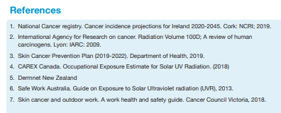
Also see https://www.hsa.ie/eng/topics/sun_protection/ and HSE SunSmart https://www.hse.ie/sunsmart
https://www.youtube.com/watch?v=-B77rRN1nKY&ab_channel=HSEIreland

Skin Cancer
Cancer is a disease of the body cells. The cells do not behave as normal and keep on growing to form a primary tumour. If a cancer is malignant, the cells can break away from the body part where they form and be carried by the bloodstream or lymph vessels elsewhere and form a secondary tumour.
Skin cancer is caused by abnormal growth of the cells nearest the skin, squamous, basal and melanocytes (see Fig.1). Squamous and basal cells form non-melanoma skin cancer while melanocytes cells which give the skin its pigment or colour form melanoma skin cancer. Basal cell cancers (BCC) are more strongly related to acute sun burn events in childhood and intermittent adult exposure while squamous cell cancer (SCC) is mostly a result of chronic long term occupational sun exposure.
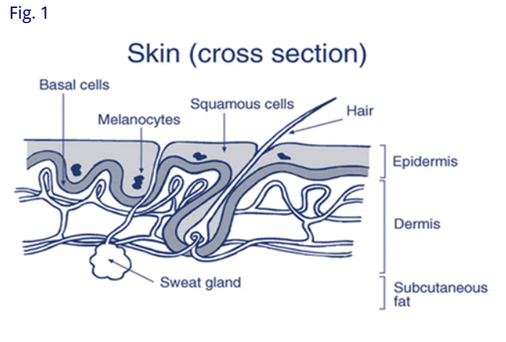

Incidences of Skin Cancer (Ireland)
Recent data indicates that the annual rates of both melanoma and non-melanoma skin cancers (NMSC) are increasing steadily in Ireland. There are over 1000 cases of melanoma and almost 12,000 cases of non-melanoma annually.
Between 2015 and 2045, it is predicted that the number of cases of melanoma per year among males will increase to 1,678 (+207%), and for females to 1,400 (+140%). The number of people diagnosed with NMSC over the same time period is predicted to increase to 16,623 (+177%) for males and 13,503 (+189%) for females¹.

18.48.2 Outdoor Work & Sun UV exposure hazards (indicative)
The harmful effects from the sun, like sunburn and skin cancer, come from UV radiation. Where employees work outdoors, these individuals might be exposed to 2-3 times more UV radiation from the sun than someone who works indoors, putting them at high risk of skin cancer. Outdoor workers such as people working in construction may be particularly at risk in heatwaves from high outdoor temperatures as well as from UV exposure. Risks increase with duration of exposure whenever the UV index is high (3 or above). Risks also increase for people with fair skin complexions.
Individual workers who utilise photo sensitising medications (personal circumstances medications) may be of increased risk and may need to take additional precautions. Increased risks may arise from work with substances that may cause photosensitivity. (These must be jointly considered by School/Department management and employees.)

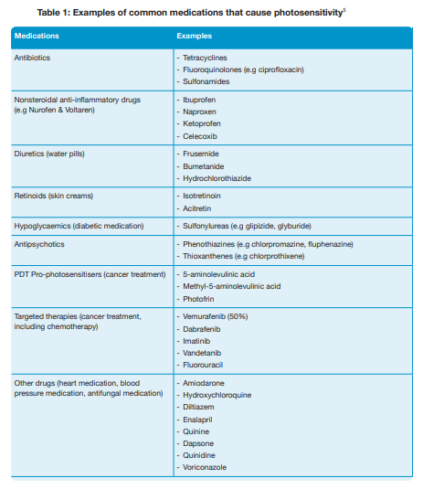
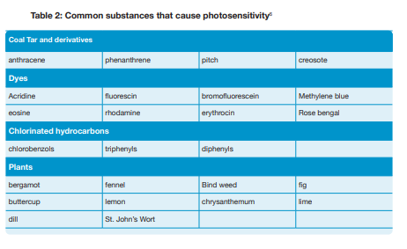

18.48.3 RISKS
The risks associated with the aforementioned hazards are to be assessed by the School/Department (using the appropriate technical input where necessary). These assessments shall be carried out using:
- Check lists provided (where applicable) and
- Departmental Hazard Identification/Risk Assessment Work Sheets contained in Document No.3 i.e. Departmental Hazard Risk Assessment (D.H.R.A.).

18.48.4 ARRANGEMENTS AND CONTROLS REQUIRED

General
Outdoor workers need to keep hydrated by drinking plenty of fluids. They also need to protect their skin from the sun. Where employees you spend all or part of the day regularly working outdoors, they can reduce their risk of skin cancer by protecting their skin (by being SunSmart). The general advice is to keep out the sun especially if outdoors between 11am to 3pm when UV rays are at their strongest. If possible, schedule outdoor work before 11am or after 3pm.
However, where employees have to go outdoors to work, protect your skin by using shade, wear clothing that covers the skin, a wide brimmed hat, sunglasses and sunscreen of 30+ for adults.
Engineering sun protection measures and sun administrative measures should also be considered and appropriately utilized to reduce the risk for work undertaken at times of the year/day with a high sun index.

School/Department maangement need to take account of increased risks arising from work with substances that may cause photosensitivity or for employees who may utilise photosenisitising personal circumstances medications.
Take cognisance of the daily UV forecast from Met Eireann www.met.ie/uv-index Check the UV index daily. Where the UV index is 3 or above there is a greater risk then apply the precautions in the UV index.
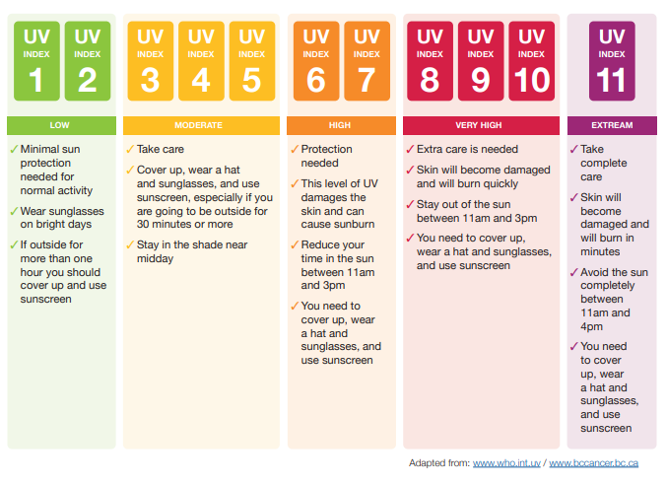

Contd...

Protective Measures (School/Department Management)
School/Department management need to make sure that their workers can keep hydrated easily and can protect their skin from UV radiation damage.
Apply a range of protective measures as follows:
- If possible, plan outdoor work in sunny weather to limit duration and intensity of employee exposure to direct sunlight (11am to 3pm sun rays are most intense)
- Limit duration of exposure if possible when UV index is high (3 or above), do indoor work if possible
- Provide shade if possible, or if that is not possible, there should be shade for breaks
- Give information to employees about dangers of sun exposure
- Ensure workers have easy access to safe drinking water. Workers should have enough time to hydrate – as the outdoor temperature rises the frequency of water breaks should go up
- Inform employees about the SunSmart code
- Educate and encourage employees to self-check skin for signs of skin cancer
- Check UV index, if 3 or above greater risk: www.met.ie/uv-index
- Ensure breaks are taken out of direct sunlight
- Encourage employees to cover up, keep clothing on with sleeves down, collars up and wear clothing with high ultraviolet protection factor (UPF), 15 or more, wear wide-brimmed hat
- Ensure employees do not strip off clothing when it is sunny
- Provide sunscreen, SPF of at least 30+ with a high UVA protection and water resistance. Reapply regularly.

SunSmart Code (Employees)
Follow the SunSmart code messages - 5 S’s:
- Slip on clothing that covers your skin, such as long sleeves, collared t-shirts.
- Slop on sunscreen on exposed areas. Use sunscreen SPF minimum 30 or higher. Apply 20 minutes before going outside and re-apply every two hours – more often if perspiring.
- Slap on a wide-brimmed hat.
- Seek shade - especially if outdoors between 11am and 3pm when UV rays are at their strongest. If possible, schedule outdoor work before 11am or after 3pm.
- Slide on wraparound sunglasses to protect your eyes.
- Provide sun glasses, wraparound are best.
https://www.youtube.com/watch?v=-B77rRN1nKY&ab_channel=HSEIreland

18.48.6 RESPONSIBILITIES
The following personnel are responsible in the Department/Office/Area for ensuring the implementation and ongoing compliance with the aforementioned arrangements and controls.

AREA/LOCATION | PERSON RESPONSIBLE
1.
2.
3.
4.
5.

