





CODA ARCHIVE USER GUIDE

Introduction 3
Getting Started with MicroStrategy Reporting Tool 3
To Start MicroStrategy Web 3
Logging In 3
Changing your Password 4
Home Page 5
Opening a Report in MicroStrategy Web 5
Selecting a Report 6
Report prompts 6
Required vs. optional prompts 7
Cancel prompt 7
Prompt Examples 7
Running a Report 13
Wait Page 13
Refreshing the wait Page 14
Cancelling execution 14
Drilling 14
Printing and Exporting Report data 16
Printing Report Data 16
More on the Print Options 17
Exporting Report Data 19
Exporting to Excel 20
Exporting to PDF 21
New Back and Forward button on Microstrategy 9 22
Navigating through folders 22
Logging Out 23

Introduction
MicroStrategy Web is a web-based query and reporting tool. Through the internet, staff members can run reports and view the results in clearly formatted tables or graphs. This document shows you how to log in and get started with MicroStrategy Web.

Getting Started with MicroStrategy Reporting Tool
Note: You can access MicroStrategy web from any computer that can run a browser.

To Start MicroStrategy Web
In a browser, enter the URL of UCC’s MicroStrategy Web site.

http://www.ucc.ie/en/datawarehouse

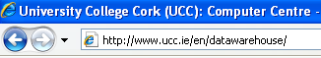

Click on

Logging In

1. Enter your User Name and Password.
2. Click Login.
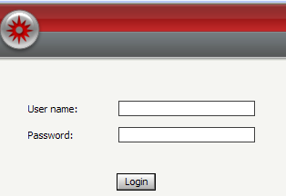

After you have done this you will be presented with another window, in order to log into MicroStrategy you must first click into your desired project depending on which company you wish to report on.

- CODA PMUL Archive.
- CODA UCCE Archive
- CODA UCCI Archive
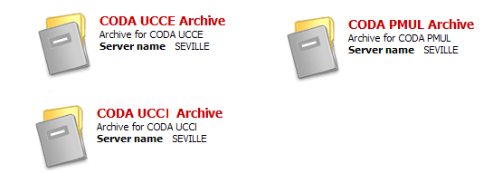

Changing your Password
To change your password:

- Click on Preferences at the top right of the page.

The Preferences page displays. Links on the left side of the page direct you to preferences related to different features.

2. Click on the Change Password link on the left hand side.

3. Old password - Enter your old password (the password you are changing).

4. New password - Enter your new password.

5. New password verification - Enter your new password again

6. Click on the Change Password button.
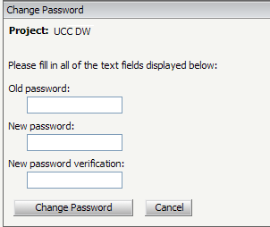

Home Page
Once you have logged in The Home Page appears, from there you can open folders containing existing reports in order to view and work with them.

Note: MicroStrategy Web uses the Home page as its start page, by default.

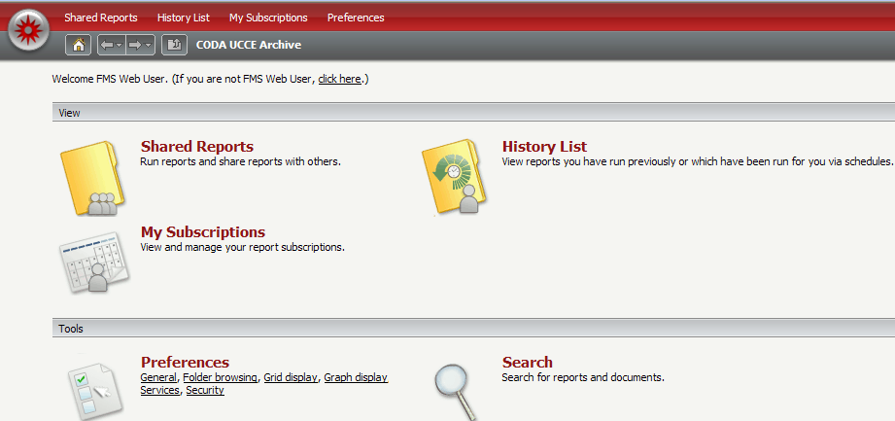

Opening a Report in MicroStrategy Web

- Select Shared Reports.

The current reports will be listed as follows:

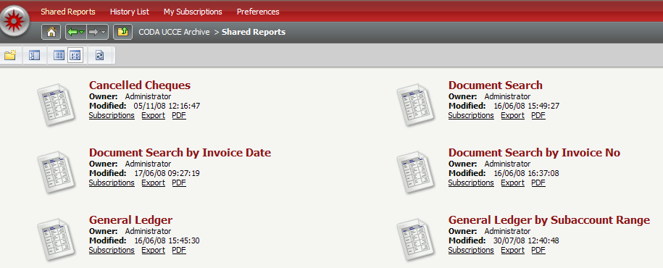

Selecting a Report

- Simply click on any report to select it.

Report prompts
Some reports may contain prompts. A prompt is a question presented to the user who runs the report. Depending on the answers the user provides, the report brings back and displays different data from the data source.

The diagram below shows an example of various prompts:

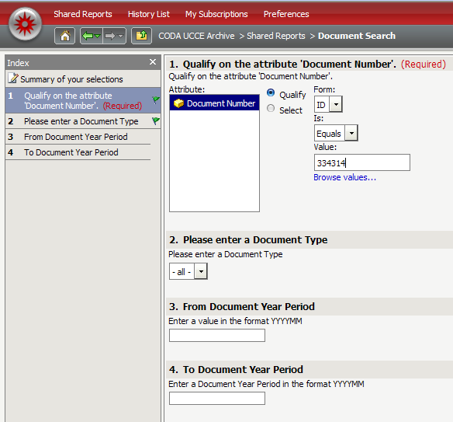
Prompts

Required vs. optional prompts

An indication of whether the prompt is required or optional appears in each prompt title bar. If a report contains a required prompt, you must answer the prompt before you can execute the report. A warning message appears when one or more required prompts are not answered. (It is not necessary to answer optional prompts to execute a report).

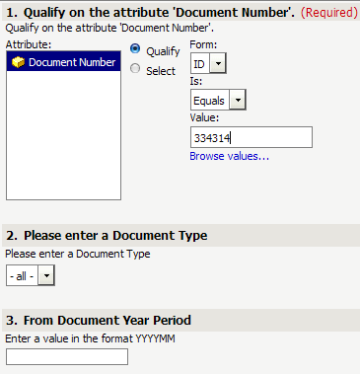
Optional

Cancel Prompt

Cancel prompt
There is a Cancel button on the prompt page (located at the bottom right of the page). If you click Cancel when you run the prompt report for the first time, you are returned to the previous folder page. If you click Cancel after re-prompting, you are returned to the previous report or document page.

Prompt Examples
Microstrategy supports several different prompt types as a result we will take a look at examples of the different prompts relevant to the CODA ARHIVE project.

Choosing a Document Number

The diagram below shows an example of choosing a Document Number

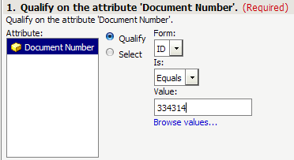

- Click into the value field and type in the document number as displayed in the above diagram

Alternatively
Click the browse values button 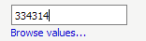

Type in the document number

Click on 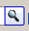 button

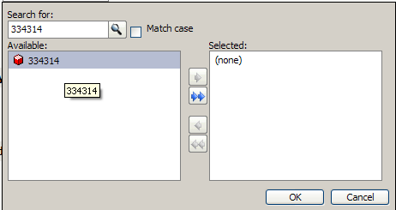

To select that document number simply double click on it.

Choosing a Document Type

- Click on the drop down menu and select the document of your choice by clicking on it.

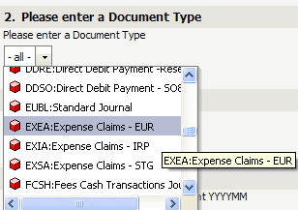

As some prompts may consist of lists that have of thousands of elements it is possible to do a search first before you select from the prompt list.

For example if you want to run a report on a particular supplier then

- Type in the supplier’s name
- Click on the magnifying glass

This will search the list for the supplier you have entered into the search field.

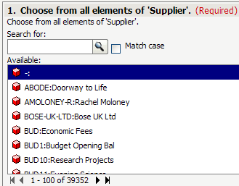

As can be seen from the diagram below this will narrow your selection considerably.

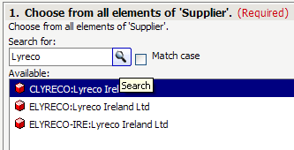

In order to select Lyreco just double click on it

Alternatively you can Click on Lyreco once and Click on the Button

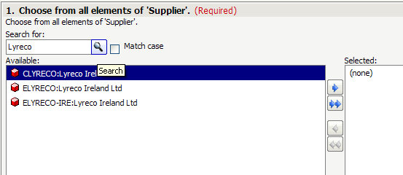
Lyreco has now moved to the right hand pane.

The diagram below shows Lyreco selected
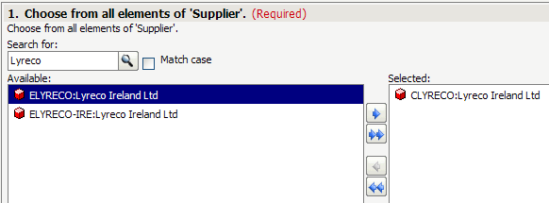

Note: If you accidently selected something from the list and you wish to deselect it simply double click on it.

Alternatively you can Click on Lyreco once in the right hand pane and Click on the
- Button.

Note: multiple suppliers can be selected by just double clicking on them

Or by Clicking the add all button

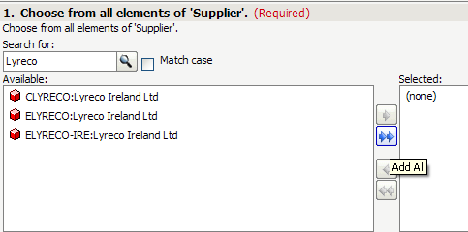

Prompts that include dates

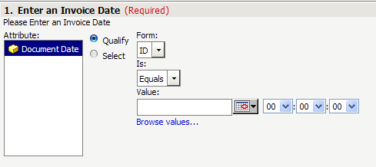

To select a date
- Click on the Date Selector button.

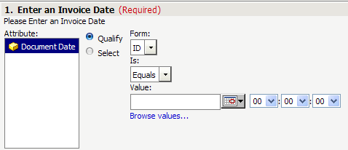
Date Selector

A mini calendar will be displayed to select your chosen date just click on it.

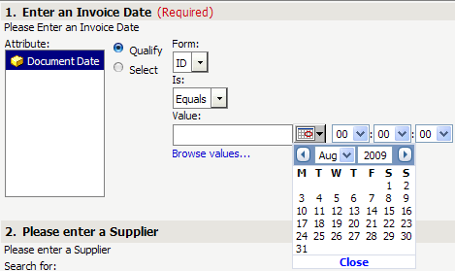

In order to navigate to a particular date use the arrow on the left to navigate to a date in the past and the one on the right to navigate to a date in the future.

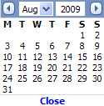

Running a Report
To run your reports

- Click on the Run Report Button at the bottom of the page.

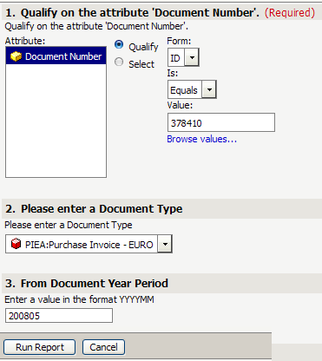

Wait Page
The Wait page is displayed if results are not immediately returned when you request the execution of a report. The Wait page contains the report name and its current execution status. When execution is complete, the Results page automatically replaces the Wait page.
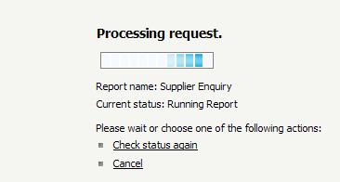

Refreshing the wait Page
To refresh the Wait page

- Click the Check Status Again button.

Cancelling execution
To cancel a report,

- Click Cancel on the Wait page to return to the folder from which you made the request.

The image below shows a subset of a report after execution:

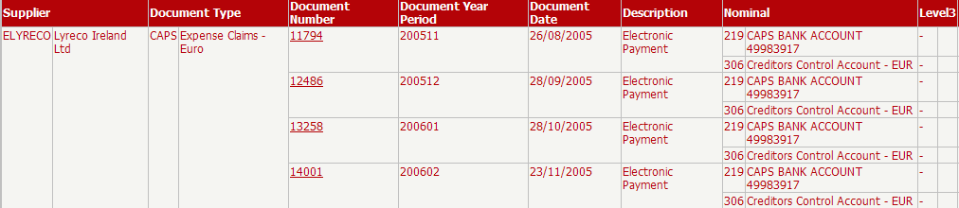

Drilling
Drilling enables users to explore data beyond the data immediately visible on a report. You can drill through a report to analyze data that is closely related to the original report data.

Any object on a Microstrategy report that has a drill attached to it is easily identifiable as it is underlined.

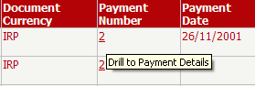
Drills

To Drill on an object

1. Click on it

When you hover over the figure it shows you what exactly it is drilling to.

From the diagram below you can see that you can drill to Payment Details.

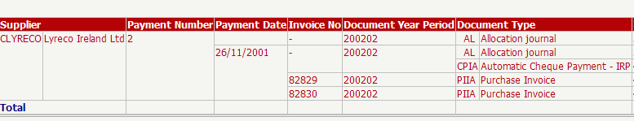

The drill now opens in the same window so all you need to do to get back to the original report is press the back button.

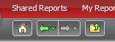
New Back Button

Printing and Exporting Report data

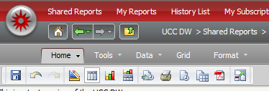
Printing Report Data

1. Click any report to execute it.

2. Click the Print icon at the top of the page.

The Print Options page opens.

Select suitable options for printing your report.

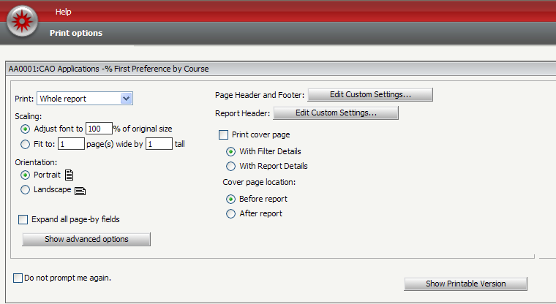
You can choose to print the entire report or the portion displayed on the screen by using this drop menu.

3. Click Show Printable Version at the bottom of the Print Options page to preview your printing.

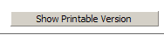

Anything within the lines (print area) will be printed; anything outside of the print area will not print.

4. To print the report, use the browser's print capabilities.

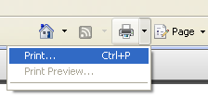

(If you have Internet Explorer Version 6 you will need to Click the File menu on your browser and select Print)

Note: If you would like to change the appearance of the printable version before printing, click the browser's Back button to return to the Print Options page. There you can change number of rows and columns per printed page.

More on the Print Options
Page Header and Footer: You can use headers and footers on all your reports.

Select Edit Custom Settings to access the Header/Footer Editor. You can specify what text to print in the left, centre, and right portions of the page's header and footer. You can simply type this text or insert fields specific to the report by choosing macros from the Insert Auto-text drop-down list at the top of the page.

Scaling: Adjust the amount of the report's content (and thus, the size of the font) that prints on a page from the following scaling options:
Adjust font to __% of original size: Manually set the percent to adjust the font on a page.

Fit to page: Specify whether the page is adjusted for All columns, All Rows, or both.

Print cover page with filter details: Print the filter details of a report on a separate page. The filter details are placed before the contents of the report.

Select Show advanced options to view the following options:

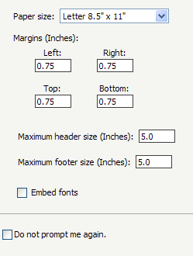
Paper size: Select the paper size on which to print a report. As Microstrategy is an American application you will need to change the paper size to A4.

Margins (Inches): Set the top, left, right and bottom margins. For reports to print correctly, these margin settings, the margin settings in the browser's File, and the Page Setup option must match. This is only applicable if PDF printing is disabled. The default values for all of them is 0.75 inches.

Click OK to save your changes and close the dialog box.

***Please note ******

When you go to print your report you may see the following message:

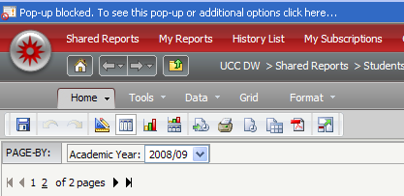

If this occurs simply click on the message and click Temporarily Allow Pop ups

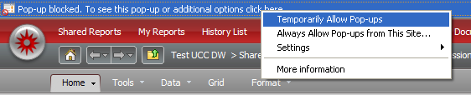

Exporting Report Data

It is also possible for you to export a report to applications such as Excel and PDF.

After your report has been executed, to export to Excel, CSV, HTML, PDF or Plain Text do the following:

- From the Home menu, choose Export or simply click Export icon.

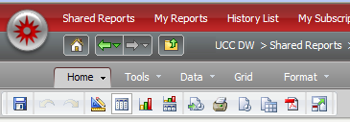
Export Icon
Home Menu

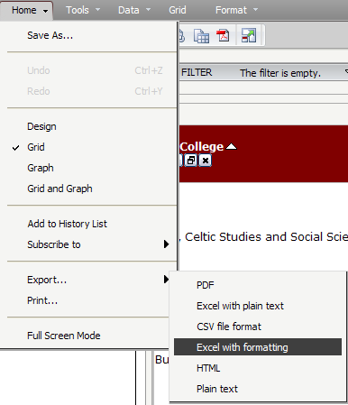

The Export Options dialog box opens.

2. Select you desired export option.
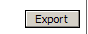
3. Click on the Export Button

You will be prompted then to open or save the report. It is best if you then save the report to your computer.

Exporting to Excel

In order to export to excel, we recommend that you export to Excel with formatting

- Click Home or Click on the Export icon
- Click Export
- Click Excel with formatting
The Export Options dialogue box will pop up

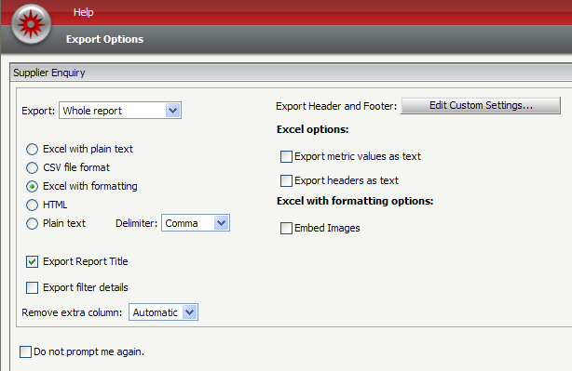

Exporting to PDF

Export to PDF Icon

New Back and Forward button on Microstrategy 9

A new aspect of Microstrategy 9 is the introduction of the new back and forward buttons, these buttons will allow you to navigate through the different pages without seeing the Page Expired Message.

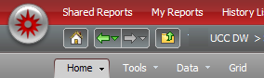

Use the Back and Forward buttons on the MicroStrategy Web toolbar to navigate back and forth among MicroStrategy Web pages you have visited:
This feature is similar to the Back and Forward buttons in browsers, but your browser's Back and Forward buttons may return a Page Expired message. So please use this feature instead of your browsers back and Forward.

Navigating through folders

In MicroStrategy Web, you browse through project folders to locate reports.

While you are navigating through MicroStrategy Web, a path appears at the top of the page showing the project you logged into, and any folders you subsequently opened. An example is shown below:

- In order to return to your Home Page at any stage just click on the Home Page icon.

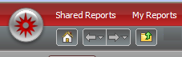

2. To navigate to the folder immediately above your current location, click the Return To icon .

- To go to any folder in the path, click the folder's name.

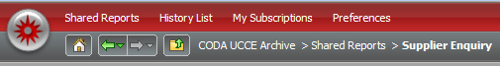

Logging Out

To log out of a project:

- Click the Logout link at the top right hand of the page.

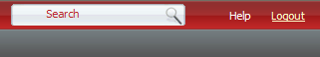

A logout dialog page opens.

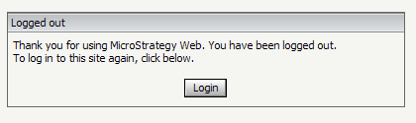

To log back in to Web, Click Login.

