Videoconferencing in North Wing Council Room

- There are two wall-mounted cameras in the room, one facing the front, and the other one facing the rear. You can use either one with the software of your choice, Teams, Panopto, Zoom etc.
- There is a remote control in the room that you can use to power on and position both cameras.
- In Teams (or Zoom etc), go to Device Settings -> Video Settings and select one of the “USB Capture SDI+” cameras in the list. They both have the same name, so you may need to try both to see which one is the one you need.
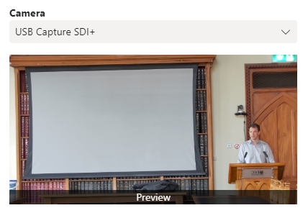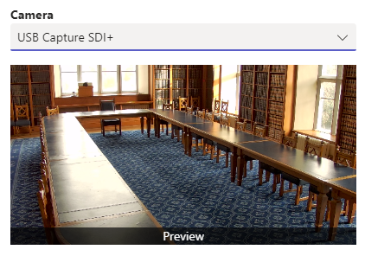

- For audio, select “Speakers (2- USB PnP Sound Device)” as the Speaker, and “Microphone(2- MXL AC-44)” as the Microphone if you are speaking from the podium.
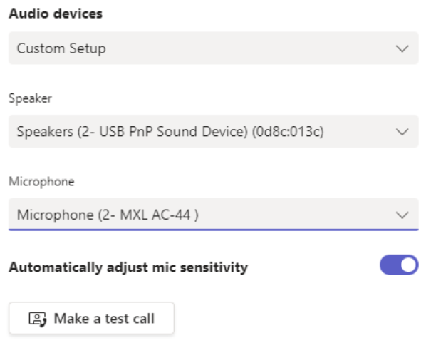

- If table mics have been set up on the table by AVMS and you want to use them instead of the podium mic, then select “Microphone (2- USB PnP Sound Device)” as the microphone instead.
- It is recommended that you make a test call in advance of your event to ensure that everything is working as intended.

