Áras na Mac Léinn Opening Hours 2025

**Monday 15th September – Sunday 14th December 2025**

**Closed Bank Holiday Monday 27th October 2025**

**Building Hours**

Monday – Thursday 07.00 – 23.30

Friday 07.00 – 19.00

Saturday 09.00 – 17.00

Sunday Closed

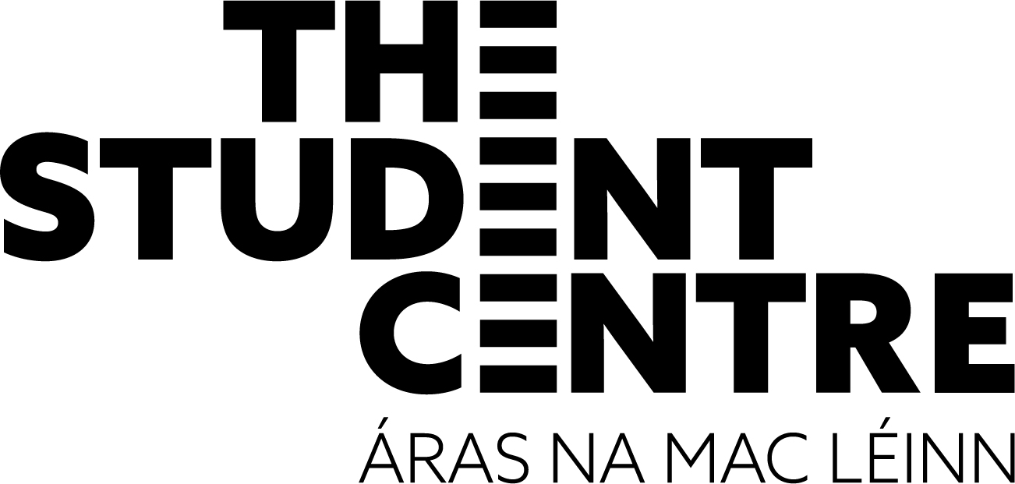

**Café Oasis**

Monday – Thursday 08.00 – 18.00

Friday 08.00 – 17.00

Saturday 09.30 – 16.00

**‘Upstairs!’**

Monday - Thursday 09.00 – 16.00

Friday 09.00 – 15.00

Saturday & Sunday Closed

**An Siopa (Ground Floor Student Centre)**

Monday – Thursday 08.00 – 19.00

Friday 08.00 – 17.00

Saturday 11.00 – 15.00

**An Siopa (Beside Main Rest)**

Monday – Thursday 08.00 – 20.00

Friday 08.00 – 17.00

**Collegear**

Monday – Thursday 09.00 – 17.00

Friday 09.00 – 16.00

**Club Áras/New Bar**

Monday – Thursday 10.00 – 23.30

Friday 10.00 – 21.00

**Unisalon**

Wednesday 10.00 – 17.00

Thursday & Friday 09.30 – 17.30

**Bank of Ireland**

Monday - Friday 10.00 – 16.00 (Closed 12.30 – 13.30)

Saturday & Sunday Closed

11/9/2025