10 Easy Ways to Bring Your Stress Levels Down
- Listening to Music
Music is a potent stress reliever. It reduces cortisol, and consequently, blood pressure. Choose quiet, instrumental tunes, or listen to the relaxing sounds of nature. Develop your unique playlist that you can use to comfort yourself during difficult times.

2. Talk to a Friend
A listening ear is always an effective stress reliever. Call a friend or a loved one when you feel your pressure building. A stable support system is a critical part of a healthy lifestyle and helps to put things in perspective.

3. Talk Calmly to Yourself
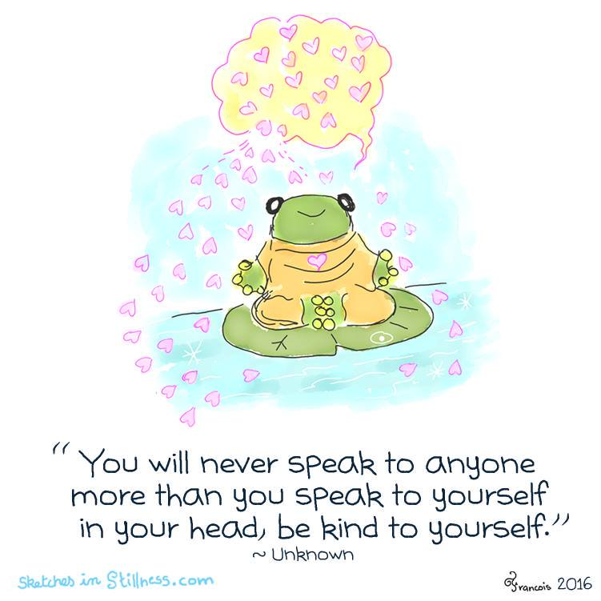
A foolproof way to deal with a stressful situation is to talk calmly to yourself. Ask yourself why you feel stressed, and more importantly, what you can do to bring your pressure down. Remind yourself of how you have dealt with pressure in the past and talk yourself through it. “I can do this”.

4. Develop Healthy Eating Habits
Like most people, you may turn to food to comfort yourself when you feel stressed. Avoid sugary drinks, sweets and pastries when the pressure builds. Try snacking on fruit, nuts and vegetables instead.

5. Have a good belly laugh

“Laughter is the medicine”. The saying is true; laughing is a proven way to reduce the stress hormones cortisol and adrenaline. So, it is confirmed – a belly laugh improves mood.

6. Tea
The caffeine in coffee causes your blood pressure to rise over the short term. It also causes the pituitary and adrenal glands to overwork.
Instead of reaching for coffee, try tea. It contains half the caffeine in coffee and has a host of valuable antioxidants. Green tea has Theanine, an amino acid that soothes the nervous system.

7. Exercise
Exercise does not mean power lifting. It may just mean standing up at your desk and stretching or going for a walk. It gets your blood flowing, releases endorphins and improves your mood.

8. Sleep
Stress, of course, worsens sleep. Try to get a daily dose of seven to eight hours of rest. Make it a point to turn off your lights early and give yourself time to wind down before going to bed.

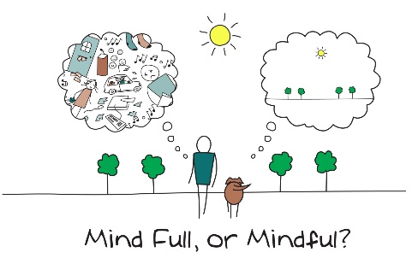
9. Mindfulness
Mindfulness incorporate physical and mental exercises that help calm the mind and prevent stress from becoming a problem. Try joining a class.

10. Take a deep breath
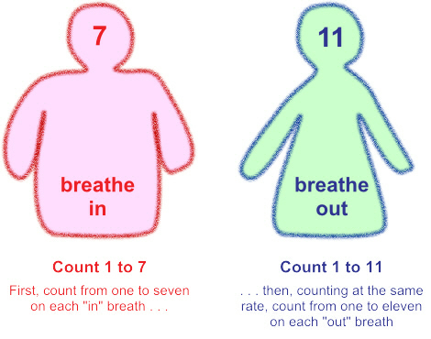
Take a deep breath in and relax and let go on the out breath, or try 3 minutes of 7/11 breathing; breathing in for a count of 7 and out for account of 11. After 3 minutes your blood pressure and hearth beat will have slowed, helping you to feel calmer.

