DIPLOMA IN SPECIALITY
AND ARTISAN FOOD ENTERPRISES

Application Form
Name:
Home Address:
Employer’s Name:
Employer’s Address:
Email address:
Telephone No: | Mobile Telephone No:
Additional Information:
Please attach additional information under headings 1 to 3 below to support your application, using in total about 400 words. All applicants must attach this information to their application form.
- Briefly outline your education and/or experience to date in the area of artisan/ speciality food production, or related business or service. (approx. 100 - 130 words)
- Outline the reasons why you would like to undertake the Diploma in Speciality Food Production. (approx. 100 - 130 words)
- Briefly describe your ambitions for a future food or food related business or service, indicating how you believe the Diploma will benefit you. (approx. 100 - 130 words)
This information will be used to allocate all places on the Diploma programme, including places funded by bursaries.
Course Fee:
The course fee is €2,800. The programme may be funded up to 64% for eligible participants, under a Department of Agriculture, Food and the Marine bursary scheme.
Contact details:
Dr Angela Sheehan
Food Industry Training Unit, College of Science, Engineering and Food Science
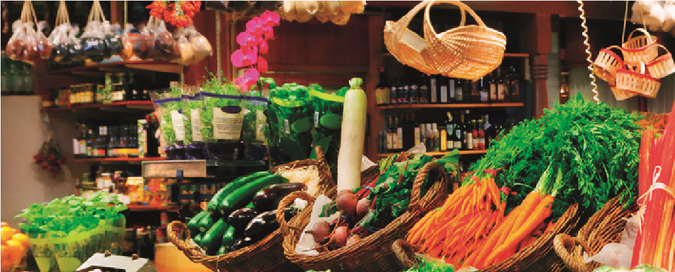
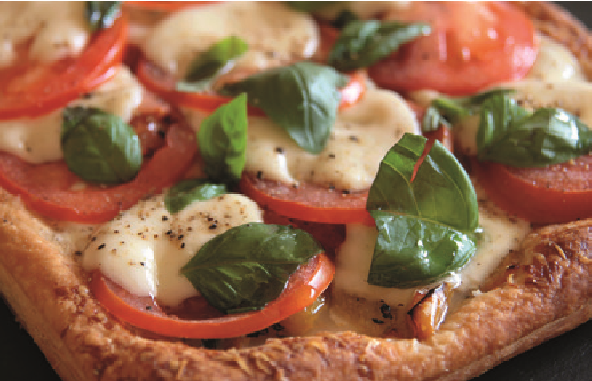
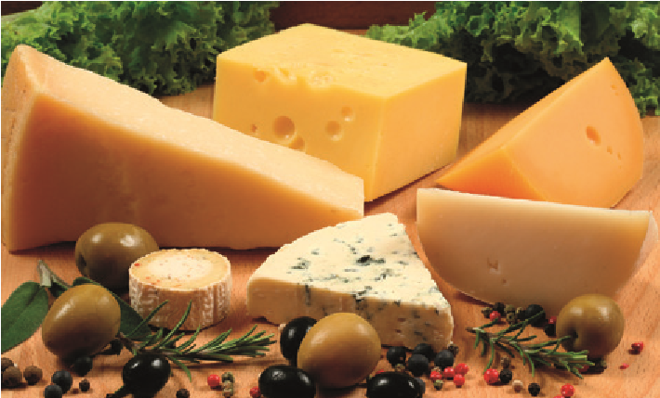
University College Cork. T: +353 (0)21 4901423 E: a.sheehan@ucc.ie

