UNIVERSITY COLLEGE CORK
CORK – SINGIDA PARTNERSHIP

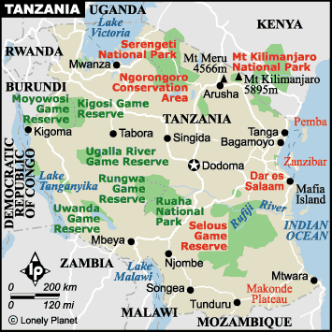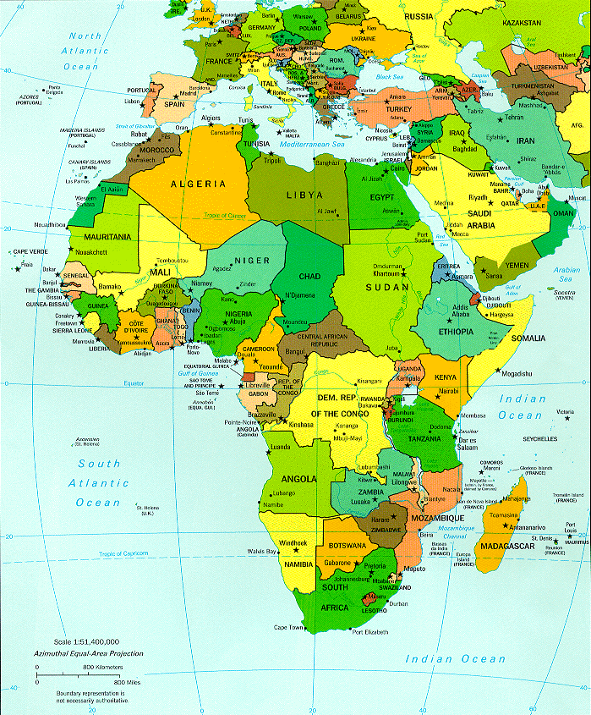

Since we started in April, 1986, this year is the Partnership’s 21st birthday. This number, beloved by our forefathers because it was the product of two magic numbers, still makes a good time for stock-taking and looking into the future.

We have just authorised the Partnership’s largest single expenditure of €40,000. (While talking figures, we should say that we have 110 Members contributing approx €1,555 per month, to whom we are very grateful.) This expenditure is for big underground tanks to collect rain water to support the bore-holes which are at present the only water resource. The Hospital is located at Makiungu, which is a semi-desert area of Singida Province where there is a short, violent rainy season and the rain water goes to waste because there is no facility to collect it. I quote from the Project Description sent by Sister Odunukwe, the Hospital administrator:

“Water is critical to life and more so for the effective running of any hospital. The hospital presently has two boreholes, which are insufficient due to the increasing demand by our patients, staff, and for other hospital services. There is no urban or rural water supply company available, which we could rely on if the present boreholes break down or dries up. Hence, the need to collect rain water is therefore urgent in order to continue to maintain the high hygiene standard in the hospital. Rain water will be used also for Sterilization as it does not corrode the autoclaves and for making Infusions. We make our own drips and rain water is highly recommended.”

Other recent projects include:

- Refurbishment of village dispensaries.

- The “topping up” of low Government salaries in an effort to retain medical personnel in the Singida region.

- The purchase of drugs to deal with the widespread Malaria outbreak in the Singida region.

On the home front, too, there have been some developments. Because of retirements, the Committee, has in effect fallen to a membership of three. (Fr) Joe Coughlan, Ray Foley (Project Accountant), David Morgan (Law). We thought it high time, therefore, to look for new blood and were delighted when the following agreed to join the Committee: Kay Doyle (Hispanic Studies), Michael Mansfield (Physics) and Ivan Perry (Public Health). Apart from their individual calibre, they also provide us with a college-wide spread.

In addition, the Partnership is registered as a charity. The major advantage of this is that, where a member makes a contribution above the threshold of €21 per month, then (with the member’s permission), we can recover this from the Revenue Commissioners for the Cork-Singida Partnership, the income tax paid in respect of the contribution. In sum, if the amount paid is €21 per month (the equivalent of €252 pa) this means that there will, in effect, be an additional donation of €103 or €50, depending on whether the member is paying tax at 41% or 20%. This will apply not only in the future but also retrospectively for the previous four years.

We hope that this bonus, together with the new blood on the Committee, can be used as a springboard for a bit of a membership campaign. As a group we can hardly, I think, be accused of being ‘in your face’. Indeed, we might be more open to the Biblical charge of hiding one’s light under a bushel. We have a good story to tell, so let us please tell it. A large number of staff have joined UCC since the Partnership started in 1986. Yet, most of the Partnership’s members are still founder-members. It might be a good idea if each of us were to mention the Partnership to colleagues in our Departments who may be interested in contributing. An email based on this newsletter will shortly be sent to ‘All Exchange Users’ in the next week. And on another matter, would you all, like Mr de Valera, look into your hearts and wallets and consider whether you can now increase your contribution and perhaps bring it up to the magical figure of €21 per month on this our 21st anniversary. The appropriate Payroll Authorisation Form, should you wish to do so, will be found at the bottom of this Newsletter.

The following is an excerpt from the Annual Report 2005 on the Makiungu Hospital, written by (Fr) Ollie O’Brien originally from Midleton who has spent his life in the service of Africa. Ollie was, at one time, administrator of the Makiungu Hospital and now lectures at the Catholic University of East Africa in Arusha, which is three hours drive from Makiungu in the dry season and six hours in the wet season.

‘Some things DO change’

There is this popular misconception of depression, doom and gloom concerning the African Continent based on the assumption that nothing ever changes and the only news is bad news. Not so long ago I read that the expression, the Dark Continent was used in Dáil Éireann, but in an Irish context and it caused furore. Agreed, it will take some time before the horrific images (once true) of Joseph Conrad’s novel ‘The Heat of Darkness’ are eroded from the collective consciousness. Many are aware of just how ‘unreal’ all of this is and there is an initiative, based in Nairobi, Kenya to launch an African news channel for broadcasting to the world something additional to the disasters, famines, the scourge of AIDS and civil strife. The reality in this huge and diverse continent is that for the majority, life goes on more or less as it does for you and me, rarely totally smooth but with joys and sorrows and never less than challenging.

These thoughts came to me as I was reading the Makiungu Hospital, Singida, Tanzania Report of 2005 as I sit and enjoy the ‘imported’ sunshine here in Midleton on a beautiful July afternoon. I am more interested in trends than in spectacular individual incidents and happenings. Scanning the statistical section of the Report I must have been thinking out loud because the reaction from a member of my family was “Don’t depress me too much on this beautiful day”. The material details didn’t seem all that bad to me and I tried to be ‘reasonable’ by pointing out that even in Ireland, one of the richest countries in the world people do become ill for many reasons. It seems the ‘many big hospitals’ are full to capacity with people lining up for admission. If we cannot cope very well with this situation one wonders what will happen in the foreseeable future as the population grows for the first time since the Great Famine and another segment becomes very old, needing care. If these ‘little matters’ pose a considerable challenge for Irish society, the scale of the task facing a country like Tanzania (with ten times the Irish population) comes into clearer perspective. Over the next few paragraphs I would hope to show that ‘some things do change’ as we take a closer look at what has been happening in Makiungu Hospital in 2005. And you the Staff at UCC have been helping to make it happen in a very effective and virtually anonymous manner.

The record on preventable diseases is very impressive. The statistics for out-patient diagnosis for both under and over five year olds shows either zero or very low numbers. That is proof positive of the success rate of the Community Based Heath Car Programme (C.B.H.C) and the impact of health education in general. The Government has put great emphasis on infant immunisation and this eases to some extent the financial burden on a voluntary agency. This and other government initiatives such as the ‘basket fund’ are examples of collaboration between the statutory and voluntary services and of course the WHO and other large NGO stakeholders. I quote for the C.B.H.C Report: “In the Hospital we make special efforts to follow-up the admissions of several malnourished children”. It is true that ‘several’ malnourished children is not acceptable. However, I take heart from this because I recall reading reports of twenty years ago which referred to hundreds and even thousands of very ill children whose problems began with malnutrition, and compounded with malaria and pneumonia.

What could be interpreted as another positive sign of progress (though this remains to be proved) is the rather dramatic decrease in the total number of out-patients (new cases) which averaged just over 200,000 in each of the past four years and is given as approx. 12,000 in 2005. Even the Doctor in Charge of the Hospital is not prepared to give the precise reasons for this quite sudden change. Certainly, the hospital has not changed its policy or ‘cut back’ on intake in the sense of refusing to treat or admit poor sick people. It could possibly mean that there were simply fewer sick people in the region in 2005. Another possibility is that the alternative healing facilities (statutory and voluntary) had improved to the extent that some had exercised their choice and gone elsewhere by preference. Either scenario or any correct explanation along those lines could be interpreted as positive. What one does not want to contemplate is that people were so poor that people could not even contemplate approaching Makiungu for medical assistance, where in fact their service charges are minimal and nowhere near replacement cost. The interesting immediate impact of this shift in ‘new attendance’ is that the Hospitals might appear to be over-staffed. The obvious but not very clever response would be retrenchment. Not very clever because it is difficult to attract or recruit staff to what is perceived as a remote rural area and it is even more difficult to retain good staff in such a situation. Plus the fact that only time will tell whether this is a permanent trend or just a freak combination of circumstances. Such are the joys of hospital administration in the tropics.

To attempt to present this Report as all good news would be just as misleading as the opposite. We are having a hard look at the facts. The informed reader of the report would ask why the figures for TB and HIV – A.I.D.S. appear to be so low. Its seems to me that this is explained by the national strategy for dealing with the scourge of HIV – A.I.D.S. whereby there are specialised clinics for testing and counselling specifically geared to dealing with the problem. Persons with this health problem would use these facilities directly and would not be necessarily referred to the Hospital. The Report also includes the encouraging line: ‘There were no leprosy patients on treatment during 2005. There have been no relapses among patients on the follow up post-treatment register.”

A quick glance at the statistical tables for causes of death reveals that the ‘extremes’ all point in one direction – MALARIA tops every table –number one for outpatients diagnosis, first cause for hospital admission for both children and adults and the leading cause of death in all categories. Include morbidity (a condition far too complex to deal with in a report of this kind) and the sad picture is complete. The figures for Makiungu hospital are remarkably similar to those in the national statistics, indeed for the entire vast area of the Continent South of the Sahara. ‘Malaria is the leading cause of morbidity and mortality in Tanzania, 20 percent of all deaths occurring in Tanzania hospitals being caused by malaria. The disease accounts for 31.4% of all hospital attendance and 15 per cent of all children who die under the age of five. About 100,000 deaths are reported from malaria every year.’ (As reported in the ‘East African newspaper’) Of that 100,000 the vast majority, almost three quarters are of infants under five years of age. Africa, is the part of the world most affected by malaria and Tanzania is unfortunately one of the worst hit countries.

As I look at the photograph of the new staff houses (funded by the UCC – Makiungu Partnership) on the front cover of the 2005 Report I vividly recall six days spent in Makiungu about three years ago. That particular year I was included in the statistics under ‘outpatients’ with diagnosis malaria. It was horrible, the worst ever, to use a phrase and I won’t forget it. Nasty as it was, my ‘case’ cannot seriously be compared to that of the young woman who also appeared as a statistic in two columns of that particular report, malaria and maternal deaths. Twenty years of age, she gave birth to a 3 kilo infant (strong and healthy) on the day she was admitted. Next day on her way to the toilet she collapsed and was dead within three hours. Cause of death? Cerebral malaria.

The environmental campaign to prevent malaria appears to have been lost. Malaria is endemic as there are mosquitoes practically everywhere in East Africa nowadays. The WHO in collaboration with Governments, have been encouraging the use of insecticide-treated nets. They are cost effective and do help to reduce both morbidity and mortality. The greatest impact could be on infant mortality if babies and small children can be protected from being bitten by the mosquito. The high cost of medication for prevention tends to rule that out. Even the relatively high cost of drugs for treatment is presently causing problems for many. Resistance is so high that the health authorities have had to change to new first line of treatment drugs which even if available tend to be expensive. Many do not consult a doctor, treat themselves, feel better after taking half the recommended dose and keep the rest of the medicine for the next time. This increases resistance and the next time will most likely be very soon. This is where poverty clicks in as a very important element in the equation where the other side equals continued good health (as in my case) or diminished mental capacity due to cerebral malaria or death. Some of us have a lot to be grateful for; perhaps we should stop and think. Your commitment to Makiungu Hospital is having a positive impact which this brief communication has attempted to convey to you with the gratitude of many who have benefited from your support.

Oliver O’Brien

PAYROLL AUTHORISATION FORM

I hereby authorise UCC to deduct from my wages/salary each week/month, the sum of €_______ with immediate effect. I further authorise UCC to pay over the amount deducted to the Treasurers of the Cork-Singida Partnership. If the amount deducted exceeds the specified limit (as of January 2006, €21 per month) the Partnership will reclaim income tax paid on the amount deducted. I understand that this authority may be revoked by me, in writing, at any time.

Name (in block capitals): __________________________________________

Department/Unit __________________________________________

Staff ID: ______________

Signed __________________________________________

Date __________________________________________

In the event that I am already a member, this authorisation prevails over any previous authorisation.

Please return this form to:
Kay Doyle,
Department of Hispanic Studies,
UCC.

