UNIVERSITY COLLEGE CORK
CORK – SINGIDA PARTNERSHIP

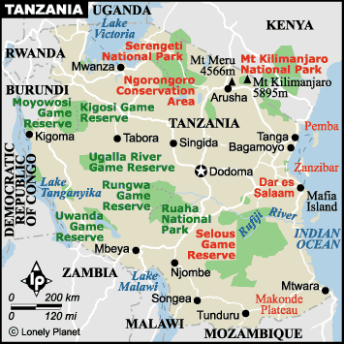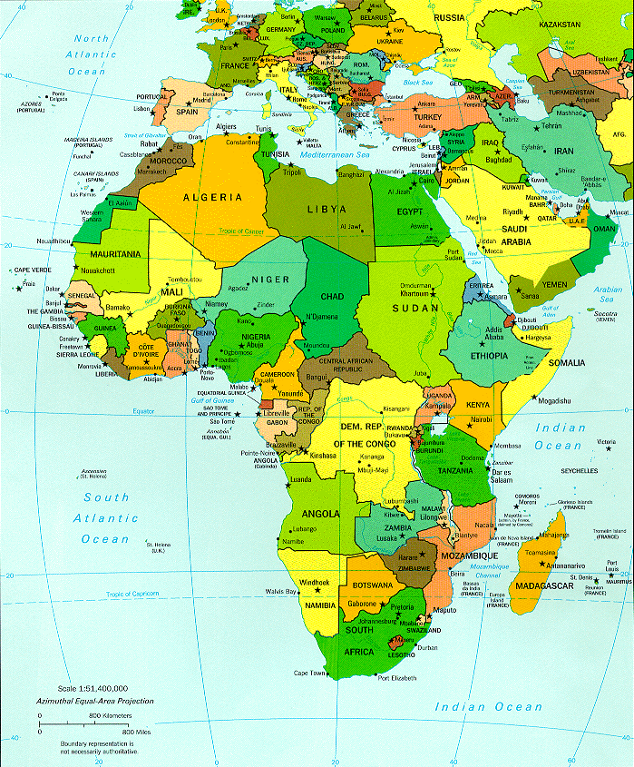

In the first place, may we wish to bid you welcome to the new academic year. Our contribution to marking this time of renewal is to launch our website which may be accessed on: http://www.ucc.ie/en/singida/ This website lists the projects to which we have contributed and also (one picture being worth a thousand words) includes several photographs of the hospital at Makiungu, its people and surroundings, and features some of our projects. In addition, there is a good deal of historical and geographical background, including some past Cork Singida Newsletters and the most recent Annual Report from the hospital. All in all, a cornucopia of Singida!

As ever, we include at the bottom of this Newsletter a Payroll Authorisation Form in case you are aware of a colleague or friend who may be interested in subscribing to our worthy cause, or should you wish to increase your own monthly subscription. We have been accused of hiding our light under a bushel and so we would be extremely grateful if those of you who have colleagues – whether newly joined to UCC or not – who may be interested in joining Cork-Singida would draw the Partnership to their attention. May we supplement this with the observation that we are genuinely grateful for any donation of whatever amount but would draw attention to the fact that where a contribution exceeds the threshold of €21 per month, then (with the member’s permission) we can recover from the Revenue Commissioners the income tax paid in respect of the contribution.

The remainder of this Newsletter consists of contributions from two people who have worked in Africa for many years and know the Makiungu Hospital in Singida well. The first of these is Dr Kevin Murphy who graduated with an M.B. from UCC in 1989 and is now a consultant neurologist at Beaumont Hospital, Dublin:

Fruitful collaboration continues!

I visited Makiungu Hospital, Singida, Tanzania, in early June 2008, having previously worked as a physician there from September 1995 to June 1996. In the interim, I had trained and worked as a neurologist in the USA and Beaumont Hospital. I returned to work as a consultant neurologist for a two-year period in Tanzania, at the Kilimanjaro Christian Medical Centre (KCMC) in June 2006. As this period ended, I took the opportunity to revisit my old ‘stomping ground’ of Makiungu Hospital. Singida is about 220 miles – or a nine-hour journey – from KCMC so I was fortunate to get a lift from some friends who were also travelling there at the time. My first observation was that there had been a marked improvement in the road from Arusha to Singida. About half way to Makiungu, we had the happy experience of the hospitality of the Pallottine sisters and secondary school in Siuyu. The sisters run a secondary school and I was very impressed with the many advances that had occurred since 1996. New buildings have been made possible as a result of continuing collaboration with friends and benefactors from overseas, especially Ireland.

In Makiungu Hospital also, there has been continuity and change. Many members of staff remain since 1996 but there are also new staff members. There are new bujildings also, but the basic hospital structure remains the same. The needs of patients are as great as ever. The staff are dedicated and committed, doing their best in difficult circumstances to try and meet those needs to a high standard. Diagnosis and management of patients is compromised by the scarcity of resources. The people of the area continue to struggle to make a living in difficult financial and climatic conditions. As ever, Makiungu depends on outside help to meet the financial and others costs of running the hospital. One of the long-standing collaborations is the UCC-Makiungu connection. This has been a consistent and reliable source of funding and other support for the hospital. Briefly, at least, I lived off the reflected glory of the generosity of UCC staff who contribute financially to Makiungu.

The next communication is from Fr Ollie O’Brien who has worked in Tanzania for thirty years, for several years of which he was the administrator of Makiungu Hospital. He now lectures in Arusha which is a three-hour drive from Makiungu (six hours in the wet season!).
Public private partnership is very much in the news and seems to be generating a lot of quite heated debate on issues concerned with the delivery of the health service in Ireland. Our focus here is to relate the concept to the African situation and the practical and pragmatic aspects of providing health care for a population upwards of 35,000,000. There is nothing new, of course, about certain aspects of the PPP which have been in operation in the African (specifically Tanzanian) context in both the colonial and national independence administrations of the past fifty years.
The Tanzania Ministry of Health uses just two categories to describe and differentiate the legal status of the entities which deliver the health service. 'Public' obviously and correctly denotes the Government or statutory service. 'Private' not so obviously and in my view probably incorrectly or at least inadequately is a hold all category for anything that is non- governmental. Residual categories tend to be confusing at the best of times and can even be dangerous because they can lump together entities of a quite dispirate nature.
In previous hospital reports, reasons have been given to explain why Makiungu Hospital has been finding it increasingly difficult to break even financially. In this respect, it is no different from other voluntary organisations providing a similar service, being victims of their own success and having got caught in a trend of decreasing funding and increasing demands on their facilities. With increasing demands and rising costs in the face of decreasing donor funds while operating in a rural, subsistence economy prone to cyclical food shortages, the future of Makiungu hospital appeared to be increasingly in jeopardy.
In fairness, it must be said that the Government of Tanzania recognises and acknowledges the contribution of the voluntary agencies, in this case the Churches, in the provision of health care for something in access of 50% of hospital care. In reality the Government was looking at places like Makiungu sinking into debt and ultimately extinction. The options were to let them sink or reach out to support them. The latter made far more sense. The Government, already hard pressed to supply a range of educational and health services to a rapidly growing, predominantly young population could see no sense in abandoning Makiungu. If it did allow the hospital to collapse it would have had to take on the additional burden and fill the gap itself.
‘Council Designated Hospital’
Accordingly, beginning this 2008 financial year, Makiungu becomes a Council Designated Hospital (CDH) receiving (on a statutory basis) Government financial support for Staff salaries and bed grants in addition to the already 'free' treatment of Mothers and Children and the treatment of some contagious diseases. This is a vast improvement on the old 'basket fund' the previous attempt to assist the ailing private (voluntary) health units. It represents a triumph of common sense over bureaucracy. I just hope someone does a cost-benefit analysis because this move has preserved a vast amount of administrative skills in the voluntary institutions which otherwise would have been lost, not only human resources but physical plant and infrastructure. Those who stand to gain most (equally to lose most had it not happened) are the oftentimes very vulnerable people in the remote villages and in particular the women and children who tend to require more from the services provided at Makiungu.
I digress a little but still a propos the public private partnership. Though I have no hard data to support this view, there appears to be quite rapid growth in private health clinics in the towns and cities. Private in this sense means FOR profit. Obviously, a cash economy is more typical of urban living but there also seems to be more cash flowing about. Equally, it seems that people are prepared to pay for high quality, private medicine even where the statutory services are reasonably good. Perhaps this is a trait of urban living that is emerging but this is an opinion only. But my real interest is in the observation that suppliers of this kind of service make it available in places where there is a demand for it (profit nexus) and, for sure, that is not in the villages of Singida and several other regions of Tanzania.
Question(s) about the future of our partner, as a CDH: What with its new status does the future hold for Makiungu and similar health units? Is there a fair chance it will be able to financially break even? balance the books? achieve reasonable stability and a fair chance of continuity as a viable health unit? The recent past was very bleak indeed and the prognosis even for survival was not optimistic.
Secondly, though financial issues will not fade away, at least there will be less pressure on the Hospital Administration in balancing the books. On the basis that the Hospital will comply with and meet the Government requirements there is no reason to believe that this type of funding will not continue well into the future.
Thirdly, the new arrangement should allow for more resources to be devoted to maintenance and possible infrastructure improvements. In addition, there is a fair chance that there may be an encouraging shift of emphasis in the allocation of financial resources from stop gap measures to more pro active involvement in preventative health especially through health education. Why? Because a health institution under extreme financial pressure will react sensibly and try to deal with the immediate issues and problems and will therefore buy drugs and equipment and treat those who show up at the hospital. While the value of prevention was never lost sight of and the programme never abandoned, it now seems far more likely that it will receive the emphasis and the resources it deserves.
Fourthly, the new status could/should reflect very positively on Staff morale. No, not because they will receive large bonuses and financial hand shakes. They will remain on the same salary scale as their Government employed colleagues in the health profession but crucially will have greater security of tenure. This fact should impact positively on morale and performance. A fair employment policy, rather good staff housing, a conducive and safe work environment will hopefully help to retain staff for longer periods. The spin-off effect should be an improvement in overall efficiency in the hospital. (Town life with its perceived advantages appears to be the dominant factor driving the rural-urban migration. Three decades ago, Tanzania was 10% urbanised. In less than thirty years into the future, almost 50% of Tanzanians will be living in large towns and cities. It will never be easy to retain Staff in rural Singida unless it becomes or takes on the so-called perceived advantages of urban living.)
The new status of Makiungu Hospital as a CDH with guaranteed Government support in key areas of financing will undoubtedly alleviate some of the more pressing problems. But for solving the present Administration, the Medical Missionaries of Mary will still be faced with considerable challenges in providing a preventative and curative service because of the very nature of where the hospital is located and the surrounding catchment area. Local contributions for services rendered comes nowhere near cost replacement and the shortfall in years of serious food shortage is a financial management nightmare. Reference has already been made to a much smaller funding base in comparison to what it used to be. The once steady and substantial flow of donations from families, church attending faithful and friends of the missionary Sisters and the Congregation has dwindled to a trickle. Even when donations are received, they tend to come with strings attached and these preconditions do not always coincide with the immediate priorities. A case in point is that the hospital could conceivably obtain funds from Governments and NGOs for capital expenditure on a new ward or new operating theatre when in fact what is required in the short term is money to buy fuel and spare parts for vehicles, hospital supplies and drugs. All funding nowadays has a bias in favour of capital investment and tends to be bilateral i.e. government to government rather than being directed to an NGO such as Makiungu.
Cork-Singida:
The Cork component of the UCC Cork - Makiungu Hospital (Singida) Partnership is quite unique in this respect. It has placed implicit trust in its Tanzanian partner particularly when most of the real needs were short term and for the most part concerned with recurring expenditure. Nor on the other hand has this trust been misplaced and there is a record of precise, explicit and comprehensive accounting for every single item. . Nothing less can be considered acceptable. The list is long and varied; generator and vehicle spare parts, medical supplies, drugs and salary increments just to mention some. Pressing short term needs have been met in a manner which has seen the hospital through a very rough patch and kept it in a position of some strength to be able to fully benefit from its new status.
Makiungu Hospital’s status as a CDH has created a new situation of realistic confidence. It would not be unreasonable to look to the future for some innovative initiatives in preventative care, community health i.e. specifically through health education utilising the hospital infrastructure resources and the Mother and Child outreach programme to the more remote rural settlements. This may indeed be that special opportunity to be proactive (for so long it has been on the defensive, trying to pay its way) in making locally produced mosquito nets more readily available to increasingly larger numbers, just to mention a single example. Those responsible for the administration of the hospital are the ones who know best and it will be interesting to hear more from them. The hospital always possessed the human resources capable of providing a caring and highly effective preventative and curative health service; now there is a good chance they will be able to realise their full potential.

Meanwhile, we attach a copy of the payroll authorisation for anyone who may be interested in joining. We are always open to new ideas for developing the Partnership – one example being our Easter egg competition last March. If you can think of any other ideas – whether in terms of the flow of information from Singida to Cork or contributions in the opposite direction – do please contact a member of the Committee:

Joe Coghlan Kay Doyle Ray Foley Ruth McDonnell Michael Mansfield
Chaplaincy Hispanic Studies Project Accountant Office of Media & Communications Physics

David Gwynn Morgan Ivan Perry
Law Epidemiology & Public Health
PAYROLL AUTHORISATION FORM

I hereby authorise UCC to deduct from my wages/salary each week/month, the sum of €_______ with immediate effect. I further authorise UCC to pay over the amount deducted to the Treasurers of the Cork-Singida Partnership. If the amount deducted exceeds the specified limit (as of January 2006, €21 per month) the Partnership will reclaim income tax paid on the amount deducted. I understand that this authority may be revoked by me, in writing, at any time.

Name (in block capitals): ________________________________________

Department/Unit ________________________________________

Staff ID: ______________

Signed ________________________________________

Date ________________________________________

In the event that I am already a member, this authorisation prevails over any previous authorisation.

Please return this form to:
Kay Doyle,
Department of Hispanic Studies,
UCC.

