UNIVERSITY COLLEGE CORK
LGBT+ STAFF NETWORK

Minutes of Network AGM

Date: | 12 December 2019
Time: | 3.30-5pm
Venue: | G01, Ashford, Donovan’s Road

Attendance: Mary O Rourke, Barra Ó Donnabháin, Fiachra Ó Súilleabháin, Amanullah de Sondy, Fatima Gunning, Cathal Kerrigan, Mary Byrne
Apologies: Gordon Dalton. Maurice Ryder, William Knott.

Sec.: Fiachra Ó Súilleabháin.

Agenda:

- Co-chairs’ report: 2019 activities and accomplishments
- Treasurer’s report
- Votes of welcome/thanks:
  - EDI Needs Assessment Preliminary Report
  - financial support from the Equality Committee and Staff Sports and Social Club;
  - President’s Strategic Fund for UCC Rainbow Alliance launch;
  - Charlie Ruxton and Tomás Tyner for their pro bono work for UCC Rainbow Alliance;
  - Chaplaincy for hosting Network coffee morning on 17 May 2019
  - Suzanne Buckley and Nora Deady – Freshers Week event.
- Vote of Condolence to Will Knott on death of his mother, Hannah Knott
- Elections: Co-chairs, Secretary, Treasurer, Events Officer, LGBT+ Staff Liaison Officer, Tyndall representative, PRO
- Event planning for 2020: Refugee Week; Equality Week; OUTing the Past; LGBT Awareness Week; Cork Pride; Lifelong Learning Festival
- UCC Rainbow Alliance
- Request from ACT UP Dublin re Letter of Support to HSE re PrEP clinic at CUH
- AOB

- CO-CHAIRS’ REPORT
LGBT+ Staff Network
UCC’s LGBT+ Staff Network was set up by the Equality and Welfare Unit of the Department of Human Resources following expressions of interest by staff in 2007. The aim of the Network is to work in partnership with management and staff of University College Cork to create a safe, inclusive and diverse working environment that encourages a culture of respect and equality for everyone regardless of their sexual orientation, in order that every individual can reach their full potential without fear of discrimination. The Network’s objectives are to:-
- Act as a consultation forum on LGBT employment and welfare related issues for the Department of Human Resources, UCC;
- Provide a forum for networking, information sharing and peer support;
- Increase the visibility of the LGBT staff Network in UCC and engage in outreach activities and;
- Liaise with other groups, e.g., staff and student societies in other third level institutions in Ireland and abroad to share information and best practice.

The Committee of the LGBT+ Network, made up of elected staff members from UCC with a representative from the Tyndall National Institute, organise and operationalise the Network’s activities. The LGBT+ Staff Network Committee, currently chaired by Mary O’Rourke and Barra Ó Donnabháin, organise a broad range of events throughout the year including seminars, symposia, coffee-mornings, information sessions on campus. In addition, the Committee are actively involved in other equality and welfare work at committee levels within the university and in Irish higher education networks. Committee members participate in civic engagement with local and national LGBT+ organisations including Gay Project, LINC, Cork LGBT Awareness week, Cork Pride, Sexual Health Centre Cork.

The LGBT+ Staff Network Committee plays a pivotal role in supporting and nurturing equality, diversity and inclusion throughout UCC and beyond, making deserving of this award. The Committee seek to champion equal rights for all and to ensure that our students and staff are connected with community and national organisations working on behalf of gender and sexual minority populations. This activities of the Committee members highlight their outstanding work promoting our university’s profile as an organisation which seeks to exhibit best practice in relation to equality. The following are examples of just some of the initiatives undertaken by Committee members to promote equality and welfare this year:

Launch of the Rainbow Alliance – Promoting Equality and Welfare
During Equality Week 2019, the LGBT+ Staff Committee launched the new UCC Rainbow Alliance with the President and the Deputy President & Registrar, and guest speaker was Dónal Óg Cusack, Irish hurling player. The Rainbow Alliance enables UCC staff to demonstrate solidarity with their LGBT+ colleagues, students, family members and friends. This ‘allies’ scheme aims to promote a sanctuary environment for staff, students and visitors on UCC campus-sites. It provides support to staff to make clear visible statements about the importance of LGBT+ equality (displaying stickers, wearing badges/rainbow lanyards) and about how to proactively intervene to challenge homophobia/biphobia/transphobia.
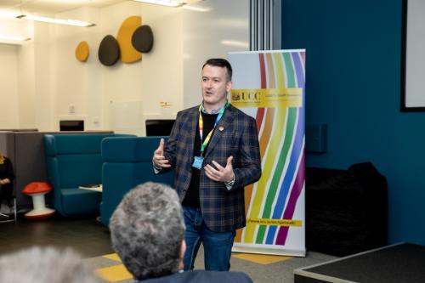(Photo by Tómas Tyner)
Cork LGBT Awareness Week
The success of the Rainbow launch resulted in the Committee (represented by Mary O’ Rourke and Barra Ó Donnabháin) being invited to give a presentation with Dr. Louise Crowley, School of Law, about the importance of allies schemes in the workplace during Cork City LGBT Awareness Week 2019. This demonstrates the impact of the work carried out by the Committee – not only in the university but at a local community level.
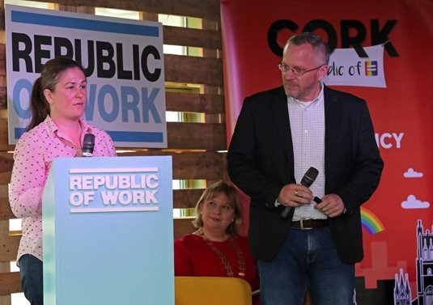

International Day Against Homophobia, Biphobia and Transphobia (IDAHOBIT) Events 2019
The Committee organised the raising of the Rainbow and Trans Pride flags on the main quadrangle on IDAHOBIT Day (17 May 2019) as well as a symposium in the Creative Zone, Boole Library. This included an awareness-raising/training session by the Gay Project, LINC and Cork’s Parents of LGB Children group; presentations and panel discussion by Dr. Louise Crowley, UCC, Dr. Martin Davoren, Sexual Health Centre Cork, Pádraig Rice, Coordinator Gay Project, and Sarah Jane Cromwell Workplace Relations and HR Management Consultant); a presentation by Liam Herrick, Director of the Irish Council for Civil Liberties on legislating for hate crimes in Ireland.

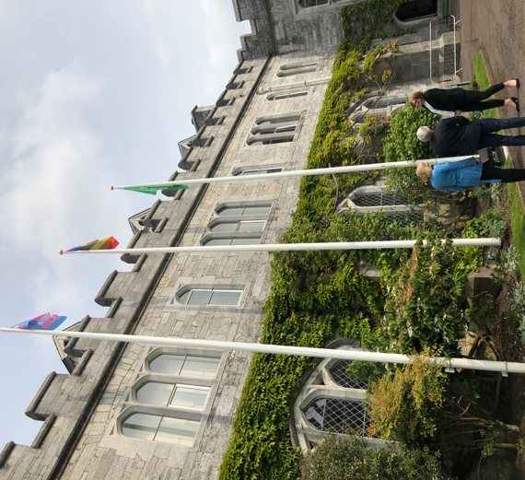

OUTing the Past Festival 2019
Committee members (Mary O’Rourke, Fiachra Ó Súilleabháin and Diarmuid Scully) were a part of the organising committee of the first LGBTQ+ history festival held in Ireland in Cork City Hall in March 2019. This work is in keeping with Goal 3 and 4 of the University’s Strategic Plan – by acting as ‘a catalyst for change and creativity, creating connections, partnerships and practices, exchanging ideas and expertise’ to enhance cultural participation and interaction at a national level.

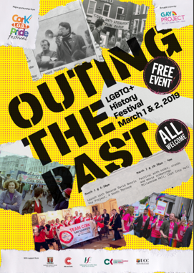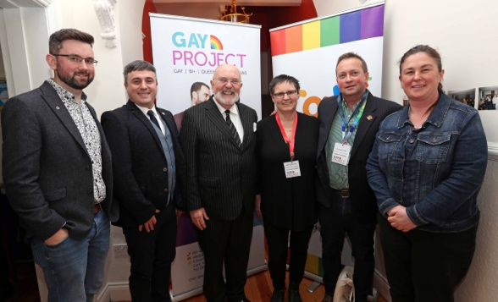

Lecture Series for the 16th Cork Lifelong Learning Festival 2019
Committee Members, Barra Ó Donnabháin, and Diarmuid Scully gave lectures on LGBT+ history as a part of Cork’s Lifelong Learning Festival 2019. These lectures were open to the public, which is in keeping with this university’s mission to be a Connected University at the heart of its locale, civically engaged and educationally inclusive.

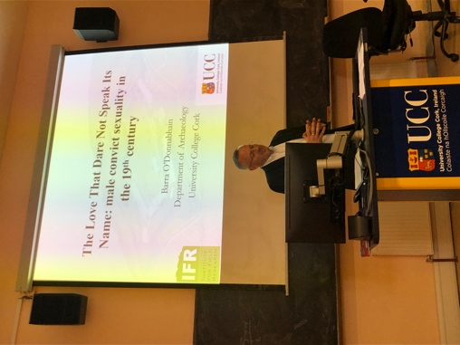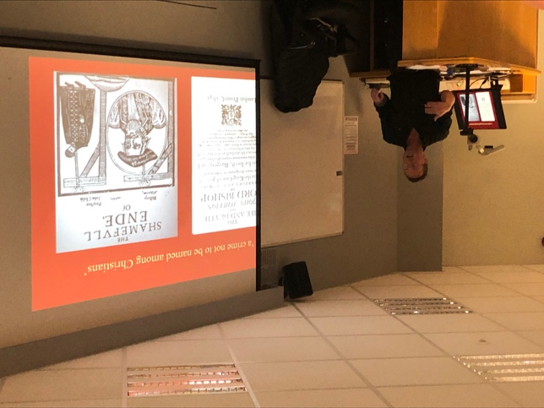

Stonewall 50th anniversary events
The Network organised a coffee morning get-together on the date of the 50th anniversary of the Stonewall revolt, and also organised a book competition where we gave away 5 copies of Stonewall-related books. The competition was advertised to ‘All Exchange Users’. We also officially donated a copy of Marc Stein’s The Stonewall Riots: A Documentary History (NYU Press, 2019). For the month of October 2019, we organised for the display of a Stonewall exhibition in the foyer of the Boole Library and the curator of the exhibition launched the exhibition on Friday 4th October as part of UCC’s inaugural ‘Community Week’. At the launch event, a copy of An Introduction to Transgender Studies was formally presented to the UCC Boole Library.
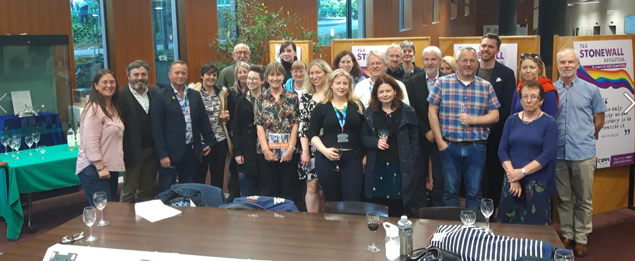

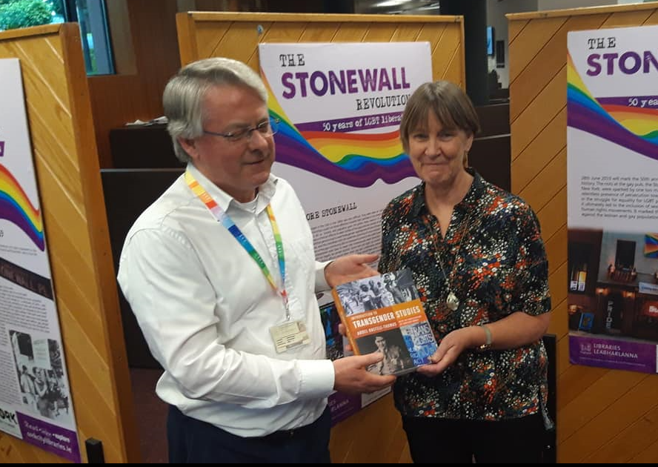

Cork Pride 2019
Members of the Network and UCC Rainbow Alliance marched in this year’s Cork Pride Parade, 2nd August 2019, where we marched with members of the UCC students’ group. Many members of the UCC Rainbow Alliance joined Network members in this year’s march, making it the largest turn-out to date from UCC.

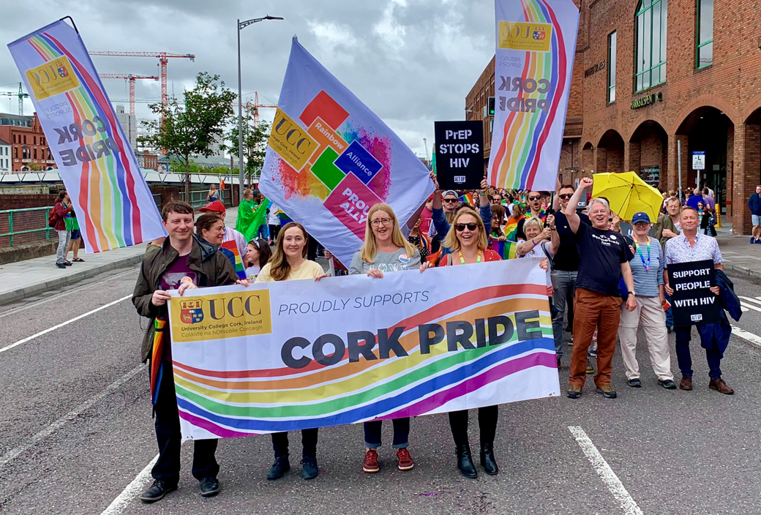

Trans Healthcare Protest on the Quad, 21 November 2019
Members of the Network joined the UCC Student Society on the Quad at 2pm on 21.11.19 for a protest rally and march to highlight the inadequacies of trans healthcare in Ireland and calling for medial action to address same.

- TREASURER’S REPORT

 | total debits | Total Credits | Total Balance
Eq Com | €3,430.90 | €5,000.00 | €1,569.10
Staff Account | €1,325.07 | €3,759.73 | €2,434.66
Total | €4,755.97 | €8,759.73 | €4,003.76

Starting Balance 2018 | €1,500
Description of expense | payable to who | Date of payment | PO number | Debit | Credit | Balance
EQ credt Laurence announcemnet in 2018 |  | 28 Nov 2018 |  |  | 1500 | €1,500.00
stickers badges Allies Launch | connect promotions | 25 March 2019 | 20326881 | €394.58 |  | €1,105.42
printing Allies Launch | city print | 25 March 2019 | 20326872 | €875.00 |  | €230.42
Coffee tea pastries | Student services | 5/4/19 | 20329090 | €82.50 |  | €147.92
President’s Strategic Fund 7195 AS1219 |  |  |  |  | 2000 | €2,147.92
Stickers and Button badges | connect promotions | 13/5/19 |  | 660.6 |  | €1,487.32
Coffee tea pastries 0000046884 | Student services | 28/2/19 | 20340973 | 70 |  | €1,417.32
Lanyards |  |  | direct transfer | 1050 |  | €367.32
Books gifts waterstones |  | 08/06/2019 | 10312340 | 129.5 |  | €237.82
Meet and greet at Gluxman | Bobos cafe | 28/6/19 | 20342469 | 67.5 |  | €170.32
Books gifts orla egan |  | not created yet | cheque | 30 |  | €140.32
Coffee tea pastries - 15+5 persons | UCC Hospitality | 17/10/19 | PO 20356558 | €71.22 |  | €69.10
Equality Fund 2019/20 bursary |  |  |  |  | 1500 | €1,569.10
Total |  |  |  | €3,430.90 | €5,000.00 | €1,569.10

Date | Details | Balance | BoI fee | Miscellenaus debits | Credit members fees | Credit Staff club | Eq comm residual | Balance
 |  | 113.67 |  |  |  |  |  | 113.67
12/12/2017 |  |  | 16.5 |  | 32.5 |  |  | 129.67
12/01/2018 | UCC0026 CTO |  |  |  | 32.5 |  |  | 162.17
12/02/2018 | UCC0073 CTO |  |  |  |  | 500 |  | 662.17
12/02/2018 | UCC0017 CTO |  |  |  | 32.5 |  |  | 694.67
12/03/2018 | UCC0017 CTO |  | 15.4 |  | 32.5 |  |  | 711.77
09/04/2018 | UCC0010 CTO |  |  |  | 32.5 |  |  | 744.27
10/05/2018 | UCC0011 CTO |  |  |  | 32.5 |  |  | 776.77
11/06/2018 | UCC0009 CTO |  | 15.3 |  | 32.5 |  |  | 793.97
09/07/2018 | UCC0009 CTO |  |  |  | 32.5 |  |  | 826.47
24/07/2018 | 365 Online 1O DONNAB |  |  | 96.36 |  |  |  | 730.11
24/07/2018 | 365 Online Cork Sig |  |  | 187.28 |  |  |  | 542.83
14/08/2018 | UCC0009 CTO |  | 15.6 |  | 32.5 |  |  | 559.73
14/08/2018 | UCC0376 CTO |  |  |  |  | 800 |  | 1359.73
11/09/2018 | UCC0008 CTO |  |  |  | 32.5 |  |  | 1392.23
08/10/2018 | UCC0021 CTO |  |  |  | 32.5 |  |  | 1424.73
12/11/2018 | UCC0023 CTO |  |  |  | 32.5 |  |  | 1457.23
21/11/2018 | UCC0001 CTO |  |  |  |  |  | 715 | 2172.23
Totals |  | 113.67 | 62.8 | 283.64 | 390 | 1300 | 715 | 2172.23 | 2172.23
Date | Details | Balance | BoI fee | Miscellenaus debits | Credit members fees | Credit Staff club | Eq comm residual | Balance
 |  | 2172.23 |  |  |  |  |  | 2172.23
10-Dec-18 | UCC0009 CTO |  |  |  | 32.5 |  |  | 2204.73
31-Dec-18 | NOTIFIED FEES |  | 15.3 |  |  |  |  | 2189.43
08-Jan-19 | 365 Online KSG |  |  | 43.06 |  |  |  | 2146.37
15-Jan-19 | UCC0021 CTO |  |  |  | 32.5 |  |  | 2178.87
11-Feb-19 | UCC0021 CTO |  |  |  | 32.5 |  |  | 2211.37
25-Feb-19 | 365 Online MILLTECH |  |  | 172.2 |  |  |  | 2039.17
 | 365 Online Cathal O |  |  | 20 |  |  |  | 2019.17
04-Mar-19 | 365 Online Gordon D |  |  | 93.73 |  |  |  | 1925.44
12-Mar-19 | UCC0021 CTO |  |  |  | 32.5 |  |  | 1957.94
22-Mar-19 | NOTIFIED FEES |  | 15.5 |  |  |  |  | 1942.44
26-Mar-19 | 365 Online Cork Gay |  |  | 350 |  |  |  | 1592.44
29-Mar-19 | CHEQUE 21 |  |  | 100 |  |  |  | 1492.44
08-Apr-19 | UCC0005 CTO |  |  |  | 32.5 |  |  | 1524.94
13-May-19 | UCC0005 CTO |  |  |  | 32.5 |  |  | 1557.44
10-Jun-19 | UCC0005 CTO |  |  |  | 32.5 |  |  | 1589.94
21-Jun-19 | NOTIFIED FEES |  | 16.3 |  |  |  |  | 1573.64
10-Jul-19 | UCC0005 CTO |  |  |  | 32.5 |  |  | 1606.14
15-Jul-19 | UCC0005 CTO |  |  |  |  |  | 1200 | 2806.14
12-Aug-19 | UCC0005 CTO |  |  |  | 30 |  |  | 2836.14
19-Aug-19 | 365 Online Cork Gay |  |  | 375 |  |  |  | 2461.14
09-Sep-19 | UCC0005 CTO |  |  |  | 32.5 |  |  | 2493.64
20-Sep-19 | NOTIFIED FEES |  |  | 15.4 |  |  |  | 2478.24
08/10/2019 | UCC0007 CTO |  |  |  | 32.5 |  |  | 2510.74
12/11/2019 | UCC0023 CTO |  |  |  | 32.5 |  |  | 2543.24
27/11/2019 | 365 Online Mary O'R |  |  | 50 |  |  |  | 2493.24
27/11/2019 | 365 Online Mary O'R |  |  | 58.58 |  |  |  | 2434.66
Totals |  | 2172.23 | 47.1 | 1277.97 | 387.5 | 0 | 1200 | 2434.66 | 2434.66

- VOTES OF WELCOME/THANKS:
- EDI Needs Assessment Preliminary Report;
- financial support from the Equality Committee and Staff Sports and Social Club;
- President’s Strategic Fund for UCC Rainbow Alliance launch;
- Charlie Ruxton and Tomás Tyner for their pro bono work for UCC Rainbow Alliance;
- Chaplaincy for hosting Network coffee morning on 17 May 2019;
- Suzanne Buckley and Nora Deady – for LGBT Friendly Campus Event during Fresher’s Week for incoming students.
The Attendees unanimously voted in favour of the above notes of gratitude to colleagues who have supported Network events and led on others.

- VOTE OF CONDOLENCE
The attendees unanimously passed of vote of condolence to Will Knott on death of his mother, Hannah Knott. May she Rest In Peace.

- ELECTIONS:
Role | Outgoing | Nominee Name(s) | Proposed | Seconded | Election Outcome
Co-Chairs | Mary O’ Rourke  Barra Ó Donnabháin | Mary O’ Rourke  Barra Ó Donnabháin | CK  CK | LD  LD | Elected  Elected
Secretary | Fiachra Ó Súilleabháin | Mary Byrne | LD | CK | Elected
Treasurer | Gordan Dalton | Fiachra Ó Súilleabháin | MOR | BOD | Elected
Events Officer | Diarmuid Scully | Diarmuid Scully | MOR | CK | Elected
LGBT+ Staff Liaison Officer | Laurence Davis  Elected in 2018 for 3-year term | Laurence to continue in this role. Election not deemed necessary but Attendees voted unanimously in favour of Laurence retaining this role.
Tyndall Representative | Will Knott | Fatima Gunning | CK | FOS | Elected*
PRO | New Role | Agreed in principles that this is a needed role.  No immediate nominee.  Proposal to invite Network Members.  Should no Network Member volunteer, further discussion will take place re. possible post-grad students.  The Network members currently operating the Twitter account and Facebook page will continue to do so.
*Note: Tyndall Branch Committee will meet to further discuss ongoing representation – another rep may be co-opted during the year.

- EVENT PLANNING FOR 2020
- Proposal made about the benefits of diversifying events beyond coffee mornings into other styles of events – e.g. Cake, Pizza and refreshments. Action: Events Officer and another member of the Network will organise a new social event in January 2020.
- Refugee Week & Equality Week;
First Week in February 2020 (2-7)
Equality Week in March 2020.
Agreement for a Network meeting in early January 2020.
- OUTing the Past Festival 2020;
Mary O’R, Diarmuid S. and Fiachra Ó S. are members of the Organising Committee.
Taking place for the second time in Cork on 21-22 Feb 2020.
- LGBT Awareness Week;
Agreed to participate with the event.
- Cork Pride;
Agreed to participate and march again this year.
- Lifelong Learning Festival 2020
We participated last year – 2 events. Agreed to participate again.
Open to further discussion about participation in Heritage Week in late August 2020.

- UCC RAINBOW ALLIANCE
Discussed the benefits of developing or seeking out a training programme for staff to intervene in an bystander situation.
The Attendees agreed in principle to proceeding

- REQUEST FROM ACT UP DUBLIN RE LETTER OF SUPPORT TO HSE RE PREP CLINIC AT CUH
Network agreed unanimously to be a signatory on the letter.

- AOB
- On behalf of the Network, the Co-Chairs thanked Cathal Kerrigan for his contribution to the Network. Cathal was a founding member of the Network and is retiring in April 2020.
- On behalf of the Network, the Co-Chairs thanked Seamus Kirpatrick for his contribution to the Network and wished him well in his retirement.
- Cathal Kerrigan advised about a recent publication by Pádraig Robinson, (2019). Gave Against Imperialism available to purchase online for €12.74 and from Cathal directly at €10.
- Stephen Doyle Art exhibition in December 2020 in the Glucksman – LGBT+ Network are going to be involved.

Signed: Fiachra Ó Súilleabháin
Outgoing Secretary

