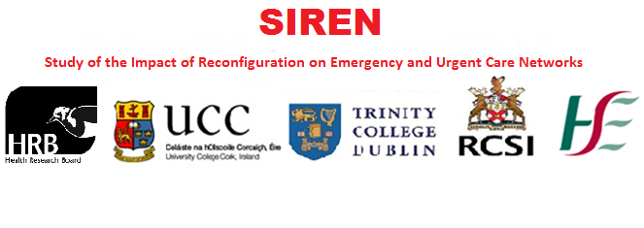
SIREN Dissemination Event

‘Urgent and Emergency Care in Ireland:
Where are we now and where are we going?’

Research & Education Centre Library Scott Building, Midland Regional Hospital, Tullamore, Co Offaly

Monday 18th July 2016
12:30pm – 2:00pm
Study of the Impact of Reconfiguration on Emergency and Urgent Care Networks (SIREN)

Emergency and urgent care in Ireland has been changing under the Health Service Executive (HSE) Transformation Programme which aims to implement a 'systems-based' approach for discrete geographical regions. The aim of the SIREN project is to describe and evaluate the development and performance of different emergency and urgent care systems (EUCS) in Ireland and produce a framework for the future evaluation of EUCS in this country. Ultimately our research will facilitate the dissemination of quality improvement strategies across the country which will lead to population wide improvements in patient experience and health outcomes. The programme, led by Professor John Browne of University College Cork, involves six inter-related work packages to address the following objectives:
1. To identify geographical networks of emergency and urgent care in Ireland, and describe the model of EUCS configuration planned/implemented in each region.
2. To analyse the process by which plans for EUCS reconfiguration were developed with a specific focus on the use of evidence and the roles of different internal and external stakeholders.
3. To analyse the relationship between different EUCS models of governance and provision, and system-level indicators of activity, process and clinical outcome.
4. To develop, implement and test a comprehensive evaluation framework for EUCS.

This four year programme of research is being undertaken in collaboration with a number of co-applicants; Dr Steve Thomas at the Centre for Health Policy and Management, Trinity College Dublin; Professor Susan Smith in the Department of General Practice at the Royal College of Surgeons Ireland; Professor Ronan O' Sullivan, consultant in emergency medicine and Director of the Paediatric Emergency Research Unit at the National Children's Research Centre; Dr Orla Healy, public health specialist with the HSE South; and Dr Sheena McHugh and Dr Tony Fitzgerald here in the Department of Epidemiology and Public Health, University College Cork (UCC). A number of national and international collaborators are involved in the research including the School of Health and Related Research (ScHARR) at the University of Sheffield; College of Medicine and Health in UCC; Health Information Systems Research Centre (HISRC) in UCC and National Directorate for Quality and Patient Safety in the HSE.

Event summary:
This is a dissemination event for the Study of the Impact of Reconfiguration on Emergency and urgent care Networks (SIREN). The aim of this event is to disseminate the main findings from our research at both regional and county level and to hear the views expressed by the key stakeholders. Stakeholders include patients, clinicians and service providers.

Agenda:
12:00 to 12:30 – Tea, coffee and sandwiches on arrival
12:30 to 13:15 – Welcome address, introduction to SIREN and presentation of results
13:15 to 13:45 – Question and answer session with Professor John Browne
13:45 to 14:00 – Closing comments

Professor John Browne
UCC Department of Epidemiology and Public Health

The key speaker at today’s presentation is Professor John Browne, UCC Department of Epidemiology and Public Health. Professor Browne is the Principal Investigator for the Health Research Board funded research programme entitled Study of the Impact of Reconfiguration on Emergency and Urgent Care Networks (SIREN).
Professor John Browne is a health services researcher with a professional background in health psychology and psychometrics. After completing his doctorate at Trinity College Dublin he worked at the Health Services Research Unit of the London School of Hygiene and Tropical Medicine (LSHTM) from 1998 to 2008, where he oversaw the development of the NHS Patient Reported Outcome Measures (PROMs) programme.
He is currently exploring the value of PROMs as a tool for engineering quality improvement in a variety of clinical areas including breast cancer surgery and joint replacement.
Professor Browne joined the Department of Epidemiology and Public Health at University College Cork in January 2009 and now holds an Honorary Professor position at LSHTM.
He has authored more than 100 publications including a co-authored text book (with Professor Judith Green of LSHTM), the 2003 NICE Head Injury Guidelines and 80 peer reviewed articles. His current H-index (January 2016) is 36.

If you wish to make any enquiries about SIREN, please contact Claire Collins, SIREN Research Assistant.
Email: claire.collins@ucc.ie Phone: +353-21-4205516

