University College Cork
Open Access to Publications Policy
Version 1.0
11/11/2016

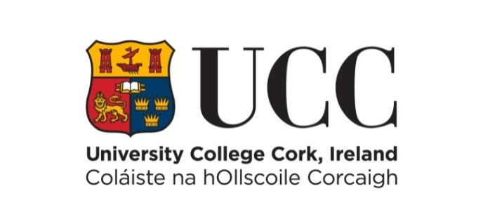

Document Location
http://www.ucc.ie/en/it-policies/policies
Consultation History
Revision Number | Consultation Date | Names of Parties in Consultation | Summary of Changes
0.1 | 2016-09-12 | ACRIC
0.1 | 2016-07-04  -  2016-09-12 | College Research Committees
0.1 | 2016-07-04 | ACRIC

Approval
Name | Date
Academic Council, Research and Innovation Committee (ACRIC) | 2016-09-12
Academic Board | 2016-10-26
Academic Council | 2016-11-11

Table of Contents
1 Introduction 3
2 Application & Procedures 4

Introduction
University College Cork is committed to sharing the findings of its research as widely as possible to enhance its use and impact within the academic and research community and more widely within society. In keeping with that commitment, University College Cork affirms its support for the National Principles for Open Access Policy Statement and for the European Union’s ambition to transition to default open access for all scientific publications by 2020.

Open Access to scholarly publications ensures “free availability on the public internet, permitting any users to read, download, copy, distribute, print, search, or link to the full texts of these articles, crawl them for indexing, pass them as data to software, or use them for any other lawful purpose, without financial, legal, or technical barriers other than those inseparable from gaining access to the internet itself. The only constraint on reproduction and distribution, and the only role for copyright in this domain, should be to give authors control over the integrity of their work and the right to be properly acknowledged and cited”. Furthermore, Open Access as adopted in this policy (“Green Open Access”) confirms the freedom of researchers to publish wherever they feel is the most appropriate and affirms the importance of rigorous selection of publications by peer review.

Open Access adds value to research, to the economy and to society. The outputs from publicly funded research should be publicly available to researchers, but also to potential users in education, business, charitable and public sectors, and to the general public. Advantages of open access for authors include wider readership, higher levels of citation, easy discovery through global search engines and harvesting services like Rian, long-term preservation of outputs, compliance with the requirements of national and international funding bodies.

Application & Procedures
This policy applies to all members of staff employed by University College Cork. Authors of peer-reviewed articles and peer-reviewed conference papers resulting from research carried out at University College Cork will deposit a copy in the CORA (Cork Open Research Archive) repository. The deposit of copies of other publications, such as books, book chapters or reports is strongly encouraged. A separate procedure covers doctoral theses.

The objective is open access availability at the earliest date possible but embargoes will be applied as required, for example to protect confidentiality, support commercialisation opportunities or meet legal obligations.

At the time of acceptance for publication, the final manuscript version should be deposited through the research information system (IRIS), or by emailing the full-text file to cora@ucc.ie. On receipt of your file, Library staff will:
- Verify that the correct version has been deposited
- Establish the open access publication rights specified by the original publisher
- Enhance the metadata description
- Apply appropriate embargoes, copyright and licence statements
- Make the full-text file available at the earliest date possible, taking account of any restrictions placed by the original publisher or authors
- Explicitly promote citation of the official, published version
- Facilitate harvesting by other repositories and aggregators, including OpenAire

Furthermore, the Library will undertake to report regularly on progress towards increased Open Access to UCC publications, and to be responsive to feedback from the research community in relation to improving workflows and systems integrations in order facilitate simple and easy deposit.

http://www.iua.ie/wp-content/uploads/2012/10/National-Principles-on-Open-Access-Policy-Statement-FINAL-23-Oct-2012-v1-3.pdf
http://data.consilium.europa.eu/doc/document/ST-9526-2016-INIT/en/pdf
Definition provided by Open Society Institute (2002). Budapest Open Access Initiative and reaffirmed in 2012 BOAI-10: Budapest Open Access Initiative after 10 years ‘Recommendations’: . http://www.soros.org/

