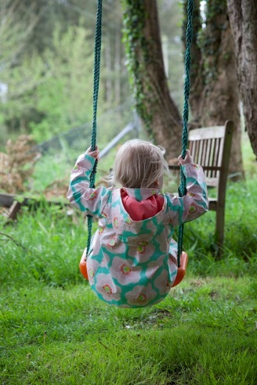
Play Matters – exploring children’s play worlds
A one-day conference to mark the 30th anniversary of Wallaroo Playschool, Cork
In collaboration with the Institute for Social Sciences in the 21st Century – Children and Young People Research Cluster
Brookfield Health Sciences Complex, 13th November 2015

PROGRAMME
10.30- Registration

11.00-12.30: Session 1 (Chair and Welcome: Linda Connolly)
Keeping the Play in Playschool (Joanie Barron and Caroline O’Callaghan, Wallaroo)
The Choreography of Play and Learning: history, playgrounds and material culture in Ireland (Vanessa Rutherford, UCC)
Play and Play Spaces: children’s participation in designing for play (Helen Lynch, Chloe Carroll and Eimear Cagney, UCC)

1.30 – 3.00: Session 2 (Chair: Caitríona Ní Laoire)
Playing with Diversity (Marian Quinn, CIT)
'Just Playing’: Processes of autonomy and belonging in children's social worlds (Susan McDonnell, IT Sligo)
Playing for Real (Tim Moran, Wallaroo)

3.30-4.30: Keynote Lecture (Chair: Helen Lynch)
Nóirín Hayes, TCD: What’s So Great About Play?

4.30 Final comments (Elizabeth Kiely)

************************************************************************

ABSTRACTS
The Choreography of Play & Learning: history, playgrounds and material culture in Ireland
Dr. Vanessa Rutherford, School of Education, University College Cork
Childhood, as ideology and lived reality, is embodied and encoded in history, playground architecture and material culture. Irish cities witnessed a demarcation of public play spaces for children together with the diffusion of modern ideals of childhood from the nineteenth century. This paper will historicise the creation of urban play spaces and play settings for Irish children. By applying the interdisciplinary methodology of critical discourse analysis and drawing on Foucault’s insights into discourse and the instrumentality of power, the paper will examine the ways in which playground discourse meshed with nineteenth-century slum rhetoric and a middle class desire to shape, embed and regiment children’s bodies in space. Ultimately, normative, disciplinary and didactic expectations impacted the choreography of play and learning for Irish children

Play and play spaces: children’s participation in designing for play
Helen Lynch, PhD., Department of Occupational Science and Occupational Therapy, UCC
Chloe Carroll and Eimear Cagney , research students, Department of Occupational Science and Occupational Therapy, UCC
Evidence is emerging that children experience fewer opportunities for outdoor play both at home and at school than in previous generations. This development has been a major concern, with researchers talking about the ‘shrinking horizons of childhood’ (Gill, 2005), play deprivation (Bundy et al, 2011), and ‘nature deficit disorder’ (Louv, 2005). Children’s right to have access to play is identified in the United Nations Convention of the Rights of the Child (UNCRC, 1989; 2013). Equally in the UNCRC, children’s participation in the development of play facilities is specifically identified as an example of the child’s voice being heard, and is given as an example of how children can contribute to implementation of their rights. This paper presents an exemplar of enabling inclusive design, through exploring the perspectives of children from a primary school in Ireland on their ideal play space and its affordances. It demonstrates how a child-centred, participatory approach can be adopted in planning and designing playspaces for children.

'Just Playing’: Processes of autonomy and belonging in children's social worlds
Dr. Susan McDonnell, IT Sligo
Discussions of children’s play typically focus on ‘rhetorics of progress’ (Sutton-Smith 1997), that is, the contribution of play to children’s learning and development. Play as children’s practice may be trivialized by adults, however its potential as a space of becoming has also been recognised (Sutton-Smith, 1997: 222). This paper draws on recent research with young children (age 5-8) that explores the significance of play in children’s peer cultures, and in particular its role in asserting, maintaining and contesting social boundaries in this context. It examines three key ways in which play and playfulness featured in children’s accounts: as a site of sociality/exclusion, as a vehicle for disrupting adult understandings of childhood, and as a means of deconstructing raced understandings. The paper argues that ‘just playing’ in fact represents a series of complex world-making processes linked to children’s autonomy and belonging, which highlight children’s agency and potential agency. It further suggests that serious engagement by adults with children’s propensity for innovation in playful processes of identity construction has important implications for opening up spaces of criticality.

