BFGTOEU AWARD SCHEME
Type of awards | Name of the award | Criteria | Award
Individual awards | European Citizenship Award | - Teacher registers for BFGTOEU  - Teacher completes a class KWL  - Attempts to document lesson engagement through school website or posts on Twitter or Facebook tagging @HubEuropCitizen | Plaque
 | European Star Teacher Award | - Teacher completes a BFGTOEU CPD course in a 3-year period  - Teacher delivers BFGTOEU 3 years  - Attempts to document lesson engagement through school website or posts on Twitter or Facebook tagging @HubEuropCitizen | €150 worth from ABC school supplies or the Learning Store (to be determined)  Can apply for a study trip to Brussels on a first come first served basis.
School awards | European Citizenship Education  Expert Citizen School  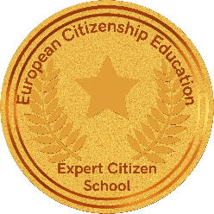 | - Register a minimum of three classes for BFGTOEU  - Register for the Europe Day Quiz  - Develop a Europe Day project per class or school  - Develop a minimum of one project with Design for Change per school  - At least one class registers for our eTwinning project  - Demonstrate engagement with the local MEP or a stakeholder at European level  - Subscribe to EU TV Junior  - At least one teacher must complete a BFGTOEU CPD in a three-year period and act as ambassador in their school.  - Attempts to document lesson engagement through school website or posts on Twitter or Facebook tagging @HubEuropCitizen | Special award  Set of table European flags  Can apply for a subsidised study trip to Brussels on a first come first served basis.
 | European Citizenship Education  Eager Citizen School  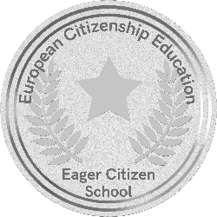 | - Register a minimum of two classes for BFGTOEU  - Develop a Europe Day project per class or school  - Register for the Europe Day Quiz  - At least one class registers for our eTwinning project  - Subscribe to EU TV Junior  - At least one teacher must complete a BFGTOEU CPD in a three-year period and act as ambassador in their school.  - Attempts to document lesson engagement through school website or posts on Twitter or Facebook tagging @HubEuropCitizen | Special award  Pack of EU resources – maps, leaflets, rulers, notebooks  Can apply for a subsidised study trip to Brussels on a first come first served basis.
 | European Citizenship Education  Emerging Citizen School  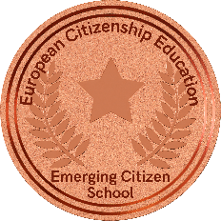 | - Register a minimum of two classes for BFGTOEU  - Register for the Europe Day Quiz  - Develop a Europe Day project, per class or school  - Subscribe to EU TV Junior  - At least one teacher must complete a BFGTOEU CPD in a three-year period and act as ambassador in their school.  - Take pictures of each lesson engagement and post on Twitter or Facebook tagging @HubEuropCitizen | Special award  Can apply for a subsidised study trip to Brussels on a first come first served basis.

