Sample Referral Form for Falls Exercise Groups- FaME and Otago
To be completed by Clinician and potential participant. Please include PPS no. and informed consent signatures. Email completed form to [INSERT EMAIL ADDRESS]
Please tick which locations(s) participants can attend:
FaME: DAY, TIME, LOCATION DAY, TIME, LOCATION
Otago: DAY, TIME, LOCATION DAY, TIME, LOCATION

Inclusion criteria:
- Aged 65 and over and medically stable, who in the last year, have had a fall or have a fear of falling.
- If any concerns regarding medical conditions e.g cardiac, their GP must clear them as safe to exercise.
- Capable of walking independently indoors and outdoors (with walking aids if necessary)
- Physically and cognitively able to take part in a group and home based exercise programme as assessed by the referrer.
Exclusion criteria:
- Uncontrolled high blood pressure, tachycardia, or experienced a significant drop in BP during exercise
- Psychiatric conditions preventing participation in class or cognitive impairment with inability to follow simple instructions & HEP
- Uncontrolled medical problems, e.g. acute systemic illness such as RA
Name: | Date of Birth: PPS No:
Address: | Mobile no:  Landline:
Contacts in case of emergency:
Name:________________________ Tel No:__________________ Relationship: ______________
Name:________________________ Tel No:__________________ Relationship: ______________
GP Name & address: ____________________________________ Tel No: ___________________
Do you give us permission to contact your GP for medical clearance if appropriate? YesNo

Physiotherapist Name & location: ____________________________ Tel No: ___________________

Details of previous physiotherapy interventions: (Incl. dates, purpose, HEP between sessions etc):

Details of any walking aid used indoors or outdoors:

Details of any ‘huff and puff’ or feeling out of breath during daily activities:

- Details of number of falls in the last year including:
- Could they get up without help if no injury? Y/N
- Did they require ambulance call out? Y/N
- Did they require visit to A&E? Y/N
- Did they require GP visit? Y/N

Personal goals you hope to achieve from attending weekly group exercise:

How are you going to get there? (e.g Drive/ Get a lift/ Taxi/ Bus/ Walk)

Medical History and Medications: If answer is YES to any questions please give some details including dates where possible | No | Yes | Details
Any history of heart trouble? (e.g heart attack, angina, valve disease, palpitations, pains in chest, dizzy spells)
Any history of problems with blood vessels? (such as thrombosis, embolus, stroke, claudication, aneurysm, dizzy spells, blood clots)
High blood pressure?
Any history of chest problems? (Bronchitis, asthma or wheezy chest)
Have you ever smoked? if YES – current or ex-smoker
Any diabetes? (if YES please state if using insulin
Any history of major illness now or in the last 20 yrs? (such as rheumatoid arthritis, blood disorders, cancer)
Any history of emotional or psychiatric problems?
Any osteoarthritis or rheumatoid arthritis? (if YES state joints affected and indicate mild, moderate or severe and any medication regularly taken)
Any broken bones? If so, which bones and when?
Any problems with your bones? osteoporosis, height loss
Any history of back problems?
Any surgery on your joints?
Any acute illness in the last six months? (e.g influenza, recurrent sore-throat, bronchitis)
Any hospital stay in the last 5 years and if so, how long?
Any physical disabilities e.g visual or hearing problems
Any MS or Parkinson’s Disease?
Any other illness or condition that affects your general health or interferes with your mobility?
Please list medication regularly taken for any condition.

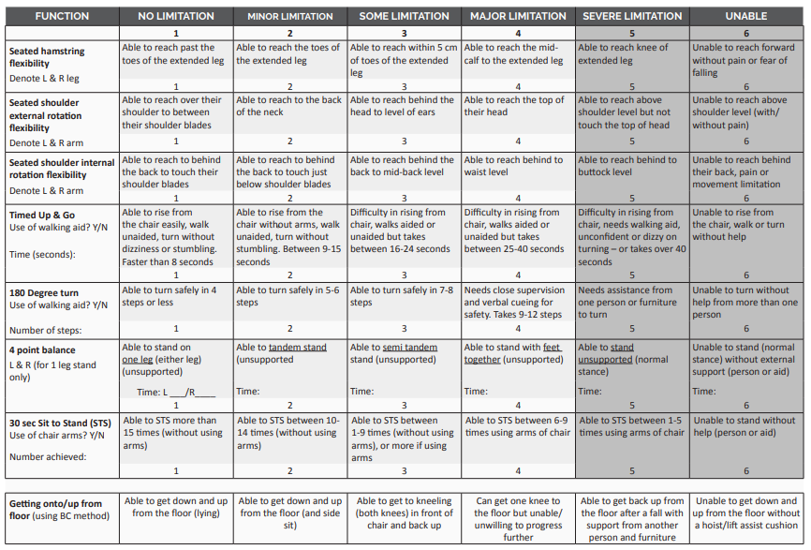
Functional Assessment Grid – Please complete 3 flexibility and 5 physical functional tests.
Score each test by circling appropriate number from 1-6. For accurate repeatability record times/distances, equipment.
Scoring guide: Mostly 1’s suitable for general community exercise groups
Mostly 2-4 – Some impairment so may benefit from Physiotherapy or PSI led interventions like FaME and Otago
Mostly 5-6’s –At higher risk of falls - Would benefit most from 1:1 Physiotherapy treatment and education

Short Falls Efficacy Scale Date:_____________
Below are some questions about how concerned you are about the possibility of falling. Please reply thinking about how you usually do the activity. If you current don’t do the activity (for example, if someone does your shopping for you), please answer to show whether you think you would be concerned about falling IF you did the activity. For each of the following activities, please check the box which is closest to your own opinion to show how concerned you are that you might fall if you did this activity.
 |  | NONE | A Little | Medium | A lot
 |  | No concern | Somewhat Concerned | Fairly Concerned | Very Concerned
1 | Getting Dressed or undressed
2 | Taking a shower or bath
3 | Getting in or out of a chair
4 | Going up or down stairs
5 | Reaching for something above your head or on the ground
6 | Walking up and down a slope
7 | Going out to a social event ( religious service, family gathering, club meeting)
 | TOTAL SCORE
Clinical Frailty Score (1-6) _______

Informed Consent
By signing this form, I confirm that I have completed the above questionnaire to the best of my ability and that I have provided accurate information regarding my current health status.
I acknowledge that it is my choice to participate in a group exercise programme and I understand the risks involved. I understand that I am free to withdraw or modify my activity levels at any time.
I consent to the information on this form being shared between physiotherapists and postural stability instructors working across agencies and that this information will be securely stored between sessions.

Signature of Participant:________________________________ Date: ______________

Signature of Referrer:__________________________________

