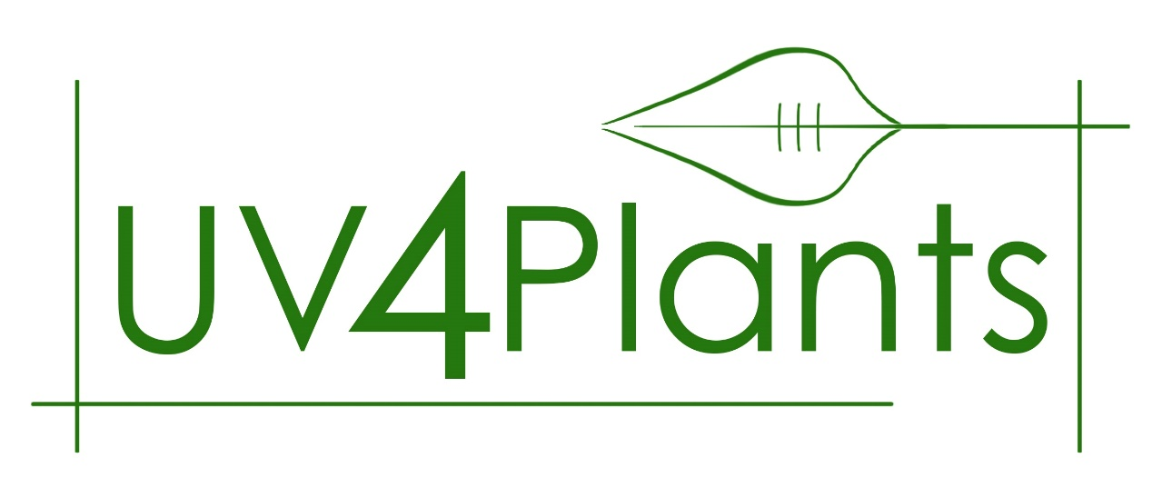

UV4Plants workshop 2019

UV-B and Climate Change; impacts on plants and vegetation.

Cork, Ireland

April 15-16, 2019

A small, discussion-intensive workshop that will focus on the interactive effects of UV-B and climate change on plants.

Keynote speakers are sponsored by Science Foundation Ireland (SFI) and the Environmental Protection Agency (EPA).

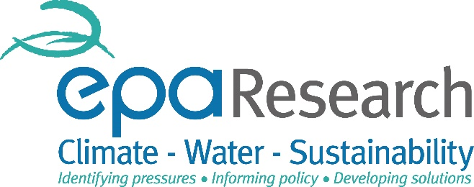

Dear colleague,

You are warmly invited to participate in a workshop organised under the auspices of UV4Plants, the International Association for Plant UV research (www.uv4plants.org/). The meeting takes place at University College Cork. The main organiser is Prof Marcel Jansen (UCC), and the scientific committee comprises Prof Éva Hideg (University of Pécs, Hungary) and Prof. Otmar Urban (CzechGlobe, Brno, Czech Republic).

Workshop programme
The objective of the workshop is to bring together plant-scientists with an interest in the interactive effects of UV-B and climate change parameters on gene-expression, molecular signalling, anti-oxidant-defences, physiology, growth, fitness and ecology of plants. Of special interest are talks on the combined effects of UV-B and climate change variables, such as drought, on plants and vegetation.

We are pleased to host four invited keynote lectures as part of the workshop:

- Prof Juergen Kreyling (Greifswald University, Germany) on experimental design of multifactorial experiments (see his recent paper Kreyling et al. “To replicate, or not to replicate–that is the question: how to tackle nonlinear responses in ecological experiments”. Ecology Letters 2018)

- Prof Ivan Couée (University of Rennes, France) on environmental sensing of climate change by plants (see his recent paper; Bigot et al. “Pivotal roles of environmental sensing and signaling mechanisms in plant responses to climate change”. Global Change Biology 2018).

- Dr Matt Robson (University of Helsinki, Finland) on the latest UNEP-EEAP report entitled “Linkages between stratospheric ozone, UV radiation and climate change: Implications for terrestrial ecosystems”.

- Dr Otmar Urban (CzechGlobe, Czech Republic) on interactive effects of UV-Radiation and atmospheric CO₂ concentration (see recent paper Plant Physiology and Biochemistry, 134, pp.20-30)

This will be a small, discussion intensive 2-day meeting (oral presentations only), and the number of attendants will be limited to 30.

The meeting lasts one-and-a half-days, starting Monday April 15 at 9am, and finishing Tuesday April 16 at 2pm.

Registration

Registration is by contacting Prof Marcel Jansen at m.jansen@ucc.ie

Following registration, participants will receive an invoice with instructions on how to pay registration fees by bank-transfer. Cash payment is possible in exceptional circumstances and when agreed with Prof Jansen.

The workshop fee is €125.- for UV4Plants members (€145.- for non-members). The fee covers the book of abstracts, three coffee/tea breaks, two lunches and a social dinner on Monday evening.

Location and venue
The workshop venue is at the North Mall Campus of UCC (https://goo.gl/maps/VD6R6dqfUdk). There are quite a few hotels in the vicinity of the workshop venue, including:
- Lancaster Lodge (https://www.lancasterlodge.com/)
- Garnish House (www.garnish.ie/)
- River Lee Hotel (https://www.doylecollection.com/hotels/the-river-lee-hotel)

There are direct flights to Cork from most major UK airports as well as Amsterdam and Paris. Alternatively, there are direct (and considerable cheaper) flights to Dublin from most major European airports. From Dublin delegates can either take a direct, long-distance bus to Cork (every hour during the day, every two hours at night time) or a train (every hour during the day, requiring local bus journey to railway station). There is a range of different types of accommodation in Cork, and availability will not be a problem in the spring season.

Draft Scientific Programme
“UV-B and Climate Change; impacts on plants and vegetation”
April 15 & 16, 2019, Cork, Ireland
April 15
8:30-9:00 Registration desk open
9:05-9:20 Welcome
9:20-9:55 Matt Robson (Helsinki): Plants Underpin Ecosystem Responses to UV-Radiation in a Changing Climate (Special EPA-funded presentation)
9:55-10:10 Astrid Wingler (Cork): Effect of climate change on autumn leaf phenology
10:10-10:25 Line Nybakken (Ås): Interannual variation in UV-B and temperature effects on bud phenology and growth in Populus tremula
10:25-10:30 Jana Barbro Winkler (Munich): Phenotyping platforms for understanding the role of UV-B radiation in climate change adaptation
10:30-10:35 Kristóf Csepregi (Pécs): Investigation of UV treated pepper seedlings’ tolerance to low temperature (UV4Plants sponsored attendee)
10:35-11:05 Coffee/tea break
11:05-11:40 Ivan Couée (Rennes): Environmental sensing and signalling mechanisms in plant responses to climate change: pivotal roles, integrative hubs and signalling conflicts (Special EPA-funded presentation)
11:40-11:55 Els Prinsen (Antwerp): The biochemical background of UV-B acclimation
11:55-12:15 Éva Hideg (Pécs): Short-term changes in leaf flavonoids during a day in the vineyard
12:15-12:20 Anikó Mátai (Pécs): BABA: a new player has entered the game
12:20-12:25 Louise M. Ryan (Cork): UV-B priming for drought tolerance
12:25-13:45 Lunch
13:45-14:20 Juergen Kreyling (Greifswald): To replicate, or not to replicate – that is the question: How to tackle non-linear responses in ecological experiments (Special SFI-funded presentation)
14:20-14:40 Pedro J. Aphalo (Helsinki): Factorial experiments: the tool for probing the role of interactions (SFI-sponsored presentation)
14:40--14:55 Knut Asbjørn Solhaug (Ås): Global warming and the distribution of dark, melanic lichens
14:55-15:00 Arnold Rácz (Pécs): Plants’ little helper, the effects of hydrogen peroxide pre-treatment (UV4Plants sponsored attendee)
15:00-15:05 Diana Sáenz de la O (Queretaro): Management of drought stress by using supplementary UV-B light in transgenic tobacco to CchGLP gene
15:05-15:50 Coffee/tea break
15:50-17:20 Round-table discussion-1
18:00 Bus leaving UCC North Mall Campus for dinner venue

April 16
09:00-09:35 Otmar Urban (Brno): Interactive effects of ultraviolet radiation and elevated CO2 concentration on plants (Special SFI-funded presentation)
09:35-09:50 Frauke Pescheck (Kiel): DNA repair plays an important role for UV-B tolerance of Arabidopsis thaliana in natural sunlight
09:50-10:05 Jakub Nezval (Ostrava): The importance of blue light for the production of UV-protective phenolic compounds and plant tolerance against acute radiation stress
10:05-10:20 Tadeja Trošt Sedej (Ljubljana): Slope orientation affects biochemical and anatomical characteristics of four alpine plant species at Julian Alps, Slovenia
10:20-10:25 Gaia Crestani (Cork): Effects of UV-B radiation on Lepidium meyenii; a high altitude crop
10:25-10:30 Gary Kett (Cork): The role of UV-B in the health status of an intertidal bivalve mollusc Crassostrea gigas and the development of pathogens
10:35-11:00 Coffee/tea break
11:00-12:30 Round-table discussion-2 / Concluding remarks
12:30-13:30 Closure of the meeting / Lunch

