UCC CACSSS Postgraduate Research Conference, University College Cork. 20-21 Feb. 2025.
Portals into perception:
Knowing with a poetic mind
Jennifer Ahern¹ and Bob Grumiau¹
¹Environmental Research Institute, UCC
Key words: poetics, epistemology, rhizome, arts-based practices, critical phenomenology.
All our education is predominantly verbal and therefore fails to accomplish what it is supposed to do. Instead of transforming children into fully developed adults, it turns out students of the natural sciences who are completely unaware of nature as the primary fact of experience. It inflicts upon the world students of the humanities who know nothing of humanity, their own or anyone else’s (Huxley, 2004 [1954]: 47).
- Introduction: Huxley’s non-verbal humanities.
Aldous Huxley is best-known for having written the all-time classic, ‘Brave new world’. Published in 1931, it is a dystopian novel describing a futuristic world state in which citizens are socially engineered, conditioned and brainwashed so to fit in into an intelligence-based social hierarchy and where general happiness is achieved through the available drug Soma, produced to cure any sort of unhappiness within society. Huxley’s novel has stood the test of time and today, the exercise of making the comparison, and questioning whether or not, and to what degree we are living in a brave new world seems to be commonplace.
However, the quote here-above does not come from Huxley’s flagship work, but from one of the author’s lesser-known books: ‘the doors of perception’ (Huxley, 2004 [1954]). In the latter, Huxley elaborates on his psychedelic experience under the influence of the substance mescaline. Throughout his essay, Huxley reflects on the potential use of psychedelic substances as facilitators of a form of mystical insight of which he claims that it can have significant benefits for science. As evidenced from the quote above, Huxley believed that a predominantly - verbal - way of educating citizens leads to non-developed adults that are unaware of nature or the human being. In Huxley’s opinion, psychedelic drugs, provide us with a more direct perception of, and thus a different access to, those realities. For Huxley this is of particular interest to the intellectual who, as he argues, can become the victim of words and symbols. Although he recognizes the latter are important for rational practice, he writes that they obscure a more holistic experience of reality. One that he believes can also be found in the arts, or as he calls them: the non-verbal humanities (Huxley, 2004 [1954]: 48).
Let’s pause here. The aim of this article is not to explore or argue for the use of psychedelic drugs in the education process, but rather, to point out the salience of the arts as a non/trans-verbal way to access reality. Huxley’s advocacy for a non-verbal experience of the world expresses the idea that something is lost in translation when science and language transcribe reality into the symbolic. Indeed, following authors as Maurice Merleau-Ponty, Deleuze & Guattari, Maria Zambrano, Julia Kristeva, or Martin Heidegger, we argue that the way human beings make sense of the world pre-dates, or transcends, what can be put into words and thus calls for an objective non-verbal attempt to understand it. Our hypothesis is that the arts present such an attempt and that the increasing use of art-based practices in the humanities points towards their ability to express a reality that traditional scientific methods seem unable to communicate. If the way human beings make sense of the world, fundamentally goes beyond the scope of the symbolic, and thus also scientific methodological knowledge, then the idea of the arts as non-verbal humanities -to use the words of Huxley (2004 [1954]: 48)-, that are directly aware of the given facts of our existence, is of crucial significance if the social sciences want to be of human importance.
We propose to proceed as follows. Starting from within the practice of one of the writers as an artist, we hope to demonstrate the multidimensionality of the artist’s mind and how this reflects the organic relationship through which a subject comes to know the world (Merleau-Ponty, 1945: 189: Valéry, 2023 [1944]: 21-26). Experimenting with a ‘different’ way of thinking, throughout this article we will accompany theoretical considerations with poetic reflections. As we will see, the organic/artistic experience of the world can be described as processual, multi-dimensional and multi-sensorial, and as a consequence, challenges the expressive capability of the verb and the symbolic in their unidimensional representative symbolic function. The second part of this article will contrast the relational and heterogenous approach of the world to the structured and unified approach of traditional sciences. Finally, the third and final part of the text will present our argument for the arts as a way of knowing the world and as an objective and non-verbal endeavour that can contribute to a better understanding of the human being and the worlds it lives in.

- Collaging as a way of knowing the world
“Collage allows the opening up of conscious, which is very direct…it's also a way of looking at what you are consuming all the time” – John Stezaker
I am a multi-disciplinary artist working across a range of mediums; but the most central, or fundamental element of my practice is collage. Collage is a visual art technique that in its simplest definition is an assemblage; the compilation of different elements together to create a new whole. These can be various materials such as paper, fabric, or photographs, but can also include drawing and painting or 3D elements. It is this process of assembling different components to make a new whole, that underpins my artistic practice as well as my interdisciplinary research. Collage as a method of inquiry, collage as sense making, collage as methodological framework, collage as mapping complexity. While the outcome in some cases will be a finished artwork with a certain aesthetic, it is more often the process of collaging itself that is the most important part.
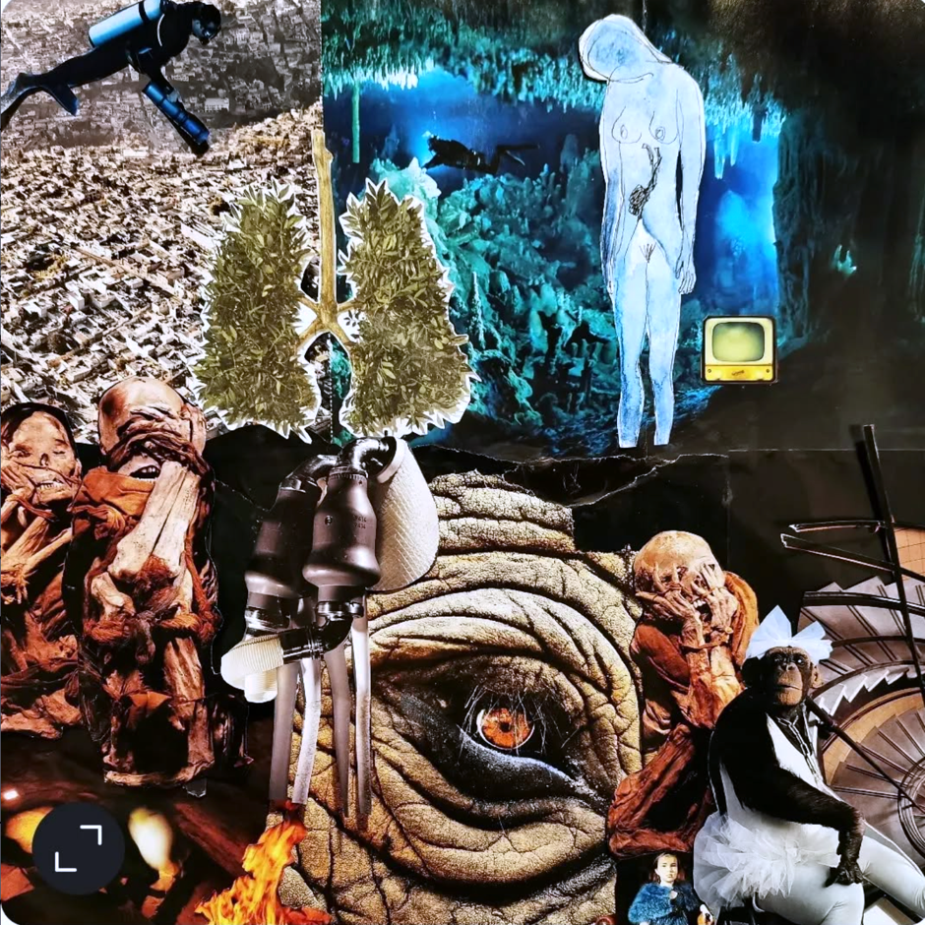
We are taking a somewhat unconventional approach with this article, where I will be writing from within the collage process and the context of the artwork itself as a means of exploring the poetic mind and the knowing it holds. The selected collage we are using was created during my doctoral research and serves as the data upon which this article is based. It is an ongoing unfinished work that is part of my artistic research practice and will be introduced in the following paragraphs, in close up sections. Writing this article is an opportunity to explore the “data” it holds. Though this is not a linear cause and effect process, much like the rhizomatic nature of collaging itself, the writing of this article was also a rhizomatic co-created conversation between theory and practice. The collage serves as an entry point into the poetic mind, into which we invite you.
Figure 1 Close up: through the portal
To begin, I will lead you first through this portal (Fig. 1); to enter this multidimensional non-verbal realm of knowing with me. We will start with looking. Let your eyes wander where they are drawn; to the shapes, colours, forms, and composition. Now to sensing, feeling with your body into the deeper layers of meaning embedded in the image. What sensations arise? What emotions stir? Where do your thoughts take you?
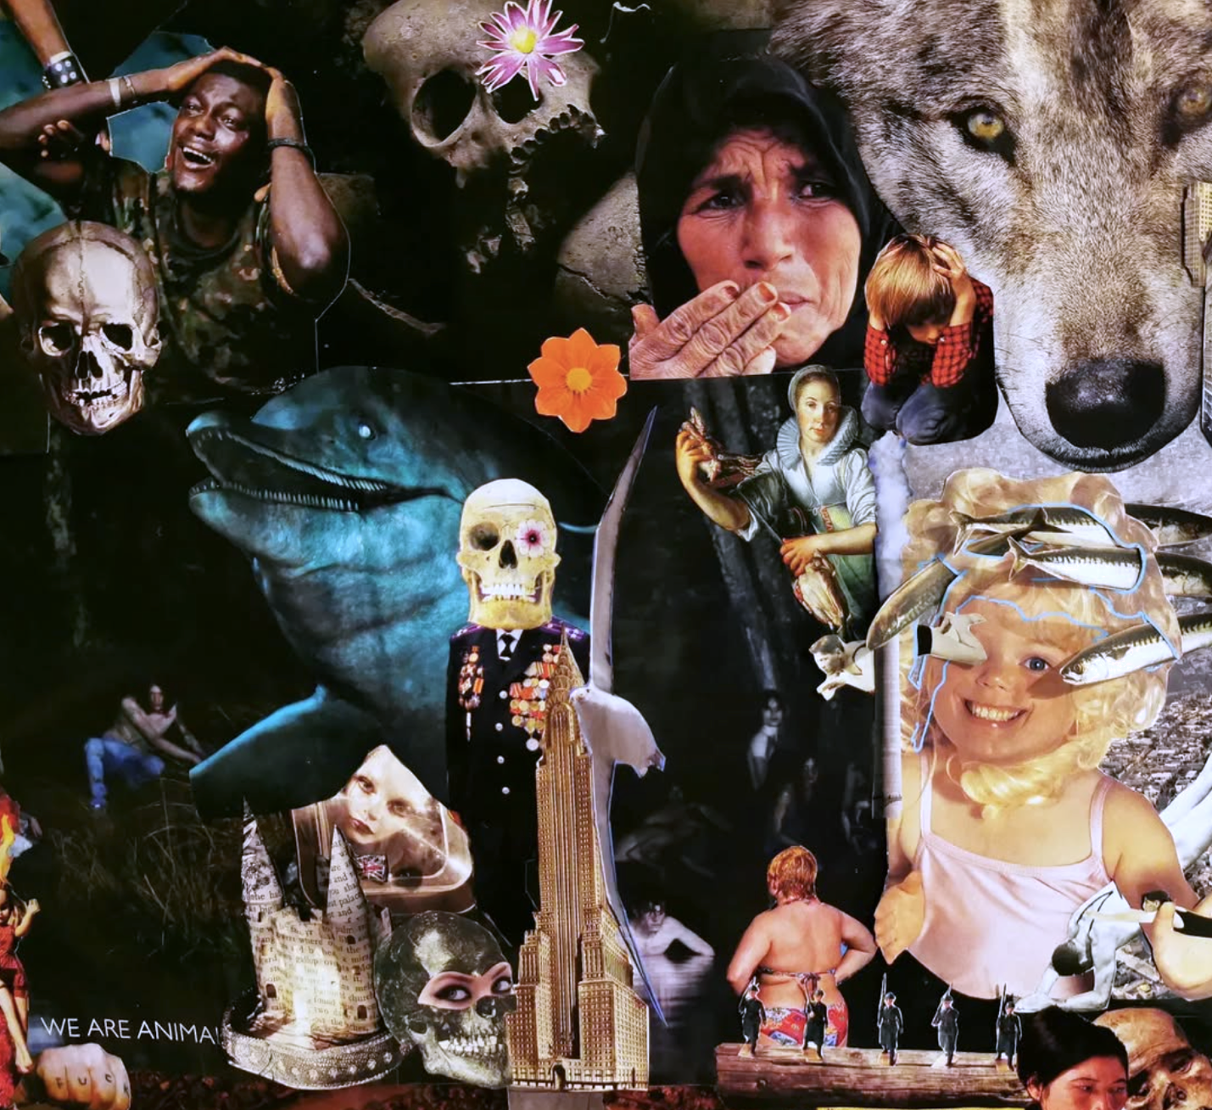
Mine took me through the eye of the elephant into the hearts and bodies of the women of Palestine, the Congo and Sudan; to the Curlews and other birds in Ireland that are heading for extinction; to AI and the resources it consumes; to the chimpanzee in a tutu and the clothes mountains in Ghana seen from space; to the grief and aguish that resides in my heart, taking up more and more room every day.
This is where it began (fig. 2). It was February 2024, a few months into the genocide in Gaza, and a year and 4 months into my research into the climate and biodiversity crisis. This research took me through sustainability and earth system science, anthropology, philosophy, decoloniality, systems thinking and complexity theory, indigenous ontologies and epistemologies and participatory action research. It was, and still is, in search of story.
As the depth, gravity and enormity of the crises dawned on me, sick of words on a screen or page, and wrestling despair, I turned to collage. This girl with the mackerel in her hair was the first part of what would go on to be a 2m x 1m collage on the wall of my office. It sits behind me now as I write this. I remember cutting out the mackerel with the scissors, making small incisions in her head and sliding the mackerel through. It was important to me that they stuck out in 3D. It happened in bursts over a few weeks in February, I would spend hours at a time flicking through magazines, pulling images, cutting, arranging, layering, sticking. Listening to podcasts and music, sometimes in silence, and to the cars passing by the road. Processing, in process, processing, in process, wayfinding through complexity and an existential crisis. I know there is truth in there, or meaning, or the given facts of existence, or even story.
Figure 2 Close up: The girl with the mackerel in her hair
Why did the mackerel have to be 3D? I wrote that only knowing it to be true, but not why. I recall the moment now, sitting at the table, slicing the hair of the girl whose frazzled face expression matched how I felt in that moment. I started pushing the mackerel through the slits along with some black and white swimmers I had cut out too. As many as I could fit, I wanted them to come out of the page, to be going in different directions, to add another dimension.
As I contemplate these thoughts, my eyes wander across from the mackerel to the three divers, one floating over a sea of development; to the other in the underwater cave; finally resting on the sketched diver going downward in the blue body. A repetitive motif in my work since this drawing in 2011. Pausing, looking and feeling this image, and like the diver, diving deeper down, in search of something. Truth? Story? Or meaning? I am yet undecided. I wonder if these things can be separated.
- Rhizomatic non-thinking in multiple dimensions
What goes on inside of our heads is not an arborescent process, but rather, something rhizomatic (Deleuze & Guattari, 1980: 24). Thinking through collages shows how instead of following a root from the trunk to its extremities, splitting on the way into different strands that may disperse but are always retraceable to their unique and unified origin, our thoughts work in more mysterious ways. Indeed, the tree and the root would inspire a sad -and partial- image of thought that merely imitates the multiple from a superior unit and reassembles difference under identity (Deleuze & Guattari, 1980: 25). Thinking as collaging, on the contrary, shows a process in which images and feelings, thoughts and sounds, seem to almost randomly connect, blend into each other, merge to form new colours, novel images, take on unexplored shapes, scream different meanings or whisper unexplored questions.
To centred arborescent systems, Deleuze & Guattari (1980, 26) oppose rhizomes. The latter are acentric systems, where communication is spontaneous and random and does not happen through established stems and channels. In these systems, individuals are all interchangeable and define themselves only by being in such a state, connected to such and such an individual, at a particular moment. Rhizomes contain both the worst and the best, the weed and the flower (Deleuze & Guattari: 13). More like meshworks, their networks function like ants. They exhibit a form of ‘complex adaptive behaviour’ in which many singular entities interact and combine to form complex entities without any need of central planning (Escobar 2004: 222).
Cutting, arranging, sticking, getting stuck, feeling colours, compositions, pandas and catacombs, skulls with flowers for eyes and the suffering face of a mother who has lost her son. A wolf, a skyscraper, an East Indian Company ship, turquoise blue into black, the fire and the cosmos, an Amy Winehouse shrine. That should have never happened on our watch, where was the central planning in that? Layers in layers in layers, colour, composition, story, emotion, back to the mackerel and adding dimensions: getting to grips with complexity. My mind shifting from 2D to 3D to Multi-D, how reality is so deeply entangled, multi-layered, and complex. I am exhausted, frazzled.
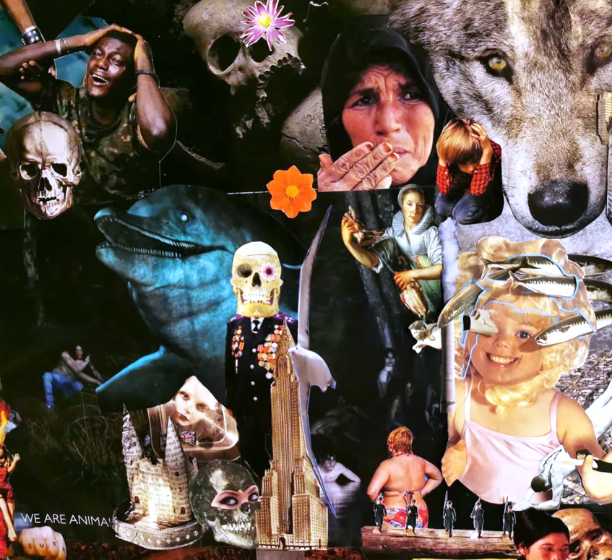
In ‘Mille Plateaux’, Deleuze and Guattari (1980) discuss some of the principles that describe the rhizome and that help, we believe, further understand the process of thinking expressed by the collage. First of all, the principles of connection and heterogeneity: in a rhizome, like in a collage, every single point can be connected to any other, even more so, it has to be. This implies that the rhizome, like the collage, links different semiotic regimes, the political is economical when the ecological is sentimental (Deleuze & Guattari, 1980: 13). Signs cannot be separated from the signified that they express, just like a language always expresses a certain layout of the world, the images and the signs of the collage cannot be dissociated from the semiotic regime from which they originate. A third characteristic of the rhizome is the principle of multiplicity, according to which the multiple cannot be reduced to the singular (Deleuze & Guattari, 1980: 15). Deleuze and Guattari (1980: 15) argue that the idea of unity only appears when the signifier takes control over the multiple, when difference is brought back to identity. In other words, when impressions and sensations are neatly arranged under categories. But the multiple of the rhizome cannot be surpassed, reduced to a simpler dimension, its difference is its meaning. Finally, the principle of insignificant breakage explains how a rhizome that can be broken at any point will always resume following another of its lines (Deleuze & Guattari, 1980: 16). Every rhizome, every collage, is organized, territorialized, stratified in its own way, but at the same time, these lines of division are lines of flight that one can follow and that bring us to new organizations and points of view.
Figure 3 Close up: Skulls and Skyscrapers

- The problem of language
We can see how the rhizomatic thinking of the artist in the collage, clashes with what can be considered as the logical operations of rational and methodological thinking. This is also what Cornelius Castoriadis (1975) contends in his book: ‘l’institution imaginaire de la société.’ According to Castoriadis (1975: 271), “there is no way in a logic-ontology of the same, of repetition, of the always timeless (aei), to think of a creation that is not simply an engendering of the same by the same.” According to Castoriadis (1975: 271), the concepts and categories of traditional ontology are designed to think the determinate and not the indeterminate. More importantly, it's not just the problem of an ontological tradition, but of the phenomenon of language itself. The illusion of uniqueness is inherent to speech, for to name things is to name them according to their unity, and at the same time to assign them with a limit, finite and incomplete (Castoriadis, 1975; Clastres, 1974). In other words, by naming things we both determine and limit them, stripping them of all the possibility inherent in indeterminacy.
Collage me this, collage me that, complexity blew me open, but despair shredded me apart. I am in the kaleidoscope making sense of multi-dimensionality, constantly questioning everything, every angle, every perspective. My feelings, their feelings, his feelings, her feelings. Her world my world our world their world. Evil, good, hope, despair, ambiguity, indifference, how do I hold them all and write in a straight line? With one word after the other? ah fitting a round peg in a square hole, words are torturous things. Collage as a rhizomatic conversation with complexity, between the rhizome and the soil. A non-verbal language, a mapping of reality. I am the girl with the mackerel in her hair, my mind split open...
Poetry revolutionizes the everyday operations of language (Kristeva, 1974). Kristeva (1974) argues that the poetic language introduces a total break in linguistic structures and only relies on the words and the order they establish in order to transcend them. She sees poetry as a different semiotic praxis that arranges a new configuration of the temporality of enunciation and signification. In other words, poetry underlines the limits of socially useful discourse and bears witness to what it represses, namely the processes that exceed the subject and its communicative structures as they are instituted by the dominant social institutions (Kristeva, 1974: 14). Kristeva argues that changes in language are modifications of the subject, for example in their relationship to the body, to others and to objects. As a consequence, any transformation of society requires a transformation the instruments -read language- through which the subject constitutes itself and the -social- realities it is embedded in.
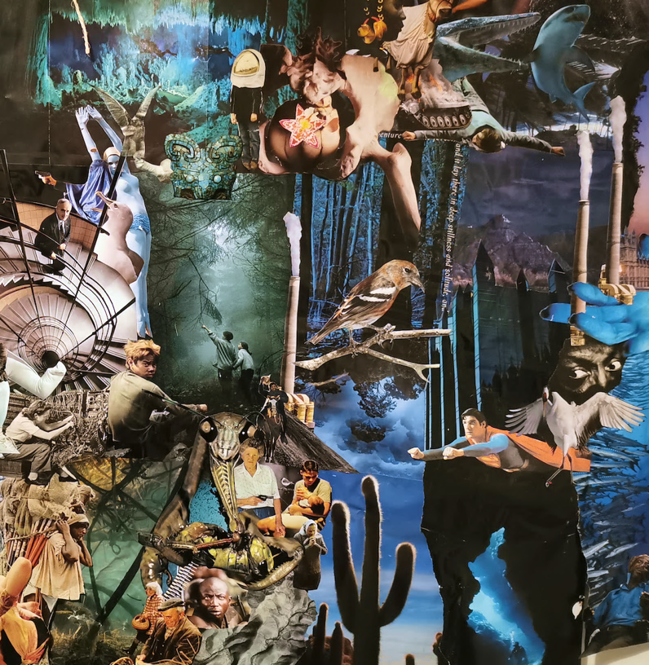
For Kristeva (1974: 12), theory, discourse and science are agents of totality that unify and assemble the infinite possibilities of signification into fixed social institutions and make them intelligible in their own realm. They are examples of what she calls the thetic, or symbolic, moment of the signifying process that accompanies the setting of a subjectivity. However, the symbolic represents only one of two modalities of the signifying process. Contrary to the symbolic, the semiotic, to which Kristeva also refers to as the Chora, refers to all the meaningful energy, drives and desires that exceed the symbolic capture of an established language and the particular social institutions it permeates. This excess of signification finds its expression in a poetic language that rebuts and rejects the fixed symbols for more processual and open signifying operations. In sum, for Kristeva (1974) poetry has a revolutionary function because it opens language up to continuous processes of signification from which instituted meaning can be transformed. Our hypothesis is that in doing so, poetry simultaneously brings us in contact with a realm where meaning is spontaneous and random, flowing and not fixed by words, in which, in other words, we come to know reality differently and beyond the verbal.
Figure 4 Close up: The Praying Mantis asks us to look again

- The poetic mind
If names, concepts and the way language usually functions -that is, as an instituted code-, contribute to obscuring and opposing a creative and flowing side of our thought processes, and consequently, also a way in which we relate to the world, where can we turn for an alternative? According to the poet Paul Valéry, we are all capable of experiencing a fundamental poetic state that overturns our relationship with the world and restores it to us in unexpected harmony (Valéry, 2023 [1944]: 21-26; Zambrano, 2024). In this poetic state, all the possible objects of the ordinary world, remaining what they normally are in terms of their appearances, suddenly find themselves in an indefinable but ‘marvellously’ right relationship with the modes of our general sensibility (Valéry, 2023 [1944]: 24). In this state, the things around us call out to one another and combine in a way that is quite different from the usual patterns. As Charles Beaudelaire (1861: 10) describes in ‘les Fleurs du Mal’, it is as if “les parfums, les couleurs et les sons se répondent”. Valery (2023 [1944] describes how in the poetic state, objects are musicalized, given a musical dimension, and become resonant with each other. For Valery, the poet is not the privileged person who alone can feel this poetic state, but rather has the function of creating it, through his words, in others (Valéry, 2023 [1944]: 26).
In the poetic state, things and objects appear the same as in our day to day lives but their meanings and relationships are quite different. Rather than being controlled by the sensibilities of our specialized senses, they represent the fluctuations of our general sensibility (Valéry, 2023 [1944]: 25). In his ‘Phénoménologie de la perception’ Maurice Merleau-Ponty (1945) studies the living relationship we have with the world through our body and argues that the poetic state corresponds to the way in which we first come to experience the world. According to Merleau-Ponty (1945: 226); the only way I, as a subjectivity, can be among things, is through my body. The objects that surround me always first coexist with me as an embodied subject, and this life of things has nothing in common with the constitution of scientific objects. According to Merleau-Ponty (1945:240) intellectual processes of signification interrupt the continual movement by which the body projects itself into things and towards others. The reflective attitude characteristic of -what can be referred to as- a vulgarized cartesian scientific tradition, defines the body as a sum of parts without an interior, and the soul as a being entirely present to itself, i.e. without distance. Despite the fact that these definitions establish clarity within and without us, they reduce the experience of the body to a mere mechanistic process. ‘An algorithm will only ever express nature without humanity’ (Merleau-Ponty, 1945: 229).
Merleau-Ponty (1945: 194) argues that truly experiencing a situation means being actively engaged in it. In other words, living a situation, implies a mode of perception distinct from reflexive perception, a kind of meaning distinct from intellectual meaning, an intentionality that is not pure ‘consciousness of something’. Here, Merleau-Ponty aligns with Valery, and argues that things never appear to us through one of our isolated senses only, but rather as the objects of a more general sensibility in which everything resonates. Seeing perception as something embodied through plural senses, shows us a different manner of experiencing unity, in which visual information can appear to us as tactile or olfactory, while sounds can for example not be dissociated from a visual aspect (Merleau-Ponty, 1945: 186). Without this profound interconnection of significations, one could for example not understand why the sun can be happy nor the rain sad (Merleau-Ponty, 1945: 194).
Because of this multidimensionality of our perception, our body, and the way we come to know the world through it, are always subject to an original ambiguity (Merleau-Ponty, 1945). Hence the comparison Merleau-Ponty draws between the body as the foundation for phenomenological perception and the work of art (Merleau-Ponty, 1945: 187). In a painting or a music piece, the content or the idea cannot be communicated in any other way than through the colours or sounds that compose it. Similarly, the complexity and ambiguity of the how we perceive through our body cannot be brought back to the identity of words and concepts. In the case of the body and the work of art, expression cannot be distinguished from the expressed and meaning is only accessible through direct contact. In other words, the way we perceive the world cannot be put into words because the latter remove a ‘thickness’ and complexity from the way we first experience it. Intellectual processes of signification interrupt the continual movement by which the body projects itself into things and towards others. This is why it is crucial to keep in mind that while the body might not be a vague object for our thinking processes, the first experience we have of it takes place in the ambiguity of experience. As a consequence, ambiguity is essential to the human existence. What we live and feel has multiple meanings which cannot be represented in the unified symbolized meanings of the verbal language.
Through his words in others,
its difference is its meaning
as an embodied subject,
stop interrupting my projecting
through plural senses.
Seeing grief
feeling death,
we’re coming to that question again about truth and meaning,
is it not all a competition for meaning?
My reality
No, my reality
is art that way of finding meaning?
or giving meaning?
or is it a never-ending search for meaning?
Either way, it does not do
to have the artist and the society
We are all co-creators,
Can the poetic mind reconnect us
to that given fact of existence?
In a mechanised society that values
neutral observation over relationality
compartmentalisation over complexity
You can break me insignificantly
But I do not end nor begin

There is no neutral observer
when Pachamama’s death
means the death of us all
- The arts of/as revealing: Heidegger
In his text: “die Frage nach der Technik” -the question concerning technology-, Martin Heidegger (1954) debates the question of the essence of technology and its consequences for the human being. Heidegger argues that, blinded as we are by a modern interpretation of technology that perceives the world as a resource for power to be used, we have forgotten the original meaning of the techne. The Greek word techne, “was the name not only for the activities and the skills of the craftsman, but also for the arts of the mind and the fine arts” (Heidegger, 1954: 4). For the ancient Greeks the concept of techne could refer both to the arts, and to more practical -scientific- forms of knowledge such as medicine. Moreover, the word techne was also closely connected to the word episteme, the Greek word for knowledge and the processes of knowledge-creation (ibid.). On the basis of these etymological roots, Heidegger argues that in techne and episteme a similar process of poiesis is at work: a her-vor-bringen: a bringing-forth or revealing (Heidegger, 1954: 3). In other words, Heidegger points out how in ancient Greece the arts and the sciences had in common that they all uncovered and revealed reality and consequently contributed in the creation of knowledge.
We have forgotten the plural ways in which the techne used to uncover the world on behalf of a modern expression of technology and science which sees the world exclusively as something to be used (Heidegger, 1954). In a world dominated by this modern understanding of the techne, objectifying nature and the human being and obscuring non-utilitarian forms of interacting with the latter, Heidegger argues that the solution lies in a return to the -etymological and historical- origins of the word techne. More specifically, to a poetic form of uncovering the earth. If the earth is that which closes on itself, obscuring the openness and indeterminacy of how the world appears to us originally, the arts uncover the latter and cast the open ahead, uncovering the earth as world. For Heidegger (2015 [1950]: 61) poetics is a saying of the ‘unconcealedness’ of being, of the tension between the world – as openness - and the earth – which encloses. As such, the arts in their poetic quality, are an activity which, in preparation of the sayable, simultaneously brings the unsayable in the world as such (Heidegger, 2015 [1950]: 61). And as we have seen here-above, it’s in this poetic state, and through its unsayable ambiguity, that we first encounter the things that surround us. As Heidegger says through the words of his favourite poet Hölderlin: “dichterisch wohnet der Mensch auf dieser Erde” (Heidegger 1954: 36).
Am I addicted to grief?
My insecurities cloud my judgement
Put that in your theoretical pipe and smoke it.
Rhizome?
Try the soil.
Are you the rhizome, the seed or the worm?
What if that’s not the question
what if
what we’re pointing at is actually the soil?
The soil of no beginnings and only endings
the soil that holds all
the rhizome
the tree seed
the worm
The dark unknown stuff that each depends on for its existence.
What if it has never been ‘either or’?
Old ways
new ways
no ways
critiquing dualism from another binary.
Scientific vs the other
ancient rhizome holding,
tree nurturing,
civilisation devouring,
unknown knowing.
the blackness that holds all.
The unseen realms that nourish our existence.
When a universe has been mechanised,
it loses its essence,
its intelligence,
its sentience,
its agency.
We are creators and it is our most intimate collaborator.
Co-creation all the way down.
That is the most sophisticated technology of them all.
7. Conclusion
Entremos más adentro en la espesura (Zambrano, 2024: 9). Let us go deeper into the thicket. According to Verdú de Gregorio, this verse from San Juan de la Cruz’ “Cántico espiritual” sublimely captures the thinking of the Spanish poet and philosopher Maria Zambrano. Verdú de Gregorio argues that if Heidegger talked about the forgetfulness of being, Zambrano sings about a forgetfulness of feeling. Zambrano’s poetry and philosophy aim to remind us of that first feeling we have before the presence of the universe (Zambrano, 2024: 9). Her words are an attempt to bring us back to an original pre-conscious, pre-subjective, sensitivity through which we originally come to know the world. Zambrano argues that this enlightening feeling is a knowledge of the heart and of stillness, alien to any method or organization of thinking (Zambrano, 2024: 16). It’s a language in which words are conceptions rather than concepts, in which nothing is a sign because signifier and signified are one and the same thing (Zambrano, 2024: 40; 30). This poetic language through which we come to know the world is later substituted by the words and concepts of our intelligence that bring order to the world so that it can undergo action (Zambrano, 2024: 44-45). Despite this usurpation of the rational, for Zambrano, the first poetic word remains hidden underneath the order and infuses it’s signs with their original meaning.
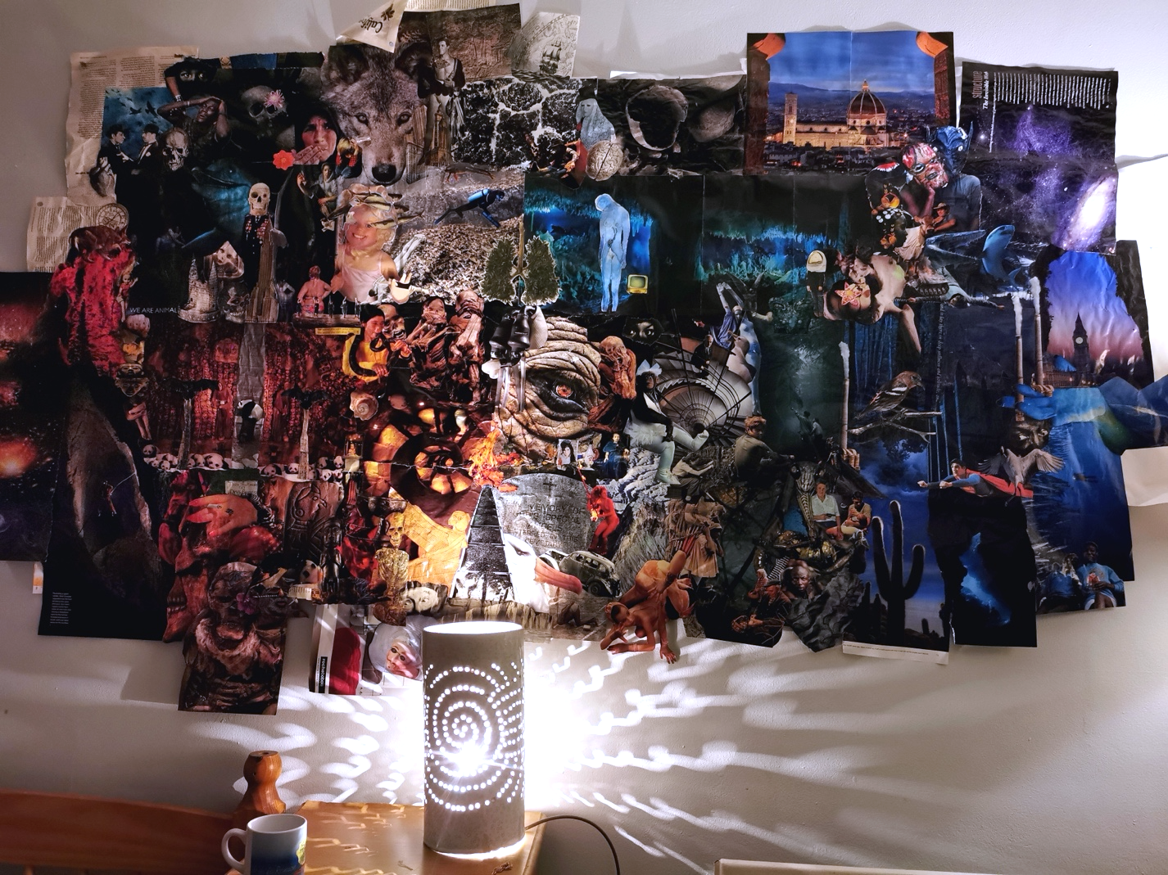
Our words here have reached a moment of temporary closure. Throughout this essay we explored Huxley’s idea that non-verbal and trans-verbal access to reality is of crucial importance in our attempt to know the world. As Huxley argues, a particular use of language, and the naming process through which it operates, obscures how the world reveals itself to us originally. Underneath and before the concept we live in a different world, without which names and concepts wouldn’t make sense to us. The notion of a tree, the concept of a tree, wouldn’t make any sense to us without having met a tree, climbed a tree, lain under its shadow, smelled its flowers, or heard about it through the stories of other people. In other words, without our experience of the world, talking about it would not make sense. Nevertheless, it seems that today, in discourse or science, meanings crystallize and make us forget the relationality and ambiguity of our original experience of the world. As the philosopher Byung-Chul Han (2023) puts it, we seem to live a crisis of narration, in which stories, and the words and symbols that constitute them, are instrumentalized and no longer connect us to the worlds we live in. We story-sell rather than story-tell (Han, 2023). A particular way of talking about the world has become hegemonic and obscures the multiple ways in which we are embedded in, and come to know, reality. To revalue the latter, we need non-verbal ways of access that do justice to its complexity. Holding back on mescaline, for now, our aim has been to suggest that “poetry [and the arts] elevates each single thing through a particular combination with the rest of the whole”, and in doing so, they restore it to us in harmony (Novalis, 1837: 533).
Figure 5 Zoomed out: 'Way finding through Complexity', Collage

Bibliography
Beaudelaire, C. (1861) Les fleurs du mal. Athena e-texts. Available at: https://athena.unige.ch/athena/baudelaire/baudelaire-fleurs-du-mal.pdf, (Accessed: 06 April 2025).
Castoriadis, C. (1975) l’Institution imaginaire de la société. Paris: éditions du seuil.
Clastres, P. (1974) La société contre l’état. Paris, Les éditions de minuit.
Deleuze, G. & Guattari, F. (1980) Mille plateaux. Paris: les éditions de minuit.
Han, B-C. (2023) Die Krise der Narration. Berlin: Matthes & Seitz.
Heidegger, M. (1954) Die frage nach der Technik. Frankfurt am Main: Vittorio Klostermann.
Heidegger, M. (2015) [1950]. Holzwege. Frankfurt am Main: Vittorio Klosterman.
Huxley, A. (2007) [1931] Brave new world. London: Vintage Classics.
Huxley, A. (2004) [1954]. The doors of perception. London: Penguin.
Kristeva, J. (1974) La révolution du langage poétique: L’avant-garde à la fin du XIXe siècle: Lautréamont et Mallarmé. Paris: Eidtions du Seuil.
Merleau-Ponty, M. (1945) Phénoménologie de la perception. Paris: Gallimard.
Novalis. (1837) Schriften. a. a. O. Band II.
Valéry, P. (2023) Poésie et pensé abstraite. Variété V. In: La poésie à vivre: paroles de poètes. Ed. Siméon, J-P. Paris: Gallimard.
Zambrano, M. (2024) Claros del Bosque. Madrid: Allianza Editorial.

A term from Plato’s Timaeus, meaning receptacle and used to refer to the state of non-being, an interval, in which the forms of matter were received from the intelligible realm. For Kristeva however, the Chora is the place of being, where meaning is constituted in a pre-lingual state of our development (Kristeva, 1974).
“as if perfumes, colors and sounds answer each other”
“Poetically the human beings dwells on this earth.”

