Title

Student Name

CARL Research Project

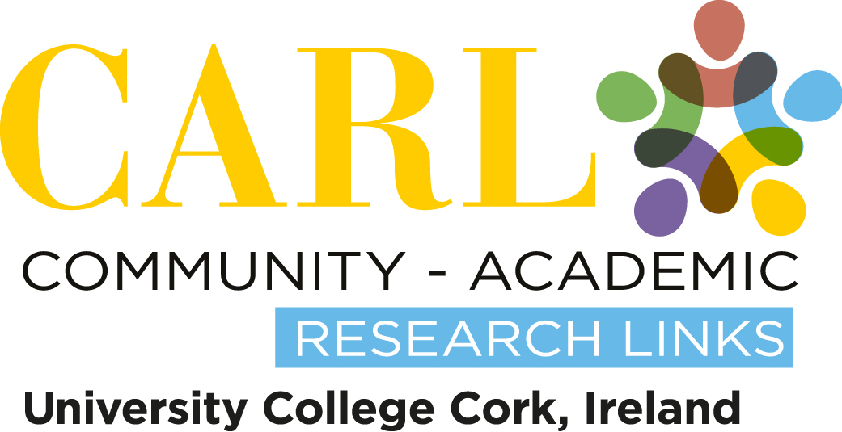

Name of student(s):
Name of civil society organization/community group:
Supervisor(s):
Name and year of course:
Date completed:

What is Community-Academic Research Links?
Community Academic Research Links (CARL) is a service provided by research institutes for the Civil Society Organisations (CSOs) in their region which can be grass roots groups, single issue temporary groups, but also well structured organisations. Research for the CSOs is carried out free of financial cost as much as possible.

CARL seeks to:
- provide civil society with knowledge and skills through research and education;
- provide their services on an affordable basis;
- promote and support public access to and influence on science and technology;
- create equitable and supportive partnerships with civil society organisations;
- enhance understanding among policymakers and education and research institutions of the research and education needs of civil society, and
- enhance the transferrable skills and knowledge of students, community representatives and researchers (www.livingknowledge.org).

What is a CSO?
We define CSOs as groups who are non-governmental, non-profit, not representing commercial interests, and/or pursuing a common purpose in the public interest. These groups include: trade unions, NGOs, professional associations, charities, grass-roots organisations, organisations that involve citizens in local and municipal life, churches and religious committees, and so on.

Why is this report on the web?
The research agreement between the CSO, student and CARL/University states that the results of the study must be made public. We are committed to the public and free dissemination of research results.

How do I reference this report?
Author (year) Project Title, [online], School of Applied Social Studies, Community-Academic Research Links/University College Cork, Available from: http://www.ucc.ie/en/scishop/completed/ [Accessed on: date].

How can I find out more about the Community-Academic Research Links and the Living Knowledge Network?
The UCC CARL website has further information on the background and operation of the Community-Academic Research Links at University College Cork, Ireland. http://carl.ucc.ie

CARL is part of an international network of Science Shops. You can read more about this vibrant community and its activities on this website: http://www.scienceshops.org

Disclaimer
Notwithstanding the contributions by the University and its staff, the University gives no warranty as to the accuracy of the project report or the suitability of any material contained in it for either general or specific purposes. It will be for the Client Group, or users, to ensure that any outcome from the project meets safety and other requirements. The Client Group agrees not to hold the University responsible in respect of any use of the project results. Notwithstanding this disclaimer, it is a matter of record that many student projects have been completed to a very high standard and to the satisfaction of the Client Group.

