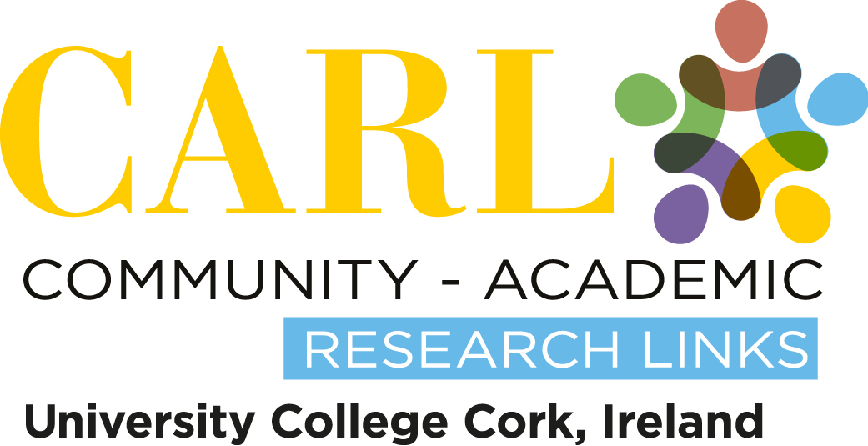

Research Agreement
Community-Academic Research Links

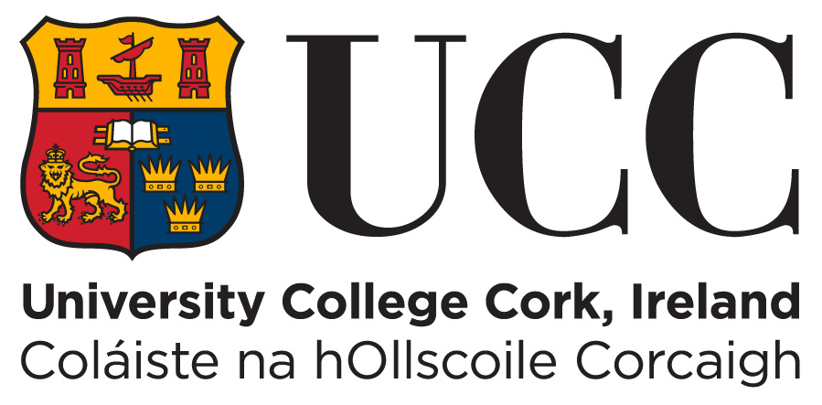

Name of community and voluntary group:
Community and voluntary group liaison:
Name of student(s):
University course and module:
Date:

An agreement between [Name of Community Partner/Community and Voluntary Group] and [Student Name(s)] (Name of Course) at University College Cork, Cork, Ireland.

This agreement relates to arrangements agreed between the student and the group for the execution of a research project entitled: [Working title of project]

- It has been agreed that [name of student(s)] will carry out research on behalf of and in participation with [name of community and voluntary group] as follows:

(Outline here what has been agreed between the student in terms of the research to be carried out and the way it will be carried out. Identify what is negotiable and non-negotiable. Address issues such as permissions (does the liaison have full support from the CSO management / board for this project?), participant sample, ideas for data-collection methods, storage, access to findings and/or raw-data, participatory methods, role of CSO liaison, ethical approval, resources and expenses, feasibility of the study (size, access to the sample, no children can be interviewed etc.,) time-scales, dissemination activities and action plans, social action activities, presentations, etc.).

- The time of the academic supervisor of the student undertaking the research will normally be provided without charge as part of the student’s degree course at the University.

- The University will provide accommodation, the use of equipment, the services of technical and other supplies to the extent that is normally provided for internally based student projects. Where the provision required for the timely and efficient execution of the project exceeds the normal allowance for student projects or exceeds the host department’s budget, the community and voluntary group may be asked to pay for such provision or to join with the University / Community-Academic Research Links (CARL) in securing provision from a third party source. No costs will be incurred without prior agreement. (These additional provisions will be listed in an appendix at the end of the Agreement or in point 1 above, if deemed necessary).

- The name of the student(s) will be listed below. The names of the students, the academic supervisor, or the University / Community-Academic Research Links (CARL) may only be used after obtaining prior approval. Permission to refer to the University will not be unreasonably withheld.

- The copyright, or any other intellectual property rights, created by the project will rest with the University. Free and full use by the Community Partner for the purpose declared when the project was initiated is agreed in advance. Use for any further purpose(s) will be for negotiation and approval on a case-to-case basis. Permission will not be unreasonably withheld.

- Use of the project report in other than its complete form will be checked with the University / Community-Academic Research Links (CARL) in reasonable and sufficient time before the intended date of such use to allow discussion as to the accuracy or suitability of the modified form.

- Students will normally carry out the project. Notwithstanding the contributions by the University and its staff, the University / Community-Academic Research Links (CARL) gives no warranty as to the accuracy of the project report or the suitability of any material contained in it for either general or specific purposes. It will be for the Community Partner, or users, to ensure that any outcome from the project meets safety and other requirements. The Community Partner agrees not to hold the University responsible in respect of any use of the project results. Notwithstanding this disclaimer, it is a matter of record that many student projects have been completed to a very high standard and to the satisfaction of the Community Partner.

- Upon completion of the project the student (as well as completing the requirements of his or her University course) and CARL will be responsible for providing the Community Partner with a completed copy of their project report. The student and CARL shall provide the Community Partner with the completed project report within a reasonable amount of time, but not more than two months after the final Examination board.

- Upon completion of the project, students should meet with the Community Partner within one month of the submission of the dissertation to the University to discuss the study findings, to explore actions / implementation plan arising from the study and to discuss future public presentations and publications related to the study by the student and/or the Community Partner.

- All parties agree that upon completion of the project, that the research report will be placed - with the approval of the course tutor providing it reaches the requisite academic and presentation standards - on the University College Cork, Community-Academic Research Links website: http://carl.ucc.ie. No party has the right to veto the publication of the research report.

Student dissertation submission date:
Completion date of research report to community group: (normally after the Examinations Board has formalised the dissertation grade, which is usually 2 months after submission of dissertation)
Date report to be published on the CARL website:
(normally after the Examinations Board has formalised the grade, which is usually 2-3 months after submission of dissertation)

Signed by the liaison person from the community and voluntary group partner
Signature (By signing this Agreement you are confirming that you have sought and secured the requisite permissions to proceed with this project within your organisation):
Print Name:
Title/Role in Group:
Date:

Signed by student(s)
Signature(s): (By signing this Agreement you are confirming that you have sought and secured the requisite permissions from your tutor and/or course team to participate in a CARL project):
Print Name(s):
University Course(s) and Year:
Date:

Signed by CARL Coordinator / Academic Supervisor(s)
Signature:
Print Name:
University Course(s) and Year:
Date:

Version 4. Updated June 2015. http://carl.ucc.ie . This form is based upon a version of the QUB Science Shop CBR contract – used with permission.

