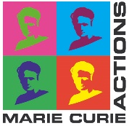

APEX CALL 2 2019

Expression of Interest (EoI)

This EoI will not be evaluated. There is no selection at this point.
The EoI will allow APC Microbiome Ireland to identify suitable expert evaluators in advance of receipt of applications.
Please note that all potential applicants must complete Call 2 Application forms and submit prior to the Call deadline to enter the evaluation process (See Call 2 application guidelines).
Please complete the form and convert to a single PDF file.
Email to APEX@ucc.ie with the subject heading EoI

Applicant details
Last Name
First Name
Title
Email address

Qualifications and Background (200 words maximum)

General information
Research Theme of Interest (Choose from one)
- Microbes to Molecules;
- Diet and Microbes at the Extremes of Life;
- Brain-Gut-Microbiota Axis;
- Host-Microbe Dialogue.
Suggested proposal title/description (max 3 lines)
Top three research areas of Interest

Host Supervisor(s) that meet your research area of interest

