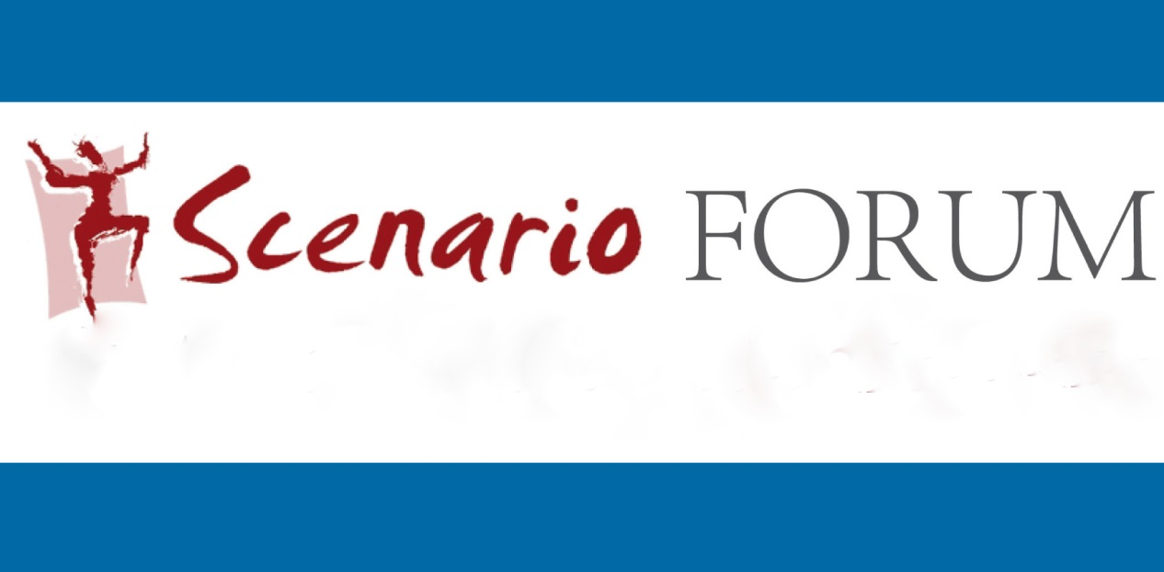

2. Symposium
Towards a Performative Teaching and Learning Culture
University College Cork ● Friday, September 25, 2015 ● ORB G27

Programme
Symposium participants are invited to attend a lecture by Prof Joelle Aden,
Université Paris-Est Créteil, to mark the inauguration of the new research cluster
Culture as Performance – Performance as Culture
in the Centre for Advanced Studies in Languages and Cultures (CASiLaC), School of Languages, Literatures and Cultures, UCC
10 a.m. – 11.00 a.m. (Alfred O’Rahilly Building – G27)
Prof Joelle Aden
Performative Approaches to Foreign and Second Language Education:
Intercultural Contexts and Perspectives
Schedule for Symposium Contributions
(Alfred O’Rahilly Building – G27)
11.30 – 13.00 Workshop
Dr John Crutchfield (Free University Berlin): Creative Writing and Performance in the EFL Classroom
13.00 – 14.30 Lunch
14.30 – 15.00 Micha Fleiner (University of Education, Freiburg)
Performative Teacher Training: Status quo and future perspectives
15.00 – 15.30 Dr Roisin O’Gorman (University College Cork)
And yet it moves: a happy-go-lucky reflection on movement strategies for performative teaching and learning
15.30 – 16.00 Coffee Break
16.00 – 16.30 Jennifer Rogers (University College Cork)
Initial Thoughts on Playwriting Practice within the Emerging Landscape of Performative Research
16.30 – 17.00 Elisa Serra Porteiro (University College Cork)
Communicating Vessels: Researching Theatre Translation, Teaching Translation and Theatre
17.00 – 17.30 Final Discussion
The Symposium is generously supported by the School of Languages, Literatures and Cultures
and the Department of German, UCC

