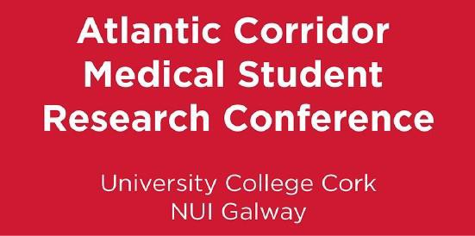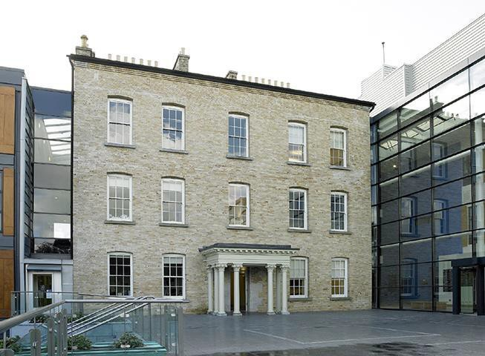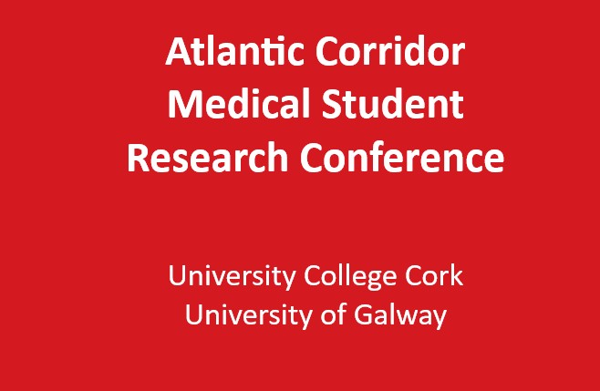

# Atlantic Corridor Medical Student

# Research Conference 2024

**Brookfield Health Sciences Complex University College Cork**

**November 8th, 2024**

**Atlantic Corridor Medical Student**

**Research Conference Schedule 2024**

**Schedule – At a Glance**

|  |  |
| --- | --- |
| 10.00 – 10.20 | **Oral Presentations in Rm 1.02**  Registration & Refreshments (*served in Jennings Gallery*) |
| 10.20 – 10.35 | Opening Address |
| 10.40 – 11.55 | Oral Presentations I  **Session Chairs: Dr Emer Galvin and Claudia Osborne** |
| 11.55 – 12.15 | Coffee, *Jennings Gallery* |
| 12.15 – 13.00 | **Plenary Lecture – Rm 1.02**  **Prof. Emma Wallace**  Professor of General Practice & Head of Department,  College of Medicine and Health,  University College Cork  **Title**: Managing multiple long term conditions  in primary care: making sense  of the evidence |
| 13.00 – 14.00 | Lunch & Poster Session, *Rm 1.01* |
| 14.00 – 15.00 | Oral Presentations II  **Session Chairs: Dr Marah Elfghi and Rory Mulcaire** |
| 15.00 – 15.15 | Break*, Jennings Gallery* |
| 15.15 – 16.00 | Oral Presentations III  **Session Chairs: Dr Deborah Heaphy and Caoimhe O’Brien** |
| 16.00 – 16.20 | Prize-giving and Closing Address |

**Oral Presentations**

|  |  |
| --- | --- |
| **Oral Presentations I – Rm 1.02** | |
| 10:40 | **Presenter**: Mark McCarthy, *University College Cork*  **Title**: Investigating Metastatic Potential in Papillary Thyroid Microcarcinoma |
| 10:55 | **Presenter**: Rayna Cox, *University of Galway*  **Title**: Biomaterial-Aided Cellular Brain Repair for Parkinson’s Disease: Therapeutic Validation in an Immunosuppressed Model |
| 11:10 | **Presenter**: Ihsan Albakri, *University College Cork*  **Title**: Prevalence of Masked Hypertension and White Coat Hypertension in Adult Patients with Chronic Kidney Disease when Evaluated by 24-hour Ambulatory Blood Pressure Monitoring: Systematic Review and Meta-analysis |
| 11:25 | **Presenter**: Maria Thomas, *University of Galway*  **Title**: Comparative Analysis of Conventional and Aerosolised Transfection Reagents and Storage Methods for Semi-synthetic mRNA Delivery |
| 11:40 | **Presenter:** Samin Abrar, *University College Cork*  **Title:** Assessing long-term compliance of DAV ratio in prediction of adequately occluded WNBA treated with WEB devices |
| **Oral Presentations II – Rm 1.02** | |
| 14:00 | **Presenter**: Saniya Kaushal, *University College Cork*  **Title**: The Experiences of Imposter Syndrome Amongst Final Year Medical Students: A Qualitative Interview Study |
| 14:15 | **Presenter**: Mary Botros, *University of Galway*  **Title**: Reproducibility of Magnetic Resonance Spectroscopy measured GABA and GSH in Hippocampus |
| 14:30 | **Presenter:** Fodhla Ni Dhalaigh, *University College Cork*  **Title:** How do General Practice trainees experience the transition from hospital to general practice: a qualitative study |
| 14:45 | **Presenter:** Kevin Lee, *University of Galway*  **Title:** In silico Screening and Comparative Profiling of MicroRNAs as Tissue-Specific or Systemic Biomarkers in HER2-Positive Breast Cancer |
| **Oral Presentations III – Rm 1.02** | |
| 15:15 | **Presenter:** Cathal Smith, *University of Galway*  **Title:** Adherence to guidelines for the management of IgA Nephropathy (IgAN) in adults in the West of Ireland |
| 15:30 | **Presenter:** Anthony Goodings, *University College Cork*  **Title:** Evaluating Physician Attitudes Toward the Use of Tap Water in Colonoscopic Irrigation: Feasibility, Safety, and Barriers to Implementation |
| 15:45 | **Presenter:** Faith Lambo, *University of Galway*  **Title:** The Screening For and Treatment of Sexually Transmitted Infections In Rural Ireland General Practice |