New Directions in the Performance of Violence and Trauma in the Hispanic World

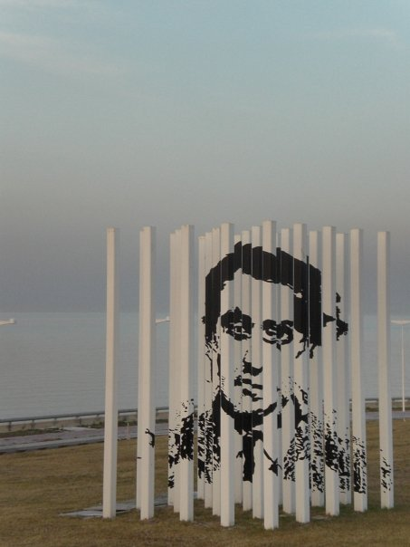

University College Cork
Department of Spanish, Portuguese and Latin American Studies

River Room
Glucksman Gallery
May 8th 2014

9:30-10:30 am

Julia Banwell, University of Sheffield
What Remains, Speaks: The Performance of Bodies and Objects in the Work of Teresa Margolles

Nuala Finnegan, University College Cork
Ethics and Acts of Witnessing in Ciudad Juárez Art

10:30-10:45 am COFFEE

10:45-11:30 am Postgraduate Roundtable. Chair: Cara Levey

Approaches to Representations of Trauma
With participation from Fiona Clancy and Donna Alexander

11:30-12:15 pm

Josebe Martínez, Universidad del País Vasco
De la performance del testigo a la “víctima aristocrática”: la lucrativa industria de la memoria del trauma en el Estado Español

12:15-1:00 pm Chair: Stephen Boyd

Helena Buffery, University College Cork
Traumatic Translations: Memories of Violence in Processes of Self-Translation
Performance by Sonia Boue
Visual Encounters with Tierra Cautiva
1:00-1:45 pm LUNCH

1:45-2:45 pm Chair: Niamh McNamara

Cara Levey, University College Cork
Afterlives of Terror? Unsettling Intervention in Sites of Memory and Trauma in Post-Dictatorship Argentina and Uruguay

Philippa Page, University of Newcastle
Re-reading Performances of Violence in the Light of Recent Theoretical Developments in the Field of Memory Studies

2:45-3:45 pm

Claire Launchbury, University of Leeds
Linguistic Violence and Alienation in Juan Goytisolo, Paisajes después de la batalla and Jorge Semprún, L’Algarabie: Displacement and Identity in post-apocalyptic Paris

Eva Bru-Domínguez, Bangor University
Phallic Imagery, Violence and Excess: Staging Rebirth in
El dibuixant by Marcel·lí Antúnez

4:00-4:15 pm COFFEE

4:15-5:15pm Performance by Beatriz Silva

Sangre y lágrimas. Conversaciones con Kama Gutier
Blood and Tears. Conversations with Kama Gutier

5:30 pm CACSSS Seminar Room. G27, O’Rahilly Building

Diana Taylor, New York University

Keynote Address: The Traumatic Repeat: Villa Grimaldi Now and Again

Trauma, like performance, is known by the nature of its repeats: “never for the first time.” We speak of trauma only when the event cannot be processed and produces the characteristic aftershocks. The traumatic blow may be in the past, but trauma, like performance, is always experienced in the present. Here. Now. In this piece based on multiple visits to Villa Grimaldi (the torture center in Chile under Pinochet), Diana Taylor explores how trauma and memory sites change over the years, always 'there' ready to be re-activated in the present.

This keynote address forms part of the Graduate School Masterclass on Violence and Trauma: Approaches to Politics, Practice and Performance in the College of Arts, Celtic Studies and Social Sciences
See: http://www.ucc.ie/en/cacsss/grads/events/

With sponsorship from UCC’s Strategic Research Fund, attendance is free but registration is compulsory. Please email nuala.finnegan@ucc.ie or c.levey@ucc.ie to register interest.

