A different discipline: revisiting Canon Sheehan of Doneraile (1852-1913) – author, activist, priest
Conference in University College Cork
Friday 26th and Saturday 27th April 2013
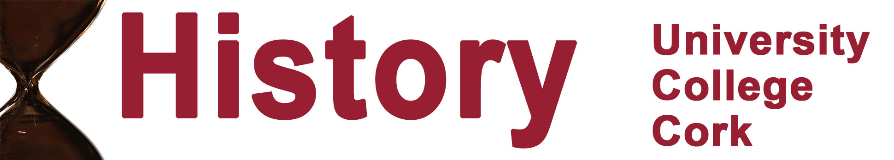

FRIDAY | Aula Maxima
7.30pm | Official conference opening
‘Irish and English Catholic Literature and its Czech Reception’
Professor Martin Putna, former Director of the Vaclav Havel Library, Prague
8.45pm | End of opening session
SATURDAY | West Wing 6
10.00am | ‘Sheehan and Heuser: collaborating for the upkeep of the church’  Fr Joseph Hubbert, Niagara University
10.50am | ‘The Canon in Germany  Professor Eda Sagarra, Trinity College Dublin
11.40am | Coffee break
12.00pm | ‘An obstinate quill: Fr Matthew Russell SJ and the Irish Monthly’  Declan O’Keefe, Clongowes Wood College
12.50pm | Lunch break
2.10pm | ‘Canon Sheehan’s apprehensions about the Ireland of his time’  Dr Ruth Fleischmann, University of Bielefeld (retired)
3.00pm | ‘Canon Sheehan's Dystopia: "Godless science" and Darwinism’  Dr Don O’Leary, University College Cork
3.50pm | Coffee break
4.10pm | ‘Canon Sheehan: a literary life’  Monsignor James O’Brien, Congregation for Divine Worship, Vatican city
5.00pm | End of conference

For further information and details on tickets please telephone Gabriel Doherty, 021-4902783, email g.doherty@ucc.ie
The School of History wishes to acknowledge the financial assistance provided by the parishes of Mallow and Doneraile in support of this event.
Conference website: http://www.ucc.ie/en/history/
Please address any correspondence to: ‘Sheehan Conference’, School of History, University College Cork.

