Early Modern Military Identity,

A One-Day Symposium, August 28th, 2pm-6pm

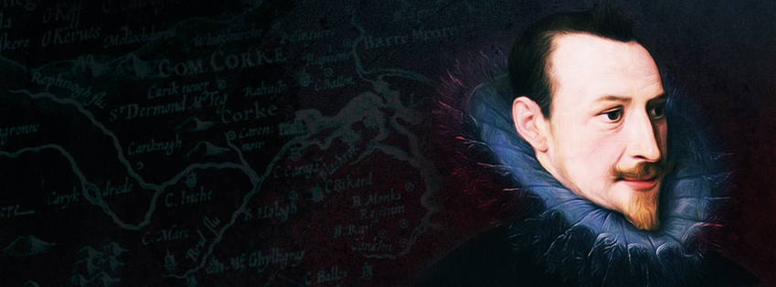

Location: University College Cork, ORB G27

Friday, August 28, 2015
14.00-14.15 | Opening Remarks

PANEL ONE
14.15-15.45 | Andrew Hadfield, ‘Dulce Bellum Inexpertis: The defence of Lord Grey’  David Edwards, ‘Campaign Journals of the Elizabethan Irish Wars’  Matthew Woodcock, ‘"I speak to thee plain soldier": Constructing and Defending Identity in Tudor Military Autobiography’
15.45-16.20 | LUNCH: Refreshments Provided

PANEL TWO
16.30-18.00 | Clodagh Tait, ‘“A print on my body of this day’s service”: Experiences of ‘wounds and hurts’ in early modern Irish warfare’  Cian O’ Mahony, ‘Souldiers, or Clarkes, or Both’: Literary and Military Identity in Pre-Civil War Norfolk’  James O’ Neill, ‘Scythians, cannibals and werewolves? The Nine Years War and the myth of the Irish primitive’

PUBLIC EVENT: Elizabeth Fort, Barrack Street
19.30-20.30  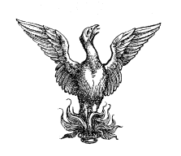 | ‘Edmund Spenser on the Munster Plantation’  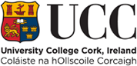  Public lecture in Elizabeth Fort, Barrack Street, by Professor Andrew Hadfield  Kindly supported by the Society for Renaissance Studies, UCC’s School of History and School of English.

