mySupport Study knowledge translation and exchange event in the Netherlands

Knowledge exchange meeting with the 6 partner countries

mySupport study is a transnational multidisciplinary implementation study across six countries: Queen’s University Belfast, Northern Ireland and Lancaster University, England; University College Cork, Republic of Ireland; Leiden University Medical Center, Netherlands; McGill and Mc Master University, Canada; Centrum Paliativini, Czech Republic and Universita Deglis Studi Di Torino, Italy.

After meeting monthly for over 2 years, on MS teams, the team were finally able to come together in Leiden University Medical Center (LUMC) on the 23rd of March 2022. The knowledge exchange meeting gave the opportunity for partners to connect and discuss work packages. The main aim of mySupport study is to adapt, implement and evaluate the Family Carer Decision Support (FCDS) intervention. This intervention has been developed to assist nursing home staff in supporting family carers when they need to make difficult decisions about end-of-life care for their relative with advanced dementia.

The consortium meeting began with a sell-out symposium entitled 'New & Emerging Models of Advance Care Planning for Older Persons'. Professor Lieve Van den Block gave the keynote presentation on Advanced Care Planning (ACP) in Dementia and shared her views on the wide range of definitions of ACP and few are specific to dementia. Professor Carl May gave an interesting and theoretically driven talk about shared decision-making. Professor Peter Martin shared his experience on how communication is a vital aspect of ACP. During the comfort break, it was great to chat with our Public and Patient Involvement (PPI) panel members who represented the international strategic guiding council.

Professor Dorothea Touwen spoke about self-determination for older persons with or without dementia. She challenged delegates to identify, using mentimeter, what makes life worth living. Professor Jenny van den Steen shared insight into a new definition of ACP based on a current international Delphi study and Prof Tamara Sussman highlighted the importance of moments and time for ACP-the naturalised ACP process emphasising the need to leverage all opportunities to inform ACP in long term care. The symposium was attended by over 100 delegates from across the globe and the team facilitated live in person, recorded and live online speakers, indicative of the hybrid/blended model of connecting that the pandemic has brought about.

Day 2 started off with the early career researchers outlining the success of the mySupport Early Carer Research Committee and the mySupport mentorship programme, key learnings were striking a balance between guidance and autonomy. This was followed by our partners from the Czech Republic presenting on the Family Carers Decision Support (FCDS) intervention implementation guidelines for transnational use before drilling down on case study theoretical propositions lead by our UK team. Dr Catherine Buckley got us all moving for the afternoon session with a creative workshop to unpack mySupport study knowledge translation exchange and dissemination opportunities. The final session of the second day was an overview of common Canadian concerns expressed by family carers before entering family care conferences.
Day 3 featured future perspectives on roles and responsibilities in ACP in the Netherlands by local partners. Followed by our Italian partners sharing strategies to tailor the mySupport intervention to local characteristics and needs. We recapped on the challenges of the training programme as part of the UK presentation on mySupport ‘training programme, evaluation and future plans’. It’s hard to think back to February 2020 we had to cautiously pivot to online as there was talks of a global pandemic...little did we know, the true research implications at this time. Finally, Professor Kevin Brazil shared consortium conclusions and acknowledged the global difficulties which have greatly impacted on our transnational study. The opportunity to meet and connect, share new ideas and explore ways to sustain the FCDS intervention in practice were long awaited and hopefully the future will allow us to continue to meet in person at key consortium junctures. mySupport study team are a marvellous team and there is greater momentum to the finish line now having met in Leiden.

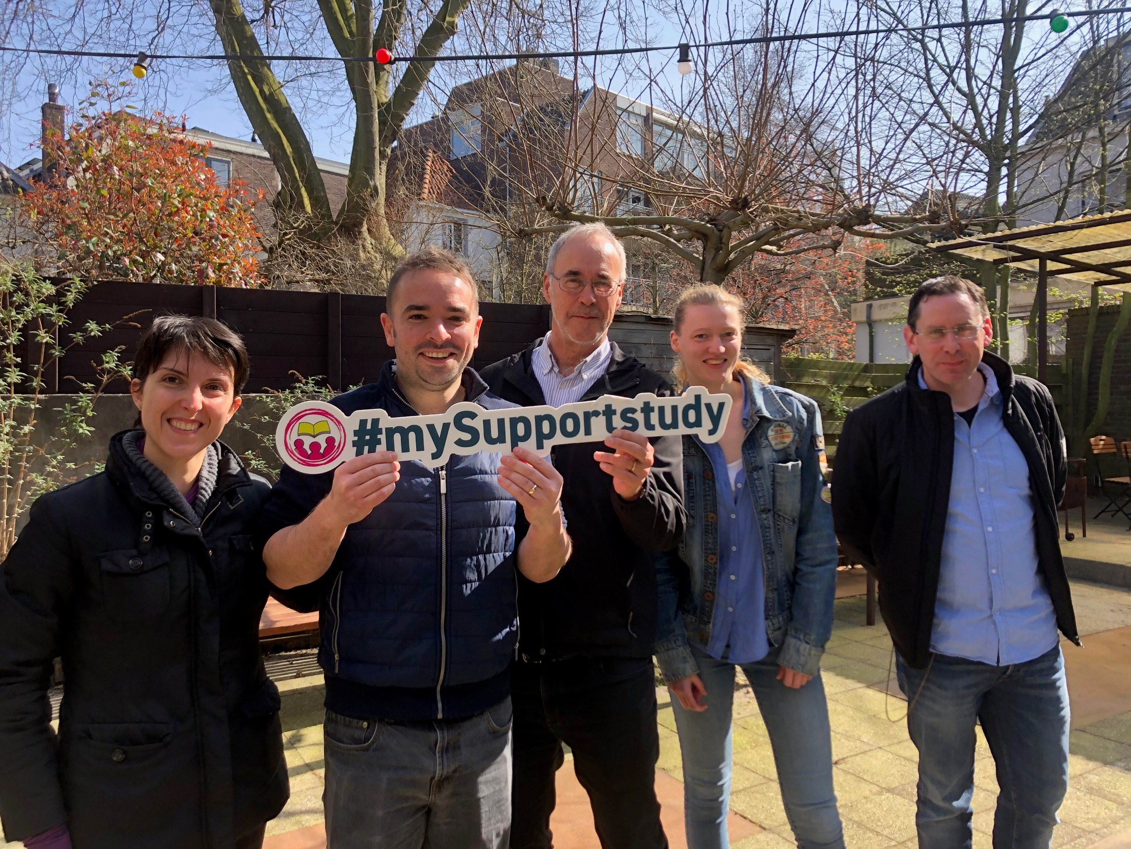
mySupport International team
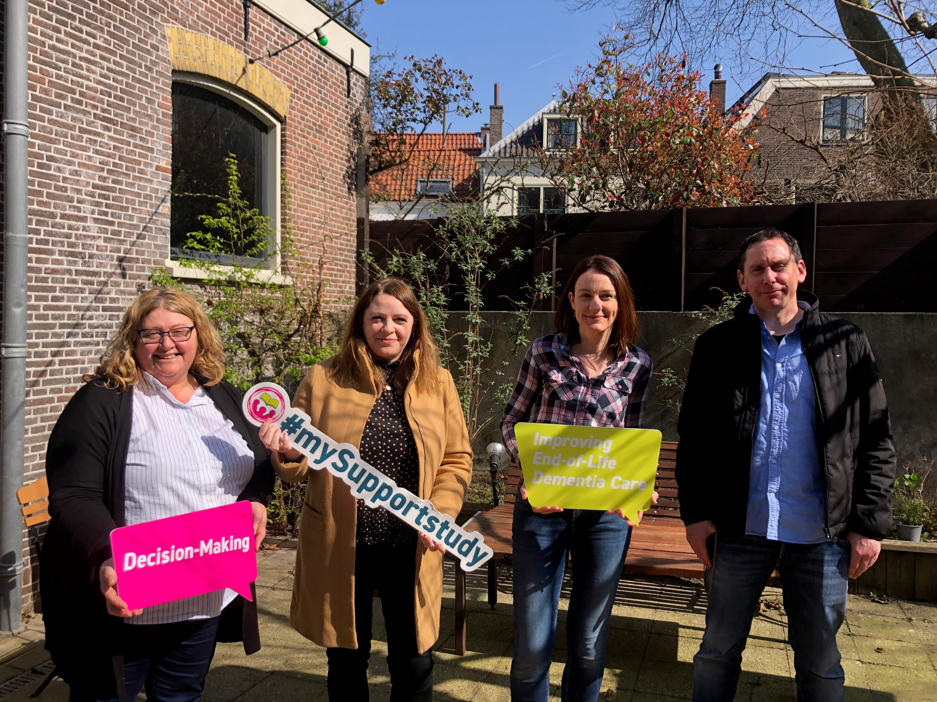
mySupport University College Cork team
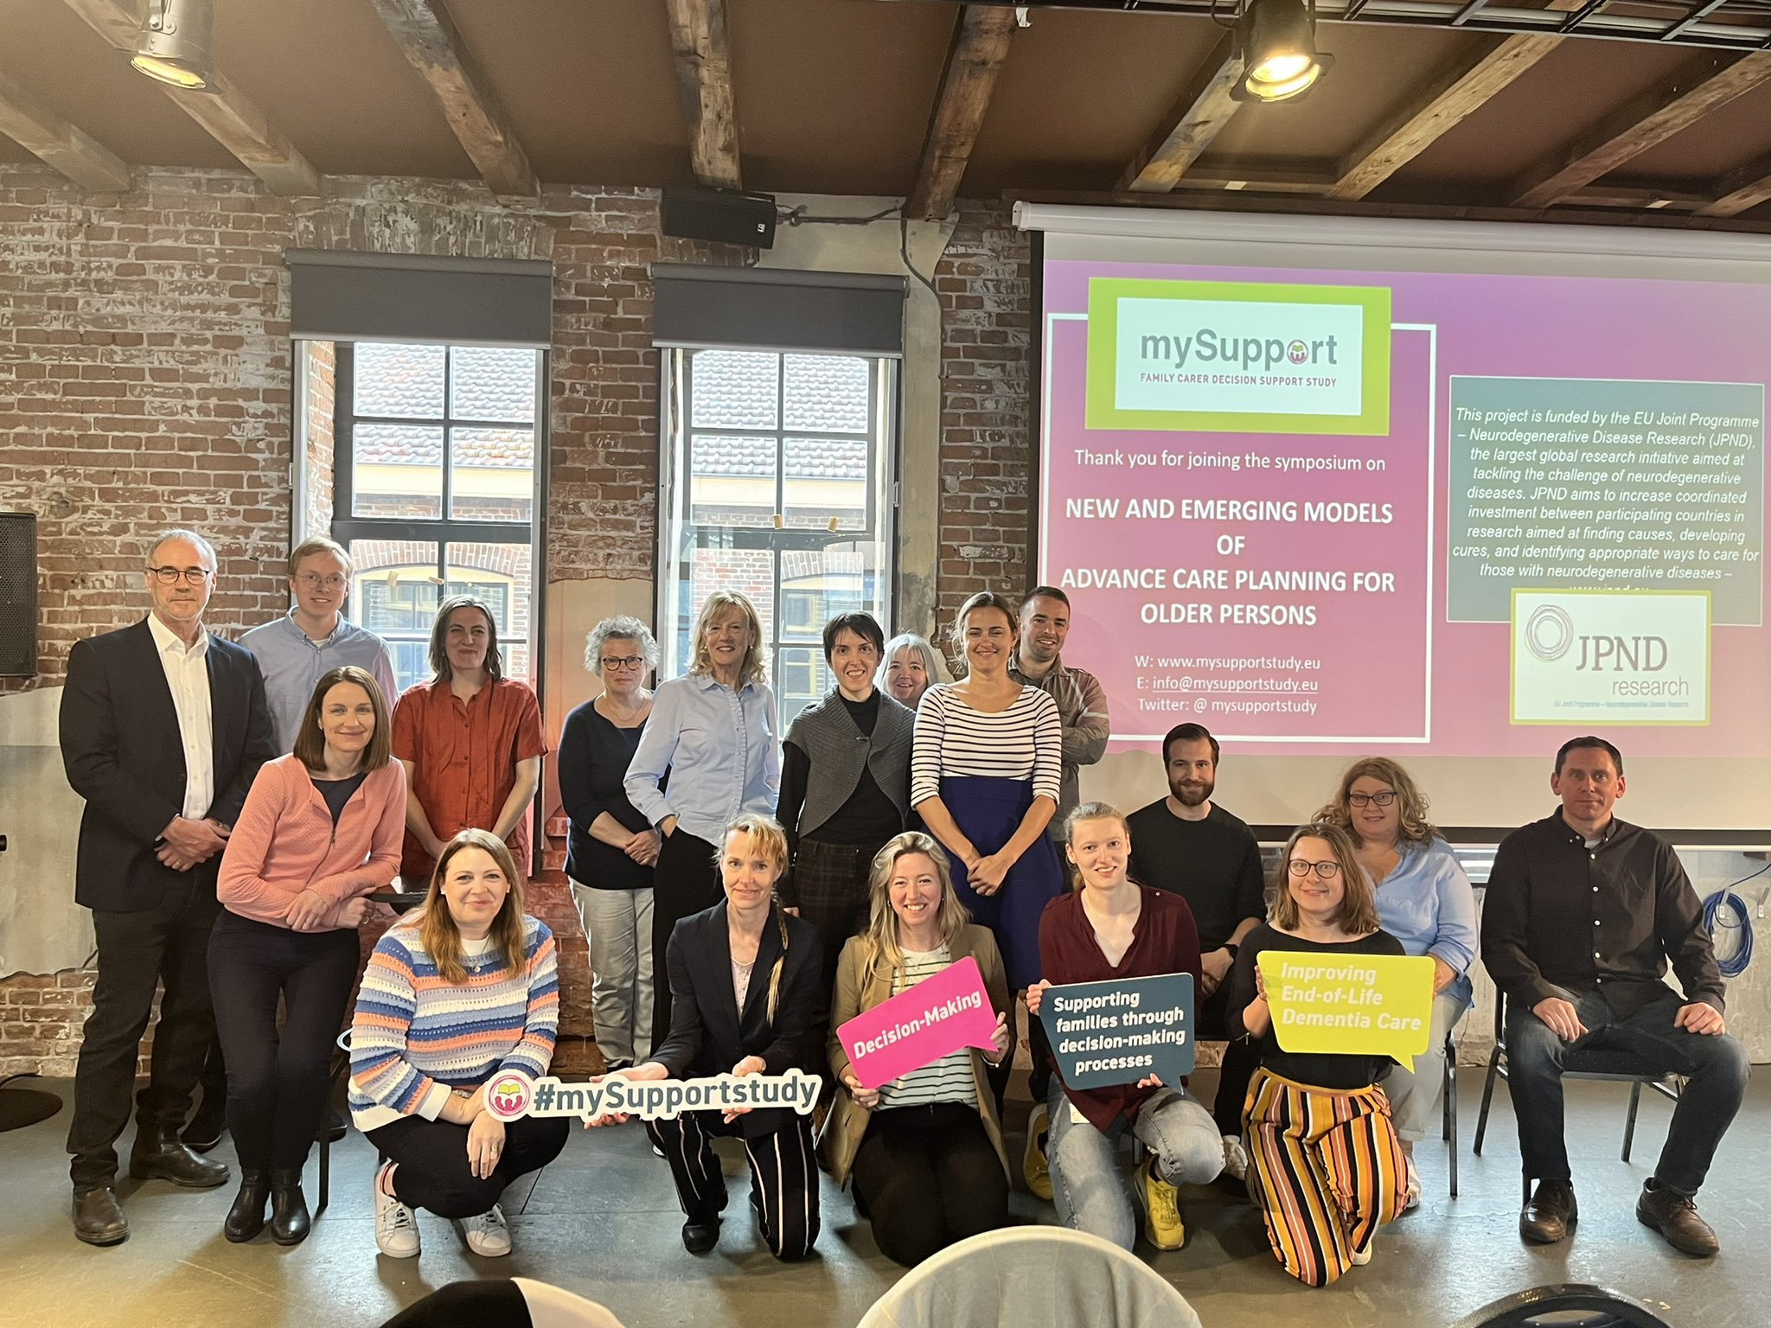
Delegates and speakers at the mySupport Symposium
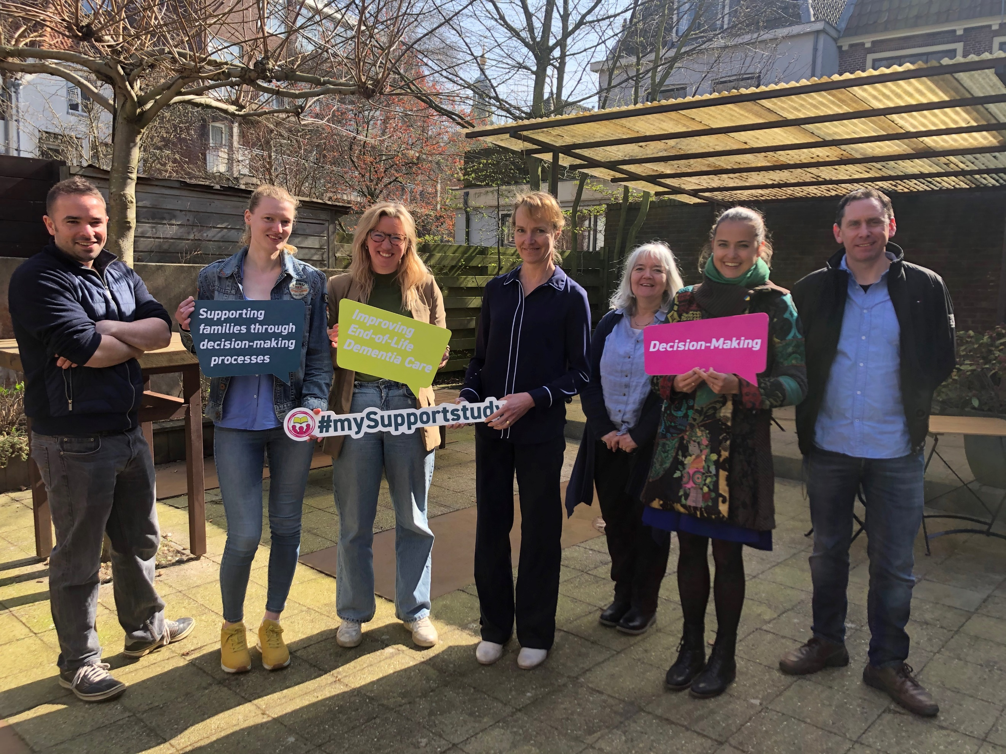
mySupport international team

