Interface

IdeNtifying prioriTiEs foR FAmily CarErs through a Participatory Process

The COVID-19 pandemic highlighted existing pressures and created new ones for family carers. In April, the Interface project set about identifying research priorities for Family Carers Ireland. This project had several data sources, such as evidence-based review of the literature, anonymised audit data, FCI webinars and focus groups discussions, that explored concerns and uncertainties around providing care in a global pandemic.

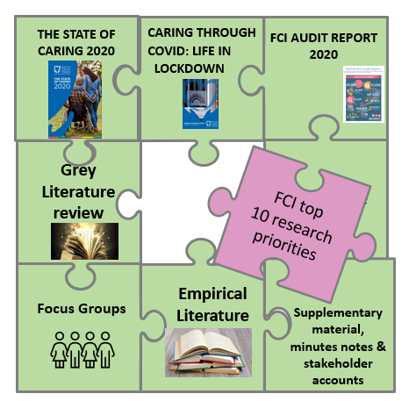

The interface project led by Dr Irene Hartigan from UCC’s School of Nursing and Midwifery, in collaboration Dr Nikki Dunne, Family Carers Ireland (FCI) and Dr Katherine Cowan, Independent Facilitator, worked in partnership with a Multi-Stakeholder Advisory Committee (MSAC) to identify gaps in the current literature, and to prioritise research questions for FCI. The MSAC which consisted of 13 members were instrumental in developing and refining the priority research questions. Members of this group included carers, caring organisation representatives and health services staff. The personal stories and accounts from members reminded researchers of the personhood and unique experience of each member. This interconnection influenced our shared understanding and is the perspective needed to give meaning and understanding to the research priority questions. Through a series of online meetings and workshops, we arrived at a list of 16 research questions for, and about, family carers in a post pandemic context. The top 10 priorities were identified through a ranking exercise, with each member identifying their top and bottom three researchable questions prior to a facilitated group discussion surrounding prioritisation. Key themes within these priorities relate to:

o Valuing carers in terms of their economic and societal contribution
o Economic impact and the financial strain of caregiving
o Provision and access to support services and infrastructure in Ireland

The agreed list of priorities will be published in November and presented at Family Carers Ireland online research conference, on the 24th of November, showcasing projects unique to Family Carers Ireland as part of the Irish Research Council New Foundations 2021 Awards. We would like to thank key organisations, such as Eurocarers and Health Research Charities Ireland for their involvement as well as PPI Ignite Network @UCC for advising on how to include the voices of carers. The wealth of experience that came from family carers and the participatory process enabled different perspectives to be heard and understood with the end result of them being translated into an indicative list for prioritisation.

Members of the research team at UCC include Olivia Rachel Donegan, Graduate Medical Students, UCC, Dr Ruth Hally Civic Engagement Office UCC, Dr Nicola Cornally Senior Lecturer School of Nursing and Midwifery, UCC, Dr Serena FitzGerald Lecturer School of Nursing and Midwifery, UCC, Dr Caroline Dalton O’Connor Lecturer School of Nursing and Midwifery, UCC.

