Textbook authored by staff from the School of Nursing and Midwifery achieves success in prestigious award.
The American Journal of Nursing (AJN) announced the winners of its annual AJN Book of the Year Awards, honouring the most valuable texts of 2018 in nursing publishing. https://journals.lww.com/ajnonline/Pages/articleviewer.aspx?year=2019&issue=01000&article=00026&type=Fulltext
The textbook won third place in Gerontolgical Nursing category
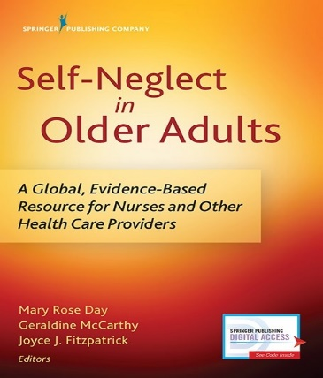
Self-Neglect in Older Adults: A Global, Evidence-Based Resource for Nurses and Other Health Care Providers Edited by Mary Rose Day, Geraldine McCarthy, and Joyce J. Fitzpatrick. New York City, Springer Publishing Company
The book is available at https://www.bookdepository.com/Self-Neglect-in-Older-Adults-Mary-Rose-Day/9780826140821?redirected=true&utm_medium=Google&utm_campaign=Base4&utm_source=IE&utm_content=Self-Neglect-in-Older-Adults&selectCurrency=EUR&w=AFFPAU9SH8YZQKA80393&pdg=pla-104399445939:kwd-104399445939:cmp-711089934:adg-37476253379:crv-163904732377:pid-9780826140821:dev-c&gclid=EAIaIQobChMI65P1sMfb3wIVyr_tCh1HXQOuEAYYASABEgI9AfD_BwE
The textbook features contributions from Dr Mary Rose Day, Professor Geraldine McCarthy, Dr Joan McCarthy, Dr Patricia Leahy-Warren and Dr Helen Mulcahy from the School of Nursing and Midwifery, UCC

