The School of Nursing and Midwifery Student Award Ceremony 2018 was held on Thursday, April 26th. The ceremony marked the outstanding achievements of the School’s undergraduate and postgraduate students. The celebratory evening highlighted the exceptional work and talent of each student and their engagement in various activities within the school, college, clinical practice and the community.
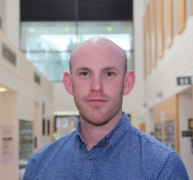
Undergraduate student of the year 2018 – Mark Harman (2nd Year BSc Mental Health Nursing)
Mark has been described as a determined and hardworking nursing student. He began the BSc in mental health nursing in 2015 following a career as Sub Lieutenant in the Irish Naval Services. He’s lecturers have highlighted that he excels in all aspects of his study. He is always present in class and demonstrates a genuine interest in his studies, his contributions are always thoughtful and well-articulated. He has also been commended on clinical placement for his empathetic and considerate engagement with those experiencing mental distress. Within the classroom, Mark has demonstrated leadership skills putting his name forward to assist anyone who needs it.
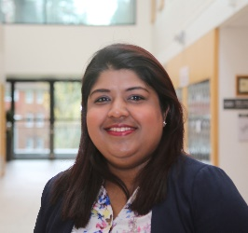
Postgraduate student of the year 2018 - Anju Menon (MSc in Nursing Studies)
Anju has been described by her supervisor as hardworking, determined and enthusiastic. She engaged extremely well with the MSc supervision process and was always open to advice and guidance taking any feedback offered in a positive way. During her time in UCC she has demonstrated the development of academic and linguistic perspectives and mastered the technique of qualitative content analysis, completing her study effectively and efficiently. Anju was awarded joint first prize at a School research conference for her poster presentation titled “An Exploration of Body Image in Women following a Mastectomy for Breast Cancer in an Irish Setting”.
Student Leader of the Year 2018 – Simone O Connor (4th Year BSc General Nursing)
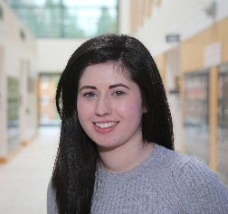
Simone has been described as a hard worker, balancing college, study, placement, friends, family and her own part time job excellently. She has a love of research and has maintained her part time research job during internship. In her last academic semester, Simone went out of her way to help a number of her classmates with any difficulties they may have had with regard to study or assignments, going over notes with them, proof reading assignments and offering suggestions where she could. She did all this looking for nothing in return only to see everyone do as well as they could. Her peers have described her as a fantastic friend, classmate and colleague who deserves recognition for all she does.

Award for Outstanding Contribution to Student Life – Niamh Hogan (4th Year BSc Integrated and General Nursing)
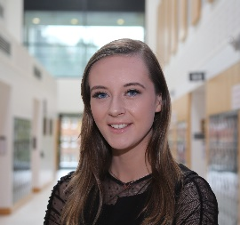
Niamh is the Vice Chairperson of the UCC Nursing and Midwifery Society. She has been a class representative for three years of her degree and represented her class at the student Council for the College of Medicine and Health. She has been involved in the organisation of numerous School events including the 2017 Nursing and Midwifery Ball. Niamh was a member if the Student experience Committee and the UCC Welfare Club in 3rd year which focused on promoting the welfare of students across campus. She is also a member of UCC Commerce Society. As part of her role in this committee she has been involved in the organisation of the Annual Commerce Ball, UCC conferences and fundraising events across campus.
Award for Recognition in Sport - Fiona O’Keeffe (3rd Year BSc Integrated and General Nursing)
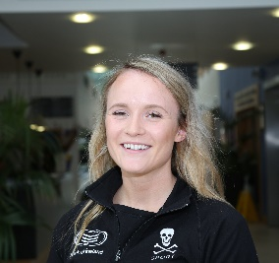
Fiona has been involved in rowing since a young age and is currently the vice-captain of the UCC rowing team. She has competed at national and international level. Fiona won the Woman’s Intermediate 4+ at the Inter Varsity Championship and placed 2nd in the Woman’s Senior 8+ at the Irish National Championship in 2017. She also represented UCC at International Regattas such as the London Metropolitan Regatta and the Roiervierkamp Regatta in Amsterdam. Fiona is a voice of encouragement and support for her team mates. Her peers have described her dedication to sport as admirable and highlighted that Fiona regularly attends early morning or late evening training sessions to fit in her training while she studies in UCC.
Award for Recognition in the Arts and Entertainment- Cliodhna Walsh (3rd year BSc Mental Health Nursing)
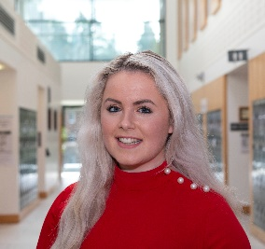
Cliodhna began dancing at the age of three at one of Cork and Munster’s most successful schools, ‘The Kiely-Walsh Academy’ which was established by her parents in Carrigaline. Cliodhna has danced competitively for twelve years. Throughout those years she achieved many Munster and All-Ireland titles at both solo and team level. The highlight of Cliodhna’s competitive career was leading the Ceili team to victory, winning the World Championships in 2007, 2010 & 2012. She represented Ireland at the prestigious ‘Lorient Interceltic’ festival in France in 2012, 2014 & 2015. She has also obtained her full qualification as an Irish Dance teacher. Every summer Cliodhna travels to South Africa to give workshops in Irish dance to both children and adults in Johannesburg, Cape Town and Durban. Cliodhna currently dances as part of University College Cork dance where this year they went on to win the ‘Dance Inter-Varsity’ title in the Cork Opera House.
Community Engagement/Activist Award – Audrey Griffin (3rd year BSc Mental Health Nursing)
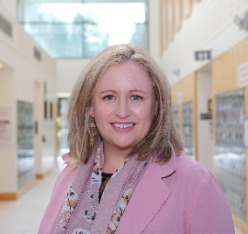
Audrey has been described as a remarkable woman who has shown wonderful insight into the care and needs of her clients. She is a member and educator of the ePrePP (electronic Preparation for Professional Practice) team where she has participated in a number of recorded interviews titled “See the person not the disease”. This resource has evolved as a national online cancer course for nurses, doctors and pharmacists in the community. Audrey is a very insightful person who sought out general clinical placements in a Medical Assessment Unit to learn additional skills to benefit mental health clients. She has also taken the time to educate the larger general clinical team with key skills in mental health assessments of patients.

Patricia J. Power Excellence in Clinical Practice Award
Awardee:
Audrey Griffin (3rd year BSc Mental Health Nursing)
Clinical staff have described Audrey as a fantastic person and an outstanding student nurse with a commitment to learning on clinical placement. Audrey is kind, caring and compassionate. Every clinical placement that Audrey undertakes is a testament to this. Audrey is committed to her studies, is motivated, self-reflective and works hard to achieve her competencies. Clinical staff have reported that Audrey has taken the time to explore her client’s physical health conditions and ensures appropriate support as required. Audrey is enthusiastic to learn and integrates herself into the multidisciplinary team. During placement she inspires hope when working with people who feel hopeless. Audrey openly relates to and connects with people who are fragile and can skilfully work in helping them in their recovery journey.
Shortlisted:
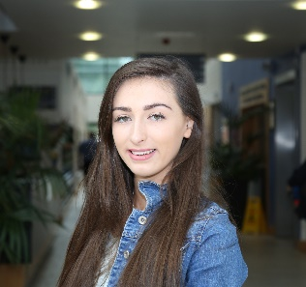
Emma Harkin (4th Year BSc General Nursing)
Emma has consistently demonstrated effective working relationships with patients, nursing staff and the multi-disciplinary team throughout her placements. She consistently shows initiative in seeking out learning opportunities in each clinical placement area, and enthusiastically participates in patient care. She has been highly praised by a Clinical Nurse Manager and preceptor in Cork University Hospital for her participation in emergency situations on the wards. Emma has had full attendance on all clinical placements and achieved all clinical learning outcomes and competencies required for her stage of the programme. Emma has demonstrated a clear understanding of patient conditions and theoretical knowledge when handing over complex patient cases. Emma has been described by her Clinical Placement Coordinators as “very focused and shows evidence of knowledge underpinning her practice”

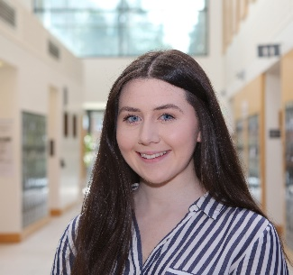
Kayleigh Hehir (2nd Year BSc General Nursing)
Kayleigh has demonstrated outstanding performance in all clinical areas and exhibits excellence in client/patient engagement at all times. Kayleigh has been described as having a natural instinct for patient care. Clinical staff have highlighted that Kayleigh stands out because of her kindness and caring attitude. She seeks out learning opportunities and her level of enthusiasm and consistent interest in learning is outstanding. Feedback from her preceptors and Clinical Nurse Manger’s have been extremely positive and they acknowledge Kayleigh’s level of care and involvement in all aspects of ward activities. A Clinical Nurse Manger of the South Infirmary Victoria Hospital described Kayleigh “as an excellent student, very conscientious and hardworking”. She also stated that Kayleigh was “a pleasure to work with and I have no doubt if she continues as she is she will go far in her career and make an excellent nurse”

Keady Clifford Excellence in Children’s Nursing 2018 – Jenny Rea (Recent graduate of the BSc Integrated and General Nursing Programme)
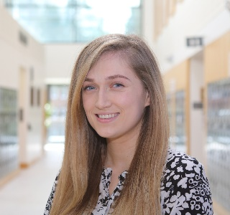
Jenny is an exceptional communicator who recognises the stress and vulnerability that comes with illness and is a strong advocate for children and their families. Her critical thinking abilities and flexibility enhance her problem-solving approach to care. She is non-judgmental, observant, highly organized, flexible and able to prioritise care effectively. Respect, sensitivity and empathy are key characteristics of her practice. aspects of her nursing role. She works well within the multidisciplinary team and is a much-respected leader among her peers. She imparts her knowledge with generosity and spirit to children, parents and junior colleagues alike. Jenny is enthusiastic about nursing but in particular, she has demonstrated a true passion and commitment to her children’s nursing.

