Employment-based MD Scholarship Programme for Health Science Professionals in the Bon Secours Hospital

Application Form
Please refer to the Guidelines which includes the eligibility criteria, application, and selection process. The completed application form together with evidence of qualifications should be compiled as one document in pdf format and emailed to gradschoolmh@ucc.ie.

Deadline for Applications is 5pm on Friday 28th March 2025.

PART A
To be completed by the Applicant in consultation with the Supervisory Team

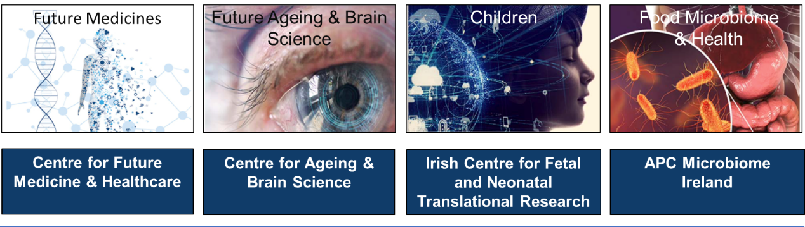
UCC Futures: please choose the UCC Futures theme with which your project aligns.
☐ | ☐ | ☐ | ☐
APPLICANT DETAILS
Name
Email
English as first language (tick X) | ☐ YES ☐ NO
Note: If English is not your first language, please provide evidence of meeting English language requirements for postgraduate programmes in UCC e.g. IELTS or equivalent) See https://www.ucc.ie/en/study/comparison/english/postgraduate/
Job title/Role in Bon Secours Hospital
Employment status i.e. permanent full time/part time/ fixed term contract for the duration of the MD

ACADEMIC QUALIFICATIONS

Undergraduate Degree Details
Title of Medical Degree
Awarding Institution
Name of School/Dept. where degree completed
Year Registered from…to Year Completed
Grade Awarded (e.g. 1H/2H.1)¹
Additional Degree Details
Title of Degree
Awarding Institution
Type of Degree (taught/by research)
Name of School/Dept. where degree completed
Year Registered from…to Year Completed
Grade Awarded (e.g. 1H/2H.1)
Note: Additional qualifications/degrees, if applicable, may be added by copying and pasting the above rows.
SUPERVISORY TEAM AND EMPLOYMENT SUPPORT DETAILS
Academic Lead Supervisor (UCC)
School of Medicine Department/Research Centre
UCC Email

Clinical Co-supervisor (Bon Secours Hospital)
Department
Email
Please copy and paste additional rows for additional co-supervisors if applicable

SCIENTIFIC EXCELLENCE AND IMPACT OF THE PROPOSED MD PROJECT
Title of proposed MD project
Hypothesis/Aims of the project (Max 200 words)
Background justifying the need for the project (Max 400 words)
Include justification for the study in line UCC Futures
Research design and methods (Max 500 words)
Include experimental design, sampling/population (e.g. sample size calculation), data collection, analytical methods as applicable
Impact (Max 400 words)
Include contribution to knowledge, societal gain from the research project and benefits of the project to the Bon Secours Hospital
Reference list for literature cited in the project proposal (Max 20 references)

WORKPLACE AND RESEARCH EXPERIENCE
Briefly outline your research experience relevant to the proposed MD project including any related achievements to date (e.g. publications (including conference proceedings, audits, reports, policy or guideline documents), awards, patents, conference presentations (Max 250 words)

PERSONAL STATEMENT
Provide a personal statement with reference to (i) why you wish to pursue an employment-based MD including career aspirations, (ii) why are you particularly suited to this research field and (iii) your capability to successfully complete an MD (Max 300 words)

SIGNATURE OF APPLICANT:
DATE:
PART B
to be completed by Supervisory team
SUPERVISORY TEAM
Academic (Lead) Supervisor (UCC)
Name
School of Medicine Department/Research Centre
Job Title
UCC Email
No. doctoral students supervised to completion
No. doctoral students currently being supervised
Research expertise relevant to the proposed MD project (Max 100 words)
collaborations, research awards, patents, funding of note (Max 100 words)
List up to 3 authored publications most relevant to the proposed MD project

Clinical Supervisor (Bon Secours Hospital, Cork)
Name
Department
Job Title
Email
No. doctoral students supervised to completion
No. doctoral students currently being supervised
Research expertise relevant to the proposed MD project (Max 100 words)
collaborations, research awards, patents, funding of note (Max 100 words)
List up to 3 authored publications most relevant to the proposed MD project
Please copy and paste additional rows for additional co-supervisors if applicable

INTERDISCIPLINARY AND SKILL MIX
Outline the strengths of the supervisory team to the proposed MD project e.g. interdisciplinarity, subject and methodological expertise, capacity building (Max 200 words)

TRAINING PROGRAMME
Outline the career development and training supports that will be provided to the applicant including any specific training relevant to the proposed research, employment-based training, structured training activities/events/ modules/workshops, conference/networking opportunities. Training should align with IUA Doctoral Skills Statement 2021 (Max. 300 words)

PARTNERSHIP BETWEEN UCC AND BON SECOURS HOSPITAL, CORK
Please provide a statement about the added value of the Employment-Based Scholarship to initiating collaborations or strengthening existing collaborations between UCC and the Bon Secours Hospital, Cork (Max 200 words)

Are there any perceived impediments to completing the MD within the proposed time frame? If yes, please elaborate here:

SIGNATURE OF ACADEMIC (LEAD) SUPERVISOR:
DATE:
SIGNATURE OF CLINICAL SUPERVISOR:
DATE:

CHECKLIST
One pdf document with each of the following should be compiled and emailed to gradschoolmh@ucc.ie
- Part A completed by the applicant in consultation with the supervisory team
- Part B completed by the supervisory team
- Examination transcripts showing evidence of qualifications and final examination grades.

MD entry criteria: a candidate must have obtained a standard of at least Second Class Honours, Grade I, in an approved primary degree of Medicine, or possess relevant professional and clinical experience to allow them to be considered under the University's policy for Recognition of Prior Learning for Admission to Research Degrees. Evidence of qualification and final examination grades must be submitted with this application.

