Medical Imaging Radiation Therapy (MIRT)

Sponsors and Prizes
 | HSE SSWHG Prize Highest Overall Mark MSc Diagnostic Radiography
2023 | Lisa Kingston
2022 | Maria Long
2021 | Shauna Doyle
2020 | Hazel Murphy

 | Affidea Highest Overall Mark in Principles and Practice of Diagnostic Radiography – MSc Diagnostic Radiography
 | Lisa Kingston
2022 | Sonya Quirke
2021 | Melissa Breen
2021 | Aisling O’Leary

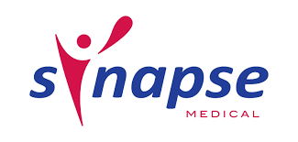 | Synapse Highest Overall Mark in Physics Subjects – MSc Diagnostic Radiography
 | Niamh Mernagh
2022 | Maria Long
2021 | Sarah Coakley
2021 | Hazel Murphy

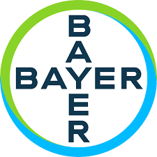 | Bayer Highest Overall Mark 1st Year MSc Diagnostic Radiography
 | Chloe Maloney
2022 | Lisa Kingston
2021 | Maria Long
2020 | Sarah Coakley

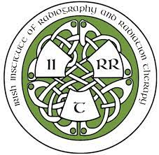 | IIRRT The Olive Fleming Memorial Award
2023 | Niamh Mernagh
2022 | Lauren Hurley
2021 | Shauna Doyle
2020 | Hazel Murpy

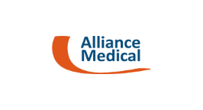 | Dr. Andy Scally Prize Award Highest Mark in Research Subjects
2023 | Lauren Hurley 2022
2022 | Maria Long
2021 | Shauna Doyle
2021 | Hazel Murphy

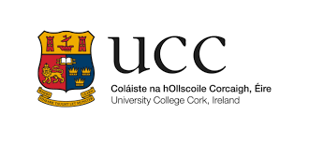 | Highest Overall Mark MSc Radiation Therapy
2023 | Amy Kate Mason
2022 | Kate Murphy
2021 | Kate Murphy

 | Highest Overall Mark in Principles and Practice of Diagnostic Radiography – MSc Radiation Therapy
2023 | Amy Kate Mason
2022 | Jennifer Delaney

 | Highest Overall Mark in Physics Subjects – MSc Radiation Therapy
2023 | Jessica Walsh
2022 | Laura Delaney

 | Bayer Highest Overall Mark 1st Year MSc Radiation Therapy
2023 | Leah Kelleher
2022 | Mary Pat O’Sullivan
2021 | Kate Murphy

 | IIRRT The Olive Fleming Memorial Award
2023 | Mary Pat O’Sullivan
2022 | Kate Murphy

