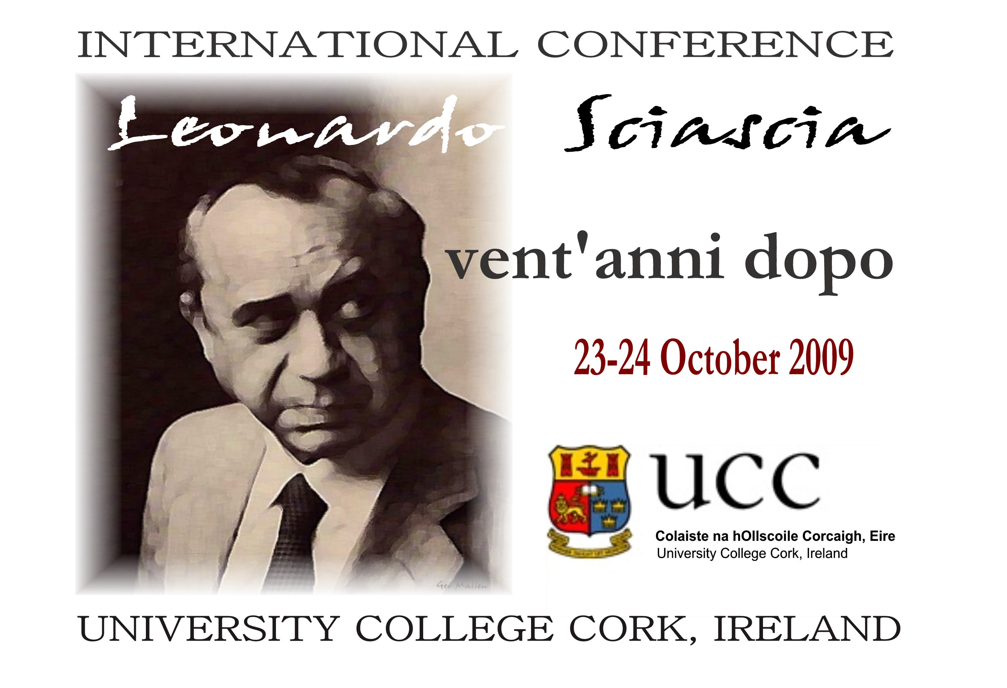

Registration Form
(PLEASE PRINT DETAILS)

Name:

Address:

Email: Tel.:

Cell phone number while in Cork (optional):

Address during conference (optional):

Dietary needs:

Audio-visual requirements (speakers only):

Please tick as appropriate:

Full registration (2 Days)

Day registration, please specify Friday or Saturday

Saturday Evening Conference Dinner

Please complete this form and send to:

Leonardo Sciascia Conference
c/o Department of Italian
University College Cork
Cork
Ireland
Or by email to: sciasciacork2009@gmail.com

