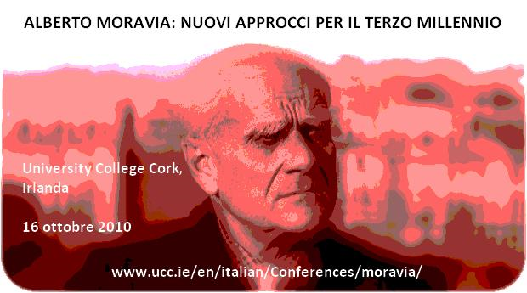

Registration Form
(PLEASE PRINT DETAILS)

Name:

Address:

Email: Tel.:

Cell phone number while in Cork (optional):

Address during conference (optional):

Dietary needs:

Audio-visual requirements (speakers only):

Please tick as appropriate:

Lunch (Saturday): €12

Saturday Evening Conference Dinner: €18

Please complete this form and send to:

Moravia Conference
c/o Department of Italian
University College Cork
Cork
Ireland
Or by email to: MChu@italian.ucc.ie

