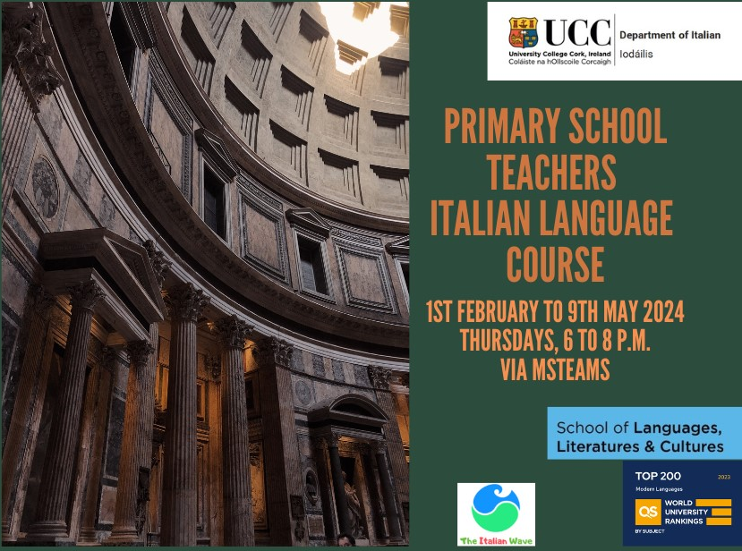

Name of teacher
Teaching Council Number
Email address of teacher
Primary School

Please email this form to:
Gabriella Caponi, gcd@ucc.ie
italian@ucc.ie

