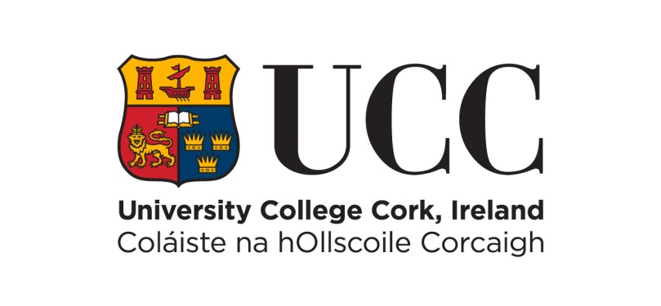
SCHOOL OF HISTORY

ANNUAL PRIZE-GIVING CEREMONY & RECEPTION
MONDAY, 6 MARCH 2023, 2.00 PM, AULA MAXIMA, UCC

PRESENTATION OF PRIZES

History Student of the Year Awards

Year I: Adrian Quinn
Year II: Luke O’Donoghue & Donal O’Connell
Year III: Deborah McMullin

European Studies Student of the Year Awards

Year I: Emily O’Keeffe
Year II: Glen Rothwell
Year III: Aoife Hennessy
Year IV: Emily O’Flynn

European Studies Dissertation of the Year

Emma O’Leary

History of Art Student of the Year Awards

Year I: Amy O’Flynn
Year II: Alison O’Mahony
Year III: Alexandra Borla

Higher Diploma in Arts (History) Student of the Year

Ciara Gimblett

The Leanora Hanrahan Prize in History

Aoife Kelly & Fiona Huggard

The James and Mary Hogan Prize in History

Deborah McMullin

The Dermot Keogh Prize in Irish History

Aimeé Browne

The Geoff Roberts Prize in International History/International Relations

John Hunter

The J.J. Lee History Prize

Nicholas Scollard

The John A. Murphy Prize in Irish History

Laura Shelly & Síofra Buckley

The John B. O’Brien Annual Prize in History

Ailbhe Griffin

The Jennifer O’Reilly Prize in Medieval History

Nicholas Scollard

The Polish Ambassador Prize in History

Stephen Crowley

Polish Ambassador Special Commendation Prize

Jurand Hadrys

Distinction Award

Jack O’Neill

Presentation by Deborah McMullin

Reception to follow

