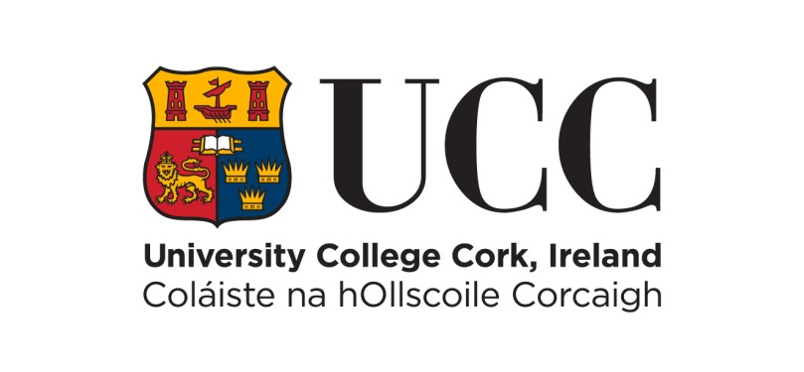
SCHOOL OF HISTORY

ANNUAL PRIZE-GIVING CEREMONY & RECEPTION
MONDAY, 13 JUNE 2022, 2.00 PM, AULA MAXIMA, UCC

PRESENTATION OF PRIZES

History Student of the Year Awards

Year I: Leah Mulcahy, Luke O’Neill & Daniel Kelleher
Year II: Nicholas Scollard
Year III: Martin Kinirons

European Studies Student of the Year Awards

Year I: Glen Rothwell
Year II: Harry Slattery
Year III: Eimear O’Neill
Year IV: Amy Sexton

Trans European Policy Studies Association (TEPSA) EU Essay Prize

Amy Sexton

European Studies Dissertation of the Year

Jack Farr

History of Art Student of the Year Awards

Year I: Shea Fitzgibbon Good
Year II (Joint Award): Alexandra Borla
Year II (Joint Award): Andrea Spoerri
Year III: Lara Ní Chuirrín

Higher Diploma in Arts (History) Student of the Year

Duncan Walker

The Leanora Hanrahan Prize in History

Luke O’Donoghue

The James and Mary Hogan Prize in History

Sarah Cremin

The Dermot Keogh Prize in Irish History

Nicola Carroll

The Geoff Roberts Prize in International History/International Relations

Joseph Linehan

The J.J. Lee History Prize

Olan Daly

The John A. Murphy Prize in Irish History

Martin Kinirons

The John B. O’Brien Annual Prize in History

Michaela Murray

The Jennifer O’Reilly Prize in Medieval History

Richard Keyes McDonnell

The Polish Ambassador Prize in History

Fabrizio Sforza

‘Remembering John A. Murphy’
Presentation by Professor Emeritus Tom Dunne

Reception to follow

