CENTRE FOR MEXICAN STUDIES
DEPARTMENT OF HISPANIC STUDIES

Presents

Professor Susana Quintanilla,
Centre for Advanced Study and Research,
Mexico City

Literatura y Revolución, 1910 - 1926

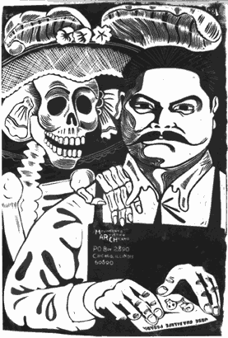
‘Revolución’ by José Guadalupe Posada

Friday 3rd December 2004
ORB 1.85 at 3 pm

Followed by Reception in the Centre for Mexican Studies

All Welcome

