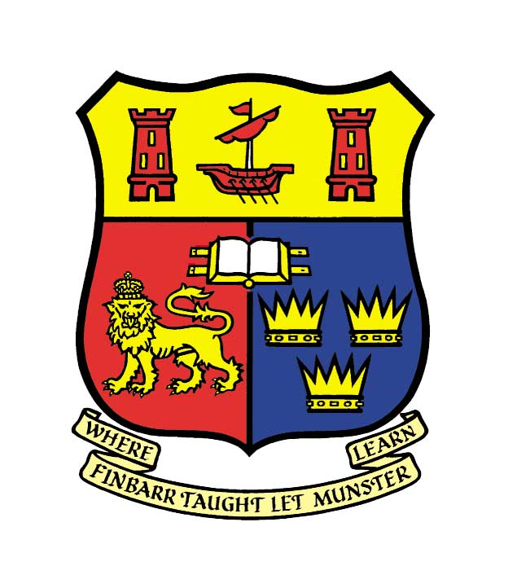
CENTRE FOR MEXICAN STUDIES
DEPARTMENT OF HISPANIC STUDIES - UCC

R E A D I N G

by Mexican Writer and Journalist

JUAN VILLORO
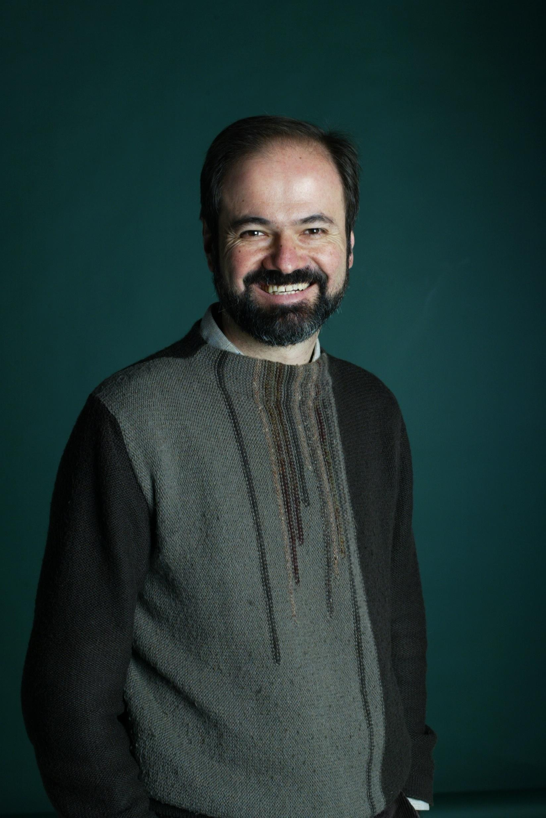

Juan Villoro was born in Mexico City in 1956 and is a writer and journalist. He has been acclaimed both nationally and internationally for his work and has won numerous awards for his fiction including the Premio Villaurrutia, the Premio Mazatlán and the Premio Herralde. He has also won awards for his journalistic endeavours and in 2006 was awarded the International Manuel Vázquez Montalbán for his book of articles on football called Dios es redondo (God is Round).

Juan Villoro will read from a selection of his works.

Reading will be in Spanish but translations will be provided.
__________________________________________________________________________
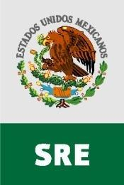
We wish to acknowledge the assistance of the Ministry of Foreign Affairs, Mexico and the Embassy of Mexico, Dublin, in facilitating this visit.

Thursday, 22nd October, 2009 – 11.00 a.m. – ORB 1.56

All Welcome

DEPARTMENT OF HISPANIC STUDIES

R E S E A R C H S E M I N A R

PROF. TERENCE O’REILLY
[Emeritus Professor, Department of Hispanic Studies, UCC]

“Don Quixote and the Hare”

The subject of this paper is the mysterious scene near the end of Don Quixote (Part 2, Chapter 73), in which a hunted hare runs up to the knight and takes refuge under Sancho’s ass. Don Quixote, deeply disturbed, describes the incident as a malum signum. What do his words mean?

___________________________________________________________________________

MR STEPHEN BOYD
[Department of Hispanic Studies, UCC]

“A Catalan in Purgatory: Ramon de Perellós’s ‘Viatge al Purgatori’”

In 1397, the Catalan nobleman, Ramon de Perellós, travelled to Ireland in order to descend into Purgatory at the one place where it was thought possible to do so: Loch Derg, Co. Donegal. The Viatge al Purgatori, written on his return, vividly recounts his experiences in the ‘other world’, but it also describes a journey through the real world of late-fourteenth-century Ireland. This paper will consider the Viatge as historical testimony.

_____________________________________________________________________________

Friday, 6th November, 2009

3.00 p.m.

O’Rahilly Building, Room 1.32

All Welcome
DEPARTMENT OF HISPANIC STUDIES
R E S E A R C H S E M I N A R

MR EOIN BARRETT
[Department of Hispanic Studies, UCC]

“The Argentine Detective Story according to Enrique Anderson Imbert”

In a country that enjoys the most illustrious tradition of crime fiction of any Spanish-speaking country, the manifold contributions of Jorge Luis Borges to the genre are without parallel. The publication of ‘La muerte y la brújula’ in 1942 marked a high point in the so-called ‘Golden Age’ of Argentine detective fiction, and presented a distinct challenge to all those writers who subsequently dared to pick up the bloodied gauntlet. This paper will examine the imaginative manner in which a number of stories by Enrique Anderson Imbert were to successfully respond to this singularly daunting challenge.
___________________________________________________________________________

MR KAREL MATULA
[Department of Hispanic Studies, UCC]

“Velázquez’s ‘Two Men at a Table’:
A Painting of no Consequence?”

Diego Velázquez became a painter in the highly stimulating intellectual milieu of early seventeenth-century Seville, as a protégé of the erudite art theorist Francisco Pacheco, who introduced the young artist to the city¹s intellectual elite, most notably the 3rd Duke of Alcalá. Velázquez seems to have been curiously untouched by these stimuli, given that he launched his artistic career by painting a series of apparently meaningless and trivial genre scenes. However, a closer look at one such painting, Two Men at a Table, shows how misleading it can be to judge only by appearances.
_____________________________________________________________________

Friday, 4th December, 2009

4.00 p.m.

O’Rahilly Building, Room 1.32
All Welcome
CENTRE FOR MEXICAN STUDIES
R E S E A R C H S E M I N A R

DR ANA CRUZ GARCIA
[Department of Hispanic Studies, UCC]

“Lesbian Love: Relationships that Kill and Heal”
This paper examines homosexual and heterosexual relationships in the novel Infinita by woman writer, Ethel Krauze. In a conservative Mexican society, discussions of lesbianism and literary portrayal of the lesbian body are rarely if at all visible. This timid exposure of homosexuality in Mexican women writing goes hand in hand with the ambivalent visibility that feminine writing has received in Mexico since the eighties. With this correspondence in mind, this paper examines the textual exposure of lesbian relationships in Infinita to shed some light on the way they are portrayed or the way they are not.

MR DYLAN BRENNAN
[Department of Hispanic Studies, UCC]

“El Despojo: Rulfo’s Unwritten Screenplay”
Recently returned from Mexico City, where he was researching the lesser known works of Juan Rulfo at UNAM and the Fundación Rulfo, Dylan Brennan is studying for a PhD in Hispanic Studies under the supervision of Prof. Nuala Finnegan. Dylan has completed a BA in Italian and Spanish & Portuguese at Trinity College Dublin (1998-2002), a MA in Cultural Policy and Arts Management at UCD (2003-2004) and a Diploma in Irish Language from NUI, Galway (2006-2008). Dylan’s seminar will focus on Rulfo’s involvement in the experimental short film from 1960 entitled ‘El despojo’.

MS NIAMH McNAMARA
[Department of Hispanic Studies, UCC]

“Moraga and the Mother Figure: Mother Archetypes in the work of Cherrie Moraga”
This paper will focus on the manner in which Mexican mythology has informed lesbian feminist discourse within the Chicano/a community in the United States. In particular it will engage with ideas and works from leading Chicana lesbian feminist and poet Cherrie Moraga who re-imagines these myths in order to re-construct gender roles within the Chicano/a society. The paper is part of a comparative thesis which will investigate the usage of Mexican mythology within two generations of Chicana writers. It will examine the manner in which these myths and archetypes are used in relation to identity and sexuality.

Friday, 11th December, 2009

3.00 p.m. O’Rahilly Building, Room 1.32
All Welcome

DEPARTMENT OF HISPANIC STUDIES
R E S E A R C H S E M I N A R

DR MARIA PALMA FAHEY
[Lecturer, Shannon College of Hotel Management]

“Un ser que no es humano no tiene opiniones, amo: Terms of address in Isabel Allende’s novel ‘La isla bajo el mar’”

In La isla bajo el mar Isabel Allende constructs a fictional world in which slavery and freedom are the main topics. In this paper I will discuss how the terms of address are exploited in the novel, in its narrative and in the dialogues of the characters, in order to convey pragmatic functions that successfully add credibility to its characters and their interactions. Levels of social distance and power are emphasised by the use of these terms and their overall presence contributes to highlight the main themes of this book.

MR MANUEL ESTEVEZ RODRIGUEZ
[Universitat de Barcelona]
“Motivational Aspects of the Formal and Non-Formal Education of Spanish as a Foreign Language”

Inspired by the theoretical framework and research done by authors like Gardner, Dörnyei or MacIntyre on motivation in second language learning, we are going to comment on the results of a modified mini Attitude/Motivation Test Battery (mini AMTB) that has been taken by the students in the University College of Cork. This test looks at the aspects of Future Self, attitudes toward the learning situation, motivation, language anxiety, instrumental orientation, and social encouragement. The study wants to point out the differences and similarities of these variables between the formal (college) and non-formal (evening classes) students of Spanish as a foreign language and possible conclusions and suggestions that this may bring.

Friday, 12th February, 2010

3.00 p.m.

O’Rahilly Building, Room 1.32

All Welcome
DEPARTMENT OF HISPANIC STUDIES
R E S E A R C H S E M I N A R

DR MIGUEL A. GIRALDEZ
[Universidade da Coruña]

“The Reception of Yeats, Synge and Joyce in Galicia and Spain in the Twentieth Century: Some Notes on the Influence of the Irish Literary Revival, ‘Riders to the Sea’ and ‘Ulysses’ on Galician and Spanish Culture”

The influence of Irish literature in Spain and Galicia has been particularly remarkable throughout the twentieth century. Though Joyce’s translations into Spanish may have had the greatest impact, the figure of Yeats and his contribution to a new perspective on Irish nationalism, derived from the achievements of the Irish Literary Revival, was received with great enthusiasm in Galicia, especially among the members of the literary group Nós. Vicente Risco wrote several articles about the transformation of the Irish nation at the turn of the century, highlighting, above all, the similarities between Irish and Galician cultural backgrounds. In the 1920s, Ramón Otero Pedrayo published the first translation of Ulysses into one of the four languages spoken in Spain, the Galician language. He translated but a few pages but certainly his work holds an enormous symbolic value even today. Joyce has always been present in Hispanic culture, mostly among writers living in exile. And Borges himself, for instance, was captured by the extraordinarily complex syntax of the book, despite the fact that he regarded it as a cultural artefact, rather than as a novel. Although the work of Yeats and Lady Gregory had many enthusiastic followers, especially in Galicia, where they were presented to the readership as an example for intellectuals of the time, it was John Millington Synge who actually reached great prestige in Spain. The translation of Riders to the Sea by Juan Ramón Jiménez and Zenobia Camprubí contributed to Synge’s prestige during Spanish Modernism and Postmodernism. Lorca was well aware of every detail of the translation process, attended its staging in Madrid and, as Jean J. Smoot has pointed out, was deeply influenced by John Millington Synge. José Moreno Villa also emphasized that Riders to the Sea was ‘the most beautiful book I’ve seen translated into Spanish’. It is said that Lorca’s visit to Santiago contributed to promoting Synge in Galicia, and the not very well-known translation by Carlos Martínez-Barbeito in 1985 may be the demonstration of such a powerful influence. That interest is still strong today.

Tuesday, 16th February

5.00 p.m.

O’Rahilly Building, Room 1.24

All Welcome
DEPARTMENT OF HISPANIC STUDIES
R E S E A R C H S E M I N A R

DR MARTÍ N VEIGA
[Department of Hispanic Studies, UCC]
“On Hills, Dogs, and Donkeys: Valparaíso Through the Eyes of Eduardo Blanco Amor”
Mostly celebrated for his fictional work, Eduardo Blanco Amor’s literary production shows surprising genre versatility, but his journalistic writings have not received enough critical attention. A good example would be Chile a la vista (1951), a compilation of articles based on his travels around Chile between 1948 and 1950. This research seminar will examine the central section of the book, Blanco Amor’s account of his trips to Valparaíso. His portrait of Valparaíso combines the detailed observation of daily life in the city with an attempt to lyrically interpret his experience of the place. The seminar will also analyse the narrative strategies developed by Blanco Amor to project the image of a city that fascinated him from his first, and unforeseen, visit.
___________________________________________________________________________
MR ADRIAN HEALY
[Department of Hispanic Studies, UCC]
“Frei Martín Sarmiento, The ‘Estudios Reales de San Isidro’ and the Iberian Pedagogical Debate of the 18th Century”
This paper shall primarily discuss the stagnation of the educational system in Spain, and indeed Europe as a whole, during the 17th and 18th centuries. The Spanish state intervened in the pedagogical debate of the eighteenth century and some improvements and changes were brought about under the guidance of Carlos III. The legislations of 1770 included the creation of the Reales Estudios de San Isidro as a alternative replacment to the old Colegio Imperial. Indeed education in the 18th century was to become the result of a combination of three motives : religious, intellectual and utilitarian. Sarmiento was such an important and prominent figure in the Iberian pedagogical enlightnment, as he encompassed all three of these motives. This paper aims to examine the importance and relevance of Sarmiento's pedagogical arguments by considering the MS Sobre Methodo de Estudios (1769), which discusses proposals for the curriculum of the Reales Estudios de San Isidro.
_____________________________________________________________________
DR RUBÉN JARAZO-ÁLVAREZ
[Department of Spanish, NUI-Galway]
“English, Irish and American Poets in Galician Periodical Press: Francisco del Riego and Álvaro Cunqueiro in ‘Faro de Vigo’ 1961-1981”
Contemporary poetry, as we will try to demonstrate in this case study, has been essential for scholars and critics in favour of free speech and against cultural repression during Spanish Dictatorship. In this sense, professionals from peripheral regions such as Catalonia, Basque Country and Galicia were in favour of foreign texts and their reception in Spanish culture as an infallible method to reveal Twentieth century Spanish culture from obscurantism. In this paper we will focus on the reception of literary texts produced by the many significant English, Irish and American poets translated in the Spanish literary panorama, paying special attention to those translations and reviews produced by Álvaro Cunqueiro and Francisco del Riego. Besides, we will also take in consideration issues which arise from the corpus selected, such as misogyny, homosexuality, feminism, Marxism, atheism, topics which in the end are immersed in the poetry translated during Franco’s Dictatorship

Friday, 5th March, 2010

3.00 p.m. - O’Rahilly Building, Room 1.32 - All Welcome
DEPARTMENT OF HISPANIC STUDIES, UCC
in conjunction with the Instituto Cervantes, Dublin, and the Cork City Library
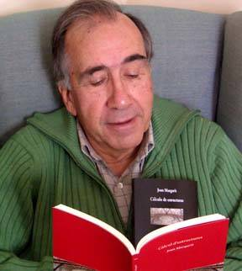

Invite you to a

P O E T R Y R E A D I N G

by acclaimed Catalan poet

JOAN MARGARIT

Joan Margarit (1938) is one of the leading figures of contemporary Catalan poetry. He is also an architect, and from 1968 until his retirement was Professor of Structural Calculations at Barcelona’s Technical School of Architecture. His work has received important literary awards such as the Premi Carles Riba, Premi de la Crítica Serra d’Or, Premi Nacional de Literatura (Generalitat de Catalunya), Premio Rosalía de Castro, and Premio Nacional de Poesía. Recent poetry collections include Estació de França (1999), Els primers freds. Poesia 1975–1995 (2001), Joana (2002), Càlcul d’estructures (2005), Casa de Misericòrdia (2007), and Misteriosament feliç (2008). Anna Crowe has translated his poetry into English: Tugs in the Fog: Selected Poems (Bloodaxe Books, 2006).

Monday 22nd March, 2010

7:00 pm

Cork City Library, Grand Parade, Cork

Reading will be in Catalan but English translations will be provided

All Welcome – Admission Free
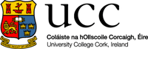
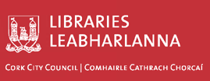
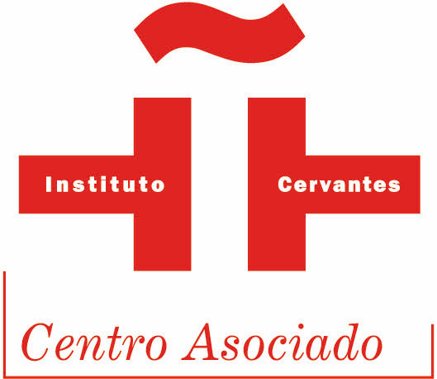

DEPARTMENT OF HISPANIC STUDIES, UCC
in conjunction with the Instituto Cervantes, Dublin, and the Cork City Library

Invite you to a

P O E T R Y R E A D I N G

by Galician Poets

MARILAR ALEIXANDRE & CHUS PATO
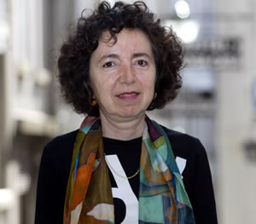
Marilar Aleixandre (Madrid, 1947) is a novelist, poet and translator. Since 1973 she has been living in Galicia, and has adopted Galician as her literary language. She has gone to become one of the most famous and awarded Galician writers, excelling particularly at children’s literature.

I use Galician as my literature language because I have a forked tongue, although not all the creatures with a cleaved tongue are evil. I think that all the stories and poems are messages written with ink, spit or blood, which we throw to the void wishing that someone would get them.(Marilar Aleixandre)

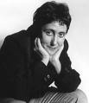
Chus Pato (Ourense, Galicia, 1955) is an acclaimed poet. All of her work is written in Galician, and her poetry colections m-Talá and Charenton have been translated into English by Erin Moure and published by Shearsman Books. Politically engaged, Chus Pato is a member of PEN Club Galicia and of Redes Escarlata, a leftist cultural group that supports independence for Galicia.

My autobiography? It does not always seem to be mine, sometimes I would rather have other lives. Insofar as all autobiography participates in fiction, I prefer not to be forced to choose, so I opt not to have one. (Chus Pato)

Thursday, 27th May, 2010

6:30 p.m. - Cork City Library, Grand Parade, Cork

Readings will be in Galician but English translations will be provided,
plus traditional music from Galicia & Ireland by Louise Cronin,
Fidelma Hanrahan, Caitríona Ní Chatháin and Isaac Xubín

All Welcome – Admission Free
