CENTRE FOR MEXICAN STUDIES
DEPARTMENT OF HISPANIC STUDIES - UCC

R E A D I N G

by Mexican Writer

ANA GARCÍA BERGUA

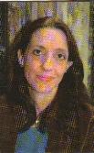
Ana García Bergua was born in Mexico City in 1960. She is widely known in Mexico as a journalist and her weekly column ‘Y ahora paso a retirarme’ (‘And now I’m off to retire’) in Mexico’s La Jornada Semanal is much acclaimed. Her award-winning first novel, El umbral: Travel and Adventures (The Threshold 1993) was followed by the intriguing Púrpura (Purple) in 1999; Rosas Negras (Black Roses) in 2004 and her most recent work, La isla de bobos (The Island of Fools 2007). She has worked in the theatre as a set designer, carried out historical research with the publishing house Clio, and, is a regular contributor to newspapers and journals in Mexico.

_______________________________________________________________________________
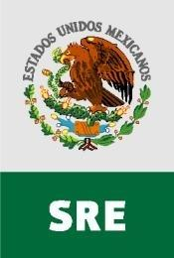
Sponsored by the Ministry of Foreign Relations and the Embassy of Mexico in Ireland.

_______________________________________________________________________________

Friday, 31st of October, 2008 – 2.00 p.m. – Boole 1

For anybody wishing to meet with Ana, the Centre for Mexican Studies will host a lunch in O’Rahilly Building, ORB 1.51 at 1 p.m.

DEPARTMENT OF HISPANIC STUDIES
& THE BOARD OF FILM STUDIES - UCC

R E S E A R C H S E M I N A R

ALFREDO MARTINEZ-EXPOSITO
[University of Queensland, Australia]

“The Image of Spain in Contemporary Spanish Cinema: Branding the Nation, Branding Places”

Theories related to ‘place branding’ – such as nation, region or city branding – provide an exciting new approach to the study of cinematic representations of human communities. In recent years, producers and investors have become increasingly aware of the branding potential of the film industry. A reading of contemporary Spanish film from this perspective reveals a progressive but radical shift from promotional to branding agendas during the 1990s. In this talk, Alfredo Martinez-Exposito will comment on films by some of the most internationally acclaimed Spanish filmmakers and film stars – including Pedro Almodóvar, Penélope Cruz and Javier Bardem – as well as films from regional centres in Barcelona and the Basque Country. The talk will seek to assess the contribution of Spanish cinema – the 6th world film market – to the successful repositioning of Brand Spain as one of the most desired destinations in recent years.

_____________________________________________________________________________

Alfredo Martinez-Exposito is Chair of Hispanic Studies and Head of the School of Languages and Comparative Cultural Studies at the University of Queensland, Australia, past President of the Association for Iberian and Latin American Studies of Australasia and Fellow of the Australian Academy of the Humanities. He has published extensively on Spanish contemporary literature and film and on the geopolitics of the Spanish Language. He has delivered talks on these topics at conferences and universities in Australia, New Zealand, Hong Kong, the Philippines, the United States, Britain and Spain. He has recently published the monograph Live Flesh: the Male Body in Contemporary Spanish Cinema (I.B. Tauris, 2007) with Santiago Fouz (Durham University) and Ten Reasons to Learn and Teach Spanish (Embassy of Spain in Canberra).

_______________________________________________________________________________

Friday, 6th of February, 2009

3.00 p.m.

O’Rahilly Building, Rm.1.23

DEPARTMENT OF HISPANIC STUDIES, UCC

R E A D I N G

ENRIQUE VILA-MATAS


Enrique Vila-Matas is one of the Spain’s most renowned contemporary writers of fiction. His books have been translated into 29 languages including English. Of note amongst his literary works are: El viajero más lento, Impostura, Historia abreviada de la literatura portátil, Una casa para siempre, Suicidios ejemplares, Hijos sin hijos, Recuerdos inventados, Lejos de Veracruz, Extraña forma de vida, París no se acaba nunca, Doctor Pasavento (Fundación Lara Prize 2006)), El viaje vertical (winner of the Rómulo Gallegos Prize, 2001), and Exploradores del abismo.. He is currently working on Dietario voluble. The author will read passages from two of his best-known novels: Bartelby y compañía (Ciudad de Barcelona Prize, Prix du Meilleur Livre Étranger, Prix Fernando Aguirre-Libralire), available in English as Bartleby & Co and El mal de Montano (Herralde Prize, Nacional Critics Prize, Prix Médicis étranger 2003, Premio Internazionale Ennio Flaiano), translated into English as Montano’s Malady. Translations will be read by Matthew Sweeney.

* * * * * * * * * * * * * * * * * * * * * * *

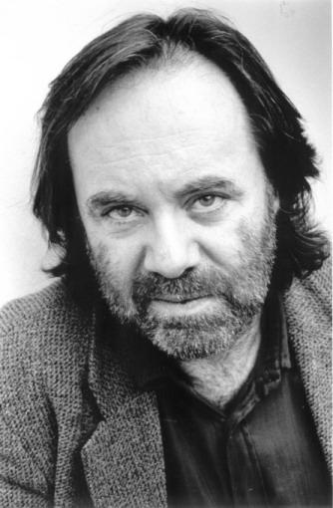
MATTHEW SWEENEY

Matthew Sweeney was born in Donegal in 1952. His poetry collections include A Dream of Maps (1981), A Round House (1983), Blue Shoes (1989), Cacti (1992), The Bridal Suite (1997) and A Smell of Fish (2000). Selected Poems, representing the best of 10 books and 20 years' work, was published in 2002. He has also published poetry for children, collections including The Flying Spring Onion (1992), Fatso in the Red Suit (1995) and Up on the Roof: New and Selected Poems (2001). His novels for children include The Snow Vulture (1992) and Fox (2002). Sweeney has held residencies at the University of East Anglia and the South Bank Centre in London, and was Poet in Residence at the National Library for the Blind as part of the 'Poetry Places' scheme run by the Poetry Society in London. He won a Cholmondeley Award in 1987 and an Arts Council Writers' Award in 1999. His latest poetry collections are Sanctuary (2004) and Black Moon (2007), the latter shortlisted for the 2007 T. S. Eliot Prize.
_______________________________________________________________________________

Friday, 13th of March, 2009 – 2 p.m. – Boole 1

All Welcome

