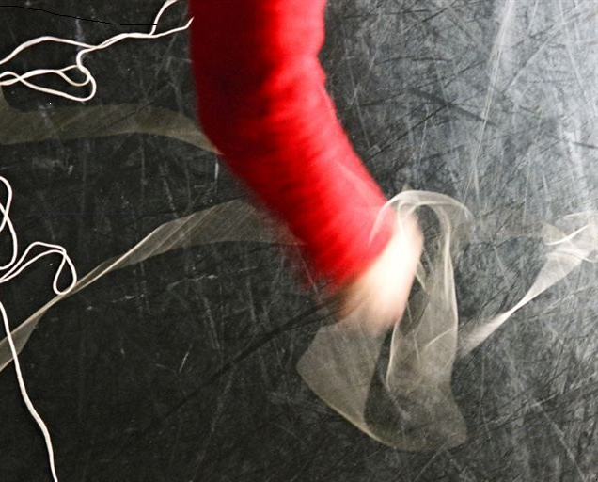

Department of Hispanic Studies Research Seminar Programme 2010-2011*

Friday 15th October Helena Buffery (UCC) – Exile in-translation: the case of the Catalan/Mexican Republican dramatist Maruxa Vilalta

Friday 29th October Rhiannon McGlade (University of Sheffield) – Tísner in Exile: Continuing a Rich Tradition

Friday 12th November Francis Lough (University of Birmingham) – Fictional Representations of the Spanish Civil War

19th-21st November Golden Age Research Symposium

Friday 26th November Niamh McNamara (UCC) – (Chicano Studies) – CANCELLED.

Friday 3rd December Terence O’Reilly (UCC) – Book launch: The Bible in the Literary Imagination of the Spanish Golden Age: Images and Texts from Columbus to Velázquez (2010)

Friday 17th December Duncan Wheeler (University of Leeds) – La dama duende adapted
in exile in Argentina

Friday 14th January Anita Howard (ex-UCC) – Book launch: The King Within: Reformations of Power in Shakespeare and Calderón (2010)

Friday 21st January Seana Ryan (UCC) – Javier Marías

Friday 4th February Martin Cunningham (UCD) – Alfonso's Cantiga nº 2 "Muito devemos, varões": the Long and the Short of it

Friday 18th February Catherine Boyle (KCL) – Latin American theatre

Friday 4th March Bruce Swansey – Mexican literature – second generation exiles

Friday 11th March PhD research presentations: Emer Clifford and Kamila McKann

Friday 18th March MA Presentations

Friday 25th March Michael d'Emic (UCC) – (Golden Age economic theory)

31st March-1st April Symposium on ‘Invisible Borders: Rethinking Translation and Minority’

24th-25th June Conference: ‘Transitions and Continuities in Contemporary Chicano/a Culture’

*Titles will be finalised in the course of the academic year. Contact Dr Helena Buffery for further information (H.Buffery@ucc.ie).

