LAS ORILLAS DE LAS COSAS
REFLECTIONS ON THE WORK OF JUAN RULFO
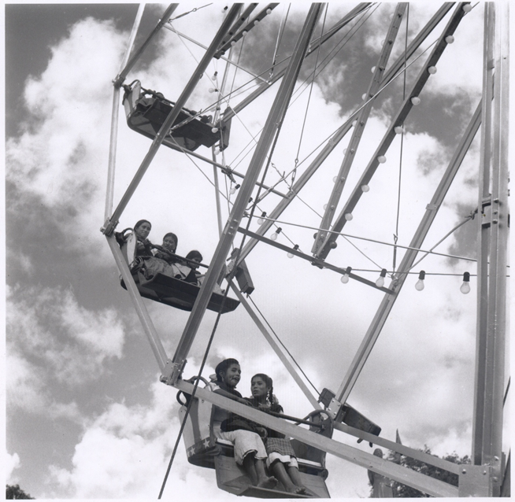
CENTRE FOR MEXICAN STUDIES
University College Cork, Ireland
29th March 2012
All talks held in the College Seminar Room, Ground Floor, Block B East, O’Rahilly Building
9:30am - Registration & Coffee
Seating Area, Ground Floor, Block B East, O’Rahilly Building
10:00 - 11:00 a.m.
DOUGLAS J. WEATHERFORD, Brigham Young University, Utah
‘Searching for Juan Rulfo in Emilio Fernández’

11:00 a.m. - 12:00 noon
DANIELE De LUIGI, Curator and Critic, Bologna
‘Juan Rulfo without words’
12:00 - 1:00 p.m.

STEPHEN MCNEFF, Composer, London
‘On Pedro Páramo the opera’
1 p.m. - Lunch
Seating Area, First Floor, Block B East, O’Rahilly Building
2:00 – 3:00 p.m.
PAULINA MILLÁN, Universidad Nacional Autónoma de México
‘La fotografía de Juan Rulfo’
3:00 – 3:45 p.m.
DYLAN BRENNAN, Centre for Mexican Studies, University College Cork
‘The Mexican Revolution – as photographed by Juan Rulfo’
3:45 p.m. – 4:15 p.m. - Coffee
Seating Area, Ground Floor, Block B East, O’Rahilly Building
4:15 – 5:00 p.m
BILL RICHARDSON, National University of Ireland Galway
‘Allí en la tierra estaba toda su vida: patterns of place and space in the work of Rulfo’
Workshop Close
Reception & Dinner for Symposium participants

