LAS ORILLAS DE LAS COSAS
REFLECTIONS ON THE WORK OF JUAN RULFO
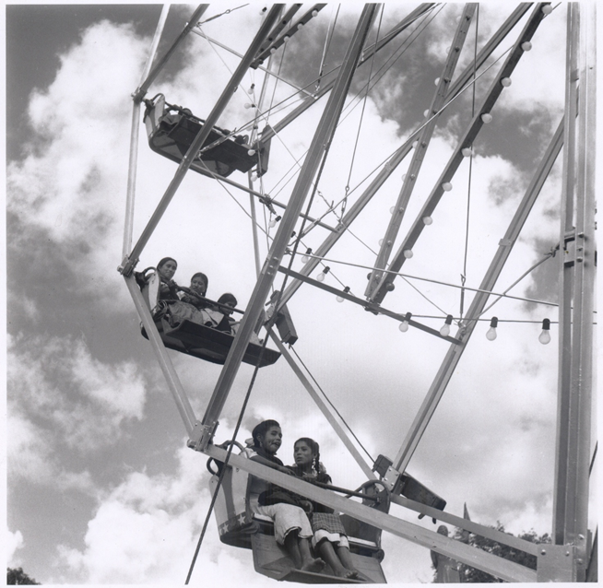

CENTRE FOR MEXICAN STUDIES
University College Cork, Ireland
29th March 2012

College Seminar Room, Ground Floor, Block B East, O’Rahilly Building

9:30 a.m. Registration & Coffee
Seating Area, Ground Floor, Block B East, O’Rahilly Building

10:00 – 11:00 a.m.
SPEAKER: Douglas J. Weatherford, Brigham Young University, Utah
TITLE: ‘Searching for Juan Rulfo in Emilio Fernández’

Rulfo’s most enduring contribution to Mexican cinema rests on his work as a writer. Rulfo created brief scripts for two short films (El despojo and La fórmula secreta), assisted with the script for at least one other film (Los confines), and wrote a number of texts—both completed (El gallo de oro) and left unfinished—that were intended for the big screen. One of Rulfo’s more unique —and yet barely understood— roles as a scriptwriter involves a project that he worked on in conjunction with Emilio Fernández.
The two worked together on a script that Fernández would not film until December of 1962. Fernández had high hopes for this project, that he titled Paloma herida. The picture contained many of the visual and thematic elements that had made popular so many of his earlier works and it boasted in the opening credits the name of Juan Rulfo who, by that time, was a well-known figure among Mexico’s literary elite. Nonetheless, Paloma herida enjoyed only modest commercial success and failed to salvage Fernández’s career. Additionally, through the years, the film has suffered a form of erasure from the canon of Rulfo texts: critics have largely ignored the piece while Rulfo himself denied having played any real part in the creation of the screenplay. My study is an attempt to discover the presence (and at times the absence) of Juan Rulfo in Emilio Fernández and to ask whether Paloma herida can or should be recovered as a Rulfo text.

11:00 a.m.- 12:00 noon
SPEAKER: Daniele De Luigi, Curator and Critic
TITLE: ‘Juan Rulfo without words’
The fame of Rulfo as a man of letters was decisive in drawing attention to his photographic production and discovering its value. On the other hand, this same aspect has often trapped interpretation of his images within the context of his narrative work. The criticism, pursued by the identity of literary and photographic subjects in his oeuvre, often aimed to establish structural and expressive analogies between his verbal and iconic language, sometimes through the tools of semiotics. Even if every creation by an artist has its roots in his own and unique cultural universe, actually photography is irreducible to the realm of verbal language and Rulfo, whom we know to have possessed a solid technical understanding, a rich personal bibliography in the subject and a utter coherent style, seems to have been well aware of that. As a result of that, his photographs should be considered following the rules of visual language and within the context of photographic production of his time, maybe to get new perspectives on his literary work.

12:00 – 1:00 p.m.
SPEAKER: Stephen McNeff, Composer
TITLE: ‘On ‘Pedro Páramo’, the opera’
Stephen McNeff was introduced to the work of Juan Rulfo in 2006 when he was commissioned by the Mexican pianist, Ana Cervantes to contribute to her recorded collection of solo piano works inspired by Pedro Páramo. The result was the Pavane for Dona Susanita which was premiered at the Cervantino Festival in Guanajuato in 2006 and which has since been broadcast and performed extensively throughout the Americas. He started work on an operatic adaptation of Pedro Páramo in 2009 and the first section – which he will discuss today – was developed in collaboration with the Royal Opera House, Covent Garden as part of their opera development programme and shown in their Exposure season in 2011. The completed opera is due to be premiered in 2015 by The Opera Group – England’s leading company producing new operatic work. A co-production between TOG and a Mexican company is planned. Along with Frederic Wake Walker, TOG’s Artistic Director, Stephen McNeff has recently returned from a research trip to Mexico (funded by the Anglo Mexican Foundation) where they explored venues and met with Juan Francisco Rulfo, the Rulfo Foundation and other collaborators to discuss further approaches to the project. Future projects include The Chalk Legends for the Bournemouth Symphony Orchestra which will premiere in May 2012, a CD of his orchestral music with the BSO and a CD of his vocal settings of the Italian poet Gabrile D’Annunzio, and continuing work on another operatic project based on Giles Foden’s novel, The Last King of Scotland. Stephen McNeff will illustrate his discussion with audio and audiovisual clips of the development workshops carried out last year.
1 p.m. Lunch
Seating Area, First Floor, Block B East, O’Rahilly Building

2:00 – 3:00 p.m.
SPEAKER: Paulina Millán, Universidad Nacional Autónoma de México
TITLE: ‘La fotografía de Juan Rulfo’
I will deal with the trajectory of Rulfo’s photography from 1932 to 1962 explaining why I have divided it into two periods. I will explore the characteristics of each period and investigate both the photographic techniques and aesthetics. I will deal with different photographic genres and analyse some of the most relevant series. Finally, I will set out the dissemination of Rulfo’s photography in his own lifetime between the years of 1949 and 1980 in books, magazines, newspapers, leaflets and exhibitions. It is important to note that I will not engage in a comparative study of Rulfo’s photography and literature but, rather, will examine the photography of Rulfo through the images that he created and his work as photographer.

3:00 – 3:45 p.m.
SPEAKER: Dylan Brennan, Centre for Mexican Studies, University College Cork
TITLE: ‘The Mexican Revolution -as photographed by Juan Rulfo’
Born in 1917, Juan Rulfo, of course, never photographed the Mexican Revolution (1910-1921). Nevertheless, his photography was used to illustrate Félix Manzano´s “Nueva Historia de la Revolución Méxicana” published in Sucesos para Todos from 1963-1964. The photographs used for these publications were taken in 1955 on the set of Roberto Gavaldón´s film La Escondida where Rulfo was employed as an advisor on historical accuracy. While on set Rulfo took between 170 and 180 shots of the principal actors, extras and made excursions in the surrounding area. The shots of featured in the “Nueva Historia de la Revolución Méxicana” will be examined in the context of photographs of the Revolution that featured in the illustrated press during the years of conflict. The “staged photograph” (or “the hallucination of truth” as Jean Baudrillard would have it) was common throughout the Revolution and U.S. intervention. Naturally, the idea of the ´staged´ presented as the ´real´ is problematic and, in this discussion, particular attention will be paid to the relationship between Rulfo’s photographs and the notion of the simulacrum and the ´hyperreal´.
3:45 p.m. – 4:15 p.m. Coffee
Seating Area, Ground Floor, Block B East, O’Rahilly Building

4:15 – 5.00 p.m.
SPEAKER: Bill Richardson, National University of Ireland Galway
TITLE: ‘Allí en la tierra estaba toda su vida: patterns of place and space in the work of Rulfo’
The theme of spatiality looms large in the work of Juan Rulfo, and the many facets of the human experience of place and space are reflected in his writings. I want to suggest a framework for examining the relevance of spatiality to literature, and propose to exemplify this with reference to Rulfo’s work. Thus, a wide range of issues come into play, from the relative abstraction of notions of an individual’s location within the greater cosmos, to the concrete experience of actual places, and from the sense of a person’s journey in search of ways to establish identity and relate to the past, to the significance of collective understandings of what places mean and of how societies can be transformed through political action. Within this framework, the work of Rulfo is seen to offer intriguing insights into the nature of human spatiality, while by highlighting spatial themes we can draw attention to some key aspects of works such as Pedro Páramo and El llano en llamas.

Workshop Close
Reception & Dinner for Symposium participants

