Tom O’Connor Working Paper Series
Department of Government, UCC

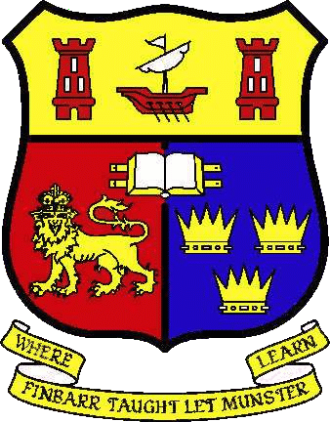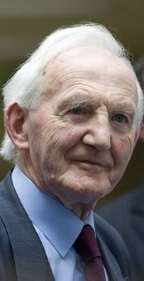

‘JFK and the Freedom of Cork’

Aodh Quinlivan and Pádraig Mac Consaidín

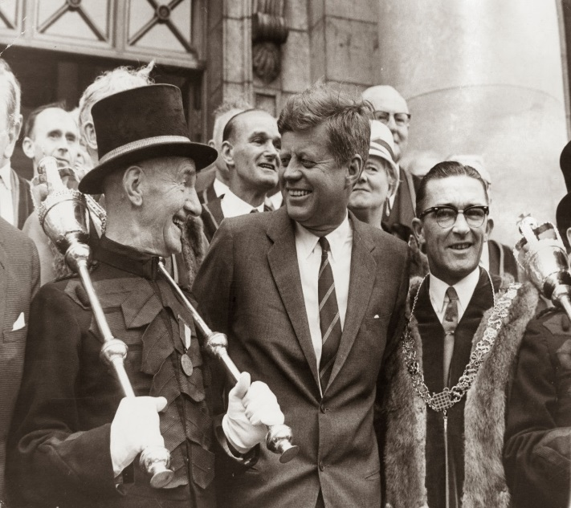

No. 42, November 2014

JFK and the Freedom of Cork

By Aodh Quinlivan & Pádraig Mac Consaidín

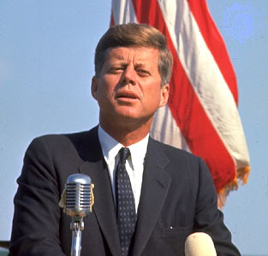

Elected as Freeman of Cork on 11 June 1963
Conferred as a Freeman of Cork 28 June 1963

‘In token of our pride that this descendant of Irish emigrant’s should have been elected to such an exalted office, and of our appreciation of his action in coming to visit the country of his ancestors; as a tribute to his unceasing and fruitful work towards the attainment of prosperity and true peace by all the people of the world; and in recognition of the close ties that have always existed between our two countries.’

Biography
The most famous recipient of the freedom of Cork, John Fitzgerald Kennedy, was born on the afternoon of 29 May 1917 in Brookline, Massachusetts. The Kennedys were already one of Americans most well-known families in 1917. His father, Joe was ‘ambitious and wealthy’ and his mother, Rose, was the daughter of John ‘Honey Fitz’ Fitzgerald, ‘one of Boston’s most colourful and mercurial characters’, the first Irish-American to be elected Mayor of Boston. Young John, known as Jack to his family and friends, had a privileged childhood and, having started his formal education at the local public school, Edward Devotion, he was sent, aged seven, to a local private school, Dexter, along with his older brother, Joe. Jack later said of his childhood, ‘it was an easy, prosperous life, supervised by maids and nurses, with more and more younger sisters to boss and to play with’. In fact, Jack had eight siblings in total, three brothers (Joe, Robert and Edward) and five sisters (Rosemary, Kathleen, Eunice, Patricia and Jean). The main frustration of Jack’s childhood was fragile physical health and he fell prey to the standard illnesses of bronchitis, chicken pox, German measles, measles, mumps, scarlet fever, and whooping cough. When Jack was aged 10, the Kennedy family moved to New York and he studied at Canterbury School and later at Choate, ‘an exclusive boarding school in Connecticut’. He was ‘an average student who was fascinated by history and English, but not remotely so by mathematics or the sciences’. While at Canterbury (at the age of 13), Jack ‘began to suffer from an undiagnosed illness that restricted his activities’. Thus began many colon-related illnesses and he was later greatly restricted by back problems.

In his youth, Jack was constantly ‘in the shadow of his irrepressible brother, Joe’ for whom his father had great ambitions and expectations. Jack followed his brother to Harvard, ‘despite being 65th in a class of 110’ at Choate. He studied ‘at his own pace’ and his ‘greatest success in his first two years at Harvard was in winning friends and proving to be “a lady’s man”’. In the later years of his degree, Jack became more diligent as he increasingly focussed on the study of international relations. His 1940 thesis ‘Appeasement in Munich’ became a bestseller when he published it as a book entitled Why England Slept (mirroring Churchill’s While England Slept).

After graduating from Harvard with a degree in international relations, Kennedy had no specific career plans but he embarked on a tour of Latin America and Europe – ‘His travels during this period would mold his understanding of world politics, such as the threat of Communism, which was spreading to developing countries’. On his return he joined the navy in October 1941 after ‘the board of medical examiners miraculously gave him a clean bill of health’, ignoring his chronic colon, stomach, and back problems. Kennedy emerged from World War II as a national hero when ‘he saved his crew members on a patrol boat, PT-109, which was rammed and sunk by a Japanese destroyer’. For his heroics, Kennedy was presented with the Navy and Marine Corps Medal. Tragically, Kennedy’s brother, Joe, did not survive the war after his plane exploded over Southern England in 1944. Joe was being groomed for a political career by his father, Joe Sr., and attention now shifted to Jack. Joe Sr. informed Jack that his brother was dead ‘and that it was therefore his responsibility to run for Congress’.

In the winter of 1944/’45 Kennedy was forced to leave the navy to recuperate from back surgery and he began to contemplate a political career. He was acutely aware of what he regarded as his family responsibilities and, later in life, as a U.S. senator, he explained, ‘just as I went into politics because Joe died, if anything happens to me tomorrow, my brother Bobby would run for my seat in the Senate. And if Bobby died, Teddy would take over from him’. Kennedy went on a European tour in the summer of 1945, which included a visit to Ireland, the country of his ancestors.

The following year, his political career commenced in earnest when he was elected as a Democrat to Congress (Massachusetts, 11th District) even though the elections ‘produced a national and state-wide Republican tidal wave’. Kennedy started work as a congressman in Washington in January 1947; nobody was in any doubt that this was little more than a first step. John Galvin, who was Kennedy’s public relations director for the election, recalled that the Kennedys were ‘always running for the next job’. Kennedy could not be accused of lacking ambition and ‘the possibility of becoming the first Catholic president intrigued him from the start of his political career’. He served in Congress for six years before taking another step forward in 1952, by winning a seat in the Senate. The following year he married Jacqueline Lee Bouvier in ‘a celebrity affair attended by the rich and famous and numerous members of the press, who described it as the social event of the year – the marriage of “Queen Deb” to America’s most eligible bachelor’.

Following his election to the Senate, Kennedy was effectively in campaign mode for the 1960 presidential election, eight years later. His already high profile received a further boost when he was awarded the Pulitzer Prize for his 1956 book, Profiles in Courage, recounting his war experiences. Kennedy, however, continued to be plagued by health issues. He was frequently absent from the Senate as he recovered from serious spinal operations and his medical records from the time show that he had ‘zero flexion and extension of his back, with difficulty reaching his left foot to pull up a sock, turn over in bed, or sit in a low chair. Biographer Robert Dallek (2003) notes,

The treatments for his various ailments included oral and implanted cortisone for Addison’s disease and massive doses of penicillin and other antibiotics to combat prostatitis and abscess. He also received anaesthetic injections of procaine at trigger points to relieve back pain, antispasmodics – principally, Lomotil and Trasentine – to control the colitis, testosterone to bulk him up or keep up his weight (which fell with each bout of colitis and diarrhoea), and Nembutal to help him sleep. He had terribly elevated cholesterol – apparently caused by the testosterone – which may also have heightened his libido and added to his stomach and prostate problems.

Nonetheless, despite all of these problems, ‘on 8 November 1960, Kennedy beat Richard Nixon in one of the most closely fought Presidential elections of the 20th century’. Out of 68 million votes cast, Kennedy only received 113,000 more votes than his opponent, ‘which translated into a victory by a margin of 303 to 219 in the electoral college’. One of the interesting dimensions of the 1960 presidential election campaign was that Kennedy and Nixon participated in the first televised presidential debate in history, ushering in ‘a new era in which crafting a public image and taking advantage of media exposure became essential ingredients of a successful political campaign’. The medium of television undoubtedly worked well for Kennedy who came across as believable, ‘unlike Nixon, who never overcame a reputation for deceitfulness’. Robert Dallek (2003) states, ‘Kennedy’s manner – his whole way of speaking, choice of words, inflection, and steady gaze – persuaded listeners to take him at his word. And the public loved it’.

John F. Kennedy was sworn in as the 35th President of the United States on 20 January 1961. Aged 43, he was the youngest person ever elected American President and, of course, he was the first Catholic holder of the office. In his inaugural speech he spoke of the need for all Americans to be active citizens – ‘Ask not what your country can do for you, ask what you can do for your country.’ He also asked the nations of the world to join together to fight what he called the ‘common enemies of man: tyranny, poverty, disease, and war itself’. With his glamorous wife and two young children, Caroline born in 1957 and John Jr., born in 1960 (Jackie gave birth to a stillborn baby girl in August 1956 who the couple intended to name Arabella; Patrick was born in August 1963 but died after two days), ‘President Kennedy brought a new youthful, spirit to the White House’.

Tragically, Kennedy’s reign as President was short, but no less dramatic, in his position as a Cold War leader. Less than four months into his presidency, he oversaw the disastrous invasion of Cuba. The CIA-led Bay of Pigs invasion had the aim of instigating an uprising amongst Cuban people in the hopes of overthrowing Fidel Castro, but it back-fired badly with the majority of the U.S.-trained invaders killed or captured. The young President was then tested enormously during the Cuban Missile Crisis which was ‘sparked by the discovery of Soviet nuclear missiles in Cuba on 18 October 1962, just 100 miles from American soil’. Tubridy (2010) records that ‘the crisis lasted 13 days and brought the world to the brink of nuclear war before its eventual resolution’. The resolution to the crisis showed off Kennedy’s diplomatic skills at their best.

Domestically, Kennedy’s presidency could not be classified as overly-successful, ‘many of the Democratic Southern conservatives in Congress often joined the Republicans in opposing Kennedy’s proposals for civil rights legislation, programmes for the aged, Medicare, and federal aid for education’. However, President Kennedy did establish the Peace Corps and he ‘was the first President to ask Congress to approve more than 22 billion dollars for Project Apollo, which had the goal of landing an American man on the moon before the end of the decade’. In addition to this, in January 1962, answering President Kennedy’s call for an elite new force that would perform clandestine operations in a maritime environment, the U.S. Navy established two teams calling them Navy SEALs (40 nine years later, it was a team, working under the original framework Kennedy envisaged, which eventually killed Osama Bin Laden, the mastermind behind the September 11, 2001 terrorist attacks on the United States).

Ultimately John F. Kennedy’s vast potential to be a world-wide force for good as American President was never realised; he was assassinated in Dallas, Texas on 22 November 1963 by Lee Harvey Oswald. Two days later, while in police custody, Oswald was shot dead by Jack Ruby. Kennedy’s death – described by Dallek as ‘a triumph of the worst in human relations over the promise of better times’ – shocked the world and he was deeply mourned in Ireland, where he had visited five months earlier.

Hundreds of thousands gathered in Washington for the President’s funeral, with millions throughout the world watching on television. He was laid to rest at Arlington National Cemetery in Virginia. At the request of his widow, Jackie, 26 Irish cadets participated in the military ceremony at the graveside. Arabella and Patrick were re-buried alongside their father. The disinterment of the children’s remains before their burial at Arlington National Cemetery was overseen by Cardinal Cushing, who was also a recipient of the freedom of Cork.

Freedom of Cork
Initially, the visit of President Kennedy to Ireland did not include a trip to the southern capital, but Kennedy asked for it to be included. His Press Secretary, Pierre Salinger, recalled how the President had called him into his office and told him that he must visit Cork. Salinger speculated that this was because Cork was a direct part of his family heritage as his ancestors on the Fitzgerald side came from the county. Therefore, when the news broke publicly on Monday morning 20 May 1963 in the Cork Examiner, that a visit to Cork had been included in the itinerary, a sense of anticipation began to grip the city. The Lord Mayor, Alderman Seán Casey said he was delighted that the President would visit Cork, ‘I know the corporation will be unanimous in extending every possible honour to him that the city can give. We look forward to his visit and he can be assured of a real Cork welcome’. Expectation was heightened further when a front page story in the Cork Examiner on 27 May proclaimed ‘Top Kennedy Men For Cork This Week’; the article went on to advise that President Kennedy’s Secretary, Kenny O’Donnell, and White House Press Officer, Pierre Salinger, would be making a visit to discuss the President’s upcoming visit and put in place plans for the Cork segment of the Irish tour.

With the planning process for the President’s visit to Cork now well underway, at a meeting of the Corporation on 26 May, and echoing the sentiments of the Lord Mayor that ‘every possible honour’ should be extended to the visiting dignitary, it was agreed that the freedom of Cork be offered to President Kennedy. Though the procedural nomination and election of President Kennedy as a freeman of the city did not take place at the meeting, the responsibility of making the necessary arrangements were assigned to the Lord Mayor, Seán Casey and the City Manager, Walter MacEvilly. In addition to the matter of conferring the freedom of the city on the President during his visit, the corporation also discussed a resolution whereby they would request all employers and public bodies to release their staff for a reasonable amount of time, to give them the opportunity to welcome the President on his historic visit to the city. The motion was deferred however until the Manager and Lord Mayor had a chance to complete their arrangements.

It was at a meeting of the Cork Corporation on 11 June that President John F. Kennedy was formally nominated and elected a freeman of the city of Cork, with the conferring ceremony to take place on the occasion of his visit to the city on 28 June 1963.

The arrangements were eventually finalised on 14 June when Pierre Salinger and the U.S. Ambassador to Ireland, Matthew McCloskey, met with the Lord Mayor, a host of senior Gardaí and military authorities and Hugh McCann, Secretary of the Department of External Affairs in City Hall, Cork. The advance party took a driving tour of the proposed route the President’s motorcade would follow, and on their return to City Hall to finalise the details, a change of location for the President’s departure from Cork was agreed. Instead of returning to Collins’ Barracks as originally intended, the President would instead depart from the playing fields at Cork. This was decided by aeronautical experts for safety reasons who were concerned that the fully loaded helicopters would only be able to take-off from the elevated location at Collins’ Barracks in almost perfect conditions.

The President’s advance party was also advised by members of the Post Office who joined the meeting, that 60 telephone lines were being installed in City Hall for the occasion along with specialist wired photograph facilities. They were also informed that 900 Gardaí would be on duty in Cork for the President’s visit. Furthermore it was confirmed that the President would speak at City Hall after the freedom of the city was conferred upon him. The meetings concluded before noon and the party returned to Cork airport to depart in three U.S. Army helicopters that struck an impressive sight on the runway in front of Cork airport.

As the momentous day approached, Cork Corporation began to release information pertaining to President Kennedy’s Cork itinerary. At a press conference held in City Hall on Thursday 21 June, the Lord Mayor, City Manager and Chief Officer of the Corporation gave details of the President’s visit. The Lord Mayor issued an appeal to employers to provide an opportunity for their employees and staff to welcome President Kennedy, while also requesting that businesses and households decorate their buildings for the great occasion, especially those that would line the President’s route from Collins’ Barracks to the City Hall. It was confirmed that the President would travel to Cork by jet helicopter where he would meet his motorcade for the journey to City Hall. The Lord Mayor also advised the press and public what they could expect when the Presidential motorcade rolled through the streets of Cork. The cavalcade would be comprised of 14 vehicles, in order; a television truck, Garda car, an open top car bearing the President and Lord Mayor, a Secret Service car, a car to carry the US Ambassador along with a Government Minister, a vehicle for senior Army and Garda officers, a U.S. Embassy vehicle, two cars for Irish and U.S. staff, two additional ‘pool’ cars and three buses for the members of the world press. The President would be conveyed through the streets of Cork in his motorcade before arriving at City Hall to be conferred with the freedom of the city. Besides the large crowds expected to line the streets, the Lord Mayor also confirmed that approximately 1,000 invitations were extended to special guests for the ceremony in City Hall. The plans had been laid, the public were buoyed by a sense of excitement and anticipation, all that remained was for the leader of the free world to touch down in Cork within the week.

On the morning of 28 June President Kennedy arrived by helicopter on Leeside to Collins’ Barracks accompanied by his sisters and sister-in-law. Marine One landed five minutes ahead of schedule and the President was welcomed by the Lord Mayor of Cork, Alderman Seán Casey, and by the City Manager, Walter MacEvilly. However, before taking a standing position in his well-known blue car for the drive to the City Hall, the Cork Examiner reported
As the President strode towards his car everything was going with smiling military precision. Then, suddenly, with a boyish grin, America’s chief citizen slipped out from the midst of security men and VIPs. In a window of the reception room he had spotted some nurses and with his escort trailing him he went across to shake hands and chat.

The journey, which started with troops lining Military Hill and saluting the President, was a chaotic one with an estimated 100,000 on the streets to welcome the legendary U.S. President. The Irish Times reported that ‘rose petals, confetti, streamers and ticker tape’ were strewn along the streets and added,

Crowds surged forward yelling their goodwill and endeavouring to shake his hand, or clap his back. There were a few anxious minutes when the crowed broke through the strong police protection at Parnell Bridge, and a number of women and children received first-aid after the crushing that took place there.

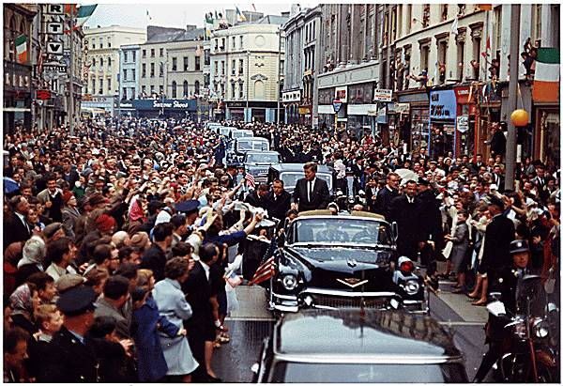
The President Kennedy motorcade making its way slowly down St. Patrick’s Street

In the context of his assassination in Dallas a few months later it is worth pointing out that President Kennedy was completely exposed to the crowd as the motorcade made its slow journey to the City Hall. Despite the erection of crash barriers, ‘a seething mass of wildly-excited people’ streamed forward continuously while ‘worried security men’ looked on.

At every corner a band, some pipes and drums, some brass and reed, some just a conglomeration of fiddles and melodeons, played for sheer joy at the presence of John Fitzgerald Kennedy, who frequently leaned from his car and brushed his hands against the outspread fingers of those nearest the motorcade.

The bells of Shandon pealed out across the city for the President, while flags and banners adorned the buildings along the route of Military Road, Summer Hill North, MacCurtain Street, St. Patrick Street, Grand Parade and South Mall, with one banner on Grand Parade reading, ‘Don’t worry Jack, the Iron Curtain will rust in peace’. When the motorcade eventually reached City Hall, Kennedy was greeted by the city’s councillors, dressed in their long, crimson robes, and by the U.S. Ambassador to Ireland, Matthew McCloskey.
Included in the welcoming party on the steps of City Hall ‘were four men who bore a startling resemblance to the esteemed guest, all of them Fitzgeralds from Skibbereen, who had been invited to say hello to their kinsman’.

Inside the City Hall, the formal proceedings began in front of 2,000 assembled guests, which included; heads of the religious orders, high ranking members of public organisations and the military, Congressmen from the U.S. and staff of the corporation including the cleaning staff who had prepared the concert hall to a scene of colorful spectacular brilliance. There were ‘elaborate floral tributes on display, including some spelling out words of welcome and a large one in front of the lectern that reproduced the American flag in red, white and blue flowers’. After the traditional roll call and prayer, the Town Clerk, Patrick Clayton, read the resolution conferring the freedom of Cork on Kennedy and then the Lord Mayor, Alderman Seán Casey, rose to speak. He stated that President Kennedy stood for the weak against the strong and for right against might and added,

Throughout its long history, Cork has received many famous visitors from many parts of the world but I can confidently say that no man has ever come within our walls who is more welcome than John Fitzgerald Kennedy, 35th President of the great republic of the west, leader of the powerful nation to whom we all owe so much.

Tubridy (2010) describes the Lord Mayor’s speech as ‘articulate if lengthy’ but there is no doubt it came from the heart. He concluded by proclaiming,

You, sir, in our eyes, represent all that is best, all that is honourable, all that is valiant in our people. We remember proudly your stirring words in your inauguration address and your call to your fellow-Americans to work for their country, to live for their country and not to ask what America could do for them. To us in Ireland these were the words of a man in the best tradition of Wolfe Tone, of Pádraig Pearse, of James Connolly. These, to us, were the words we expected of a great Irishman, and that, Mr. President, in our heart of hearts, is what we regard you to be.

President Kennedy listened intently throughout the Lord Mayor’s speech, although he did squirm in his seat and grimace on a couple of occasions – either out of concern at the length of the speech or because of pain from his well-documented bad back. When it was his turn to speak, he took a moment to look around the room before remarking, wearing his famous cheeky grin and tightly grasping his freedom casket in both hands, that ‘the Irish have not lost their ability to speak’. The freedom casket itself was made of solid silver, gilted in fine gold, mounted on a plinth of Connemara marble and engraved with shamrock, Celtic design and the Kennedy and Cork coats of arms and U.S. eagle crest. President Kennedy spoke for eight minutes, describing Ireland’s unique history of immigration and explaining the necessity for strong, cooperative international relations in an increasingly global climate.
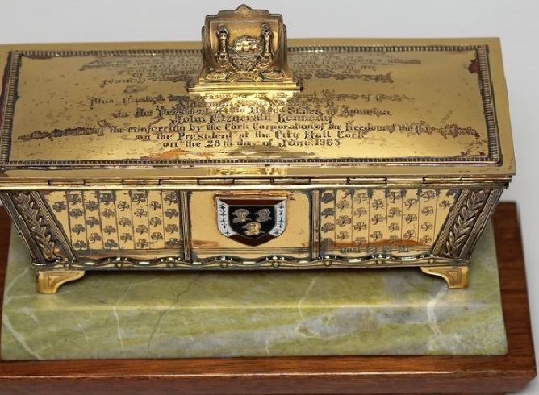
The gold freedom casket presented to President Kennedy

He said that he was delivering a welcome to Corkonians from the people of Galway, New York; Dublin, New Hampshire; Killarney, West Virginia; Kilkenny, Minnesota; Limerick, Maine; and Shamrock, Texas, noting, ‘most countries send out oil or iron, steel or gold to somewhere else, but Ireland only has one export – its people’.

Changing his tone, President Kennedy continued by stating that the world was in the most difficult and dangerous struggle it had ever seen and that weapons now existed ‘which could annihilate the human race in a few hours’. Tubridy (2010) comments that this statement was an extraordinary one ‘that was at odds with the jollity of the occasion’.

Right at the end of his address, Kennedy paused, lowered his voice, turned to the Lord Mayor and said, with some hint of emotion in his voice, ‘when I am retired from public life, I will take the greatest pride and satisfaction from not only having been President of my own country but a freeman of this city.’
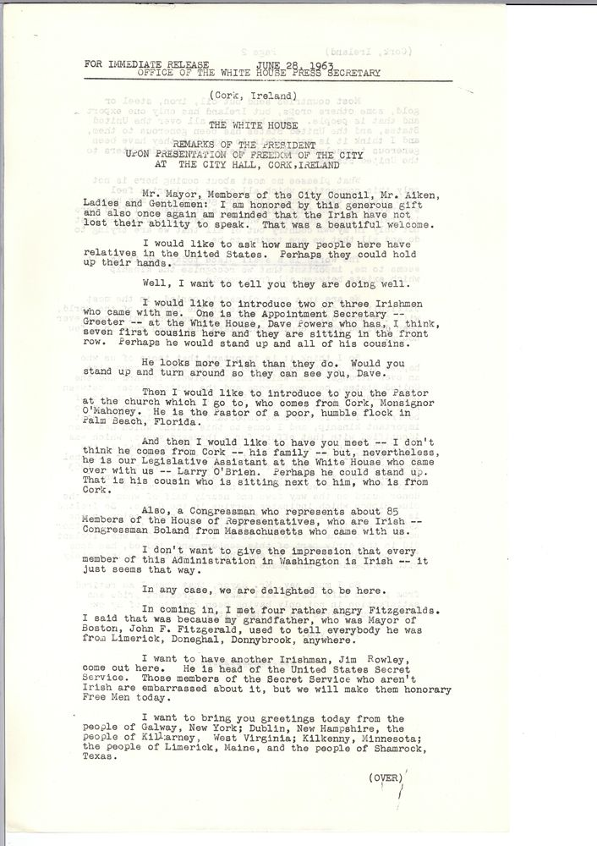
A copy of President Kennedy’s speaking notes
After the ceremony, President Kennedy had to return to Dublin (in total he was in Cork for less than two hours) but, before leaving, he had to do battle once again with the large, enthusiastic crowds. The Irish Times recorded,

When the President emerged from the building, his grin was as broad as ever, as he leaned to right and left giving the brush of the fingers. But this gesture was his undoing. A hand clasped his wrist, he pulled, the hand relaxed and he slipped down with a bump on the seat of the car while a security guard who had tried a blocking tackle went head first into the back seat. And through it all, the President smiled.

President Kennedy departed from Cork in a helicopter which was waiting in a local field, along with a crowd of approximately 5,000 people. With spectators standing too close to the aircraft, a space had to be cleared to facilitate the take-off. One member of the White House Press Corps noted,

Gee, that was the most dangerous take-off I’ve ever seen in many years of covering American Presidents. Cork outdoes anything I’ve ever seen before. I thought the mobbing in Berlin was bad, but now I know better. My message home will be of this one helluva hooley we had in Cork.

Cork, it should be remembered, was the one part of the Irish trip the President specifically requested be added to the itinerary. Kennedy was no stranger to mentioning Cork in his speeches. In 1956 at the Irish Fellowship Club in Chicago, and in 1957 at the Irish Institute in New York City, addressing Irish and those of Irish decent in the U.S., both speeches contained the quote ‘and whether we live in Cork or Boston, Chicago or Sydney, we are all members of a great family which is linked together by that strongest of chains – a common past’. Tragically, the final time a reference to Cork was contained in one of President Kennedy’s speeches he never got the chance to utter the words.

In San José and Mexico City, in Bonn and West Berlin, in Rome and Cork, I saw and heard and felt a new appreciation for an America on the move—an America which has shown that it cares about the needy of its own and other lands, an America which has shown that freedom is the way to the future, an America which is known to be the first in the effort for peace as well as preparedness.

The speech was due to be delivered on 22 November 1963, the day John F. Kennedy, President of the United States and freeman of Cork, was killed in Dallas.
This paper initially appeared as a chapter in The Freedom of Cork: A Chronicle of Honour by Aodh Quinlivan, which was published by The Collins Press in 2013.

REFERENCES

Carter Smith (2005), ‘John Fitzgerald Kennedy’, in Presidents – All You Need to Know, New York: Hylas Publishing, p. 220
Ryan Tubridy (2010), JFK in Ireland – Four Days That Changed a President, London: HarperCollins Press, p. 10
Robert Dallek (2003), John F. Kennedy – An Unfinished Life, London: Penguin Books, p. 26/27
Ibid. p. 27/28, from a conversation with Kennedy’s a960 biographer, James MacGregor Burns
Robert Dallek (2003), John F. Kennedy – An Unfinished Life, p. 27
Ryan Tubridy (2010), JFK in Ireland – Four Days That Changed a President, p. 11
Ibid.
Robert Dallek (2003), John F. Kennedy – An Unfinished Life, p. 35
Ryan Tubridy (2010), JFK in Ireland – Four Days That Changed a President, p. 11
Robert Dallek (2003), John F. Kennedy – An Unfinished Life, p. 41
Ryan Tubridy (2010), JFK in Ireland – Four Days That Changed a President, p. 12
Robert Dallek (2003), John F. Kennedy – An Unfinished Life, p. 45
Ibid. p. 65
Carter Smith (2005), ‘John Fitzgerald Kennedy’, in Presidents – All You Need to Know, p. 220
Robert Dallek (2003), John F. Kennedy – An Unfinished Life, p. 83
Ryan Tubridy (2010), JFK in Ireland – Four Days That Changed a President, p. 24
Joan and Clay Blair Jr. (1974), The Search for JFK, New York: Berkeley, p. 356
Carter Smith (2005), ‘John Fitzgerald Kennedy’, in Presidents – All You Need to Know, p. 220
Robert Dallek (2003), John F. Kennedy – An Unfinished Life, p. 133
Ibid. p. 135
Ibid. p. 182
Ibid. p. 194
Ibid. p. 213
Ibid.
Ryan Tubridy (2010), JFK in Ireland – Four Days That Changed a President, p. 38
Ibid.
The Nixon-Kennedy debates on history.com at http://www.history.com/topics/kennedy-nixon-debates
Robert Dallek (2003), John F. Kennedy – An Unfinished Life, p. 336
Ibid.
‘Life of John F. Kennedy’ from the web site of the John F. Kennedy Presidential Library and Museum, at http://www.jfklibrary.org/JFK/Life-of-John-F-Kennedy.aspx?p=4
Ibid.
Thomas Reeves (1991), A Question of Character: A Life of John F. Kennedy, London: Arrow Books
Ryan Tubridy (2010), JFK in Ireland – Four Days That Changed a President, p. 41
Ibid.
Carter Smith (2005), ‘John Fitzgerald Kennedy’, in Presidents – All You Need to Know, p. 220
‘Life of John F. Kennedy’ from the web site of the John F. Kennedy Presidential Library and Museum
John F. Kennedy Presidential Library and Museum, The Kennedy Legacy Exhibit
Robert Dallek (2003), John F. Kennedy – An Unfinished Life, p. 702
‘Life of John F. Kennedy’ from the web site of the John F. Kennedy Presidential Library and Museum
Ryan Tubridy (2010), JFK in Ireland – Four Days That Changed a President, p. 274/275
The Cork Examiner (1963), ‘Pres. Kennedy Asked To Go To Cork’, 15 June 1963, p. 9
The Cork Examiner (1963), ‘Kennedy’s Irish Visit’, 20 May 1963 p. 10
The Cork Examiner (1963), ‘Top Kennedy Men For Cork This Week’, 27 May 1963 p. 1
The Cork Examiner (1963), ‘Freedom of Cork To Be Offered To Pres. Kennedy’, 29 May 1963, p. 9
The Cork Examiner (1963), Salinger and U.S. Envoy in Cork Today, 14 June 1963, p. 1
The Cork Examiner (1963), ‘Kennedy Visit Plans Finalised’, 15 June 1963, p. 1, 9
The Cork Examiner (1963), ‘900 Gardaí will be on duty in Cork’, 16 June 1963
The Cork Examiner (1963), ‘Kennedy Visit Plans Finalised’, 15 June 1963, p. 1, 9
The Cork Examiner (1963), ‘Kennedy Will Fly To Cork In Jet Helicopter’, ‘Kennedy’s Visit to South’, 21 June 1963, p. 1, 12
The Cork Examiner (1963), ‘The Special Kennedy Touch Was Soon Applied’, 29 June 1963 p. 9
The Irish Times (1963), ‘Rose petal showers as Cork greets honorary freeman’, by Michael Foy and Noel Conway, 29 June 1963
Ibid.
The Irish Times (1963), ‘Rose petal showers as Cork greets honorary freeman’, by Michael Foy and Noel Conway, 29 June 1963
Ibid.
Ibid.
Maurice N. Hennessy (1967), I’ll Come Back in the Springtime, London: Sphere Books, p. 68
Ryan Tubridy (2010), JFK in Ireland – Four Days That Changed a President, p. 169
Ibid.
The Cork Examiner (1963), ‘Tumultuous Cork Reception’, 29 June 1963 p. 11
Ryan Tubridy (2010), JFK in Ireland – Four Days That Changed a President, p. 172
Cork Examiner (1963), ‘Cork’s New Freeman Regarded as a Great Irishman’, 29 June 1963
Ryan Tubridy (2010), JFK in Ireland – Four Days That Changed a President, p. 172
Cork Examiner (1963), ‘Cork’s New Freeman Regarded as a Great Irishman’, 29 June 1963
The Irish Times (1963), ‘Rose petal showers as Cork greets honorary freeman’, by Michael Foy and Noel Conway, 29 June 1963
Ryan Tubridy (2010), JFK in Ireland – Four Days That Changed a President, p. 173
Ibid.
The Irish Times (1963), ‘Rose petal showers as Cork greets honorary freeman’, by Michael Foy and Noel Conway, 29 June 1963
Ibid.
John F. Kennedy Presidential Library and Museum (2013), John F. Kennedy Speeches; Speech to the Irish Institute NYC 12 January 1957, available at: http://www.jfklibrary.org/Research/Research-Aids/JFK-Speeches/Irish-Institute-NYC_19570112.aspx
John F. Kennedy Presidential Library and Museum (2013), John F. Kennedy Speeches; President John F. Kennedy 22 November 1963, available at: http://www.jfklibrary.org/Research/Research-Aids/JFK-Speeches/AustinUndelivered_19631122.aspx

