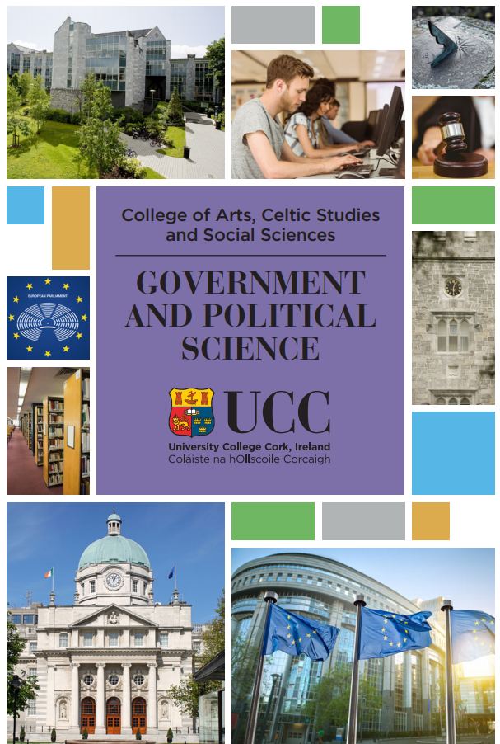

BSC GOVERNMENT AND POLITICAL SCIENCE (CK122)

Handbook

Academic Year 2024- 2025



It gives me great pleasure to welcome you to the Department of Government and Politics.

Never has it been a more exciting time to study Government and Politics. The many challenges we face, a global pandemic, climate change, the migration crisis, the rise of far-right populism, etc. require complex, creative and collaborative responses. It is imperative for us as global citizens to work individually and collectively to resolve them.

As students in our Department, you will be introduced to concepts of democracy, conflict resolution, policy making, political decision making (at the local, national, European and Global level), and international relations.

Through your participation in class and elsewhere across the University, you will develop the knowledge and skills to critically assess and address key political issues of the day as well as build on your existing transferable skills (most notably through your work placement).

As a department, we endeavour to provide an energetic and supportive learning environment through our student-friendly approach to education, our mentoring programme and our public events. Ultimately our wish is for each and every one of you to join our expanding cohort of successful graduates.

We look forward to working with you as you embark on this exciting journey through College.

Wishing you every success,

Dr Liam Weeks - Head of Department

Contact Details

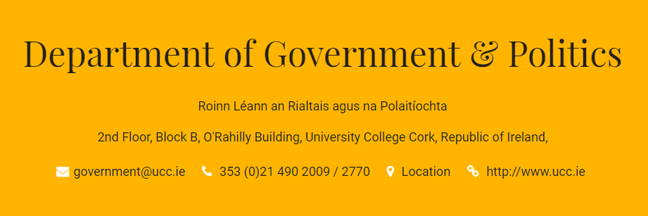

Web Address: <https://www.ucc.ie/en/government-and-politics/>

Academic Staff

Professor

Prof Andrew Cottey’s research and teaching interests are in the following areas: international relations and global governance; foreign, security and defence policy; European security, including NATO; the EU’s foreign security and defence policy; central and eastern Europe; conflict prevention and management; problems of international military intervention; civil-military relations and democracy.

Email: [a.cottey@ucc.ie](mailto:a.cottey@ucc.ie) Phone: 021 490 3899 Office: ORB_2.49

Senior Lecturers

Dr Laurence Davis specialises in political theory and ideologies, with a particular expertise in radical political thought. He is also responsible for the department's teaching in the area of U.S. politics.

Email: [l.davis@ucc.ie](mailto:l.davis@ucc.ie)  Phone: 021 490 3472 Office: ORB_2.46

Dr Niall Duggan has a strong interest in developing and testing IR theories – in particular, role theory and neo-Gramscian approaches. Dr Duggan's research has focused on how ideas and concepts can affect a national role in IR. He has conducted research in Sino-EU and Asia-EU relations.

Email: [n.duggan@ucc.ie](mailto:n.duggan@ucc.ie) Phone: 021 4903238 Office: ORB_2.10

Dr Clodagh Harris’ research focuses on deliberative and participatory democracy, democratic innovations, intergenerational deliberation, and deliberative democracy and climate change.

Email: [clodagh.harris@ucc.ie](mailto:clodagh.harris@ucc.iee) Phone: 021 490 2941 Office: ORB_2.53

Dr Aodh Quinlivan specialises in local government studies and in reform of the public sector. He has written books about Philip Monahan (Ireland’s first local authority manager), the local elections and public sector innovation.

Email: [a.quinlivan@ucc.ie](mailto:a.quinlivan@ucc.ie) Phone: 021 490 3368 Office: ORB_2.54

Dr Theresa Reidy’s research interests lie in the area of Irish politics, with a particular focus on voting behaviour at referendums and elections.

Email: [t.reidy@ucc.ie](mailto:t.reidy@ucc.ie) Phone: 021 490 3028 Office: ORB_2.52

Dr Liam Weeks  is the Head of Department. His main research interests include comparative politics, but particularly electoral systems, political parties and voting behaviour. He is interested in most aspects of Irish politics.

Email: [l.weeks@ucc.ie](mailto:l.weeks@ucc.ie)  Phone: 021 490 2941 Office: 4 Bloomfield Terrace, 1st Floor

Lecturers

Dr Fiona Buckley’s main research and teaching interests are in the areas of women in politics; Irish politics; electoral integrity; experiential learning in political science. Biography [here](http://publish.ucc.ie/researchprofiles/B007/fbuckley)

Email: [f.buckley@ucc.ie](mailto:f.buckley@ucc.ie) Phone: 021 490 3237 Office: ORB_2.45

Dr Emmanuelle Schön-Quinlivan completed her doctoral research on the institutional impact of the administrative reforms launched by Kinnock in the European Commission. Her research interests include organisational and institutional change, European institutions, public management and public administration, French politics, comparative European politics.

Email: [e.schon@ucc.ie](mailto:e.schon@ucc.ie)  Phone: 021 490 2325 Office: ORB_2.47

Emeritus Professor

Professor Neil Collins brings a strong academic profile to the Department deriving from his extensive experience in America, Britain and Ireland. He is the author of a standard text on Irish Politics, Irish Politics Today, now in its fourth edition. He has also published in the leading political science and marketing journals in Europe. His current research interests are in political corruption, clientelism and e-politics.

Email: [n.collins@ucc.ie](mailto:n.collins@ucc.ie)

Administrative Staff

The Departmental Administrative office is located in Room 2.50.

The Undergraduate Programmes Administrator is Irene Halpin. Her contact details are: 021 490 2770 or [I.Halpin@ucc.ie](mailto:I.Halpin@ucc.ie).

The Work Placement Manager is Dearbhail O’Callaghan.

Dearbhail can be contacted at [dearbhail.ocallaghan@ucc.ie](mailto:dearbhail.ocallaghan@ucc.ie) and she is located in ORB_2.48.

{During the third year of the BSc Government and Political Science degree, students undertake a work placement for 12 weeks. This work placement is facilitated by Dearbhail O’Callaghan and she will engage with students over their four years on the programme}.

Term Dates 2024– 2025

ORIENTATION for Year I: Wednesday 4th September 2024

Autumn semester

Monday 9th September – Friday 30th November – All years except first year

Monday 16th September – Friday 6th December – First Years

Directed Study Week – Monday 4th November – Friday 8th November

(There are no Government lectures on BSc GPS programme that week)

Study Review Week (All years except first year): 2nd December – 6th December

WINTER EXAMINATIONS: Monday 9th December – Friday 21st December

CHRISTMAS RECESS: Monday 23rd December– Sunday 12th January

Spring semester

SPRING CLASS DATES: Monday 13th January – Friday 4th April

EASTER RECESS: Saturday 5th April – Monday 21st April (inclusive)

STUDY REVIEW WEEK: Monday 21st April – Thursday 24th April

FINAL EXAMINATIONS: Friday 25th April – Friday 9th May

Repeat Exams: Autumn Exams start 01/08/2025

For Third Year BSc Government and Political Science students, the second semester typically runs for 6-8 weeks with Spring exams thereafter (to facilitate placement).

BSc Government and Politics Programme Content

Please see the programme outline on the UCC website: <https://www.ucc.ie/en/ck122/>

Specific information on the content of each year is available at <https://ucc-ie-public.courseleaf.com/programmes/bscgps/>

Pay particular attention to the marks and standards for 3rd and 4th year and the rules governing the calculation of the final degree mark.

It is the responsibility of each student to ensure that they register for the correct combination of modules for each year of the programme. Failure to do so will result in the student having to complete supplemental modules in the Summer period.

Details on individual modules can be accessed at <https://ucc-ie-public.courseleaf.com/modules/>

Timetables for each year of the programme are available at <https://www.ucc.ie/en/build/roombookings/timetables/>

Assessment submission process

Assignments should be submitted through Turnitin on the Canvas site of each module.

Assignments which are submitted late will be given a mark of zero.

In exceptional circumstances, it may be possible to available of a late penalty waiver. More information on this policy can be found at <https://www.ucc.ie/en/government-and-politics/undergraduatestudy/submissionofassignments/>

Medical Certificates

The Department supports students who have genuine difficulties and asks students to please be aware of and observe the following procedures:

Medical Certificates must be submitted to the administration office (ORB 2.50) or by emailing [government@ucc.ie](mailto:government@ucc.ie) no later than two weeks after the date of examination/assessment deadline or approved assessment submission date. Flexibility will be allowed in exceptional circumstances that prevent submission within the two-week window.

A medical certificate should include the following details:

The name and address of the prescribing doctor, the date of the examination/GP visit, the date the certificate was issued specifying the date of return to study or identify a chronic/on-going condition, state the impact on the student’s ability to attend for lectures, tutorials, examinations/submit the relevant programme assessment(s), the student’s name.

Plagiarism

Library Guides and Training Sessions

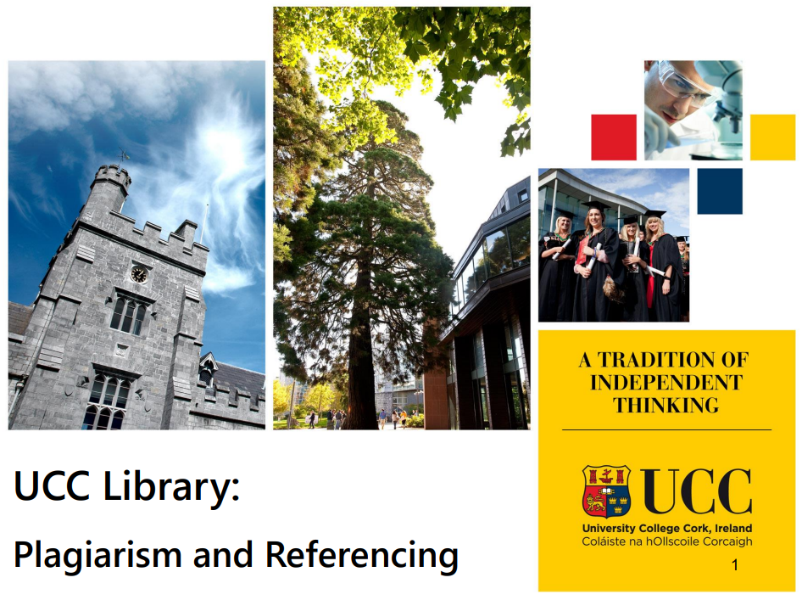

<https://libguides.ucc.ie/academicintegrity/referencing>

<https://libguides.ucc.ie/libraryessentials>

Grading Policy

The department follows guidelines of the National University of Ireland (NUI) while grading students’ work. The descriptors are available at

chrome-extension://efaidnbmnnnibpcajpcglclefindmkaj/https://www.ucc.ie/en/media/support/skillscentre/pdfx27sampbookmarks/NUIMarksBands.pdf

Information for First Years

Freshers’ Fest is on Saturday 14 September 2025. More information is available at [www.ucc.ie/en/study/undergrad/events/festivals](http://www.ucc.ie/en/study/undergrad/events/festivals)

