The following on-line supports available 24/7 for all our UCC students. To discover the full range of free supports available to our students at  [**UCC Support Tree**](https://www.ucc.ie/en/media/support/studentexperience/SupportTreeInfographic.pdf).

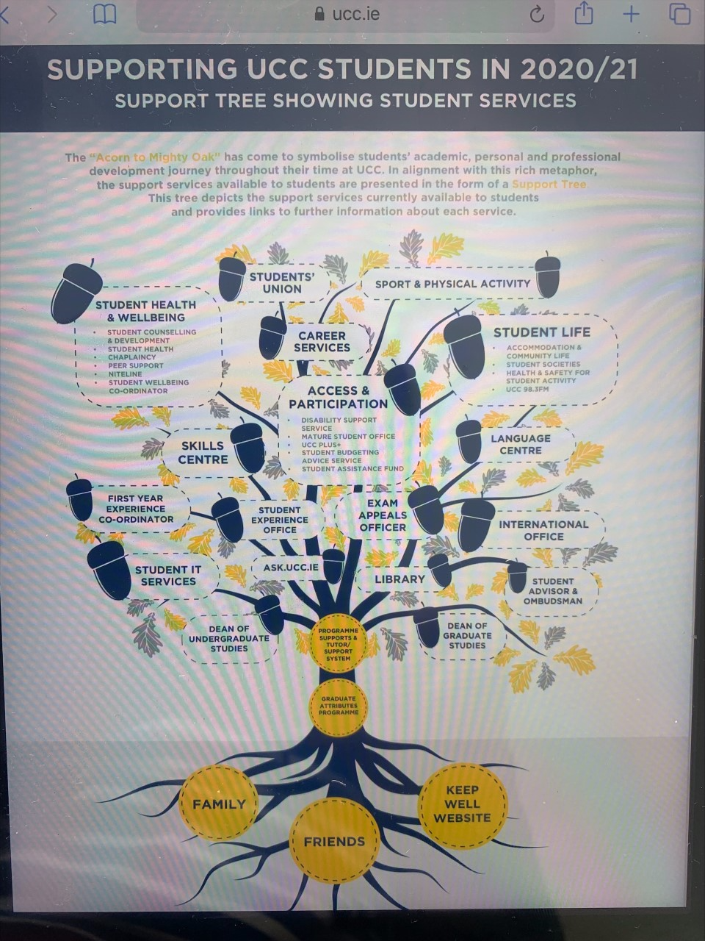

[**Silvercloud**](https://ucc.silvercloudhealth.com/onboard/ucc/programs/)**.**

designed to help you improve and maintain your wellbeing by addressing underlying issues that can have a negative impact on how you would like to live your life. Check out

* [**Space for Stress**](https://ucc.silvercloudhealth.com/onboard/ucc/programs/54/details)

* [**Space for Sleep**](https://ucc.silvercloudhealth.com/onboard/ucc/programs/89/details)

* [**Space for Positive Body Image**](https://ucc.silvercloudhealth.com/onboard/ucc/programs/3/details)

* [**Space for Resilience**](https://ucc.silvercloudhealth.com/onboard/ucc/programs/99/details)

[**Keep Well UCC**](https://www.ucc.ie/en/keep-well/)

Helping us to look after our health and wellbeing during challenging times. Including

* [**Mental Wellbeing**](https://www.ucc.ie/en/keep-well/mental/)
* [Physical Wellbeing](https://www.ucc.ie/en/keep-well/physical/)
* [Spiritual Wellbeing](https://www.ucc.ie/en/keep-well/spiritualwellbeing/)
* [Social Wellbeing](https://www.ucc.ie/en/keep-well/social/)

[**Everyday Matters**](https://www.ucc.ie/en/keep-well/mental/#everyday-matters-series)

You will learn how to create and maintain daily habits and routines that support physical and emotional wellbeing for learning and life.

To discover all the digital supports available to our students 24/7 check out <https://www.ucc.ie/en/studentexperience/digital/>

|  |  |
| --- | --- |
| F,{5c782d7d-52ff-4386-bc0c-94d9464f4db2}{112},5,3.75 | [Digital Supports for Students | University College Cork](https://www.ucc.ie/en/studentexperience/digital/)  Digital Supports for Students. Digital Student Supports - Always available to you on-line. Health and Wellbeing Supports . UCC Student Support Tree - for all your students support links in one place. Keep Well - Tips on how to look after all aspects of your health with updates on free live events. Follow us on our Keep Well Instagram page to keep in touch. ...  www.ucc.ie |

Maura O'Neill,

Student Wellbeing Coordinator