Information for Incoming First Years
Course Structure Year 1 Film & Screen Media

Semester 1 | Semester 2
Start Date: 28th September 2020 | Start Date: 25th January 2021
FX1001 Introduction to Film Studies (10 credits)
FX1004 Introduction to Digital Media (10 credits)
FX1002 Introduction to Screen Media and Culture (5 credits)  +  15 credits from minor subjects | FX1003 Early Cinema - From the Magic Lantern to the Pioneers (5 credits)  +  15 credits from minor subjects

Semester Dates
FIRST SEMESTER PERIOD | 1 WEEK STUDY/REVIEW | CHRISTMAS RECESS | SECOND SEMESTER PERIOD | EASTER RECESS | 1 WEEK STUDY/REVIEW
ALL DEGREE/DIPLOMA STUDENTS* | M. 28.09.2020  to  F. 18.12.2020 | Sa.19.12.2020  to  Su. 03.01.2021 | M. 25.01.2021  to  F. 23.04.2021 | F. 02.04.2021  to  Su.11.04.2021 | M. 26.04.2021  to  T. 29.04.2021

Please note it is up to the individual student to check timetabling information related to their minor subject.

Timetable
Semester 1
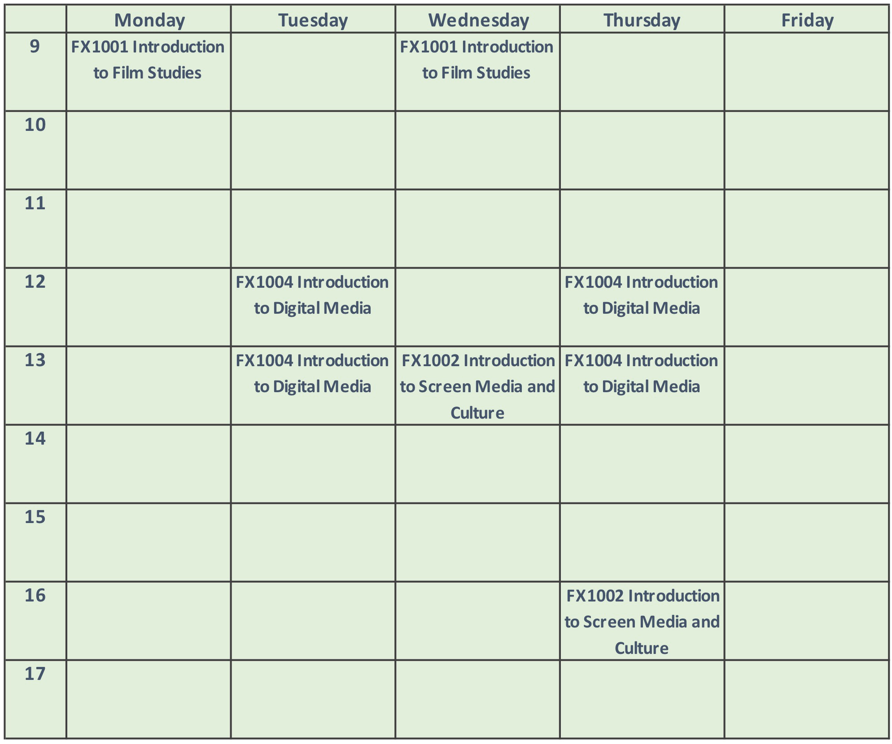
Semester 2
