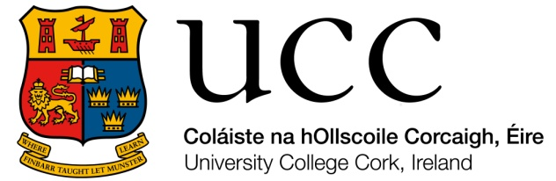

Film and Screen Media, University College Cork
ANNUAL PROGRESS REPORT FORM (DOCTORAL CANDIDATE)

All PhD students are required to complete an annual progress report. This will provide the University with details of the progress of the research project and allow any challenges or issues to be identified and acted upon in a timely fashion. The reports from you and your supervisors will be considered by the Film and Screen Media Graduate Studies Committee before you may be allowed to progress to the next academic year.

Details of doctoral candidate
Name: Date of initial registration:

Mode of Study: Full-time ☐ Part-time ☐ Currently registered for:
PhD ☐
Source of funding: PhD (Creative Practice) ☐

Supervisor(s)/Adviser
- Name: Discipline:
- Name: Discipline:
- Name: Discipline:

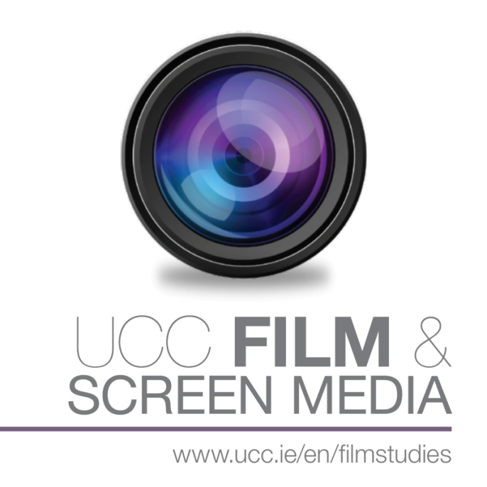

Report on progress (not to exceed 500 words)

Training undertaken (not to exceed 500 words)

Timetable for completion including proposed date of submission of thesis

Please comment on the supervision you have received:

Have you identified any challenges in the course of your research which may affect your proposed submission date?

Signed: Date:

