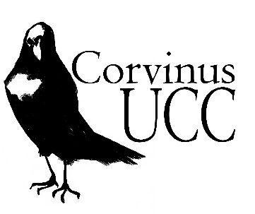 | 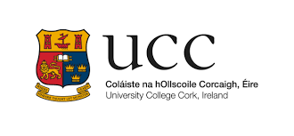
CORVINUS: APPLICATION FORM

Please fill out the following (typed applications only) and return to Catherine.Ware@ucc.ie.
Deadline for application: Monday, 1st December 2025

Student name:
Date of Birth:
Address:
Phone number:
E-mail:
Name of Parent/Guardian:
Phone no. of Parent/Guardian
E-mail of Parent/Guardian
School name and address:
School phone number:
Transition year co-ordinator:

JUNIOR CERTIFICATE
Subject | Level (H/O) | Grade achieved
LEAVING CERTIFICATE: please list the subjects you plan to take
Subject | Level (H/O)

REASONS FOR APPLICATION (2OO words max.)
Please state why you have applied for this programme. Describe any interests/studies/
attributes you may have which particularly qualify you for a place on the programme.

